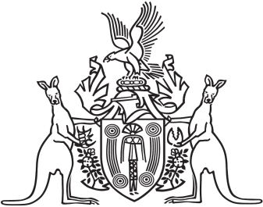
Northern Territory of Australia

Government Gazette
ISSN-0157-833X
No. S20 22 March 2018
Northern Territory of Australia

Aboriginal Land Act
Declaration of Open Areas
I, Michael Patrick Grant, Acting Administrator of the Northern Territory of Australia, acting with the advice of the Executive Council and on the recommendation of the Northern Land Council, under section 11(1) of the Aboriginal Land Act, declare each area of Aboriginal land described in the Schedule, Part A, and depicted on the maps in the Schedule, Part B, to be an open area.
Dated 19 March 2018
M. P. Grant
Acting Administrator
By His Honour's Command
G. F. McCarthy
Minister for Housing and Community Development
acting for
Minister for Infrastructure, Planning and Logistics
Schedule
Part A
1 Those parts of land and sea in the vicinity of Cox Peninsula and Bynoe Harbour (including islands and reefs) that are the subject of the Deed of Grant to the Kenbi Aboriginal Land Trust dated 28 June 2012, and more particularly delineated on Compiled Plan 5595 lodged with the Surveyor-General, Darwin, and which:
(a) lie within the intertidal zone, being between the low water mark and the high water mark; and
(b) where there are beaches, being:
(i) the land from the low water mark to the crest of secondary sand dune where such a dune exists; and
(ii) where there is no secondary sand dune, to a point 50 metres inland from the landward boundary of the beach.
2 The following land is excluded from this declaration:
(a) the whole of Northern Territory Portion 4768 (Crocodile Island to low water mark);
(b) the whole of Northern Territory Portion 4769 (Knife Island to low water mark); and
(c) that part of Ida Bay lying east of Meridian of East Longitude 130 degrees 35 minutes 35 seconds (GDA94).
3 This declaration is subject to:
(a) the restrictions more particularly delineated on Compiled Plan 5596 lodged with the Surveyor-General, Darwin; and
(b) Aboriginal Areas Protection Authority Certificates C2018/015 and C2018/016 issued in accordance with the Northern Territory Aboriginal Sacred Sites Act.

Part B
