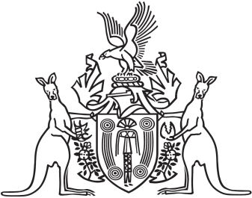
Northern Territory of Australia

Government Gazette
ISSN-0157-8324
No. G11 14 March 2018

General information
The Gazette is published by the Office of the Parliamentary Counsel.
The Gazette will be published every Wednesday, with the closing date for notices being the previous Friday at 4.00 pm.
Notices not received by the closing time will be held over until the next issue.
Notices will not be published unless a Gazette notice request form together with a copy of the signed notice and a clean copy of the notice in Word or PDF is emailed to gazettes@nt.gov.au
Notices will be published in the next issue, unless urgent publication is requested.

Availability
The Gazette will be available online at 12 Noon on the day of publication at https://nt.gov.au/about-government/gazettes
Unauthorised versions of Northern Territory Acts and Subordinate legislation are available online at https://legislation.nt.gov.au/

Northern Territory of Australia

Interpretation Act
Notification of Making of Rules
under Supreme Court Act
I, Natasha Kate Fyles, Attorney-General and Minister for Justice, under section 63(3) of the Interpretation Act, give notice that the following rules have been made under section 86 of the Supreme Court Act:
Subordinate Legislation No. 6 of 2018: Supreme Court Amendment (Miscellaneous) Rules 2018
Copies of the rules may be purchased from the Print Management Unit in the Department of Corporate and Information Services, by email request sent to pmu.ntg@nt.gov.au.
Dated 5 March 2018
N. K. Fyles
Attorney-General and Minister for Justice

