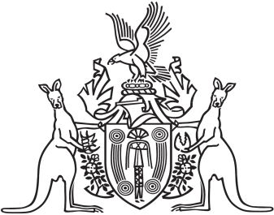
Northern Territory of Australia

Government Gazette
ISSN-0157-833X
No. S2 23 January 2018
Northern Territory of Australia

Local Government Act
Dismissal of Members – City of Palmerston
I, Gerald Francis McCarthy, Minister for Housing and Community Development, under section 224(5)(b) of the Local Government Act, dismiss the suspended members of the City of Palmerston from office.
Dated 23 January 2018
G. F. McCarthy
Minister for Housing and Community Development

