Northern Territory of Australia

Government Gazette
ISSN-0157-8324
No. G1 3 January 2018

General information
The Gazette is published by the Office of the Parliamentary Counsel.
The Gazette will be published every Wednesday, with the closing date for notices being the previous Friday at 4.00 pm.
Notices not received by the closing time will be held over until the next issue.
Notices will not be published unless a Gazette notice request form together with a copy of the signed notice and a clean copy of the notice in Word or PDF is emailed to gazettes@nt.gov.au
Notices will be published in the next issue, unless urgent publication is requested.

Availability
The Gazette will be available online at 12 Noon on the day of publication at https://nt.gov.au/about-government/gazettes
Unauthorised versions of Northern Territory Acts and Subordinate legislation are available online at https://legislation.nt.gov.au/

General Gazette Publication Dates 2018
Gazette number | Publication Date | Closing Date
1 | 3 January | 29 December
2 | 10 January | 5 January
3 | 17 January | 12 January
4 | 24 January | 19 January
5 | 31 January | 26 January
6 | 7 February | 2 February
7 | 14 February | 9 February
8 | 21 February | 16 February
9 | 28 February | 23 February
10 | 7 March | 2 March
11 | 14 March | 9 March
12 | 21 March | 16 March
13 | 28 March | 23 March
14 | 4 April | 30 March
15 | 11 April | 6 April
15 | 18 April | 13 April
16 | 25 April | 20 April
17 | 2 May | 27 April
18 | 9 May | 4 May
19 | 16 May | 11 May
20 | 23 May | 18 May
21 | 30 May | 25 May
22 | 6 June | 1 June
23 | 13 June | 8 June
24 | 20 June | 15 June
25 | 27 June | 22 June
26 | 4 July | 29 June
27 | 11 July | 6 July
28 | 18 July | 13 July
29 | 25 July | 20 July
30 | 1 August | 27 July
31 | 8 August | 3 August
32 | 15 August | 10 August
33 | 22 August | 17 August
34 | 29 August | 24 August
35 | 5 September | 31 August
36 | 12 September | 7 September
37 | 19 September | 14 September
38 | 26 September | 21 September
39 | 3 October | 28 September
40 | 10 October | 5 October
41 | 17 October | 12 October
42 | 24 October | 19 October
43 | 31 October | 26 October
44 | 7 November | 2 November
45 | 14 November | 9 November
46 | 21 November | 16 November
47 | 28 November | 23 November
48 | 5 December | 30 November
49 | 12 December | 7 December
50 | 19 December | 14 December

Northern Territory of Australia
Transport of Dangerous Goods by Road and Rail
(National Uniform Legislation) Act
Appointment of Officers
I, Stephen Hugh Gelding, the Competent Authority:
- under section 23(1) of the Transport of Dangerous Goods by Road and Rail (National Uniform Legislation) Act and with reference to section 44 (1) of the Interpretation Act, terminate all appointments of authorised officers in force immediately before the date of this instrument; and
- under section 23(1) of the Transport of Dangerous Goods by Road and Rail (National Uniform Legislation) Act, appoint the people named in the Schedule to be authorised officers and exercise the powers under:
- sections 31, 32, 33, 34, 35, 36, 37, 38, 39, 40, 44, 45, 46, 47, 48, 49, 50, 54, 55, 56, 57, 58, 59, 62, 63, 64, 65, 86, 88, 90, 93, 95, 96 and 99 of the Transport of Dangerous Goods by Road and Rail (National Uniform Legislation) Act; and
- regulation 232 of the Transport of Dangerous Goods by Road and Rail (National Uniform Legislation) Regulations.
The power to amend a notice pursuant to sections 88 and 96 is restricted to minor amendments:
- for clarification; or
- to correct errors or references; or
- to reflect changes of address or other circumstances.
Dated 19 December 2017
S. Gelding
Work Health Authority
_________________________________
Schedule
Allan Crombie Fischer
Amber Louise Sayers
Andrew James Lucas
Anthony Paul Clifford
Anthony John Waite
Brian Cleary
Brian Wingrove
Carolynne Murrell
Christos Despotis
Collins Dubere Gipey
David James Mallett
Fiona Louise Peters
Fred James Munro
Gillian Hylton
Joseph Peter Pisani
Kerry Lee-Anne Barnaart
Maria Staunton
Maria Rigas
Natalie Joan Clifton
Neil William Burgess
Nigel Butler
Rebecca Sue Trimble
Robert Stanley Fereday
Robin Leslie Paget Smith
Shane Victor Thompson
Stewart Pritchard
_________________________________
Northern Territory of Australia

Petroleum Act

Notification of Partial Surrender of Petroleum Exploration Permit (EP) 154
I, Vicki Lorraine Jackson, the Delegate of the Minister for Primary Industry and Resources by virtue of an instrument of delegation dated 11 October 2016, in pursuance of Section 70(c) of the Petroleum Act, give notice that 22 full and part blocks have been surrendered from Petroleum Exploration Permit (EP) 154 as per the highlighted area below.
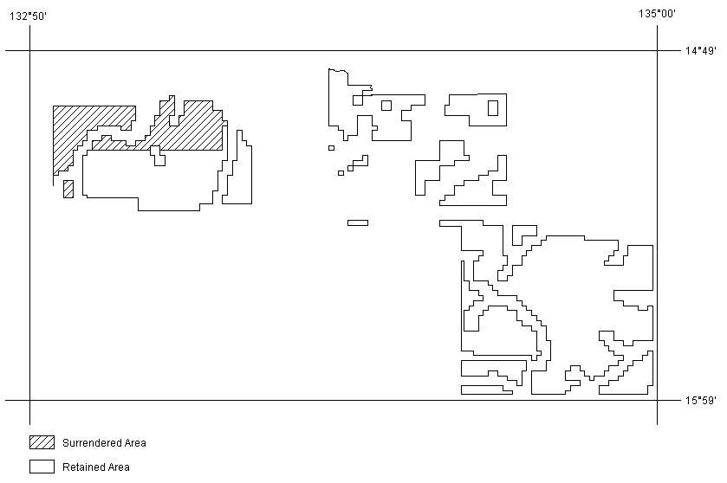Datum: The displayed grid defining the 5’x 5’ blocks is AGD66 and coordinates shown are GDA94

Dated 20 December 2017
V. L. Jackson

Executive Director, Energy

Northern Territory of Australia

Petroleum Act
Release of Information under Section 61(8)
I, Vicki Lorraine Jackson, the Delegate of the Minister for Primary Industries and Resources, in pursuance of section 61(8) of the Petroleum Act -
- notify that I propose to make the information specified in the Schedule available or publicly known;
- invite interested persons to give to me, within 45 days after the publication of this notice, a notice objecting to the whole or any part of the information being made available or publicly known; and
- notify that if a person does not make an objection in accordance with this invitation, the person will be taken to have consented to the information being made available or publicly known.

Note
- A notice objecting to information being made available or publicly known shall set out the person’s reasons for making the objection.
- A person may not object to information being made available or publicly known under this -
  - a trade secret; or
  - any other information the disclosure of which would, or could reasonably be expected to, adversely affect the person in respect of the lawful business, commercial or financial affairs of the person.
Dated: 21 December 2017
Made under the Petroleum Act of the Northern Territory of Australia
V. L. Jackson
Delegate of the Minister for Primary Industries and Resources
Pursuant to Instrument of Delegation Dated 11 October 2016
Schedule
PR | Tenure | Onshore Interpretive data, Reports and Samples | Release Date | Legislation | Notes
PR2007-0139 | EP98 | Shenandoah 1 Interpretative Log Data | 12/12/2016 | Section 61(8) Petroleum Act | Routine
PR2011-0126 | EP107 | CMB 107-001 Well Completion Report Interpretative | 25/02/2016 | Section 61(8) Petroleum Act | Routine

Northern Territory of Australia

Weeds Management Act
Declared Weed
Limnobium Laevigatum (Amazon Frogbit)
I, Lauren Jane Moss, Minister for Environment and Natural Resources, under section 7(1) of the Weeds Management Act and with reference to section 7(4)(c) of the Act:
(a) declare Limnobium laevigatum (Amazon frogbit) to be a declared weed; and
(b) classify Limnobium laevigatum (Amazon frogbit) for the whole of the Territory as a class C weed, having regard to the necessity to prevent the introduction of it into the Territory.
Dated 20 December 2017
L. J. Moss
Minister for Environment and Natural Resources

Police Administration Act

Sale of Goods
Notice is hereby given that pursuant to Section 166 of the Police Administration Act, the following property as shown on the attached schedule has been in the possession of the Officer in Charge, Police Station, Peter McAulay Centre, for a period in excess of 3 months and this property will be sold or otherwise disposed of in a manner as determined by the Commissioner of Police, if after twenty-eight (28) days from the publication of this notice the property remains unclaimed.
Nouvelle Reed
Superintendent
iCOP 2020
CIO Branch
29 December 2017
MPR/Exhibits Disposal
Exhibit number | Item Description
495012/001 | Blue Dunlop bike
492390/001 | Blue men’s mountain bike
448128/001 | White/blue Southern Star ladies bike
448127/001 | White/purple Southern Star ladies bike
453197/003 | 1 x silver men’s Citizen watch
453197/004 | Pink Moki speaker
492596/001 | Ladies watch with thick leather band
492493/002 | Samsung digital camera
491633/001 | Baseball bat
491621/003 | Gold wedding ring
491512/001 | Black Sony digital camera
483467/001 | Black Casio G Shock watch
483093/002 | Gold plated Quartz watch
482809/001 | Black Apple iWatch
468654/001 | Black Samsung digital camera
492845/001 | $3.90
492736/002 | $50
492598/001 | $50
492535/002 | $96.20
492527/002 | 20 Thai Baht
492570/001 | $500
492262/002 | $4
492180/002  492180/003 | $1.50  5 cents Singapore
492922/002 | $60.10
492014/002 | $23
491923/002 | $2.70
491621/002 | $50
491464/001 | 50cents
491334/002 | $30.20
491266/001 | $155
488780/001/001 | $167.20
468656/003 | 85 American dollars
477745/006 | 3421 Yen, 200 Rupiah + 20 NZ dollars
492871/001 | Grey Apple iPad mini
492865/001 | Telstra mobile phone
492845/001 | Wallet and contents
492776/001  492776/002 | White iPhone  White Telstra mobile phone
492736/001 | Wallet and contents
492595/001  492595/002 | White Telstra mobile phone  Mobile phone charge
492410/001 | White Samsung tablet
492573/001 | Black Apple iPhone 7
492535/001 | Wallet and contents
492527/001 | Wallet and contents
492497/002 | Black Huawei mobile phone
492493/001 | Telstra mobile phone
492365/002  492365/003  492365/001 | Black Telstra mobile phone  Black Telstra mobile phone  Black Telstra tablet
492349/001  492349/001 | Silver Telstra mobile phone  Multi coloured purse
492262/001 | Wallet and contents
492261/001 | Black Apple iPhone
492231/001/001 | Black glasses in case
492226/001 | White Samsung Mobile Phone
492180/001 | Wallet and contents
492161/001 | Black Samsung S8 mobile phone
492159/001 | Black Apple iPhone S
493075/001 | Black Samsung S6 mobile phone
492997/001  492997/002 | White ZTE mobile phone  White ZTE mobile phone
492922/001 | Black canvas wallet
492144/001 | Gold Apple iPhone SE
492118/001 | Black Apple tablet
492070/001 | Beige Telstra mobile phone
492039/001 | Black LG mobile phone
492014/001 | Black Adidas bum bag
491923/001 | Wallet and contents
491892/001 | Silver Apple iPhone 6s
491781/001 | Black Apple iPhone 5
491777/002  491777/001 | White Apple iPhone 4  Black wallet and contents
491695/001 | Grey HTC mobile phone
491688/001 | Black Apple iPhone
491680/001 | White Telstra ZTE mobile phone
491641/001 | Silver Telstra ZTE mobile phone
491621/001 | Wallet and contents
491491/001 | Wallet and contents
491464/001 | Wallet and contents
491334/001 | Wallet and contents
491279/003  491279/004  491279/005  491279/006  491279/002  491279/001 | Black Telstra ZTE mobile phone  Black Alcatel mobile phone  White Telstra ZTE mobile phone  Black Huawei mobile phone  White Samsung mobile phone  White Apple iPhone
491215/001 | Gold Apple iPhone
488780/001 | Wallet and contents
487810/001 | Black Telstra mobile phone
483093/001 | Black Telstra Smart pad
473908/001 | Wallet and contents
468656/002  468656/002/001  468656/001 | Wallet and contents  Bum bag  White Samsung mobile phone
463041/001 | Black Apple iPad
488974/001 | White ZTE mobile phone
443582/001 | Black Samsung flip phone
469662/001  469662/002  469662/003 | Black/grey Telstra Smart phone  Black/silver Boost Mobile phone  Black Telstra Tablet
477745/002  477745/003  477745/004 | Silver Apple Iphone  White Apple Iphone  Black Samsung phone
492172/001  492172/002 | Black Telstra Alcatel phone  Black Samsung phone
472328/014  472328/015 | White Iphone  Samsung phone
482790/001  482790/002  482790/003  482790/004 | Women’s floral short sleeve top  Women’s black denim skirt  Beige bra  Black underwear
488623/006 | Shotgun barrel
481466/001 | Lanber 12G SUO S/N # 13030086105
496852/001 | BSA .303 rifle cut down S/N # 56272
492658/001 | Men’s silver mountain bike
492438/001 | Blue Diamond Back child’s bike
492395/001 | Blue Everest bike
492386/001 | Green Fluid Bike
492148/001 | Black Trek Bontrager bike
492908/001 | Black and red Nitro Bike
492030/001 | Grey Giant XTC bike
491942/001 | Blue mountain bike
491575/001 | White Hyper Steed women’s mountain bike
491493/001 | Black GT Aggressor bike
491448/001 | Black Merida bike
491446/001 | Red Norco ladies bike
491445/001 | Cream Avanti ladies bike
469470/001 | NT CB08BV – White Mazda 121
486916/003 | NT CB87HL – Honda Civic (burnt out)
489160/001 | NT 97497 – Black Kawasaki Motorcycle

