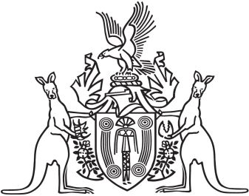
Northern Territory of Australia

Government Gazette
ISSN-0157-833X
No. S94 11 December 2017

Assent to Proposed Laws
Her Honour the Administrator assented to the following proposed laws:
8 December 2017
Independent Commissioner Against Corruption Act 2017 (Act No. 23 of 2017)
Liquor Amendment Act 2017 (Act No. 24 of 2017)
Michael Tatham
Clerk of the Legislative Assembly

