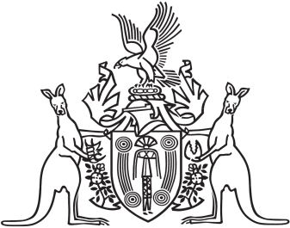
Northern Territory of Australia

Government Gazette
ISSN-0157-833X
No. S91 30 November 2017
Northern Territory of Australia

Public Sector Employment and Management Act
Appointment of Chief Executive Officer
I, Michael Patrick Francis Gunner, Chief Minister, under section 19A(1) of the Public Sector Employment and Management Act, appoint Joanne Townsend to be the Chief Executive Officer of the Department of Environment and Natural Resources on and from the date of this instrument.
Dated 27 November 2017
M. P. F. Gunner
Chief Minister

