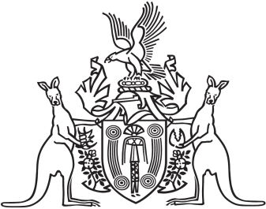
Northern Territory of Australia

Government Gazette
ISSN-0157-833X
No. S76 27 October 2017

Notification of Subordinate Legislation
Notice is given of the making of the following subordinate legislation, effective from the date specified:
Subordinate Legislation | Commencement details | Empowering Act
Liquor Amendment (General Policy Direction) Regulations 2017  (No. 29 of 2017) | These Regulations commence on the day on which they are notified in the Gazette | Liquor Act
For copies of legislation please direct your request to the Print Management Unit, email pmu.ntg@nt.gov.au or phone (08) 8999 6727

