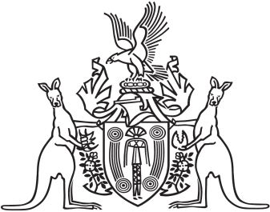
Northern Territory of Australia

Government Gazette
ISSN-0157-833X
No. S47 4 July 2017
Northern Territory of Australia
Licensed Surveyors Act
Fees for Registration and Restoration to Register
I, Craig Leslie Sandy, Chairperson of the Surveyors Board of the Northern Territory, under section 20 of the Licensed Surveyors Act and with effect from the later of 1 July 2017 or the date this instrument is published in the Gazette, prescribe:
- for section 20 of the Act, the application for registration fee payable by a licensed surveyor during the period from:
- the date this instrument takes effect to 31 December 2018 to be 66 revenue units; and
- 1 January 2019 to 31 December 2019 to be 75 revenue units; and
- 1 January 2020 to 31 December 2020 to be 87 revenue units.
- for section 20 of the Act, the application for registration of a professional training agreement fee during the period from:
- the date this instrument takes effect to 31 December 2018 to be 26 revenue units; and
- 1 January 2019 to 31 December 2019 to be 30 revenue units; and
- 1 January 2020 to 31 December 2020 to be 35 revenue units.
- for section 20 of the Act, to issue a letter of accreditation fee during the period from:
- the date this instrument takes effect to 31 December 2018 to be 66 revenue units; and
- 1 January 2019 to 31 December 2019 to be 75 revenue units; and
- 1 January 2020 to 31 December 2020 to be 87 revenue units.
- for section 26(2) of the Act, the application to sit for the professional assessment examination fee during the period from:
- the date this instrument takes effect to 31 December 2018 to be 291 revenue units; and
- 1 January 2019 to 31 December 2019 to be 335 revenue units; and
- 1 January 2020 to 31 December 2020 to be 385 revenue units.
- for section 26(2) of the Act, the application to sit a supplementary professional assessment examination fee during the period from:
- the date this instrument takes effect to 31 December 2018 to be 145 revenue units; and
- 1 January 2019 to 31 December 2019 to be 167 revenue units; and
- 1 January 2020 to 31 December 2020 to be 192 revenue units.
The change in fees can be viewed on the Boards website: www.surveyorsboard.nt.gov.au.
Dated 28 June 2017
C. L. Sandy
Chairperson of the Board

