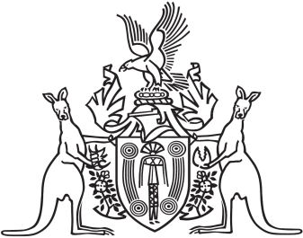
Northern Territory of Australia

Government Gazette
ISSN-0157-833X
No. S122 28 December 2016
Notice pursuant to section 54 of the
Northern Territory of Australia
Associations Act
Notice is hereby given that YMCA of Central Australia Inc ABN 13 381 977 987 has passed a resolution in accordance with its constitution:
- pursuant to section 54 of the Associations Act, determining subject to section 110 of the Associations Act, to transfer all of its real and personal property (other than “prescribed property” as that term is defined in the Associations Act) to The Young Men’s Christian Association of the Northern Territory Ltd. ACN 616 111 463.
- subject to section 110 of the Associations Act and receiving written consent from the Minister, determining to transfer all of its “prescribed property” (as that term is defined in section 4 of the Act) to The Young Men’s Christian Association of the Northern Territory Ltd. ACN 616 111 463.
Dated: 21 December 2016
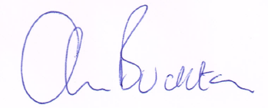
Andrew Buckton
Secretary
YMCA of Central Australia Inc

