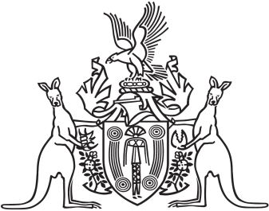
Northern Territory of Australia

Government Gazette
ISSN-0157-833X
No. S112 7 November 2016
Return to Work Act

Workers Rehabilitation and Compensation Advisory Council

Members - Expressions of Interest
The Attorney-General and Minister for Justice invites nominations from persons within the Northern Territory who:
- have a wide range of experience across major industry sectors
- are representatives of organisations representing employees or employers
- have expertise in the rehabilitation of injured workers or the insurance industry
The Workers’ Rehabilitation and Compensation Advisory Council comprises of the person constituting the Work Health Authority and no more than ten members appointed by the Minister.
The function of the Council is to:
- keep the operation of the Return to Work Act under review
- make recommendations to the Minister on possible improvements to the administration of the Act, or the statutory scheme for the rehabilitation and compensation of injured workers in the Territory
- carry out investigations, at the request of the Minister, into questions about the rehabilitation and compensation of injured workers and to report to the Minister on the results of the investigation
- perform any other advisory functions relating to workers’ rehabilitation and compensation as the Minister directs
The term of office is not to exceed two years, as determined by the Minister and sitting fees are available to eligible members.
Forward your written application, addressing your suitability for appointment to the Workers Rehabilitation and Compensation Advisory Council to:
The Attorney-General and Minister for Justice
C/o: The Department of Attorney-General’s and Justice
Secretariat
GPO Box 1722
Darwin NT 0801

or by email to AGD.Secretariat@nt.gov.au
Applications close on 23 December 2016.

