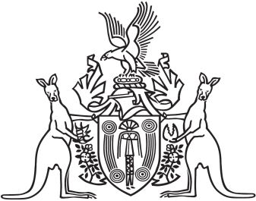
Northern Territory of Australia

Government Gazette
ISSN-0157-833X
No. S110 26 October 2016
Northern Territory of Australia

Weeds Management Act
Declared Weed – Sagittaria (Sagittaria platyphylla)
I, Lauren Jane Moss, Minister for Environment and Natural Resources:
(a) under section 7(1) of the Weeds Management Act and with reference to section 43 of the Interpretation Act, revoke the instrument entitled "Declared Weeds", dated 15 July 2016 and published in Gazette No. G30 of 27 July 2016 to the extent the instrument relates to Sagittaria (Sagittaria platyphylla); and
(b) under section 7(1) of the Weeds Management Act and with reference to section 7(4)(a) and (c) of the Act:
(i) declare Sagittaria (Sagittaria platyphylla) to be a declared weed; and
(ii) classify Sagittaria (Sagittaria platyphylla for the whole of the Territory as:
(A) a Class A weed, having regard to the necessity to eradicate it; and
(B) a Class C weed, having regard to the necessity to prevent the introduction of it into the Territory.
Dated 19 October 2016
L. J. .Moss
Minister for Environment and Natural Resources

