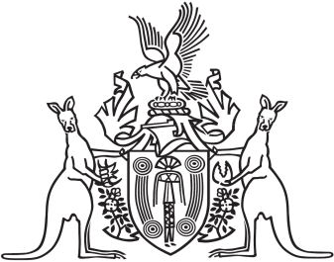
Northern Territory of Australia

Government Gazette
ISSN-0157-833X
No. S97 24 August 2016

Northern Territory of Australia
Motor Vehicles Act
Exemption from Motor Vehicles (Standards) Regulations
Brake Light Exemption
I, Simon Phillip Saunders, Registrar of Motor Vehicles, pursuant to section 59(2) of the Motor Vehicles Act, exempt a class of vehicle, as described in the Schedule, from the requirements of Rule 98(6) of Schedule 6 of the Motor Vehicles (Standards) Regulations.
Schedule
An exempt class of vehicle is a vehicle that:
has a pair of brake lights fitted to the rear that function as both brake lights and direction indicator lights; and
is a motor vehicle with 4 or more wheels; and
is built before 1 January 1973.
Dated this 23 day of August 2016
S. P. Saunders
Registrar of Motor Vehicles

