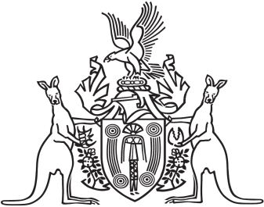
Northern Territory of Australia

Government Gazette
ISSN-0157-833X
No. S96 23 August 2016
Northern Territory of Australia

Weeds Management Act
Appointment of Weed Management Officer
I, Alastair John Shields, Chief Executive Officer of the Department of Land Resource Management, as the delegate of the Minister for Land Resource Management, under section 24(1) of the Weeds Management Act, appoint Peter John Phillips to be a weed management officer.
Dated 22 August 2016
A. J. Shields
Chief Executive Officer
Department of Land Resource Management
Northern Territory of Australia

Weeds Management Act
Appointment of Weed Management Officers
I, Alastair John Shields, Chief Executive Officer of the Department of Land Resource Management, as the delegate of the Minister for Land Resource Management, under section 24(1) of the Weeds Management Act, appoint Veronica Opden and Christopher James Parker to be weed management officers.
Dated 22 August 2016
A. J. Shields
Chief Executive Officer
Department of Land Resource Management

