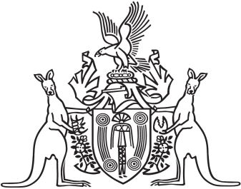
Northern Territory of Australia

Government Gazette
ISSN-0157-833X
No. S67 18 July 2016
Northern Territory of Australia

Justice Legislation Amendment (Drug Offences) Act 2016
Commencement Notice
I, John Laurence Hardy, Administrator of the Northern Territory of Australia, under section 2 of the Justice Legislation Amendment (Drug Offences) Act 2016 (No. 17 of 2016) (the Act), fix 18 July 2016 as the day on which section 17 of the Act, other than to the extent it inserts new section 15 in the Misuse of Drugs Act, commences.
Dated 15 July 2016
J. L. Hardy
Administrator

