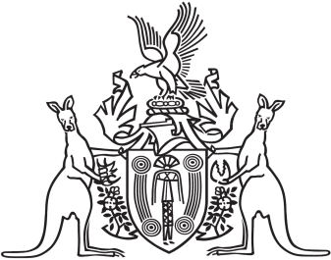
Northern Territory of Australia

Government Gazette
ISSN-0157-833X
No. S65 14 July 2016
Northern Territory of Australia

Justice Legislation Amendment (Drug Offences) Act 2016
Revocation of Commencement Notice
I, John Laurence Hardy, Administrator of the Northern Territory of Australia, under section 2 of the Justice Legislation Amendment (Drug Offences) Act 2016 (No. 17 of 2016) and with reference to section 43 of the Interpretation Act, revoke the commencement notice dated 1 July 2016.
Dated 12 July 2016
J. L. Hardy
Administrator
Northern Territory of Australia

Justice Legislation Amendment (Drug Offences) Act 2016
Commencement Notice
I, John Laurence Hardy, Administrator of the Northern Territory of Australia, under section 2 of the Justice Legislation Amendment (Drug Offences) Act 2016 (No. 17 of 2016) (the Act):
(a) fix 10 October 2016 as the day on which section 17 of the Act, to the extent it inserts new section 15 in the Misuse of Drugs Act, commences; and
(b) fix 18 July 2016 as the day on which the remaining provisions of the Act commence.
Dated 12 July 2016
J. L. Hardy
Administrator

