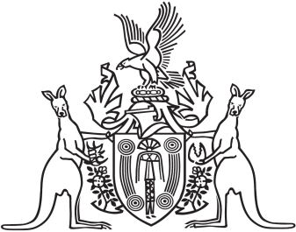
Northern Territory of Australia

Government Gazette
ISSN-0157-833X
No. S54 24 June 2016
Northern Territory of Australia

Pastoral Land Act
Pastoral Land Board
Appointment of Member and Chairman
I, Gary John Higgins, Minister for Land Resource Management:
(a) under section 12(1) of the Pastoral Land Act, appoint Paul Zlotkowski to be a member of the Pastoral Land Board from 26 June 2016 to 25 June 2019; and
(b) under section 16(1) of the Act, appoint Paul Zlotkowski to be the Chairman of the Board on and from 26 June 2016.
Dated 20 June 2016
G. J. Higgins
Minister for Land Resource Management
Northern Territory of Australia

Pastoral Land Act
Pastoral Land Board
Appointment of Member
I, Gary John Higgins, Minister for Land Resource Management, under section 12(1) of the Pastoral Land Act, appoint Anne Margaret Kilgariff to be a member of the Pastoral Land Board for 3 years on and from the date of this instrument.
Dated 20 June 2016
G. J. Higgins
Minister for Land Resource Management

