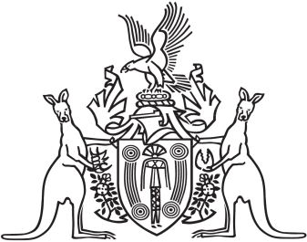

Northern Territory of Australia

Government Gazette

ISSN-0157-8324

No. G25 22 June 2016

# General information

The Gazette is published by the Office of the Parliamentary Counsel.

The Gazette will be published every **Wednesday**, with the closing date for notices being the previous Wednesday at 4.00 pm.

Notices not received by the closing time will be held over until the next issue.

Notices will not be published unless a Gazette notice request form together with a copy of the signed notice and a clean copy of the notice in Word or PDF is emailed to [gazettes@nt.gov.au](mailto:gazettes@nt.gov.au)

Notices will be published in the next issue, unless urgent publication is requested.

# Availability

The Gazette will be available online at 12 Noon on the day of publication at <http://www.nt.gov.au/ntg/gazette.shtml>

Unauthorised versions of Northern Territory Acts and Subordinate legislation are available online at <http://www.legislation.nt.gov.au>

*Crown Lands Act*

Notice of Temporary Closure of Reserve

Robbie Robbins Reserve

Notice is hereby given in accordance with the *Crown Lands Act* and Section 8 (b) of the *Crown Lands (Recreation Reserve) Regulations*, that Robbie Robbins Reserve will be closed to the public for the period 24 June to 26 June 2016 inclusive, for the purpose of conducting the Professional Bull Riders Event.

Dated 10 June 2016

John McLaren

Chairman

Board of Trustees