REMOTE ABORIGINAL DEVELOPMENT FUND
Economic Development grant – Application form

Organisation Details
Organisation name:
Postal address |  |  |  |  |  |  |  |  |  |  |  |  |  | Postcode
Principal place of business address |  |  |  |  |  |  |  |  |  |  |  |  |  | Postcode
Telephone: |  |  |  |  |  |  |  |  |  |  |  | Mobile:
ABN: |  |  |  |  |  |  |  |  |  |  | GST registered |  |  |  | Yes No
Incorporated association |  |  |  |  |  |  | Unincorporated
Not for Profit |  |  |  |  |  |  | Office of the Registrar of Indigenous Corporations
Other (please state)

Contact Officer Details
Mr Mrs Ms Miss Other
Full name:
Position in organisation:
Telephone:
Email address:
Small Grant  (between 15K and 50K) |  |  |  |  |  |  |  |  |  | Large Grant  (between 50K and 100K)

Location
Please indicate the region in the Territory where your organisation conducts its main activities (you may select more than one region if applicable).
Top End Region (incl. Tiwi Islands, Jabiru, Maningrida)
East Arnhem Region
Big Rivers Region
Barkly Region
Central Region

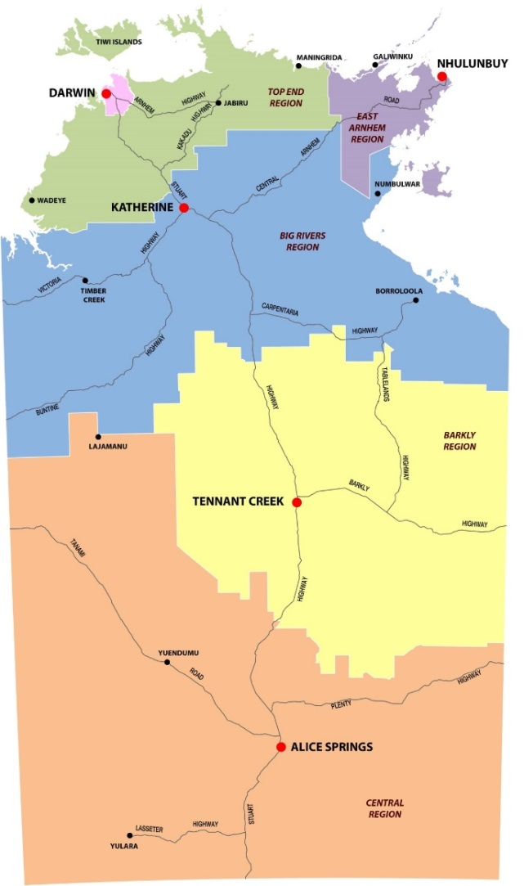

Please indicate which regional location that will benefit from the grant (you may select more than one region if applicable).

Top End Region (incl. Tiwi Islands, Jabiru, Maningrida)
East Arnhem Region
Big Rivers Region
Barkly Region
Central Region

Community or communities that will benefit_____________________________________

Activities of the applicant organisation
Please briefly describe the activities and services provided by your organisation to the region(s) and community(s). (If more space is required please attached it separately)

Summary of grant

A detailed overview of the initiative to be an attachment to this application
Initiative title:

Initiative summary:

Describe the overall purpose of the grant and include benefits to remote Aboriginal people in terms of economic development outcomes

What regional and / or and community support and / or involvement does your initiative have?

Performance indicators
What are the expected outcomes? |  |  | How will you know if these outcomes have been achieved?

Please indicate the target group for your project by ticking one of the boxes below
Older people | Carers | Families
Women  Young People (up to 25 years) | Children | Men

Proposed budget for this application
Please summarise your budget requirements and provide a detailed budget including quote and attached to this application
Budget |  |  |  |  | Total Cost $ (GST excl.)
Total project cost:
Less organisation’s contribution to project (if applicable)
Less funds to be raised (if applicable)
Total amount sought:

If unable to obtain any Northern Territory quotes please explain why?

If full funding is not available would you like your application considered? Yes No

Other funding
Does your organisation currently receive funding from Australian, Territory or local government sources? (including non-government sources)
Yes No If Yes, please specify:

Funding name and source |  |  | Amount $
Have you applied or are you going to apply for any other funding in relation to this initiative?
Yes No If Yes, please specify:

Agreement and declaration
I certify that the statements in this application are true. I have read and understand the
Remote Aboriginal Development Fund – Economic development grant (RADF)
I acknowledge that if the RADF approves this application for a grant, I will be required to
meet the eligibility criteria as outlined in the RADF – Economic development grant.
I acknowledge that the RADF may vary the level of funding provided through the program at
its sole discretion.
The RADF cannot guarantee funding for any application, and cannot guarantee funding to
the full amount requested by any applicant.

I have been authorised by |  | to make this application.
 | (name of organisation)
Full name
Position in organisation:
Signature:
Date:

Grant application checklist
Before submitting your application, please use this checklist to ensure your application is accurately completed. Incomplete applications will not be considered.
Have you confirmed that your organisation is eligible to apply? (i.e. Not for Profit)
Have you provided your organisation’s details including your ABN and GST information?
Have you indicated the region(s) and community(s) where the funding will be utilised?
If your group is not incorporated, have you provided details of your auspice organisation?
Have you completed the project description and given details of your budget?
Have you included quotes for all the budget items listed in your application?
Have you advised us of other sources of funding your organisation may receive?
Have you indicated the target group for your project?
Have you provided the name of your accountable officer and have they signed the
application form?
Have you kept a copy of your application for your organisation’s internal records?

Submitting your application

Please send completed applications via email (preferred method), post or delivered to the RADF – Economic development grant Secretariat at:
Email
cado.nt@nt.gov.au
Post:
PO Box 8470
ALICE SPRINGS NT 0871
Delivery:
Central Australian Development Office
55 Todd Mall
ALICE SPRINGS NT 0870

1.11 RADF – Economic Development grant Contact Details

Telephone: (08) 8951 5785
Email: cado.nt@nt.gov.au
Web: www.nt.gov.au

OFFICE USE ONLY

Regional Economic Development Officers Comments:
Regional Executive Directors Comments:

