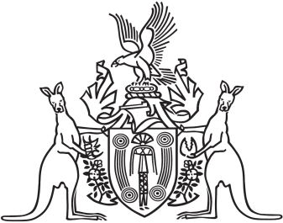
Northern Territory of Australia

Government Gazette
ISSN-0157-833X
No. S17 7 March 2016

Assent To Proposed Laws
His Honour the Administrator assented to the following proposed laws:
2 March 2016
Electoral Legislation Amendment Act 2016 (Act No. 1 of 2016)
Justice Legislation Amendment (Vulnerable Witnesses) Act 2016 (Act No. 2 of 2016)
Justice Legislation Amendment (Small Claims and Other Matters) Act 2016 (Act No. 3 of 2016)
Small Claims Act 2016 (Act No. 4 of 2016)
Yours sincerely

Michael Tatham
Clerk of the Legislative Assembly

