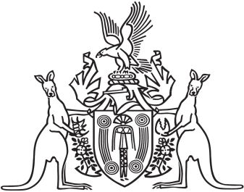
Northern Territory of Australia

Government Gazette
ISSN-0157-833X
No. S14 25 February 2016
Northern Territory of Australia

Police Administration Act
Police Arbitral Tribunal
Appointment of Minister's Nominee
I, Peter Donald Styles, Minister for Public Employment, under section 36(2)(b) of the Police Administration Act, appoint Theo Tsikouris to be a member of the Police Arbitral Tribunal as the Minister's nominee for 3 years on and from the date on which this instrument is published in the Gazette.
Dated 19 February 2016
P. D.Styles
Minister for Public Employment

