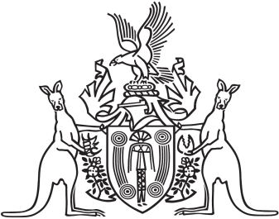
Northern Territory of Australia

Government Gazette
ISSN-0157-833X
No. S5 5 February 2016

Northern Territory of Australia
Petroleum Act

Section 21E Guidelines
I, Debby Anne James, as delegate of the Minister for Mines and Energy, in accordance with Section 21E(2) of the Petroleum Act (the Act) give notice that guidelines relating to the making, and consideration and determination of, an application for the grant of an exploration permit have been issued effective as of 5 February 2016.
Petroleum Exploration Permit Application Conditions guidelines are available from the Department of Mines and Energy, Level 4, Centrepoint Building, 48-50 Smith Street Mall, Darwin NT 0801 or at www.minerals.nt.gov.au.
Dated 5 February 2016
D. A. James
Director Petroleum Tenure
Delegate of the Minister for Mines and Energy
Pursuant to the Instrument of Delegation dated 15 June 2015

