Mineral Titles Act 2010
NOTICE OF LAND CEASING TO BE A MINERAL TITLE AREA
Title Type and Number: | Extractive Mineral Permit 31334
Area ceased on: | 06 October 2026
Area: | 78.00 Hectare
Locality: | KOOLPINYAH
Name of Applicants(s)Holder(s): | 100% MOUSELLIS & SONS PTY. LTD. [ACN. 009 654 791]
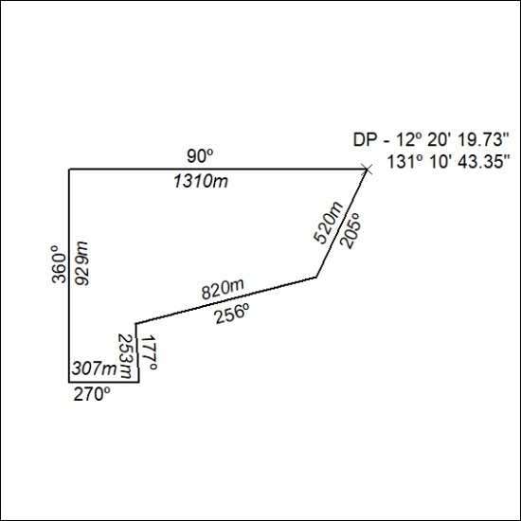

407/26

Mineral Titles Act 2010
NOTICE OF LAND CEASING TO BE A MINERAL TITLE AREA
Title Type and Number: | Extractive Mineral Permit 31335
Area ceased on: | 06 October 2026
Area: | 72.00 Hectare
Locality: | KOOLPINYAH
Name of Applicants(s)Holder(s): | 100% MOUSELLIS & SONS PTY. LTD. [ACN. 009 654 791]
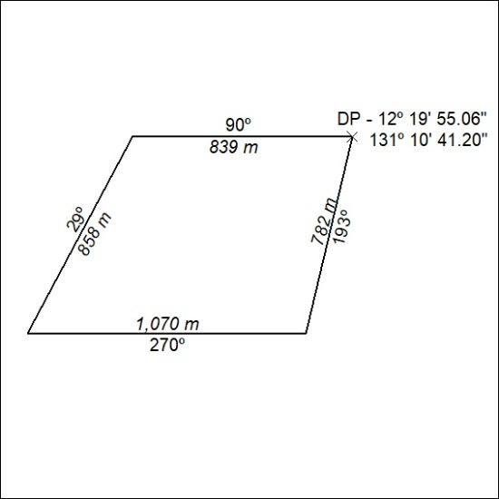

408/26

Mineral Titles Act 2010
NOTICE OF LAND CEASING TO BE A MINERAL TITLE AREA
Title Type and Number: | Extractive Mineral Permit 31336
Area ceased on: | 06 October 2026
Area: | 93.00 Hectare
Locality: | KOOLPINYAH
Name of Applicants(s)Holder(s): | 100% MOUSELLIS & SONS PTY. LTD. [ACN. 009 654 791]
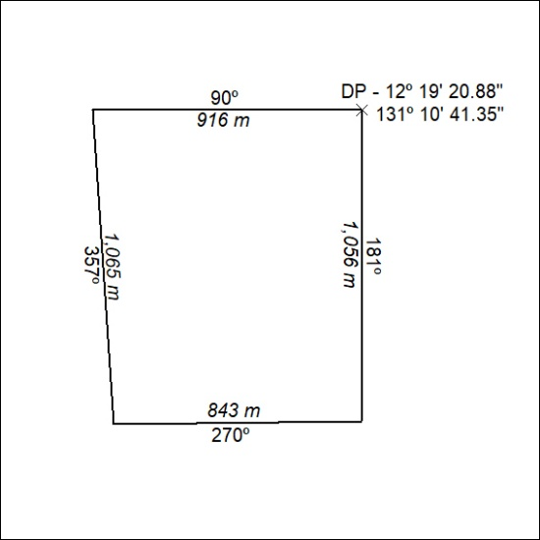

409/26

Mineral Titles Act 2010
NOTICE OF LAND CEASING TO BE A MINERAL TITLE AREA
Title Type and Number: | Extractive Mineral Permit 31337
Area ceased on: | 06 October 2026
Area: | 58.00 Hectare
Locality: | KOOLPINYAH
Name of Applicants(s)Holder(s): | 100% MOUSELLIS & SONS PTY. LTD. [ACN. 009 654 791]
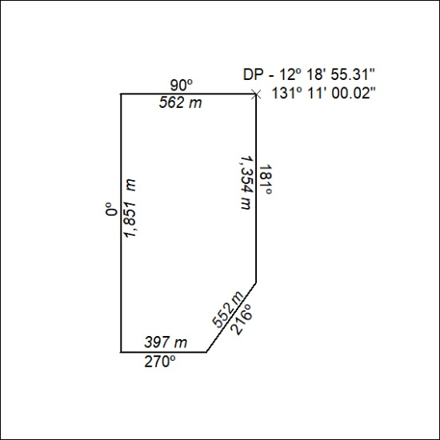

410/26

Mineral Titles Act 2010
NOTICE OF LAND CEASING TO BE A MINERAL TITLE AREA
Title Type and Number: | Extractive Mineral Permit 31338
Area ceased on: | 06 October 2026
Area: | 91.00 Hectare
Locality: | KOOLPINYAH
Name of Applicants(s)Holder(s): | 100% MOUSELLIS & SONS PTY. LTD. [ACN. 009 654 791]
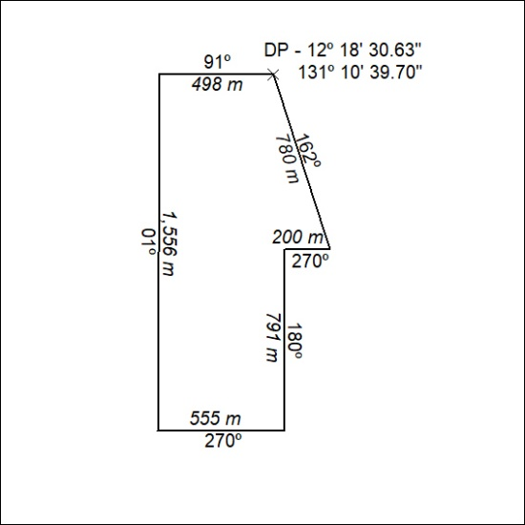

411/26

Mineral Titles Act 2010
NOTICE OF LAND CEASING TO BE A MINERAL TITLE AREA
Title Type and Number: | Extractive Mineral Permit 31339
Area ceased on: | 06 October 2026
Area: | 99.00 Hectare
Locality: | KOOLPINYAH
Name of Applicants(s)Holder(s): | 100% MOUSELLIS & SONS PTY. LTD. [ACN. 009 654 791]
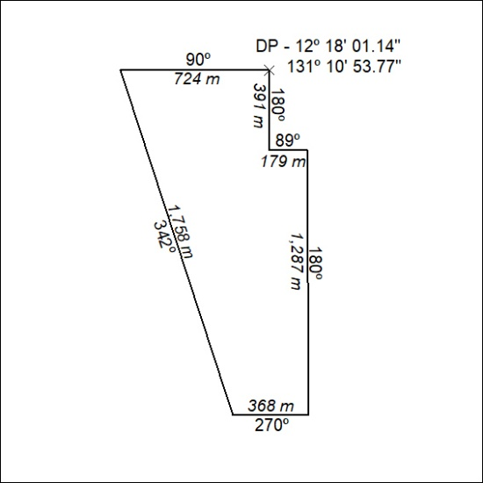

412/26

Mineral Titles Act 2010
NOTICE OF LAND CEASING TO BE A MINERAL TITLE AREA
Title Type and Number: | Extractive Mineral Permit 31642
Area ceased on: | 06 October 2026
Area: | 34.00 Hectare
Locality: | KOOLPINYAH
Name of Applicants(s)Holder(s): | 100% MOUSELLIS & SONS PTY. LTD. [ACN. 009 654 791]
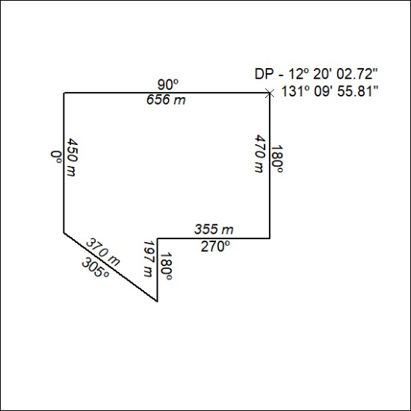

413/26

Mineral Titles Act 2010
NOTICE OF LAND CEASING TO BE A MINERAL TITLE AREA
Title Type and Number: | Extractive Mineral Permit 32169
Area ceased on: | 06 October 2026
Area: | 26.00 Hectare
Locality: | KOOLPINYAH
Name of Applicants(s)Holder(s): | 100% MOUSELLIS & SONS PTY. LTD. [ACN. 009 654 791]
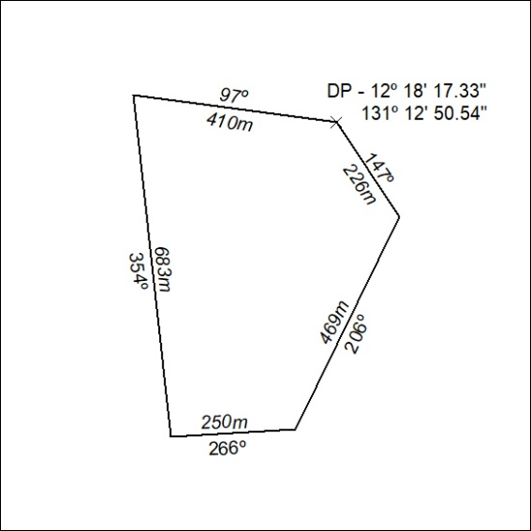

414/26

Mineral Titles Act 2010
NOTICE OF LAND CEASING TO BE A MINERAL TITLE AREA
Title Type and Number: | Extractive Mineral Permit 32170
Area ceased on: | 06 October 2026
Area: | 36.00 Hectare
Locality: | KOOLPINYAH
Name of Applicants(s)Holder(s): | 100% MOUSELLIS & SONS PTY. LTD. [ACN. 009 654 791]
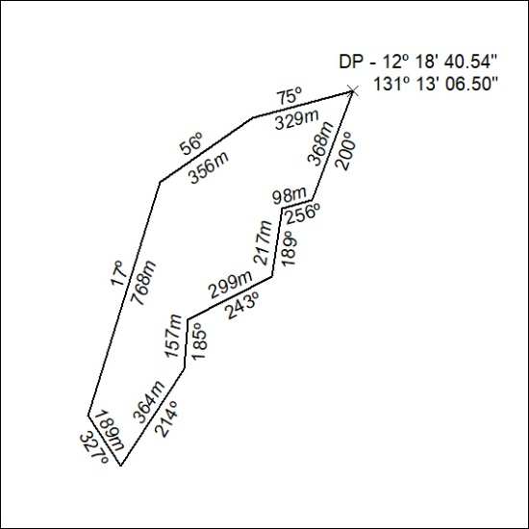

415/26

Mineral Titles Act 2010
NOTICE OF LAND CEASING TO BE A MINERAL TITLE AREA
Title Type and Number: | Extractive Mineral Permit 32171
Area ceased on: | 06 October 2026
Area: | 26.00 Hectare
Locality: | KOOLPINYAH
Name of Applicants(s)Holder(s): | 100% MOUSELLIS & SONS PTY. LTD. [ACN. 009 654 791]
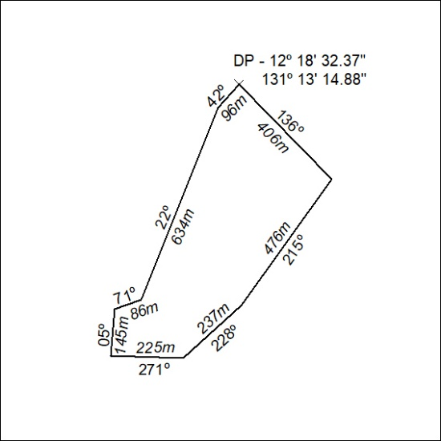

416/26

Mineral Titles Act
NOTICE OF GRANT OF A MINERAL TITLE
Title Type and Number: | Exploration Licence 34359
Granted: | 25 September 2026, for a period of 6 Years
Area: | 23 Blocks, 72.99 km²
Locality: | NAPPERBY
Name of Holder/s: | 100% MAC MINERALS PTY LTD [ACN. 664 335 424]
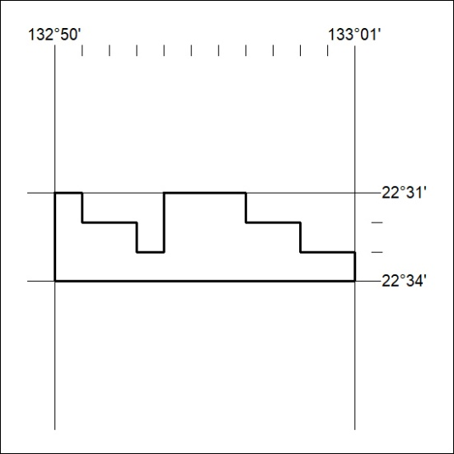
Area granted is indicated above. The titleholder is not permitted to exercise occupational rights on any land that is subject to a development title, or an application for a development title. Any land the subject of a Reserved Land gazettal under the Mineral Titles Act and all land vested in the Commonwealth of Australia is also excluded by description but not excised from the grant area.
417/26

Mineral Titles Act
NOTICE OF GRANT OF A MINERAL TITLE
Title Type and Number: | Exploration Licence 34360
Granted: | 25 September 2026, for a period of 6 Years
Area: | 81 Blocks, 251.13 km²
Locality: | REYNOLDS RANGE
Name of Holder/s: | 100% MAC MINERALS PTY LTD [ACN. 664 335 424]
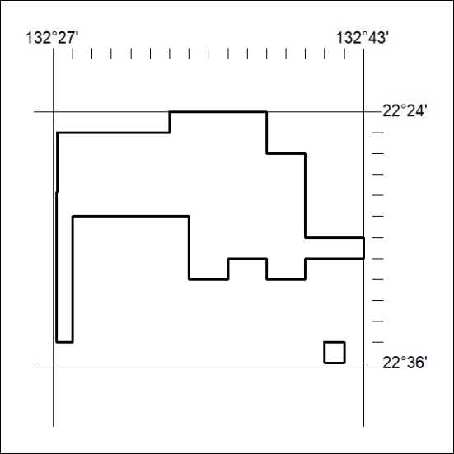
Area granted is indicated above. The titleholder is not permitted to exercise occupational rights on any land that is subject to a development title, or an application for a development title. Any land the subject of a Reserved Land gazettal under the Mineral Titles Act and all land vested in the Commonwealth of Australia is also excluded by description but not excised from the grant area.
418/26

