Mineral Titles Act
NOTICE OF GRANT OF A MINERAL TITLE
Title Type and Number: | Exploration Licence 34215
Granted: | 06 August 2026, for a period of 6 Years
Area: | 80 Blocks, 254.39 km²
Locality: | DOREEN
Name of Holder/s: | 100% GSW RESOURCES PTY LTD [ACN. 653 791 130]
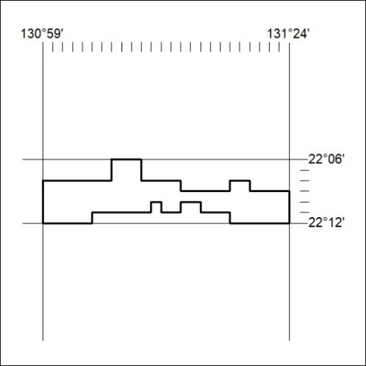
Area granted is indicated above. The titleholder is not permitted to exercise occupational rights on any land that is subject to a development title, or an application for a development title. Any land the subject of a Reserved Land gazettal under the Mineral Titles Act and all land vested in the Commonwealth of Australia is also excluded by description but not excised from the grant area.

339/26

Mineral Titles Act
NOTICE OF GRANT OF A MINERAL TITLE
Title Type and Number: | Exploration Licence 34217
Granted: | 06 August 2026, for a period of 6 Years
Area: | 32 Blocks, 100.99 km²
Locality: | RIDDOCH
Name of Holder/s: | 100% TEN BRICKS CAPITAL PTY LTD [ACN. 689 796 067]
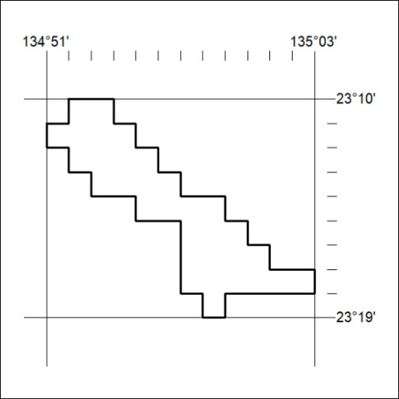
Area granted is indicated above. The titleholder is not permitted to exercise occupational rights on any land that is subject to a development title, or an application for a development title. Any land the subject of a Reserved Land gazettal under the Mineral Titles Act and all land vested in the Commonwealth of Australia is also excluded by description but not excised from the grant area.

340/26

