2024 Black Jewfish Stock Assessment
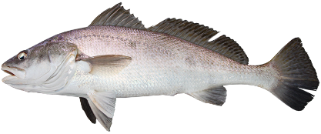
Northern Territory (NT) fish stock assessments are evidence-based and informed by international best practice science and modelling standards.
Regular assessments of the health of Black Jewfish (Protonibea diacanthus) stocks are required by the NT Coastal Line Fishery Harvest Strategy (the Harvest Strategy).

Stocks below required levels in the Greater Darwin Region
Figure 1. Black Jewfish

The 2024 stock assessment classifies Black Jewfish (Protonibea diacanthus) as ‘sustainable’ in the Northern Territory, including the Greater Darwin Region. However, spawning biomass (the mature fish capable of reproducing) in the Greater Darwin Region is at 41% of original stock levels. This is below the level that is needed in the Greater Darwin Region to provide the good quality fishing that is expected by the Territory community. Action is required to improve stocks in the Greater Darwin Region.

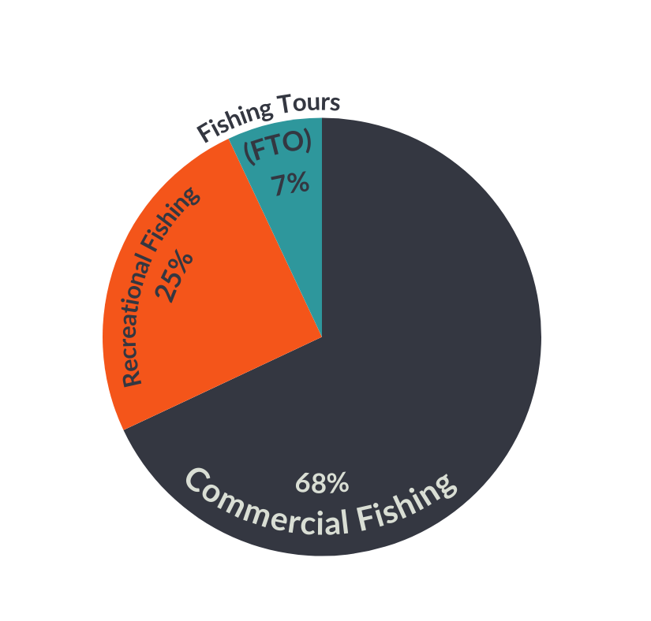
Why are Black Jewfish at risk?
Black Jewfish are under a high level of fishing pressure in the Greater Darwin Region. While the majority of catch is associated with the commercial fishing sector, recreational and charter fishing also has an impact.

Black Jewfish are vulnerable to ‘hyper-stable’ catch rates that mask stock declines until it is too late. Hyper-stable catch rates occur with species that aggregate in known locations making them easier to catch. On the surface, fishers are able to maintain high catch rates, while underwater the number of fish in the stock is decreasing.

Known aggregations of Black Jewfish have been depleted internationally and in other parts of Australia. Localised sustainability concerns have also recently been detected at known Black Jewfish aggregation sites around the Greater Darwin Region, and are being managed in accordance with the Harvest Strategy.
Figure 2: 2024 Black Jewfish catch statistics in the Greater Darwin Region across fishing sectors

Black Jewfish also suffer from barotrauma and low post-release survival.

Data sources
NT Fisheries uses the latest available information and science to undertake stock assessments. The 2024 stock assessment uses fisheries data up to June 2024. This includes:
- long term catch records of commercial fishing licence holders, fishing tour operator licence holders, and recreational fishers
- the lengths and ages of the fish being caught, which gives scientists information about growth rate, mortality rates, and maturity of the stock.

The assessment was independently reviewed by stock assessment experts.

Black Jewfish recovery planning
The current stock health of Black Jewfish in the Greater Darwin Region triggers a requirement under the Harvest Strategy to develop a Recovery Plan.
A Recovery Plan is being developed in collaboration with key stakeholders to reduce fishing pressure and rebuild stocks in the Greater Darwin Region to target biomass. A draft Recovery Plan will be publicly released for consultation prior to being finalised.
While the Recovery Plan is being developed, every fisher can help take pressure off Black Jewfish stocks by using best practice reef fishing methods.
Tomorrow’s fishing starts TODAY


For more information, please visit nt.gov.au/marine

