Northern Territory Skilled Occupation Priority List: Information Paper
  - October 2025

Document title | Northern Territory Skilled Occupation Priority List: Information Paper
Contact details | Office of Workforce Development

Acronyms | Full form
NTSOPL | Northern Territory Skilled Occupation Priority List
NT | Northern Territory
DTBAR | Department of Trade, Business and Asian Relations
ISACNT | Industry Skills Advisory Council NT
ANZSCO | Australian and New Zealand Standard Classification of Occupations
ABS | Australian Bureau of Statistics
LFS | Labour Force Survey
CAGR | Compound Annual Growth Rate
DAMA | Designated Area Migration Agreement
OSCA | Occupation and Skills Classification of Australia
z-score | Standardised statistical measure showing how far a value is from the average, expressed in standard deviations

Contents
1. Background 4
2. Introduction 4
3. Methodology 4
3.1. Identifying the Preliminary List 5
3.2. Quantitative Assessment 5
Standardising the Data 6
3.3. Qualitative Assessment 6
3.4. Synthesis of two methods 6
4. Appendix A – Development Process Flowchart 7
5. Appendix B – ISACNT Survey Instrument (2025) 8
6. Notes 8

Background
The Northern Territory Skilled Occupation Priority List (NTSOPL) was first released in 2013 and draws on a model originally developed in Western Australia. The NTSOPL is updated each year to identify occupations that are either in short supply or considered strategically important to the Northern Territory. Its purpose is to provide a clear, evidence-based guide for:
- Workforce planning and development
- Training investment decisions
- Targeted employer incentives
- Skilled migration programs, including the Northern Territory’s Designated Area Migration Agreement
- National and international recruitment initiatives
- Population and economic growth strategies
- Strategic policy decision-making
The list is developed by the Office of Workforce Development in the Department of Trade, Business and Asian Relations (DTBAR). The methodology combines quantitative analysis undertaken by DTBAR’s Analytics & Insights Unit with qualitative input from the Industry Skills Advisory Council NT (ISACNT).
The methodology incorporates both statistical rigour and the practical realities faced by businesses and workers across the Territory. It is designed not just as a labour market snapshot, but as a tool to help government, industry, and training providers plan for the Territory’s future workforce.

Introduction
In 2025, the quantitative assessment was refined to use Australian Bureau of Statistics (ABS) Census employment by occupation data instead of quarterly employment by occupation data. This change improves reliability given the volatility of quarterly employment by occupation data.
This paper outlines the 2025 methodology, explaining how the list is developed and sources used. It covers:
- the method for preliminary identification of occupations considered for inclusion on the NTSOPL
- the statistical methods used to rank occupations
- the industry consultation process
- how the data and consultation are combined to produce the final list.
A summary flowchart of the methodology is at Appendix A.

Methodology
The process begins by identifying a preliminary list of eligible occupations, which is then indexed through both quantitative and qualitative assessments using data, modelling, and analysis. Results are validated and complemented using qualitative information before the final list is confirmed.

Identifying the Preliminary List
Occupations are first screened against three criteria. The occupation:
- must have an ANZSCO Code (6-digit level, ANZSCO 2022), noting non-specific or catch-all classifications designed only for the ABS Census collection are excluded (e.g. ANZSCO 599999 – Clerical and Administrative Workers nec [not elsewhere classified])
- should have an ANZSCO Skill Level of 1–4, though Skill Level 5 occupations may be assessed and included on a case-by-case basis
- must have a recognised education or training pathway through VET or higher education.
In 2025, 918 of 1,069 ANZSCO occupations met these criteria and progressed to detailed analysis.

Quantitative Assessment
The quantitative assessment ranks occupations in short supply by considering a range of supply and demand factors using a weighted indicator model. The Market Index reflects demand-side factors, and the Structural Index reflects supply-side factors (to capture the complexity of supplying workers with the right skills). Each factor is weighted to reflect its significance to forecasts of future skills demand.
Market Index (labour demand signals):
Factors | Measure / Unit | Source | Weight
Current employment by occupation | Number of workers | ABS LFS modelled to 2021 Census | 20%
5-year past employment growth by occupation | % growth rate | ABS Census (CAGR 2016 vs 2021) | 20%
Average annual vacancies by occupation | Number of job ads | Job Skills Australia | 20%
5-year forecast growth by occupation | Number of additional jobs | Victoria University employment forecast | 40%
Structural Index (supply-side complexity):
Factors | Measure / Unit | Source & Description | Weight
% of workers with required qualification# | % of Workforce | Indicates specialisation and difficulty to training barrier | 20%
Migration dependency# | % of workforce (rely heavily on migrants to fill) | Indicates NT reliance on incoming skilled labour | 15%
Training lead time^ | Years of study/training required | Time to gain necessary qualification | 15%
Study diversity# | Number of formal pathways | Number of different training paths | 20%
Industry portability# | Occupational mobility rate across industries | Ability to transfer across sectors | 30%
# ABS Census 2021
^ Australian Skills Quality Authority and Study Australia

Standardising the Data
Because the variables use different units (percentages, counts, years, and rates) they cannot be directly compared. To resolve this, each data point is converted to a standardised statistical measure called a z-score. A z-score shows how far a result is from the average, measured in standard deviations:
The formula is: z = (x − μ) / σ
x = the data point (e.g. employment growth in one job)
μ = the average value across all jobs
σ = the standard deviation (a measure of spread in the data)
Each data point z-score is multiplied by its weight, then summed to produce an index score and ranked.
Out of 918 eligible occupations, 836 had sufficient data to be modelled and were ranked from 1 (highest priority) to 836 (lowest priority).

Qualitative Assessment
Independent to the quantitative assessment ISACNT uses an eight-question survey (Appendix B) to gather information from stakeholders for each occupation on the preliminary list. This included:
- 607 NT businesses
- 23 peak industry bodies
The information collected is used to independently develop a list of ‘high priority’ and ‘priority’ occupations. This list is not ranked. The survey assessed and prioritised 528 occupations as per below:
- 111 occupations as ‘high priority’
- 229 occupations as ‘priority’
- 188 occupations as ‘not a priority’.

Synthesis of two methods
The final list is a synthesis of the statistical method and qualitative information. It also reflects situational intelligence from a range of sources, including Australian Government sources, and considers whether an occupation, were it not available, could significantly disrupt economic activity.
Each of the occupations ISACNT identified as ‘priority’ and ‘high priority’ are also validated and assessed with reference to the Top 400 ranked occupations from the quantitative assessment, as well as with reference to:
- Australian Government shortage and migration lists
- forecast workforce demand for major projects
- whether the absence of the occupation could significantly disrupt economic activity.
Occupations rated as priority or high priority through this combined process are included in the NTSOPL.
The 2025 NTSOPL has 381 occupations and is available at: https://nt.gov.au/employ/for-employers-in-nt/skills-existing-and-needed/hard-to-fill-jobs-in-the-nt

Appendix A – Development Process Flowchart
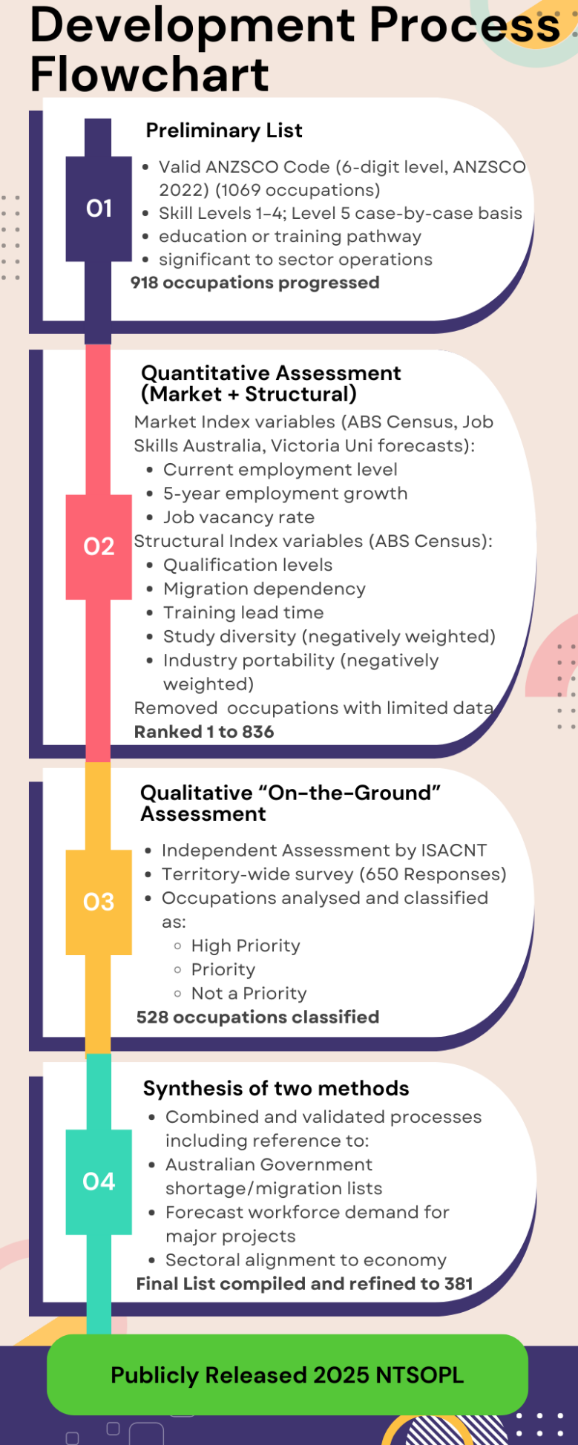

Appendix B – ISACNT Survey Instrument (2025)
Key questions include:
Occupation: Insert Name
ANZSCO Code: Insert Code
Question 1: In the past 12 months (including the current month) has your organisation/branch experienced any difficulties in attracting or retaining workers for this occupation, and how many?
Question 2: Is the occupation expected to be in shortage or experience recruitment difficulties in the next 12 months?
If the answer is ‘No’ to both Question 1 and 2, go to Question 5.
Question 3: Priority Status (Choices: Highest Priority, Priority or Not a Priority)
Question 3a: For this occupation, What are the challenges that apply?
Question 3b: Occupation remains vacant after 6 months? (Choices: Yes or No)
Question 3c: Occupation remains vacant after 12 months? (Choices: Yes or No)
Question 3d: Number of businesses/employers with identified issues.
Question 4: Are the challenges affecting this occupation considered to be short term
(1-2 years), medium term (3-5 years) or long term (5+ years)?
Question 4a: Why?
Question 5: Total number of employees that are on temporary visa with business's that have responded or contacted?
Question 5a: Count of Temporary Work (Skilled) Visa
Question 6: Number of businesses that made up question 5?
Question 7: Are you aware of any specific issues relating to this occupation in particular sub-Territory regions? (Choices: Greater Darwin, Top End, Central Australia, Katherine, Barkly, Arnhem or free text)
Question 8: Do you have any further comments about the occupation?

Notes
- The 2025 NTSOPL uses ANZSCO 2022, as data collection occurred before implementation of OSCA 2025.
- ANZSCO is produced and managed by the ABS.
- ANZSCO provides the framework for consistent collection, analysis, and reporting of occupation data across Australia and New Zealand.
- Modelling for the NTSOPL uses 2021 ABS Census data, Victoria University forecasts, and Job Skills Australia vacancy datasets.
- Forecasts are conservative and may understate short-term pressures from major projects not yet at final investment decision.
- The model operates at an NT-wide level and may not capture localised shortages.

