Mineral Titles Act
NOTICE OF GRANT OF A MINERAL TITLE
Title Type and Number: | Exploration Licence 33835
Granted: | 19 February 2025, for a period of 6 Years
Area: | 32 Blocks, 88.30 km²
Locality: | REYNOLDS RIVER
Name of Holder/s: | 100% CUFE TENNANT CREEK PTY LTD [ACN. 655 367 105]
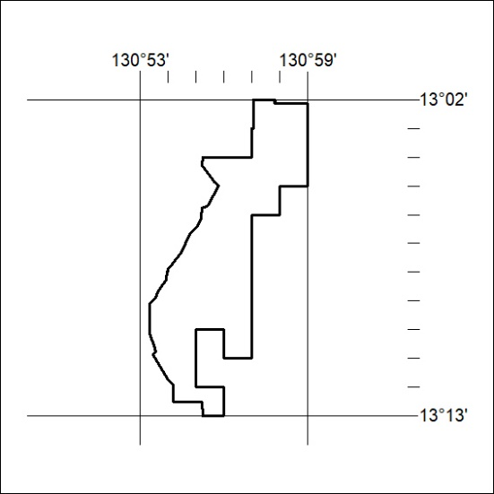
Area granted is indicated above. The titleholder is not permitted to exercise occupational rights on any land that is subject to a development title, or an application for a development title. Any land the subject of a Reserved Land gazettal under the Mineral Titles Act and all land vested in the Commonwealth of Australia is also excluded by description but not excised from the grant area.

52/25

