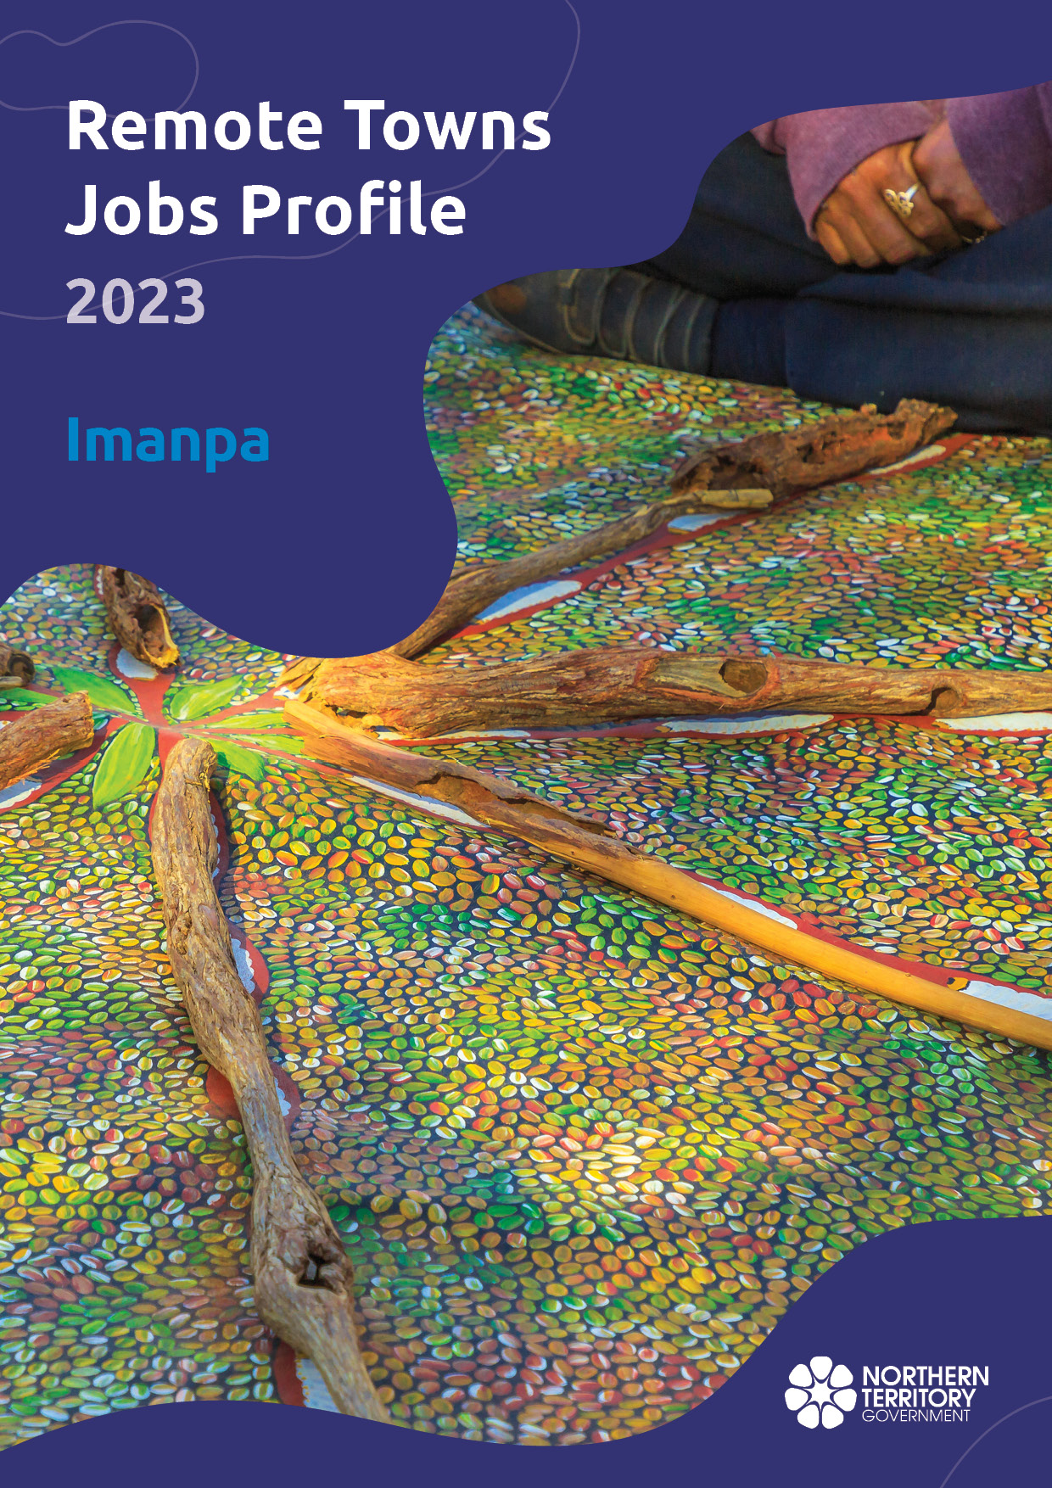

**© Northern Territory of Australia 2025**

**Preferred Reference:** Department of Trade, Business and Asian Relations, 2023 Remote Towns Jobs Profiles, Northern Territory Government, January 2025, Darwin.

**Front cover image:** Aboriginal bush painting at Karrke Aboriginal Cultural Experience.

**Disclaimer**

The data in this publication was collected by conducting a survey of businesses located in the 28 remote town boundaries. This body of work was completed in 2023 by the former Northern Territory Department of Industry, Tourism and Trade.

The collection methodology was created in accordance with Australian Bureau of Statistics data quality framework principles. Data in this publication is only reflective of those businesses reported on as operating in the town at the time of data collection (see table at the end of publication for list of businesses reported on). To comply with privacy legislation or where appropriate, some data in this publication may have been adjusted and will not reflect the actual data reported by businesses. As a result of this, combined with certain data not being reported by some businesses, some components may not add to totals. Changes over time may also reflect change in business propensity to report on certain data items rather than actual changes over time. Total figures have generally not been adjusted. Caution is advised when interpreting the comparisons made to the earlier 2011, 2014 and 2017 publications as the businesses identified and reported on and the corresponding jobs may differ between publications. The surveys have not always gathered data on training and jobs in the same years.

**Notes for each table and chart are ordered alphabetically and listed at the end of the publication.**

The Northern Territory of Australia exercised due care and skill to ensure that at the time of publication the information contained in this publication is true and correct. However, it is not intended to be relied on as professional advice or used for commercial purposes. The Territory gives no warranty or assurances as to the accuracy of the information contained in the publication and to the maximum extent permitted by law accepts no direct or indirect liability for reliance on its content.

Any use of this report for commercial purposes is not endorsed by the Department of Trade, Business and Asian Relations.

Contents

Imanpa 4

Introduction 5

Summary 6

Jobs Overview 7

Jobs filled by Aboriginality 8

Jobs by Sector: Private and Public 10

Job Status: Permanent and Temporary 14

Job Vacancies 16

Jobs by Industry 17

Jobs by Occupation 21

Jobs by Industry by Occupation 23

Jobs by Gender 24

Jobs by Age 27

Vocational Education and Training 31

Population 33

Community Development Program 35

Businesses 36

Notes 37

Abbreviations and Acronyms 38

# Imanpa

Imanpa is located 200 kilometres southwest of Alice Springs, with a population of 123 residents.

Source: Department of Industry, Tourism and Trade

# Introduction

This jobs profile provides a snapshot of jobs and the characteristics of job holders in Imanpa as at September 2023.

This job profile is one of 28 profiles developed for remote towns in the Northern Territory. It is anticipated these, and subsequent profiles will contribute to a robust evidence base to inform decision making in and relating to these remote Territory towns.

This profile contains information collected by the Northern Territory Department of Industry, Tourism and Trade from businesses operating within the town and is supplemented by other administrative data sets and information.

Each profile provides up-to-date information that is intended to inform the planning and design of current and future government programs and as an evidence base to inform decision making relating to workforce development, enterprise and job opportunities.

The profile may best be understood as a point-in-time tool. The number of business surveys from which the data was drawn is significantly less than in earlier surveys, and business participation has decreased with each survey. For Imanpa, 37.5% fewer businesses than in 2017 are reported here.

The data collection methodology and corresponding questionnaire were created in partnership with the Australian Bureau of Statistics (ABS) and in accordance with ABS data quality framework and survey principles.

The Northern Institute at Charles Darwin University facilitated the surveys with the support of the Department of Industry, Tourism and Trades’ Territory Engagement and Delivery teams.

The information collected and reported on represents a significant goodwill investment by those businesses and organisations that participated. Each business is listed at the end of this publication.

# Summary

The 2023 jobs profile was developed based on responses from 5 businesses operating within the Imanpa town boundary, 3 less than in the 2017 survey. Of these, there were:

* 3 businesses from the private sector, accounting for 8 filled jobs or 53% of total filled jobs
* 2 businesses from the public sector, accounting for 7 filled jobs or 47% of total filled jobs.

A total of 28 filled and vacant jobs in Imanpa were reported.[1]

The 2023 profile highlights:

* there were 15 filled jobs of which:
* 9 jobs (60%) were filled by Aboriginal people
* 6 jobs (40%) were filled by non-Aboriginal people
* 33% of employed Aboriginal people are working in the public sector
* Aboriginal females made up 75% of total Aboriginal filled jobs
* there were 13 vacant jobs, of which:
* job vacancies as a percentage of jobs is 46.4%
* job vacancies equate to 1 in 2 jobs
* 6 of the vacancies were in Community and Personal Service Workers area
* Education and Training and Public Administration and Safety were the largest industry employers in 2023
* Building and Construction had the highest student numbers in 2023.

The overall population in Imanpa decreased by 66 people (-34.9%) between 2011 and 2021 to 123 people.

In comparison, the overall Northern Territory population increased by 9.7% between 2011 and 2021.

In 2021, the working age population (15 years and over) in Imanpa was an estimated 83 people compared to 140 in 2011.

There were 0.3 jobs in Imanpa per working age person compared to 0.3 jobs per working age person across the 28 remote towns in the Northern Territory.

# Jobs Overview

Table 1: Count of filled jobs and vacancies, 2017 & 2023 (a)(b)

|  |  |  |  |
| --- | --- | --- | --- |
|  | **2017** | **2023** | **Change 2017-2023** |
| **Total All Jobs** | **33** | **28** | **-5** |
| **Vacancies** | **19** | **13** | **-6** |
| Vacancies as % of Total All Jobs | 57.6% | 46.4% | -11.2 ppt |
| **Filled Jobs** | **14** | **15** | **1** |
| Full-time | 10 | 7 | -3 |
| Part-time | 4 | 8 | 4 |

Source: Department of Industry, Tourism and Trade

Chart 1: Count of vacant jobs and filled jobs by full-time/part-time status, 2023 (a)(b)

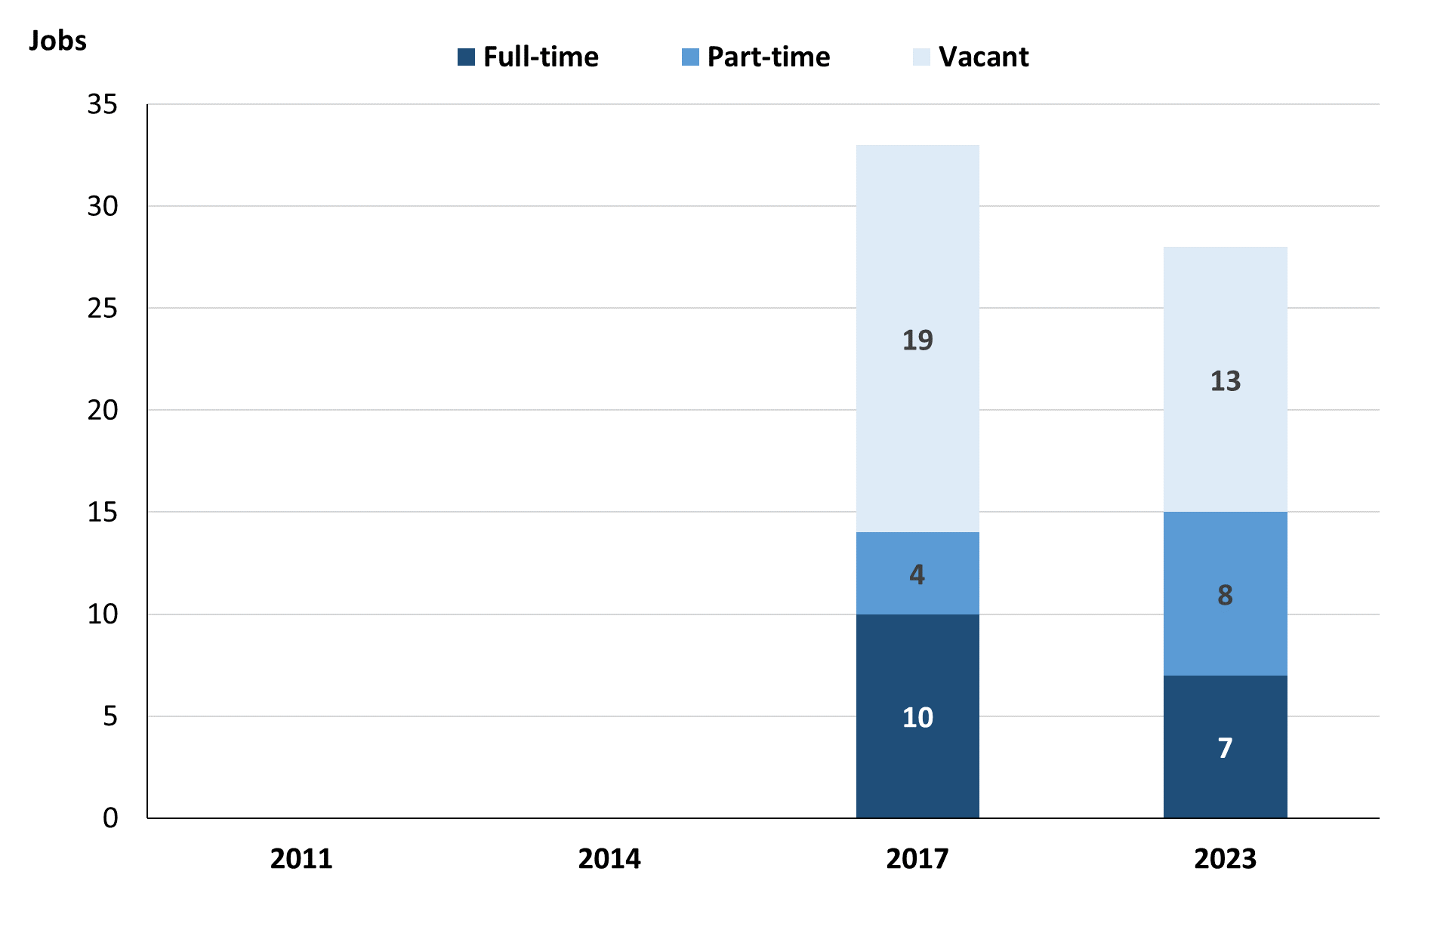

Source: Department of Industry, Tourism and Trade

In 2023 in Imanpa:

* there was a total of 15 **filled jobs**, an increase of 1 job from 2017. Of these:
* 7 were **full-time** jobs, a decrease of 3 jobs from 2017
* 8 were **part-time** jobs, an increase of 4 jobs from 2017
* there were 13 total job **vacancies**, a decrease of 6 vacancies from 2017.

# Jobs filled by Aboriginality

Chart 2: Count of filled jobs by Aboriginality, 2017 & 2023 (a)(c)

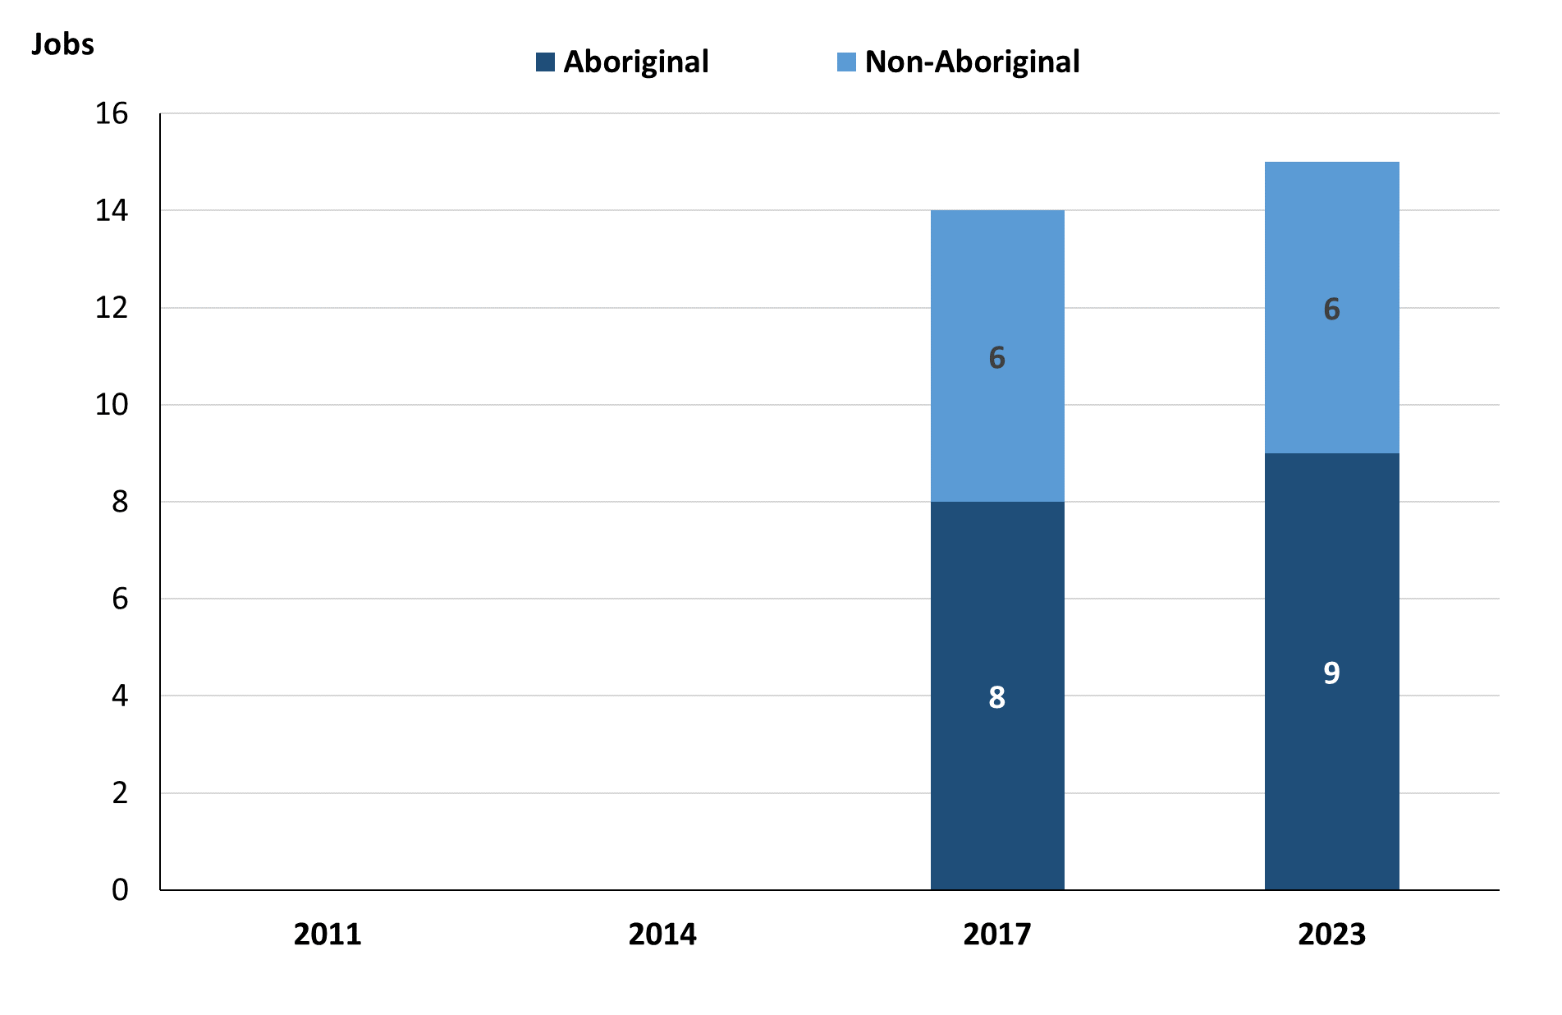

Source: Department of Industry, Tourism and Trade

In 2023 in Imanpa:

* of the 15 filled jobs:
* 9 jobs were filled by **Aboriginal** people, an increase of 1 job from 2017
* 6 jobs were filled by **non-Aboriginal** people, unchanged from 2017
* **Aboriginal** people accounted for 60% of job holders compared to 57% in 2017.

Table 2: Count of filled jobs by full-time/part-time status, 2017 & 2023 (a)(b)(c)

|  |  |  |  |  |  |  |  |  |  |
| --- | --- | --- | --- | --- | --- | --- | --- | --- | --- |
| **Indicator** | **2017** | | | **2023** | | | **Change**  **2017-2023** | | |
| **Aboriginal** | **Non-Aboriginal** | **Total** | **Aboriginal** | **Non-Aboriginal** | **Total** | **Aboriginal** | **Non-Aboriginal** | **Total** |
| Full-time | 4 | 6 | **10** | 1 | 6 | **7** | -3 | 0 | **-3** |
| Part-time | 4 | 0 | **4** | 8 | 0 | **8** | 4 | 0 | **4** |
| **Total** | **8** | **6** | **14** | **9** | **6** | **15** | **1** | **0** | **1** |

*Source:* *Department of Industry, Tourism and Trade*

Chart 3: Count of filled jobs by full-time/part-time status, 2017 & 2023 (a)(b)(c)

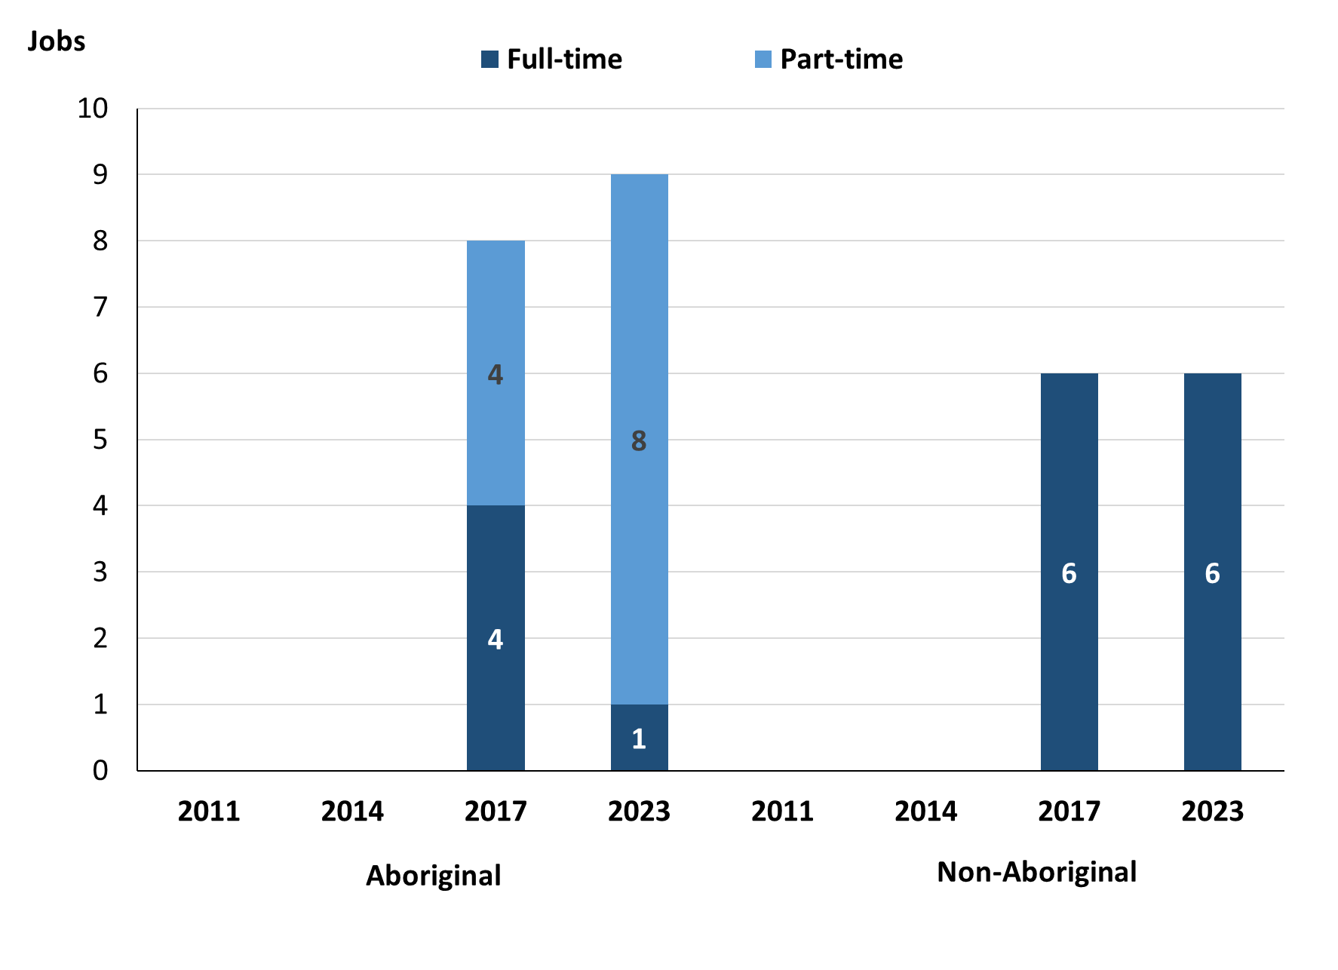

Source: Department of Industry, Tourism and Trade

In 2023 in Imanpa:

* of the 15 **filled jobs**:
* 1 was a full-time job filled by an **Aboriginal** person, a decrease of 3 jobs from 2017
* 8 were part-time jobs filled by **Aboriginal** people, an increase of 4 jobs from 2017
* 6 were full-time jobs filled by **non-Aboriginal** people, unchanged from 2017
* none were part-time jobs filled by **non-Aboriginal** people, unchanged from 2017.

# Jobs by Sector: Private and Public

Table 3: Count of filled jobs by sector of business, 2017 & 2023 (a)(c)(d)

|  |  |  |  |  |  |  |  |  |  |
| --- | --- | --- | --- | --- | --- | --- | --- | --- | --- |
| **Indicator** | **2017** | | | **2023** | | | **Change**  **2017-2023** | | |
| **Aboriginal** | **Non-Aboriginal** | **Total** | **Aboriginal** | **Non-Aboriginal** | **Total** | **Aboriginal** | **Non-Aboriginal** | **Total** |
| **Public Sector** | 1 | 4 | **5** | 5 | 2 | **7** | 4 | -2 | **2** |
| Australian Government | 0 | 0 | **0** | 0 | 0 | **0** | 0 | 0 | **0** |
| Territory Government | 1 | 4 | **5** | 0 | 2 | **2** | -1 | -2 | **-3** |
| Local Government | 0 | 0 | **0** | 5 | 0 | **5** | 5 | 0 | **5** |
| **Private Sector** | 7 | 2 | **9** | 4 | 4 | **8** | -3 | 2 | **-1** |
| **Total** | **8** | **6** | **14** | **9** | **6** | **15** | **1** | **0** | **1** |

Source: Department of Industry, Tourism and Trade

Chart 4: Count of filled jobs by sector of business, 2023 (a)(d)

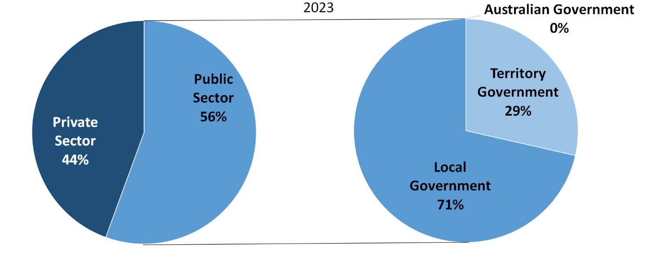

Source: Department of Industry, Tourism and Trade

In 2023 in Imanpa:

* there were 7 jobs in the **public sector**, an increase of 2 jobs from 2017, of these:
* none were in the Australian Government, unchanged from 2017
* 2 jobs were in the Territory Government, a decrease of 3 jobs from 2017
* 5 jobs were in the Local Government, an increase of 5 jobs from 2017
* there were 8 jobs in the **private** **sector**, a decrease of 1 job from 2017.

Chart 5: Count of filled jobs by sector of business, 2017 & 2023 (a)(c)(d)

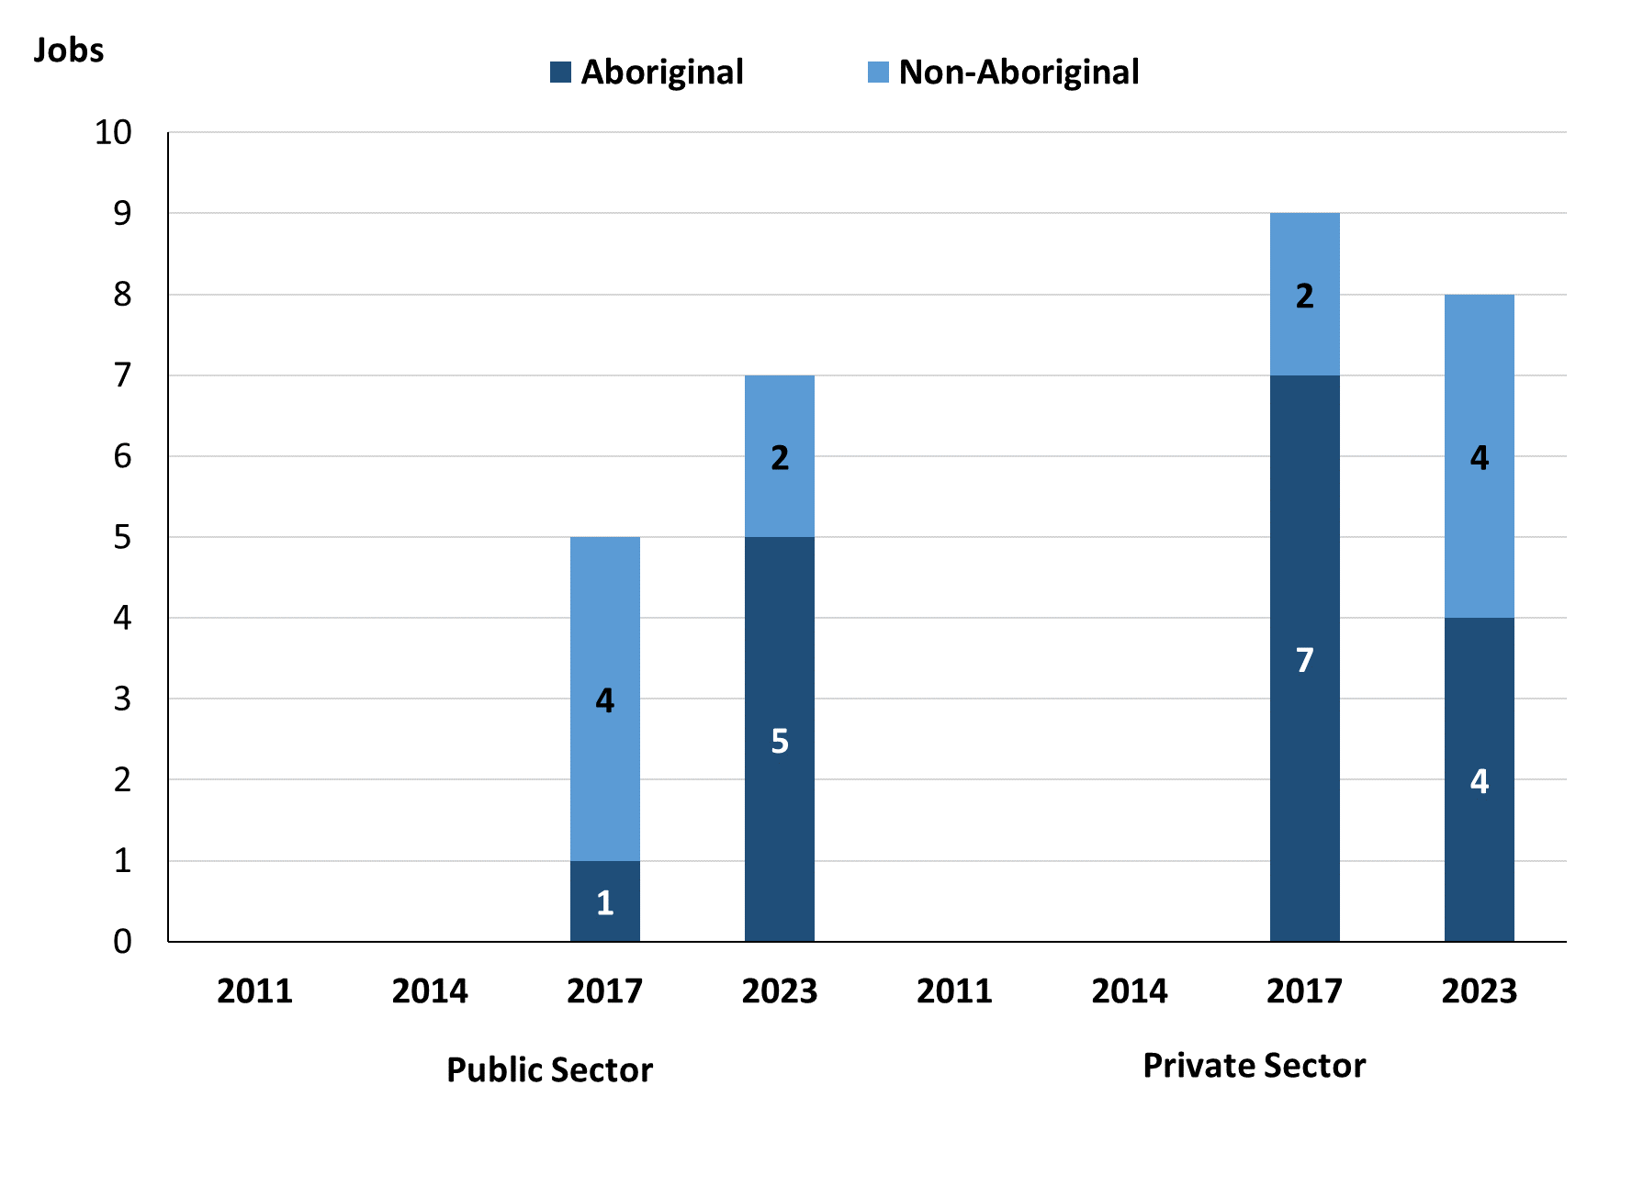

Source: Department of Industry, Tourism and Trade

In 2023 in Imanpa:

* of the 7 jobs in the **public** **sector**:
* 5 jobs were filled by **Aboriginal** people, an increase of 4 jobs from 2017
* 2 jobs were filled by **non-Aboriginal** people, a decrease of 2 jobs from 2017
* of the 8 jobs in the **private** **sector**:
* 4 jobs were filled by **Aboriginal** people, a decrease of 3 jobs from 2017
* 4 jobs were filled by **non-Aboriginal** people, an increase of 2 jobs from 2017.

Chart 6: Count of filled jobs by sector and full-time/part-time status, 2017 & 2023 (a)(b)(d)

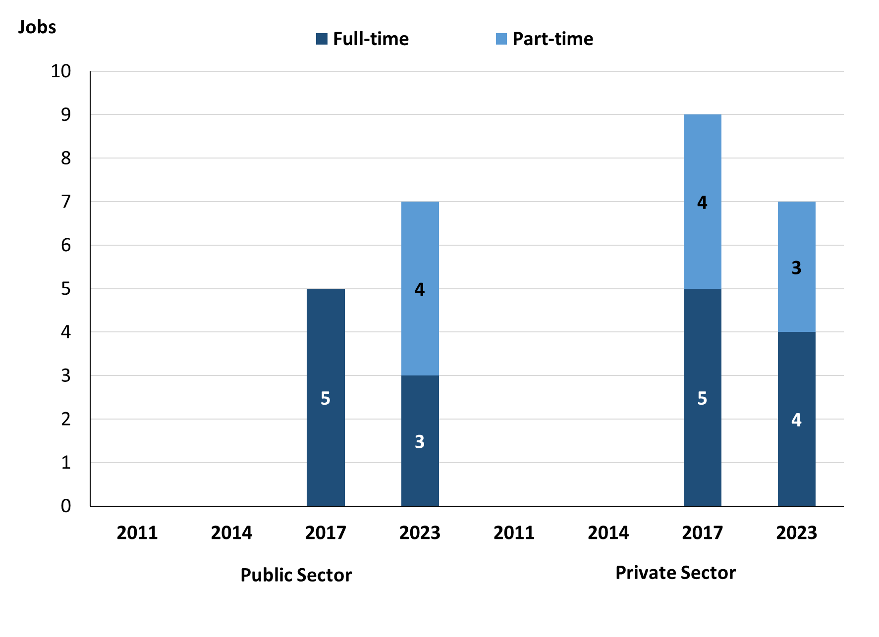

Source: Department of Industry, Tourism and Trade

In 2023 in Imanpa:

* of the 7 jobs in the **public** **sector**:
* 3 were full-time jobs, a decrease of 2 jobs from 2017
* 4 were part-time jobs, an increase of 4 jobs from 2017
* of the 8 jobs in the **private** **sector**:
* 4 were full-time jobs, a decrease of 1 job from 2017
* 4 were part-time jobs, unchanged from 2017.

Table 4: Count of filled jobs by full-time/part-time status by sector, 2017 & 2023 (a)(b)(c)(d)

|  |  |  |  |  |  |  |  |  |  |
| --- | --- | --- | --- | --- | --- | --- | --- | --- | --- |
| **Indicator** | **2017** | | | | | | | | |
| **Aboriginal** | | | **Non-Aboriginal** | | | **Total** | | |
| **Full-time** | **Part-time** | **Total** | **Full-time** | **Part-time** | **Total** | **Full-time** | **Part-time** | **Total** |
| Public Sector | 1 | 0 | **1** | 4 | 0 | **4** | 5 | 0 | **5** |
| Private Sector | 3 | 4 | **7** | 2 | 0 | **2** | 5 | 4 | **9** |
| **Total** | **4** | **4** | **8** | **6** | **0** | **6** | **10** | **4** | **14** |

|  |  |  |  |  |  |  |  |  |  |
| --- | --- | --- | --- | --- | --- | --- | --- | --- | --- |
| **Indicator** | **2023** | | | | | | | | |
| **Aboriginal** | | | **Non-Aboriginal** | | | **Total** | | |
| **Full-time** | **Part-time** | **Total** | **Full-time** | **Part-time** | **Total** | **Full-time** | **Part-time** | **Total** |
| Public Sector | 1 | 4 | **5** | 2 | 0 | **2** | 3 | 4 | **7** |
| Private Sector | 0 | 4 | **4** | 4 | 0 | **4** | 4 | 4 | **8** |
| **Total** | **1** | **8** | **9** | **6** | **0** | **6** | **7** | **8** | **15** |

Source: Department of Industry, Tourism and Trade

In 2023 in Imanpa there were:

* 5 jobs in the **public** **sector** filled by **Aboriginal** people, an increase of 4 jobs from 2017, of which:
* 1 was a full-time job, unchanged from 2017
* 4 were part-time jobs, an increase of 4 jobs from 2017
* 4 jobs in the **private** **sector** filled by **Aboriginal** people, a decrease of 3 jobs from 2017, of which:
* none were full-time jobs, a decrease of 3 jobs from 2017
* 4 were part-time jobs, unchanged from 2017
* 2 jobs in the **public** **sector** filled by **non-Aboriginal** people, a decrease of 2 jobs from 2017, of which:
* 2 were full-time jobs, a decrease of 2 jobs from 2017
* none were part-time jobs, unchanged from 2017
* 4 jobs in the **private** **sector** filled by **non-Aboriginal** people, an increase of 2 jobs from 2017, of which:
* 4 were full-time jobs, an increase of 2 jobs from 2017
* none were part-time jobs, unchanged from 2017.

# Job Status: Permanent and Temporary

Table 5: Count of filled jobs by employment status, 2017 & 2023 (a)(c)(e)

|  |  |  |  |  |  |  |  |  |  |
| --- | --- | --- | --- | --- | --- | --- | --- | --- | --- |
| **Indicator** | **2017** | | | **2023** | | | **Change**  **2017-2023** | | |
| **Aboriginal** | **Non-Aboriginal** | **Total** | **Aboriginal** | **Non-Aboriginal** | **Total** | **Aboriginal** | **Non-Aboriginal** | **Total** |
| Permanent | 4 | 4 | **8** | 2 | 3 | **5** | -2 | -1 | **-3** |
| Temporary | 4 | 2 | **6** | 7 | 3 | **10** | 3 | 1 | **4** |
| **Total** | **8** | **6** | **14** | **9** | **6** | **15** | **1** | **0** | **1** |

Source: Department of Industry, Tourism and Trade

**Chart 7: Count of filled jobs by employment status, 2017 & 2023 (a)(c)(e)**

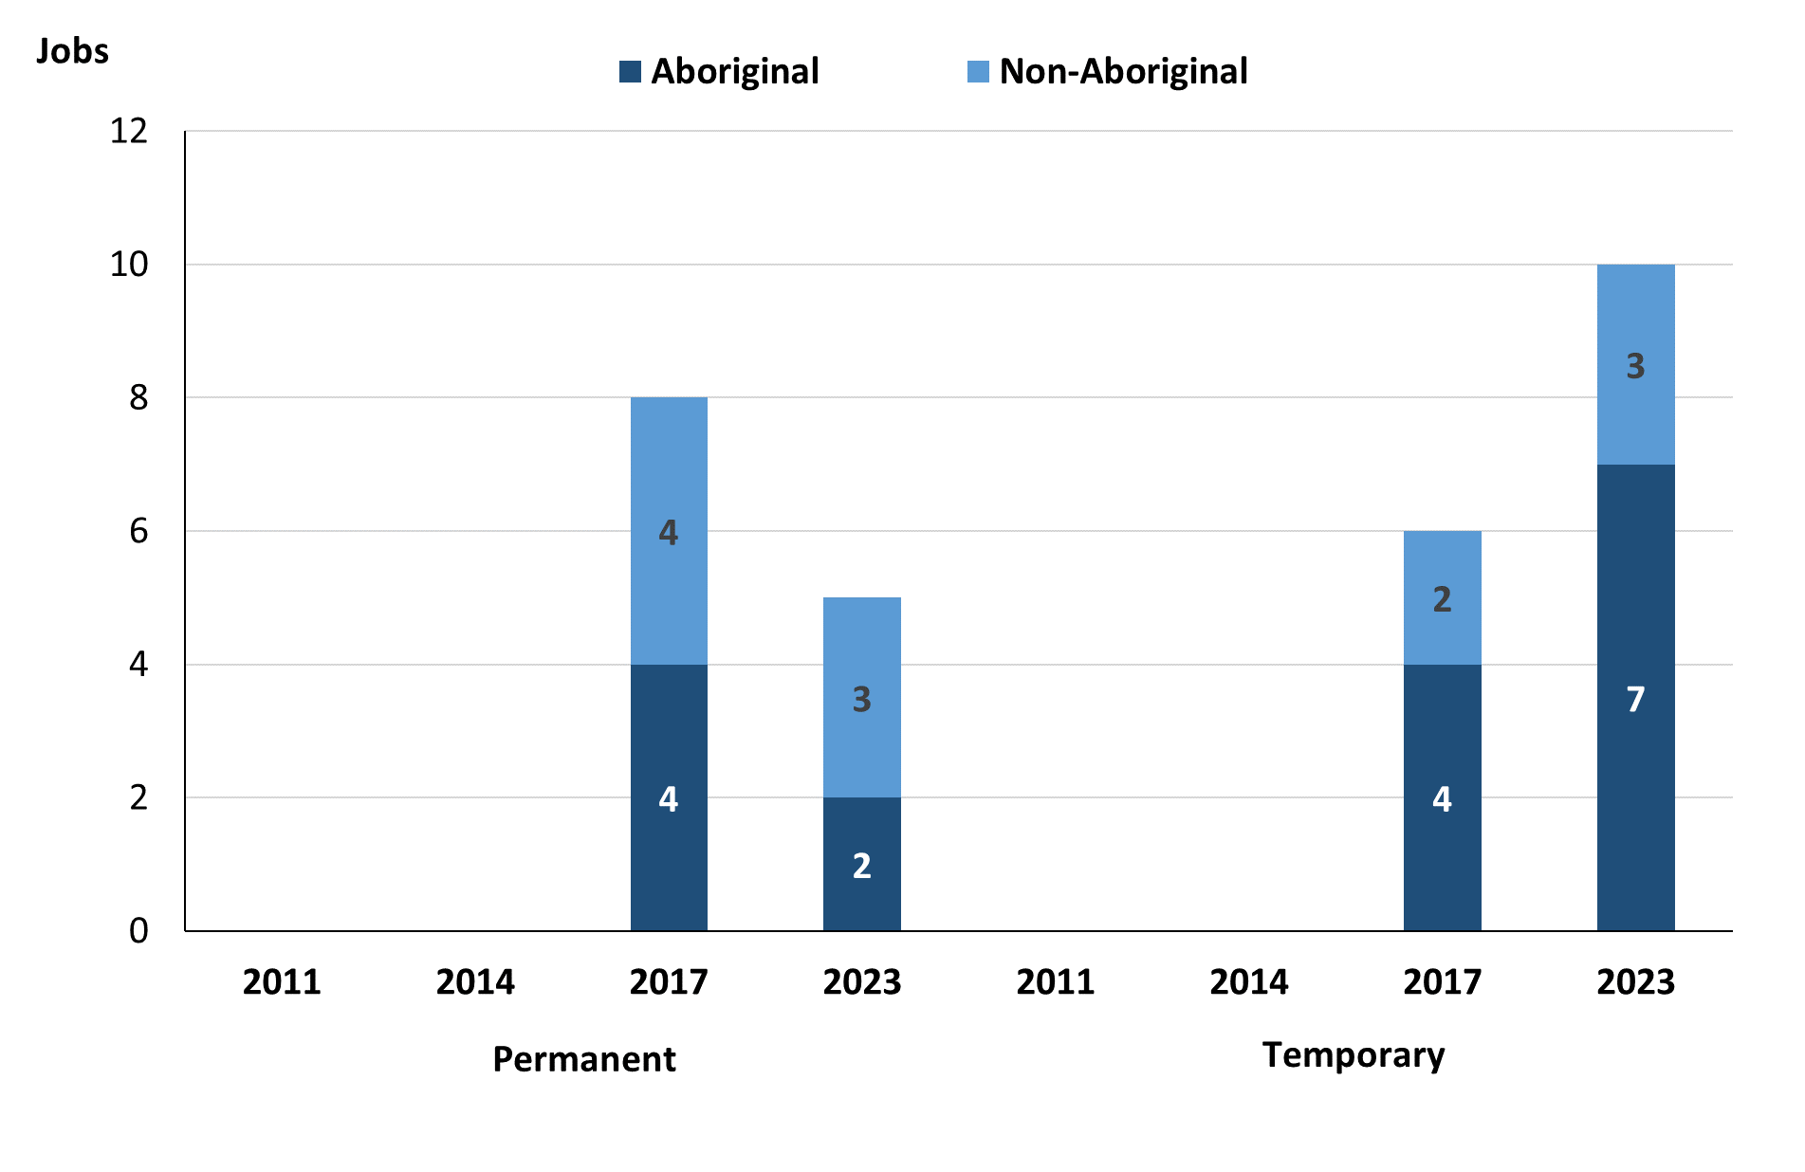

Source: Department of Industry, Tourism and Trade

In 2023 in Imanpa:

* there were 5 **permanent** jobs, a decrease of 3 jobs from 2017, of which:
* 2 jobs were filled by **Aboriginal** people, a decrease of 2 jobs from 2017
* 3 jobs were filled by **non-Aboriginal** people, a decrease of 1 job from 2017
* there were 10 **temporary** jobs, an increase of 4 jobs from 2017, of which:
* 7 jobs were filled by **Aboriginal** people, an increase of 3 jobs from 2017
* 3 jobs were filled by **non-Aboriginal** people, an increase of 1 job from 2017.

Table 6: Count of filled jobs by sector and employment status, 2017 & 2023 (a)(c)(d)(e)

|  |  |  |  |  |  |  |  |  |  |
| --- | --- | --- | --- | --- | --- | --- | --- | --- | --- |
| **Indicator** | **2017** | | | | | | | | |
| **Aboriginal** | | | **Non-Aboriginal** | | | **Total** | | |
| **Perm** | **Temp** | **Total** | **Perm** | **Temp** | **Total** | **Perm** | **Temp** | **Total** |
| Public Sector | 1 | 0 | **1** | 3 | 1 | **4** | 4 | 1 | **5** |
| Private Sector | 3 | 4 | **7** | 1 | 1 | **2** | 4 | 5 | **9** |
| **Total** | **4** | **4** | **8** | **4** | **2** | **6** | **8** | **6** | **14** |

|  |  |  |  |  |  |  |  |  |  |
| --- | --- | --- | --- | --- | --- | --- | --- | --- | --- |
| **Indicator** | **2023** | | | | | | | | |
| **Aboriginal** | | | **Non-Aboriginal** | | | **Total** | | |
| **Perm** | **Temp** | **Total** | **Perm** | **Temp** | **Total** | **Perm** | **Temp** | **Total** |
| Public Sector | 0 | 5 | **5** | 0 | 2 | **2** | 0 | 7 | **7** |
| Private Sector | 2 | 2 | **4** | 3 | 1 | **4** | 5 | 3 | **8** |
| **Total** | **2** | **7** | **9** | **3** | **3** | **6** | **5** | **10** | **15** |

Source: Department of Industry, Tourism and Trade

In 2023 in Imanpa there were:

* 7 jobs in the **public** **sector**, an increase of 2 jobs from 2017, of which:
* none were **permanent**, a decrease of 4 jobs from 2017, of which:
* none were filled by **Aboriginal** people, a decrease of 1 job from 2017
* none were filled by **non-Aboriginal** people, a decrease of 3 jobs from 2017
* 7 jobs were **temporary**, an increase of 6 jobs from 2017, of which:
* 5 were filled by **Aboriginal** people, an increase of 5 jobs from 2017
* 2 jobs were filled by **non-Aboriginal** people, an increase of 1 job from 2017
* 8 jobs in the **private** **sector**, a decrease of 1 job from 2017, of which:
* 5 jobs were **permanent**, an increase of 1 job from 2017, of which:
* 2 jobs were filled by **Aboriginal** people, a decrease of 1 job from 2017
* 3 jobs were filled by **non-Aboriginal** people, an increase of 2 jobs from 2017
* 3 jobs were **temporary**, a decrease of 2 jobs from 2017, of which:
* 2 jobs were filled by **Aboriginal** people, a decrease of 2 jobs from 2017
* 1 job was filled by a **non-Aboriginal** person, unchanged from 2017.

# Job Vacancies

Table 7: Job vacancies, 2017 & 2023

|  |  |  |  |
| --- | --- | --- | --- |
| **Indicator** | **2017** | **2023** | **Change 2017-2023** |
| **Job vacancies** | **19** | **13** | **-6** |

Source: Department of Industry, Tourism and Trade

Table 8: Job vacancies by occupation, 2017 & 2023 (f)(g)

|  |  |  |  |  |
| --- | --- | --- | --- | --- |
| **Occupation (ANZSCO major group)** | **2017** | **2023** | **Change 2017-2023** | |
| Professionals | 1 | 2 | 1 | |
| Clerical and Administrative Workers | 2 | 0 | -2 | |
| Community and Personal Service Workers | 13 | 6 | -7 | |
| Labourers | 3 | 1 | -2 | |
| Other | 0 | 4 | 4 |
| **Total** | **19** | **13** | **-6** | |

Source: Department of Industry, Tourism and Trade

Table 9: Job vacancies by job title, 2023 profile (f)

|  |  |  |
| --- | --- | --- |
| **Job Vacancy** | **No.** | |
| Aboriginal and Torres Strait Islander Education Worker | 2 | |
| Classroom Teacher | 2 | |
| Commercial Cleaner | 1 | |
| Social Worker | 1 | |
| Youth Worker | 3 | |
| Other (inadequately described) | 4 |
| **Total** | **13** | |

Source: Department of Industry, Tourism and Trade

In 2023 in Imanpa:

* there were 13 **vacancies** reported, a decrease of 6 vacancies from 2017
* of the 13 reported **vacancies**, the largest requirements were for:
* 6 Community and Personal Service Workers in the following jobs:
* Aboriginal and Torres Strait Islander Education Worker
* Social Worker
* Youth Worker
* 2 Professionals in the following job:
* Classroom Teacher
* 1 Labourer in the following job:
* Commercial Cleaner.

# Jobs by Industry

Table 10: Count of filled jobs by industry of business, 2017 & 2023 (a)(h)

|  |  |  |  |  |  |
| --- | --- | --- | --- | --- | --- |
| **Industry (ANZSIC Division)** | **2017** | | **2023** | | **Change 2017-2023** |
| **Total** | **% of Total** | **Total** | **% of Total** | **Total** |
| Administrative and Support Services | 3 | 21.4% | 0 | 0.0% | -3 |
| Education and Training | 5 | 35.7% | 5 | 33.3% | 0 |
| Health Care and Social Assistance | 3 | 21.4% | 3 | 20.0% | 0 |
| Public Administration and Safety | 1 | 7.1% | 5 | 33.3% | 4 |
| Retail Trade | 2 | 14.3% | 2 | 13.3% | 0 |
| **Total** | **14** | **100.0%** | **15** | **100.0%** | **1** |

Source: Department of Industry, Tourism and Trade

In 2023 in Imanpa:

* the Education and Training and Public Administration and Safety industries were the **largest** **industry** **employers**, with 5 filled jobs or 33.3% of filled jobs each, unchanged from 2017 for Education and Training, and an increase of 4 jobs from 2017 for Public Administration and Safety
* **other** **significant** industry employers were:
* Health Care and Social Assistance with 3 jobs (or 20.0% of filled jobs), unchanged from 2017
* Retail Trade with 2 jobs (or 13.3% of filled jobs), unchanged from 2017.

Table 11: Count of filled jobs by industry of business, 2017 & 2023 (a)(c)(h)

|  |  |  |  |  |  |  |  |  |  |
| --- | --- | --- | --- | --- | --- | --- | --- | --- | --- |
| **Industry (ANZSIC division)** | **2017** | | | **2023** | | | **Change**  **2017-2023** | | |
| **Aboriginal** | **Non-Aboriginal** | **Total** | **Aboriginal** | **Non-Aboriginal** | **Total** | **Aboriginal** | **Non-Aboriginal** | **Total** |
| Administrative and Support Services | 3 | 0 | **3** | 0 | 0 | **0** | -3 | 0 | **-3** |
| Education and Training | 2 | 3 | **5** | 1 | 4 | **5** | -1 | 1 | **0** |
| Health Care and Social Assistance | 1 | 2 | **3** | 2 | 1 | **3** | 1 | -1 | **0** |
| Public Administration and Safety | 1 | 0 | **1** | 5 | 0 | **5** | 4 | 0 | **4** |
| Retail Trade | 1 | 1 | **2** | 1 | 1 | **2** | 0 | 0 | **0** |
| **Total** | **8** | **6** | **14** | **9** | **6** | **15** | **1** | **0** | **1** |

Source: Department of Industry, Tourism and Trade

Chart 8: Count of filled jobs by industries of business, 2023 (a)(c)(h)

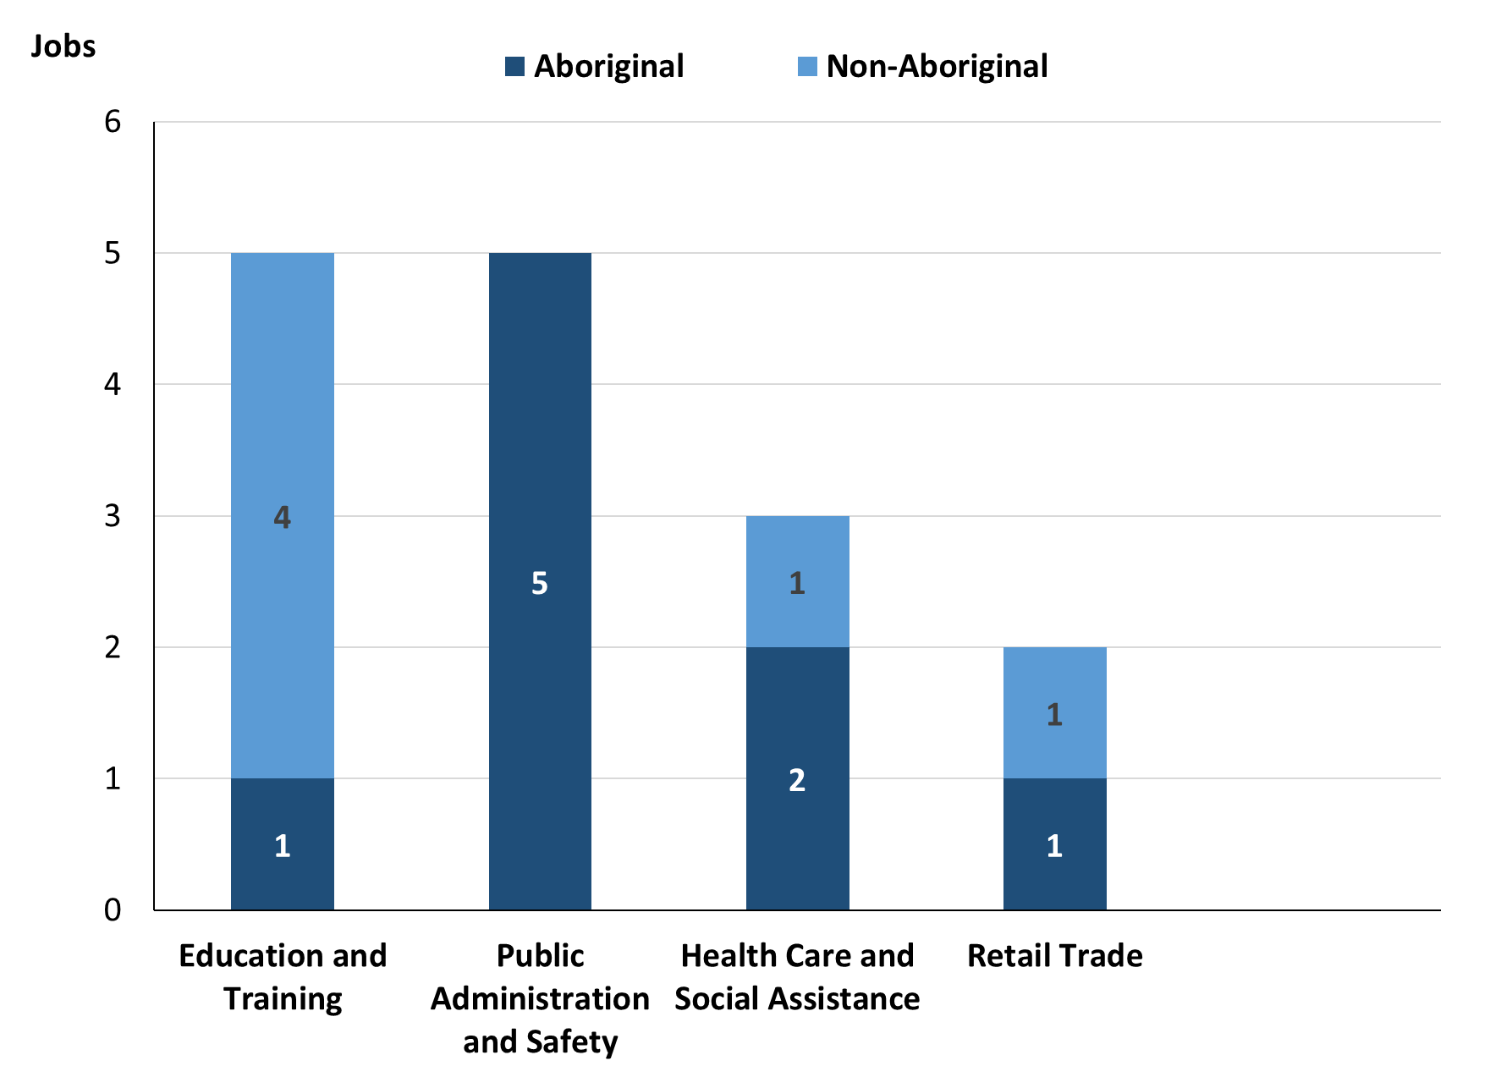

Source: Department of Industry, Tourism and Trade

In 2023 in Imanpa:

* of the 9 jobs filled by **Aboriginal** people, there were:
* 5 jobs in Public Administration and Safety, an increase of 4 jobs from 2017
* 2 jobs in Health Care and Social Assistance, an increase of 1 job from 2017
* 1 job in Education and Training, a decrease of 1 job from 2017
* 1 job in Retail Trade, unchanged from 2017
* of the 6 jobs filled by **non-Aboriginal** people, there were:
* 4 jobs in Education and Training, an increase of 1 job from 2017
* 1 job in Health Care and Social Assistance, a decrease of 1 job from 2017
* 1 job in Retail Trade, unchanged from 2017.

Table 12: Count of filled jobs by industry and employment status, 2017 (a)(c)(e)(h)

|  |  |  |  |  |  |  |  |  |  |  |
| --- | --- | --- | --- | --- | --- | --- | --- | --- | --- | --- |
| **Industry (ANZSIC division)** | **2017** | | | | | | | | | |
| **Aboriginal** | | | **Non-Aboriginal** | | | **Total** | | | |
| **Perm** | **Temp** | **Total** | **Perm** | **Temp** | **Total** | **Perm** | **Temp** | **Total** |
| Administrative and Support Services | 3 | 0 | **3** | 0 | 0 | **0** | 3 | 0 | **3** |
| Education and Training | 0 | 2 | **2** | 3 | 0 | **3** | 3 | 2 | **5** |
| Health Care and Social Assistance | 1 | 0 | **1** | 1 | 1 | **2** | 2 | 1 | **3** |
| Public Administration and Safety | 0 | 1 | **1** | 0 | 0 | **0** | 0 | 1 | **1** |
| Retail Trade | 0 | 1 | **1** | 0 | 1 | **1** | 0 | 2 | **2** |
| **Total** | **4** | **4** | **8** | **4** | **2** | **6** | **8** | **6** | **14** |

Source: Department of Industry, Tourism and Trade

Table 13: Count of filled jobs by industry and employment status, 2023 (a)(c)(e)(h)

|  |  |  |  |  |  |  |  |  |  |
| --- | --- | --- | --- | --- | --- | --- | --- | --- | --- |
| **Industry (ANZSIC division)** | **2023** | | | | | | | | |
| **Aboriginal** | | | **Non-Aboriginal** | | | **Total** | | |
| **Perm** | **Temp** | **Total** | **Perm** | **Temp** | **Total** | **Perm** | **Temp** | **Total** |
| Administrative and Support Services | 0 | 0 | **0** | 0 | 0 | **0** | 0 | 0 | **0** |
| Education and Training | 0 | 1 | **1** | 2 | 2 | **4** | 2 | 3 | **5** |
| Health Care and Social Assistance | 2 | 0 | **2** | 1 | 0 | **1** | 3 | 0 | **3** |
| Public Administration and Safety | 0 | 5 | **5** | 0 | 0 | **0** | 0 | 5 | **5** |
| Retail Trade | 0 | 1 | **1** | 0 | 1 | **1** | 0 | 2 | **2** |
| **Total** | **2** | **7** | **9** | **3** | **3** | **6** | **5** | **10** | **15** |

Source: Department of Industry, Tourism and Trade

In 2023 in Imanpa:

* of the 5 **permanent** jobs, there were:
* 3 jobs in Health Care and Social Assistance, an increase of 1 job from 2017, including:
* 2 jobs filled by **Aboriginal** people, an increase of 1 job from 2017
* 1 job filled by a **non-Aboriginal** person, unchanged from 2017
* 2 jobs in Education and Training, a decrease of 1 job from 2017, including:
* none filled by **Aboriginal** people, unchanged from 2017
* 2 jobs filled by **non-Aboriginal** people, a decrease of 1 job from 2017
* of the 10 **temporary** jobs, there were:
* 5 jobs in Public Administration and Safety, an increase of 4 jobs from 2017, including:
* 5 jobs filled by **Aboriginal** people, an increase of 4 jobs from 2017
* none filled by **non-Aboriginal** people, unchanged from 2017
* 3 jobs in Education and Training, an increase of 1 job from 2017, including:
* 1 job filled by an **Aboriginal** person, a decrease of 1 job from 2017
* 2 jobs filled by **non-Aboriginal** people, an increase of 2 jobs from 2017
* 2 jobs in Retail Trade, unchanged from 2017, including:
* 1 job filled by an **Aboriginal** person, unchanged from 2017
* 1 job filled by a **non-Aboriginal** person, unchanged from 2017.

# Jobs by Occupation

Table 14: Count of filled jobs by occupation, 2017 & 2023 (a)(f)(g)

|  |  |  |  |  |  |
| --- | --- | --- | --- | --- | --- |
| **Occupation (ANZSCO major group)** | **2017** | | **2023** | | **Change 2017-2023** |
| **Total** | **% of Total** | **Total** | **% of Total** | **Total** |
| Clerical and Administrative Workers | 2 | 14.3% | 4 | 26.7% | 2 |
| Community and Personal Service Workers | 4 | 28.6% | 2 | 13.3% | -2 |
| Managers | 4 | 28.6% | 0 | 0.0% | -4 |
| Professionals | 3 | 21.4% | 8 | 53.3% | 5 |
| Sales Workers | 1 | 7.1% | 1 | 6.7% | 0 |
| **Total** | **14** | **100.0%** | **15** | **100.0%** | **1** |

Source: Department of Industry, Tourism and Trade

Chart 9: Count of top 6 filled jobs by occupation, 2017 & 2013 (a)(f)(g)

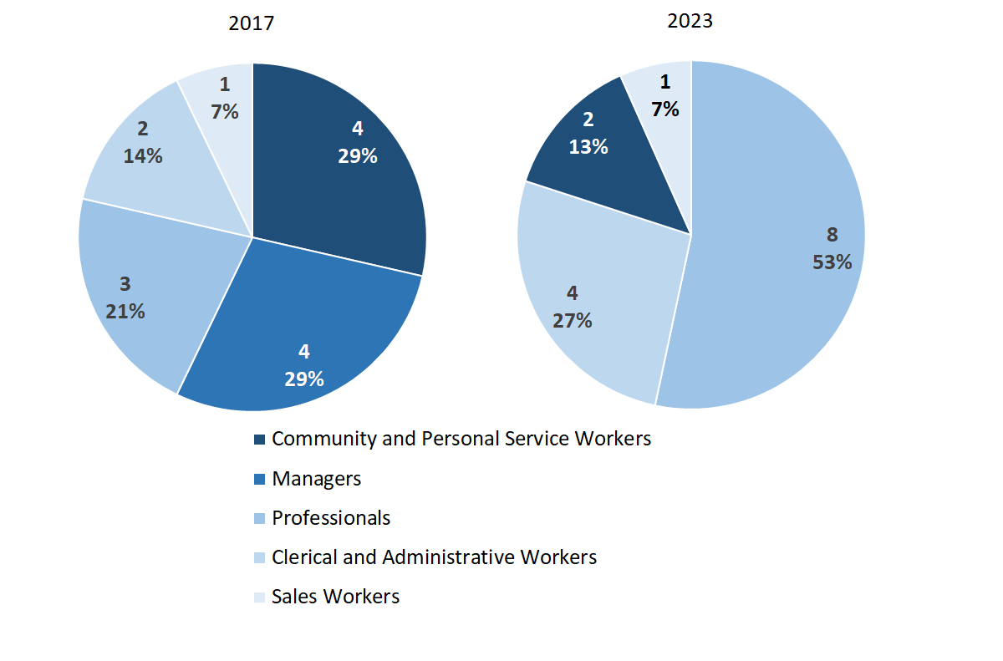

Source: Department of Industry, Tourism and Trade

In 2023 in Imanpa:

* Professionals was the **largest** **occupation** **classification** in terms of filled jobs, accounting for 8 jobs (53.3% of total filled jobs), an increase of 5 jobs from 2017
* **other** **occupation** classifications were:
* Clerical and Administrative Workers (4 jobs or 26.7%), an increase of 2 jobs from 2017
* Community and Personal Service Workers (2 jobs or 13.3%), a decrease of 2 jobs from 2017
* Sales Workers (1 job or 6.7%), unchanged from 2017.

**Table 15: Count of filled jobs by ANZSCO occupation, 2017 & 2023 (a)(c)(f)(g)**

|  |  |  |  |  |  |  |  |  |  |
| --- | --- | --- | --- | --- | --- | --- | --- | --- | --- |
| **Occupation (ANZSCO major group)** | **2017** | | | **2023** | | | **Change 2017-2023** | | |
| **Aboriginal** | **Non-Aboriginal** | **Total** | **Aboriginal** | **Non-Aboriginal** | **Total** | **Aboriginal** | **Non-Aboriginal** | **Total** |
| Clerical and Administrative Workers | 2 | 0 | **2** | 3 | 1 | **4** | 1 | 1 | **2** |
| Community and Personal Service Workers | 4 | 0 | **4** | 1 | 1 | **2** | -3 | 1 | **-2** |
| Managers | 1 | 3 | **4** | 0 | 0 | **0** | -1 | -3 | **-4** |
| Professionals | 0 | 3 | **3** | 4 | 4 | **8** | 4 | 1 | **5** |
| Sales Workers | 1 | 0 | **1** | 1 | 0 | **1** | 0 | 0 | **0** |
| **Total** | **8** | **6** | **14** | **9** | **6** | **15** | **1** | **0** | **1** |

Source: Department of Industry, Tourism and Trade

In 2023 in Imanpa:

* of the 9 jobs filled by **Aboriginal** people, there were:
* 4 Professionals, an increase of 4 jobs from 2017
* 3 Clerical and Administrative Workers, an increase of 1 job from 2017
* 1 Community and Personal Service Worker, a decrease of 3 jobs from 2017
* 1 Sales Worker, unchanged from 2017
* of the 6 jobs filled by **non-Aboriginal** people, there were:
* 4 Professionals, an increase of 1 job from 2017
* 1 Clerical and Administrative Worker, an increase of 1 job from 2017
* 1 Community and Personal Service Worker, an increase of 1 job from 2017.

# Jobs by Industry by Occupation

**Table 16: Count of filled jobs by occupation and by industry, 2017 (a)(f)(g)(h)**

|  |  |  |  |  |  |  |  |  |  |  |
| --- | --- | --- | --- | --- | --- | --- | --- | --- | --- | --- |
| **Industry (ANZSIC Division)** |  | **Occupation (ANZSCO major group)** | | | | | | | | |
| **Clerical and Administrative Workers** | **Community and Personal Service Workers** | **Labourers** | **Machinery Operators and Drivers** | **Managers** | **Professionals** | **Sales Workers** | **Technicians and Trades Workers** | **Other occupations** | **Total** |
| Administrative and Support Services | 2 | 0 | 0 | 0 | 1 | 0 | 0 | 0 | 0 | **3** |
| Education and Training | 0 | 2 | 0 | 0 | 1 | 2 | 0 | 0 | 0 | **5** |
| Health Care and Social Assistance | 0 | 1 | 0 | 0 | 1 | 1 | 0 | 0 | 0 | **3** |
| Public Administration and Safety | 0 | 1 | 0 | 0 | 0 | 0 | 0 | 0 | 0 | **1** |
| Retail Trade | 0 | 0 | 0 | 0 | 1 | 0 | 1 | 0 | 0 | **2** |
| **Total** | **2** | **4** | **0** | **0** | **4** | **3** | **1** | **0** | **0** | **14** |

Source: Department of Industry, Tourism and Trade

**Table 17: Count of filled jobs by occupation and by industry, 2023 (a)(f)(g)(h)**

|  |  |  |  |  |  |  |  |  |  |  |  |
| --- | --- | --- | --- | --- | --- | --- | --- | --- | --- | --- | --- |
| **2023** | | | | | | | | | | | |
| **Industry (ANZSIC Division)** | **Occupation (ANZSCO major group)** | | | | | | | | | | |
| **Clerical and Administrative Workers** | **Community and Personal Service Workers** | **Labourers** | **Machinery Operators and Drivers** | **Managers** | **Professionals** | **Sales Workers** | **Technicians and Trades Workers** | **Other occupations** | **Total** |
| Education and Training | 0 | 1 | 0 | 0 | 0 | 4 | 0 | 0 | 0 | **5** |
| Health Care and Social Assistance | 0 | 0 | 0 | 0 | 0 | 3 | 0 | 0 | 0 | **3** |
| Public Administration and Safety | 3 | 1 | 0 | 0 | 0 | 1 | 0 | 0 | 0 | **5** |
| Retail Trade | 1 | 0 | 0 | 0 | 0 | 0 | 1 | 0 | 0 | **2** |
| **Total** | **4** | **2** | **0** | **0** | **0** | **8** | **1** | **0** | **0** | **15** |

Source: Department of Industry, Tourism and Trade

In 2023 in Imanpa:

* Professionals was the largest occupation group, showing 8 of the total jobs filled for 2023, an increase of 5 jobs from 2017, with the majority of the jobs shared across the Education and Training (4) and Health Care and Social Assistance (3) industries.
* Education and Training and Public Administration and Safety were the largest industry groups showing 10 of the total jobs filled for 2023.

# Jobs by Gender

**Table 18: Count of filled jobs by gender, 2017 & 2023 (a)(c)(i)**

|  |  |  |  |  |  |  |  |  |  |
| --- | --- | --- | --- | --- | --- | --- | --- | --- | --- |
| **Indicator** | **2017** | | | **2023** | | | **2017-2023 Change** | | |
| **Aboriginal** | **Non-Aboriginal** | **Total** | **Aboriginal** | **Non-Aboriginal** | **Total** | **Aboriginal** | **Non-Aboriginal** | **Total** |
| Male | 2 | 3 | **5** | 1 | 3 | **4** | -1 | 0 | **-1** |
| Female | 6 | 3 | **9** | 3 | 3 | **6** | -3 | 0 | **-3** |
| **Total** | **8** | **6** | **14** | **9** | **6** | **15** | **1** | **0** | **1** |

Source: Department of Industry, Tourism and Trade

**Chart 10: Count of filled jobs by gender, 2017 & 2023 (a)(c)(i)**

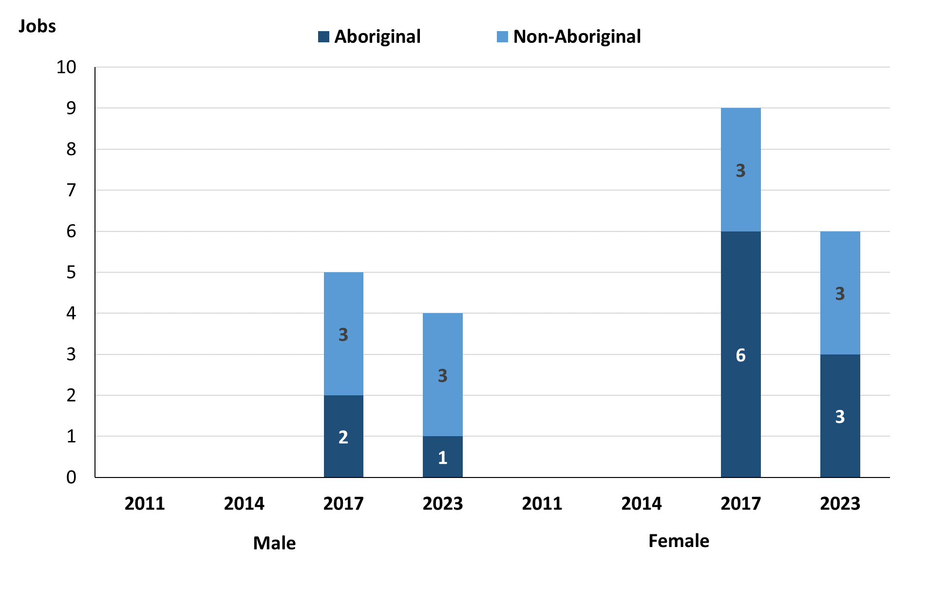

Source: Department of Industry, Tourism and Trade

In 2023 in Imanpa there were:

* 4 **jobs** **filled** **by** **males,** a decrease of 1 job from 2017, of which:
* 1 was **Aboriginal**,a decrease of 1 job from 2017
* 3 were **non-Aboriginal**, unchanged from 2017
* 6 **jobs** **filled** **by** **females,** a decrease of 3 jobs from 2017, of which:
* 3 were **Aboriginal**, a decrease of 3 jobs from 2017
* 3 were **non-Aboriginal**, unchanged from 2017

**Table 19: Count of filled jobs by gender, by full-time/part-time status, by job permanency and by sector, 2017 (a)(b)(c)(d)(e)(i)**

|  |  |  |  |  |  |  |  |  |  |  |
| --- | --- | --- | --- | --- | --- | --- | --- | --- | --- | --- |
| **2017** | | | | | | | | | | |
| **Indicator** | **Male** | | | **Female** | | | **Total** | | | |
| **Aboriginal** | **Non-Aboriginal** | **Total** | **Aboriginal** | **Non-Aboriginal** | **Total** | **Aboriginal** | **Non-Aboriginal** | **Total** |
| Full-time | 1 | 3 | **4** | 3 | 3 | **6** | 4 | 6 | **10** |
| Part-time | 1 | 0 | **1** | 3 | 0 | **3** | 4 | 0 | **4** |
| **Total** | **2** | **3** | **5** | **6** | **3** | **9** | **8** | **6** | **14** |
| Permanent | 1 | 2 | **3** | 3 | 2 | **5** | 4 | 4 | **8** |
| Temporary | 1 | 1 | **2** | 3 | 1 | **4** | 4 | 2 | **6** |
| **Total** | **2** | **3** | **5** | **6** | **3** | **9** | **8** | **6** | **14** |
| Public sector | 0 | 2 | **2** | 1 | 2 | **3** | 1 | 4 | **5** |
| Private sector | 2 | 1 | **3** | 5 | 1 | **6** | 7 | 2 | **9** |
| **Total** | **2** | **3** | **5** | **6** | **3** | **9** | **8** | **6** | **14** |

Source: Department of Industry, Tourism and Trade

Table 20: Count of filled jobs by gender, by full-time/part-time status, by job permanency and by sector 2023 (a)(b)(c)(d)(e)(i)

|  |  |  |  |  |  |  |  |  |  |
| --- | --- | --- | --- | --- | --- | --- | --- | --- | --- |
| **2023** | | | | | | | | | |
| **Indicator** | **Male** | | | **Female** | | | **Total** | | |
| **Aboriginal** | **Non-Aboriginal** | **Total** | **Aboriginal** | **Non-Aboriginal** | **Total** | **Aboriginal** | **Non-Aboriginal** | **Total** |
| Full-time | 0 | 3 | **3** | 0 | 3 | **3** | 1 | 6 | **7** |
| Part-time | 1 | 0 | **1** | 3 | 0 | **3** | 8 | 0 | **8** |
| **Total** | **1** | **3** | **4** | **3** | **3** | **6** | **9** | **6** | **15** |
| Permanent | 0 | 1 | **1** | 2 | 2 | **4** | 2 | 3 | **5** |
| Temporary | 1 | 2 | **3** | 1 | 1 | **2** | 7 | 3 | **10** |
| **Total** | **1** | **3** | **4** | **3** | **3** | **6** | **9** | **6** | **15** |
| Public sector | 0 | 1 | **1** | 0 | 1 | **1** | 0 | 2 | **2** |
| Private sector | 1 | 2 | **3** | 3 | 2 | **5** | 4 | 4 | **8** |
| **Total** | **1** | **3** | **4** | **3** | **3** | **6** | **9** | **6** | **15** |

Source: Department of Industry, Tourism and Trade

In 2023 in Imanpa:

* of the 4 **jobs** **filled** **by** **males**, there were:
* 1 job filled by an **Aboriginal** male, a decrease of 1 job from 2017, including:
* no full-time jobs, a decrease of 1 job from 2017
* 1 part-time job, unchanged from 2017
* no permanent jobs, a decrease of 1 job from 2017
* 1 temporary job, unchanged from 2017
* no public sector jobs, unchanged from 2017
* 1 private sector job, a decrease of 1 job from 2017
* 3 jobs filled by **non-Aboriginal** males, unchanged from 2017, including:
* 3 full-time jobs, unchanged from 2017
* no part-time jobs, unchanged from 2017
* 1 permanent job, a decrease of 1 job from 2017
* 2 temporary jobs, an increase of 1 job from 2017
* 1 public sector job, a decrease of 1 job from 2017
* 2 private sector jobs, an increase of 1 job from 2017
* of the 6 **jobs** **filled** **by** **females**, there were:
* 3 jobs filled by **Aboriginal** females, a decrease of 3 jobs from 2017, including:
* no full-time jobs, a decrease of 3 jobs from 2017
* 3 part-time jobs, unchanged from 2017
* 2 permanent jobs, a decrease of 1 job from 2017
* 1 temporary job, a decrease of 2 jobs from 2017
* no public sector jobs, a decrease of 1 job from 2017
* 3 private sector jobs, a decrease of 2 jobs from 2017
* 3 jobs filled by **non-Aboriginal** females, unchanged from 2017, including:
* 3 full-time jobs, unchanged from 2017
* no part-time jobs, unchanged from 2017
* 2 permanent jobs, unchanged from 2017
* 1 temporary job, unchanged from 2017
* 1 public sector job, a decrease of 1 job from 2017
* 2 private sector jobs, an increase of 1 job from 2017.

# Jobs by Age

**Table 21: Count of filled jobs by age, 2017 & 2023 (a)(c)(j)**

|  |  |  |  |  |  |  |  |  |  |
| --- | --- | --- | --- | --- | --- | --- | --- | --- | --- |
| **Indicator** | **2017** | | | **2023** | | | **Change 2017-2023** | | |
| **Aboriginal** | **Non-Aboriginal** | **Total** | **Aboriginal** | **Non-Aboriginal** | **Total** | **Aboriginal** | **Non-Aboriginal** | **Total** |
| 15-24 years | 0 | 0 | 0 | 0 | 0 | **0** | 0 | 0 | **0** |
| 25-44 years | 5 | 2 | **7** | 3 | 3 | **6** | -2 | 1 | **-1** |
| 45+ years | 3 | 4 | **7** | 1 | 3 | **4** | -2 | -1 | **-3** |
| **Total** | **8** | **6** | **14** | **9** | **6** | **15** | **1** | **0** | **1** |

Source: Department of Industry, Tourism and Trade

**Chart 11: Count of filled jobs by age, 2017 & 2023 (a)(c)(j)**

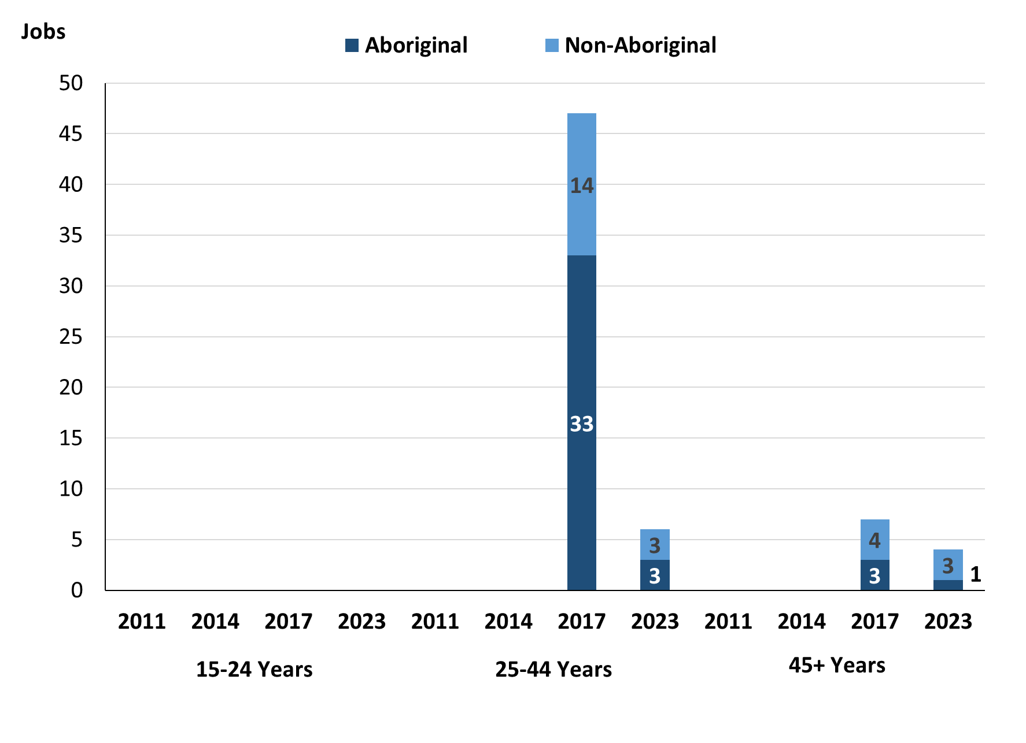

Source: Department of Industry, Tourism and Trade

In 2023 in Imanpa there were:

* no **jobs** **filled** by people aged **15-24 years**, unchanged from 2017
* 6 **jobs** **filled** by people aged **25-44 years**, a decrease of 1 job from 2017, of these:
* 3 jobs were filled by **Aboriginal** people, a decrease of 2 jobs from 2017
* 3 jobs were filled by **non-Aboriginal** people, an increase of 1 job from 2017
* 4 **jobs** **filled** by people aged **45+ years**, a decrease of 3 jobs from 2017, of these:
* 1 job was filled by an **Aboriginal** person, a decrease of 2 jobs from 2017
* 3 jobs were filled by **non-Aboriginal** people, a decrease of 1 job from 2017.

**Table 22: Count of filled jobs by age, by full-time/part-time status, by job permanency and by sector, July 2017 (a)(b)(c)(d)(e)(i)**

|  |  |  |  |  |  |  |  |  |  |  |  |  |  |
| --- | --- | --- | --- | --- | --- | --- | --- | --- | --- | --- | --- | --- | --- |
| **2017** | | | | | | | | | | | | | |
| **Indicator** | **15-24 years** | | | **25-44 years** | | | **45+ years** | | | **Total** | | | |
| **Aboriginal** | **Non-Aboriginal** | **Total** | **Aboriginal** | **Non-Aboriginal** | **Total** | **Aboriginal** | **Non-Aboriginal** | **Total** | **Aboriginal** | **Non-Aboriginal** | **Total** |
| Full-time | 0 | 0 | **0** | 2 | 2 | **4** | 2 | 4 | **6** | 4 | 6 | **10** |
| Part-time | 0 | 0 | **0** | 3 | 0 | **3** | 1 | 0 | **1** | 4 | 0 | **4** |
| **Total** | **0** | **0** | **0** | **5** | **2** | **7** | **3** | **4** | **7** | **8** | **6** | **14** |
| Permanent | 0 | 0 | **0** | 2 | 2 | **4** | 2 | 2 | **4** | 4 | 4 | **8** |
| Temporary | 0 | 0 | **0** | 3 | 0 | **3** | 1 | 2 | **3** | 4 | 2 | **6** |
| **Total** | **0** | **0** | **0** | **5** | **2** | **7** | **3** | **4** | **7** | **8** | **6** | **14** |
| Public Sector | 0 | 0 | **0** | 0 | 2 | **2** | 1 | 2 | **3** | 1 | 4 | **5** |
| Private Sector | 0 | 0 | **0** | 5 | 0 | **5** | 2 | 2 | **4** | 7 | 2 | **9** |
| **Total** | **0** | **0** | **0** | **5** | **2** | **7** | **3** | **4** | **7** | **8** | **6** | **14** |

Source: Department of Industry, Tourism and Trade

Table 23: Count of filled jobs by age, by full-time/part-time status, by job permanency and by sector, September 2023 (a)(b)(c)(d)(e)(i)

| **2023** | | | | | | | | | | | | |
| --- | --- | --- | --- | --- | --- | --- | --- | --- | --- | --- | --- | --- |
| **Indicator** | **15-24 years** | | | **25-44 years** | | | **45+ years** | | | **Total** | | |
| **Aboriginal** | **Non-Aboriginal** | **Total** | **Aboriginal** | **Non-Aboriginal** | **Total** | **Aboriginal** | **Non-Aboriginal** | **Total** | **Aboriginal** | **Non-Aboriginal** | **Total** |
| Full-time | 0 | 0 | **0** | 0 | 3 | **3** | 0 | 3 | **3** | 1 | 6 | **7** |
| Part-time | 0 | 0 | **0** | 3 | 0 | **3** | 1 | 0 | **1** | 8 | 0 | **8** |
| Total | **0** | **0** | **0** | **3** | **3** | **6** | **1** | **3** | **4** | **9** | **6** | **15** |
| Permanent | 0 | 0 | **0** | 2 | 3 | **5** | 0 | 0 | **0** | 2 | 3 | **5** |
| Temporary | 0 | 0 | **0** | 1 | 0 | **1** | 1 | 3 | **4** | 7 | 3 | **10** |
| Total | **0** | **0** | **0** | **3** | **3** | **6** | **1** | **3** | **4** | **9** | **6** | **15** |
| Public Sector | 0 | 0 | **0** | 0 | 0 | **0** | 0 | 2 | **2** | 0 | 2 | **2** |
| Private Sector | 0 | 0 | **0** | 3 | 3 | **6** | 1 | 1 | **2** | 4 | 4 | **8** |
| Total | **0** | **0** | **0** | **3** | **3** | **6** | **1** | **3** | **4** | **9** | **6** | **15** |

Source: Department of Industry, Tourism and Trade

In 2023 in Imanpa:

* there were no **jobs** **filled** by people aged **15-24 years**
* of the 6 **jobs** filled by people aged **25-44 years**, there were:
* 3 jobs filled by **Aboriginal** people, of which:
* none were full-time jobs, a decrease of 2 jobs from 2017
* 3 were part-time jobs, unchanged from 2017
* 2 were permanent jobs, unchanged from 2017
* 1 was a temporary job, a decrease of 2 jobs from 2017
* none were public sector jobs, unchanged from 2017
* 3 were private sector jobs, a decrease of 2 jobs from 2017
* 3 jobs filled by **non-Aboriginal** people, of which:
* 3 were full-time jobs, an increase of 1 job from 2017
* none were part-time jobs, unchanged from 2017
* 3 were permanent jobs, an increase of 1 job from 2017
* none were temporary jobs, unchanged from 2017
* none were public sector jobs, a decrease of 2 jobs from 2017
* 3 were private sector jobs, an increase of 3 jobs from 2017
* of the 4 **jobs** **filled** by people aged **45+ years**, there were:
* 1 job filled by an **Aboriginal** person, of which:
* none were full-time jobs, a decrease of 2 jobs from 2017
* 1 was a part-time job, unchanged from 2017
* none were permanent jobs, a decrease of 2 jobs from 2017
* 1 was a temporary job, unchanged from 2017
* none were public sector jobs, a decrease of 1 job from 2017
* 1 was a private sector job, a decrease of 1 job from 2017
* 3 jobs filled by **non-Aboriginal** people, of which:
* 3 were full-time jobs, a decrease of 1 job from 2017
* none were part-time jobs, unchanged from 2017
* none were permanent jobs, a decrease of 2 jobs from 2017
* 3 were temporary jobs, an increase of 1 job from 2017
* 2 were public sector jobs, unchanged from 2017
* 1 was a private sector job, a decrease of 1 job from 2017.

# Vocational Education and Training

Table 24: Northern Territory Vocational Education and Training (VET) students, 2016 & 2023 (k)

|  |  |  |  |  |  |
| --- | --- | --- | --- | --- | --- |
| **VET Funding Group** | **2016** | | **2023** | | **Change** |
| **No.** | **% of Total** | **No.** | **% of Total** | **2016-2023** |
| Building and Construction | 4 | 31% | 14 | 61% | 10 |
| Business and Clerical | 0 | 0% | 5 | 22% | 5 |
| Community Services, Health and Education | 7 | 54% | 4 | 17% | -3 |
| Sales and Personal Service | 2 | 15% | 0 | 0% | -2 |
| **Total** | **13** | **100%** | **23** | **100%** | **10** |

Source: Department of Industry, Tourism and Trade

In Imanpa in 2023:

* there were 23 **VET students**,an increase of 10 students from 2016
* the areas of VET activity with the most students were Building and Construction (14), Business and clerical (5), and Community Services, Health and Education (4)
* Building and Construction reported the largest increase in students (10) compared to 2016 and Community Services, Health and Education reported the largest decrease in students (-3) over the same period.

Table 25: Northern Territory Vocational Education and Training (VET) unit enrolments, 2016 & 2023 (l)

|  |  |  |  |  |  |
| --- | --- | --- | --- | --- | --- |
| **VET Funding Group** | **2016** | | **2023** | | **Change** |
| **No.** | **% of Total** | **No.** | **% of Total** | **2016-2023** |
| Building and Construction | 4 | 8% | 55 | 50% | 51 |
| Business and Clerical | 0 | 0% | 49 | 44% | 49 |
| Community Services, Health and Education | 21 | 44% | 7 | 6% | -14 |
| Sales and Personal Service | 23 | 48% | 0 | 0% | -23 |
| **Total** | **48** | **100%** | **111** | **100%** | **63** |

Source: Department of Industry, Tourism and Trade

In Imanpa in 2023:

* there were 111 **VET unit enrolments**, an increase of 63 unit enrolments from 2016
* the areas of VET activity with the most unit enrolments were Building and Construction (55), Business and clerical (49), and Community Services, Health and Education (7)
* Building and Construction reported the largest increase in unit enrolments (51) compared to 2016 and Sales and Personal Service reported the largest decrease in unit enrolments (-23) over the same period.

Table 26: Northern Territory Vocational Education and Training (VET) nominal hours, 2016 & 2023 (m)

|  |  |  |  |  |  |
| --- | --- | --- | --- | --- | --- |
| **VET Funding Group** | **2016** | | **2023** | | **Change** |
| **No.** | **% of Total** | **No.** | **% of Total** | **2016-2023** |
| Building and Construction | 80 | 12% | 3108 | 60% | 3028 |
| Business and Clerical | 0 | 0% | 1815 | 35% | 1815 |
| Community Services, Health and Education | 0 | 0% | 240 | 5% | 240 |
| Sales and Personal Service | 610 | 88% | 0 | 0% | -610 |
| **Total** | **690** | **100%** | **5163** | **100%** | **4473** |

Source: Department of Industry, Tourism and Trade

In Imanpa in 2023:

* there were 5163 **VET nominal hours** delivered, an increase of 4473 nominal hours delivered from 2016
* the areas of VET activity with the most nominal hours delivered were Building and Construction (3108), Business and clerical (1815), and Community Services, Health and Education (240)
* Building and Construction reported the largest increase in nominal hours delivered (3028) compared to 2016 and Sales and Personal Service reported the largest decrease in nominal hours delivered (-610) over the same period.

Caveat: *Nominal hours are based on the hours funded through Department of Industry, Tourism and Trade contracts; students and units includes delivery that has been funded in a previous year, fee for service or training that did not meet the funding requirements. Because of this a direct match cannot be made between hours and student/units*.

**Table 27: Northern Territory Vocational Education and Training (VET) unit completions, 2016 & 2023 (n)**

|  |  |  |  |  |  |
| --- | --- | --- | --- | --- | --- |
| **VET Funding Group** | **2016** | | **2023** | | **Change** |
| **No.** | **% of Total** | **No.** | **% of Total** | **2016-2023** |
| Building and Construction | 4 | 7% | 44 | 100% | 40 |
| Community Services, Health and Education | 29 | 48% | 0 | 0% | -29 |
| Sales and Personal Service | 28 | 46% | 0 | 0% | -28 |
| **Total** | **61** | **100%** | **44** | **100%** | **-17** |

Source: Department of Industry, Tourism and Trade

In Imanpa in 2023:

* there were 44 **VET unit completions**, a decrease of 17 unit completions from 2016
* the areas of VET activity with the most unit completions were Building and Construction (44)
* Building and Construction reported the largest increase in unit completions (40) compared to 2016 and Community Services, Health and Education reported the largest decrease in unit completions (-29) over the same period.

# Population

**Table 28: Population distribution by gender and age (p)(r)**

|  |  |  |  |  |  |  |  |  |  |
| --- | --- | --- | --- | --- | --- | --- | --- | --- | --- |
| **Indicator** | **2011** | | | **2021** | | | **Change (2011-2021)** | | |
| **Male** | **Female** | **Total** | **Male** | **Female** | **Total** | **Male** | **Female** | **Total** |
| **0-4 years** | 7 | 4 | **11** | 4 | 0 | **4** | -3 | -4 | **-7** |
| **5-14 years** | 9 | 21 | **30** | 17 | 12 | **29** | 8 | -9 | **-1** |
| **15-24 years** | 26 | 16 | **42** | 8 | 12 | **20** | -18 | -4 | **-22** |
| **25-44 years** | 27 | 36 | **63** | 25 | 14 | **39** | -2 | -22 | **-24** |
| **45-64 years** | 18 | 12 | **30** | 13 | 11 | **24** | -5 | -1 | **-6** |
| **65+ years** | 5 | 0 | **5** | 0 | 0 | **0** | -5 | 0 | **-5** |
| **Total** | **94** | **95** | **189** | **69** | **54** | **123** | **-25** | **-41** | **-66** |

*Source: Australian Bureau of Statistics*

In 2021 in Imanpa:

* there were an estimated 123 people, of which:
* 69 (56.1%) were male
* 55 (43.9%) were female
* between 2011 and 2021, the overall population in Imanpa decreased by 66 people from 2011, or an average of -3.5% per year compared to -0.5% across the 28 remote towns and 1.0% Territory wide
* the male population decreased by 25 people from 2011
* the female population decreased by 41 people from 2011
* in 2021, the working age population (15 years and over) in Imanpa was an estimated 83 people (67.5% of the total population) compared with 140 people (74.1% of the total population) in 2011. Of these:
* 20 (16.3%) were between 15 and 24 years of age
* 39 (31.7%) were between 25 and 44 years of age
* 24 (19.5%) were between 45 and 64 years of age
* none were over 65 years of age
* of the 83 people of working age:
* 46 (55.4%) were male
* 37 (44.6%) were female.

There were 0.3 jobs in Imanpa per working age person compared to 0.3 jobs per working age person across the 28 remote towns in the Northern Territory.

**Chart 12: Population comparison (p)(q)**

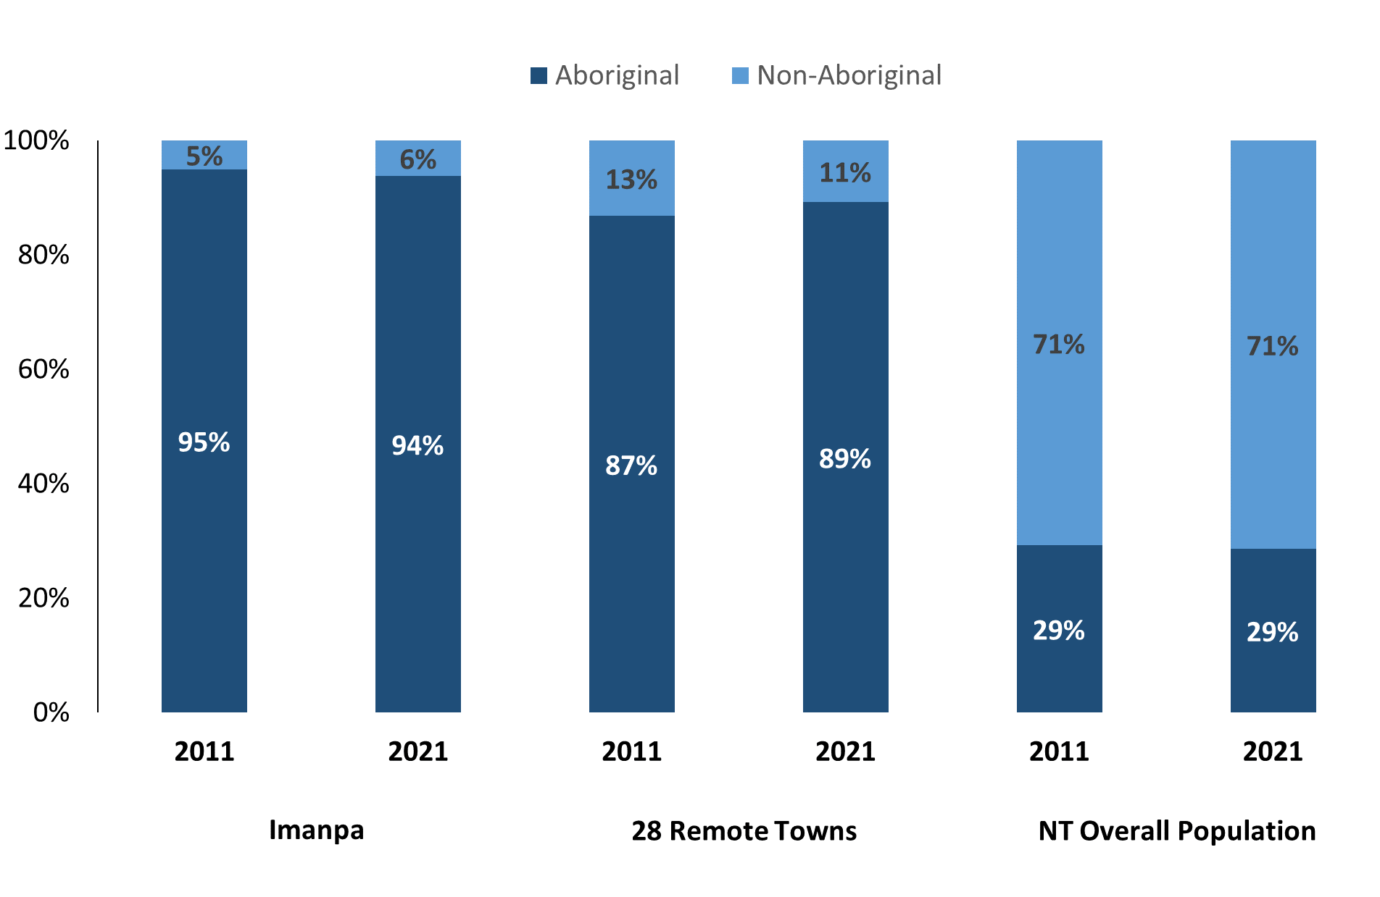

*Source: Australian Bureau of Statistics*

In 2021 in Imanpa:

* 94% of the population in Imanpa were **Aboriginal**, compared to 95% in 2011
* 89% of the population across all 28 remote towns were **Aboriginal**
* 29% of the NT population were **Aboriginal**.

**Table 29: Unemployment and Aboriginal participation rates (q)**

|  |  |  |  |  |  |  |
| --- | --- | --- | --- | --- | --- | --- |
|  | **Imanpa** | | | **Northern Territory** | | |
| **Aboriginal** | **Non-Aboriginal** | **Total** | **Aboriginal** | **Non-Aboriginal** | **Total** |
| **Unemployment rate** | 40.7% | 0.0% | 34.4% | 20.8% | 3.2% | 5.6% |
| **Participation rate** | 39.7% | 83.3% | 55.1% | 35.4% | 78.3% | 64.9% |

*Source: Australian Bureau of Statistics*

In 2021 in Imanpa the:

* **total unemployment rate** was 34.4% compared to 5.6% for the total Northern Territory
* **Aboriginal** **unemployment rate** was 40.7% compared to 20.8% for the total Northern Territory
* **non-Aboriginal unemployment rate** was 0.0% compared to 3.2% for the total Northern Territory
* **total participation rate** was 55.1% compared to 64.9% for the total Northern Territory
* **Aboriginal** **participation rate** was 39.7% compared to 35.4% for the total Northern Territory
* **non-Aboriginal participation rate** was 83.3% compared to 78.3% for the total Northern Territory.

# Community Development Program

**Table 30: Community Development Program Aboriginal Job Seekers, 31 December 2023 (o)**

|  |  |  |
| --- | --- | --- |
| **Indicator** | **Aboriginal** | |
| **No.** | **%** |
| **Total Aboriginal Job Seekers** | 57 | N/A |
| **Age (years)** | | |
| 15-24 | <20 | N/A |
| 25-44 | 32 | 56.1% |
| 45+ | <20 | N/A |
| **Total** | 57 | 100.0% |
| **Gender** | | |
| Male | 27 | 47.4% |
| Female | 30 | 52.6% |
| **Total** | 57 | 100.0% |
| **Employment Outcome – 1 January 2023 to 31 December 2023** | | |
| 13 Weeks | <20 | N/A |
| 26 Weeks | <20 | N/A |

*Source: Department of Prime Minister and Cabinet*

As at 31 December 2023, in Imanpa, there were 57 CDP **Aboriginal** job seekers, of these:

* 27 (47.4%) were male and 30 (52.6%) were female
* less than 20 were aged 15-24 years, 32 (56.1%) were aged 25-44 years, and less than 20 were aged 45+ years
* between 1 January 2023 to 31 December 2023, less than 20 had reached the 13 week reporting milestone and less than 20 had reached the 26 week reporting milestone.

# Businesses

**Table 31: Businesses by sector (d)(s)**

|  |  |  |
| --- | --- | --- |
| **Business Name** | **Reported in 2017?** | **Reported in 2023?** |
| **PUBLIC SECTOR** | | |
| **Department of Education** | Yes | **Yes** |
| Department of Health | Yes | No |
| **MacDonnell Regional Council** | Yes | **Yes** |
| Northern Territory Police, Fire Emergency Services | Yes | No |
| **PRIVATE SECTOR** | | |
| Mutitjulu Community Aboriginal Corporation | Yes | No |
| **Ngaanyatjarra Pitjantjatjara Yankunytjatjara Women's Council Aboriginal Corporation (NPY Women’s Council)** | No | **Yes** |
| **Nyangatjatjara Aboriginal Corporation (Nyangatjatjara College)** | Yes | **Yes** |
| **Outback Stores Pty Ltd t/a Imanpa Community Store** | Yes | **Yes** |
| The Trustee for Wana Ungkunytja Trust trading as Anangu Jobs | Yes | No |

*Source: Department of Industry, Tourism and Trade*

*Note: Business names captured have been identified by the current 2023 Business ABN name listed.*

In 2023 in Imanpa:

* there were 5 businesses reported on, of which:
* 2 businesses were from the public sector (40%)
* 3 businesses were from the private sector (60%).

# Notes

1. These counts represent numbers of filled jobs and not numbers of people. As such the totals represent the total number of filled jobs, not the total number of employees. This count is not directly comparable to the total number of employed people as a person may have several jobs or one job may be shared by more than one person.
2. Full-time is defined as a job usually requiring 35 hours or more per week or that required 35 hours or more work during the reference week. Part-time is defined as a job usually requiring less than 35 hours per week or that required less than 35 hours work during the reference week. The reference week refers to the period that respondents were asked to provide information about. In most instances it would be the week prior to the week the questionnaire was completed. Questionnaires were predominantly conducted in June and July.
3. Care needs to be taken when analysing the counts of filled jobs by Aboriginal people. Aboriginality was reported by the business representative completing the questionnaire.
4. Sector was classified using the Standard Economic Sector of Classifications of Australia (SESCA), 2008.
5. Job permanency is classified according to what the business believes the level of job permanency is based on guidelines provided by data collectors. Those guidelines state a permanent job has paid annual and/or sick leave entitlements while a temporary job includes casual and fixed-term contract jobs.
6. Classified according to the Australian and New Zealand Standard Classification of Occupations (ANZSCO), 2006, major occupation level.
7. Other occupations include jobs where occupation was not stated, not known or inadequately described.
8. Classified using the Australian and New Zealand Standard Industrial Classification (ANZSIC), 2006, division level.
9. Care needs to be taken when analysing the counts of filled jobs by the gender of people in the jobs. The gender of the person employed in a job is reported by the business representative completing the questionnaire.
10. Care needs to be taken when analysing the counts of filled jobs by the age of people in the jobs. The age of the person employed in a job is reported by the business representative completing the questionnaire.
11. Students represent the number of individual clients that enrolled in a Vocational Education and Training unit during the calendar year.
12. Unit enrolments represent the count of individual units that students enrolled in during the calendar year.
13. Nominal hours delivered is the sum of the nominal hours of the units commenced during the calendar year regardless of when the course enrolment commenced.
14. Unit completions are the count of all successfully completed units reported in the calendar year regardless of the year of commencement of the units.
15. The Community Development Program (CDP) supports job seekers in remote Australia to build skills, address barriers and contribute to their communities through a range of flexible activities. Under the CDP, job seekers with activity requirements are expected to do up to 25 hours per week of work-like activities that benefit their community. It should be noted that some CDP participants may be reported on within the profile if they are attached to a filled position with an employer captured in the survey. Due to confidentiality issues, data below 20 people is not published.
16. Population estimates for both 2011 and 2021 are taken from the estimated resident population (ERP) data produced by the Australian Bureau of Statistics (ABS) and based on Australian Statistical Geography Standard (ASGS) Statistical Area Level 1 (SA1) regions. ERP are official estimates of the Australian population, which link people to a place of usual residence with Australia. All ERP data sources, including the Census of Population and Housing (Census), are subject to error (including inaccuracies in collection, recording and processing data) and should be used with caution.
17. Indigenous population proportions, unemployment and workforce participation rates are based on ABS Census counts at ASGS Indigenous Locations (ILOCs) for each remote town.
18. Working-age population includes all residents aged 15 years and over (commonly referred to as the civilian population) and consists of people that are employed, unemployed or not in the labour force.
19. A ‘business’ has been defined as any organisation that has undertaken productive activities in the last year, including companies, non-profit organisations, government departments and enterprises operating within the designated remote geography (town), and has one or more employees in paid employment and an Australian Business Number (ABN).

# Abbreviations and Acronyms

ABN Australian Business Number

ABS Australian Bureau of Statistics

ANZSCO Australian and New Zealand Standard Classification of Occupations

ANZSIC Australian and New Zealand Standard Industrial Classification

ASGS Australian Statistical Geography Standard

CDP Community Development Program

ERP Estimated Resident Population

ILOC Indigenous Locations

nec Not Elsewhere Classified

No. Number

Perm Permanent

ppt Percentage point

RJCP Remote Jobs and Communities Program

Temp Temporary

SA1 Statistical Area Level 1

VET Vocational Education and Training

1. The number of filled jobs does not represent numbers of people as a person may have several jobs or one job may be shared by more than one person.