**© Northern Territory of Australia 2025**

**Preferred Reference:** Department of Trade, Business and Asian Relations, 2023 Remote Towns Jobs Profiles, Northern Territory Government, January 2025, Darwin.

**Front cover image**: *Gossypium sturtianum* - known commonly as Sturts Desert Rose

**Disclaimer**

The data in this publication was collected by conducting a survey of businesses located in the 28 remote town boundaries. This body of work was completed in 2023 by the former Northern Territory Department of Industry, Tourism and Trade.

The collection methodology was created in accordance with Australian Bureau of Statistics data quality framework principles. Data in this publication is only reflective of those businesses reported on as operating in the town at the time of data collection (see table at the end of publication for list of businesses reported on). To comply with privacy legislation or where appropriate, some data in this publication may have been adjusted and will not reflect the actual data reported by businesses. As a result of this, combined with certain data not being reported by some businesses, some components may not add to totals. Changes over time may also reflect change in business propensity to report on certain data items rather than actual changes over time. Total figures have generally not been adjusted. Caution is advised when interpreting the comparisons made to the earlier 2011, 2014 and 2017 publications as the businesses identified and reported on and the corresponding jobs may differ between publications. The surveys have not always gathered data on training and jobs in the same years.

**Notes for each table and chart are ordered alphabetically and listed at the end of the publication.**

The Northern Territory of Australia exercised due care and skill to ensure that at the time of publication the information contained in this publication is true and correct. However, it is not intended to be relied on as professional advice or used for commercial purposes. The Territory gives no warranty or assurances as to the accuracy of the information contained in the publication and to the maximum extent permitted by law accepts no direct or indirect liability for reliance on its content.

Any use of this report for commercial purposes is not endorsed by the Department of Trade, Business and Asian Relations.

Contents

Borroloola 4

Introduction 5

Summary 6

Jobs Overview 7

Jobs filled by Aboriginality 8

Jobs by Sector: Private and Public 11

Job Status: Permanent and Temporary 18

Job Vacancies 22

Jobs by Industry 24

Jobs by Occupation 32

Jobs by Industry by Occupation 37

Jobs by Gender 40

Jobs by Age 46

Vocational Education and Training 52

Population 60

Community Development Program 62

Businesses 63

Notes 65

Abbreviations and Acronyms 66

# Borroloola

Borroloola is located at the end of the Carpentaria Highway, 1,000 kilometres south-east of Darwin, 662 kilometres from Katherine and 1,007 kilometres from Mt Isa, Queensland, with a population of 758 residents.A map of the state of australia
*Source: Northern Territory Department of Industry, Tourism and Trade*

# Introduction

This jobs profile provides a snapshot of jobs and the characteristics of job holders in Borroloola as of September 2023. Trends from the surveys conducted in 2011, 2014, and 2017 are also described. Additionally, it presents data on Community Development Program activity, Population, and Vocational Education and Training.

This job profile is one of 28 profiles developed for remote towns in the Northern Territory. It is anticipated these, and subsequent profiles will contribute to a robust evidence base to inform decision making in and relating to these remote Territory towns.

This profile contains information collected by the Northern Territory Department of Industry, Tourism and Trade from businesses operating within the town and is supplemented by other administrative data sets and information.

Each profile provides up-to-date information that is intended to inform the planning and design of current and future government programs and as an evidence base to inform decision making relating to workforce development, enterprise and job opportunities.

The profile may best be understood as a point-in-time tool. The number of business surveys from which the data was drawn is significantly less than in earlier surveys, and business participation has decreased with each survey. For Borroloola, 53% fewer businesses than in 2017 are reported here.

The data collection methodology and corresponding questionnaire were created in partnership with the Australian Bureau of Statistics (ABS) and in accordance with ABS data quality framework and survey principles.

The Department of Industry, Tourism and Trades’ Territory Engagement and Delivery, Skills Initiative and VET data teams collaborated with the Northern Institute at Charles Darwin University to facilitate the surveys and reports.

The information collected and reported on represents a significant goodwill investment by those businesses and organisations that participated. Each business is listed at the end of this publication.

# Summary

The 2023 jobs profile was developed based on responses from 15 businesses operating within the Borroloola town boundary, 17 less than in the 2017 survey. Of these, there were:

* 8 businesses from the Private Sector, accounting for 143 filled jobs or 69% of total filled jobs
* 7 businesses from the public sector, accounting for 64 filled jobs or 31% of total filled jobs
* 8 businesses participated in all four surveys (completed in 2011, 2014, 2017 and 2023).

A total of 207 filled and 81 vacant jobs in Borroloola were reported, a decrease of 104 jobs from 2017.[1]

* there were 207 filled jobs of which:
* 121 out of 207 jobs (58%) were filled by Aboriginal people, a decrease of 77 jobs from 2017
* 86 jobs (42%) were filled by non-Aboriginal people, a decrease of 53 jobs from 2017
* 42% of employed Aboriginal people are working in the Private Sector
* Aboriginal people accounted for 58% of job holders in the town compared to 59% in 2017
* Aboriginal females made up 57% of total Aboriginal filled jobs in the town compared to 48% in 2017
* there were 81 vacant jobs, of which:
* job vacancies as a percentage of jobs increased to 28% in 2023 from 14% in 2017
* 1 job in 3.6 was vacant
* 63 of the vacancies were in the Professionals and Community and Personal Services Workers areas
* Public Administration and Safety industry continues to be the largest industry employer over the four survey periods despite a decrease of 91 filled jobs compared to 2017
* training had a decrease in student numbers of 65 between 2016 and 2023
* Building and Construction was the largest training activity sector in 2023 followed by Primary Industry.

The overall population in Borroloola decreased by 169 people (-18.2%) between 2011 and 2021 to 758 people.

In comparison, the overall Northern Territory population increased by 9.7% between 2011 and 2021.

In 2021, the working age population (15 years and over) in Borroloola was an estimated 569 people compared to 650 in 2011 a decrease of 12.5%.

There were 0.5 jobs in Borroloola per working age person compared to 0.3 jobs per working age person across the 28 remote towns in the Northern Territory.

# Jobs Overview

Table 1: Count of filled jobs and vacancies, 2011, 2014, 2017 & 2023 (a)(b)

|  |  |  |  |  |  |  |  |
| --- | --- | --- | --- | --- | --- | --- | --- |
|  | **2011** | **2014** | **2017** | **2023** | **Change 2011-2014** | **Change 2014-2017** | **Change 2017-2023** |
| **Total All Jobs** | **322** | **379** | **392** | **288** | **57** | **13** | **-104** |
| **Vacancies** | **24** | **37** | **55** | **81** | **13** | **18** | **26** |
| Vacancies as % of Total All Jobs | 7.5% | 9.8% | 14.0% | 28.1% | 2.3 ppt | 4.3 ppt | 14.1 ppt |
| **Filled Jobs** | **298** | **342** | **337** | **207** | **44** | **-5** | **-130** |
| Full-time | 219 | 252 | 239 | 160 | 33 | -13 | -79 |
| Part-time | 79 | 90 | 98 | 47 | 11 | 8 | -51 |

Source: Northern Territory Department of Industry, Tourism and Trade

**Chart 1: Count of vacant jobs and filled jobs by full-time/part-time status, 2011, 2014, 2017 & 2023 (a)(b)**

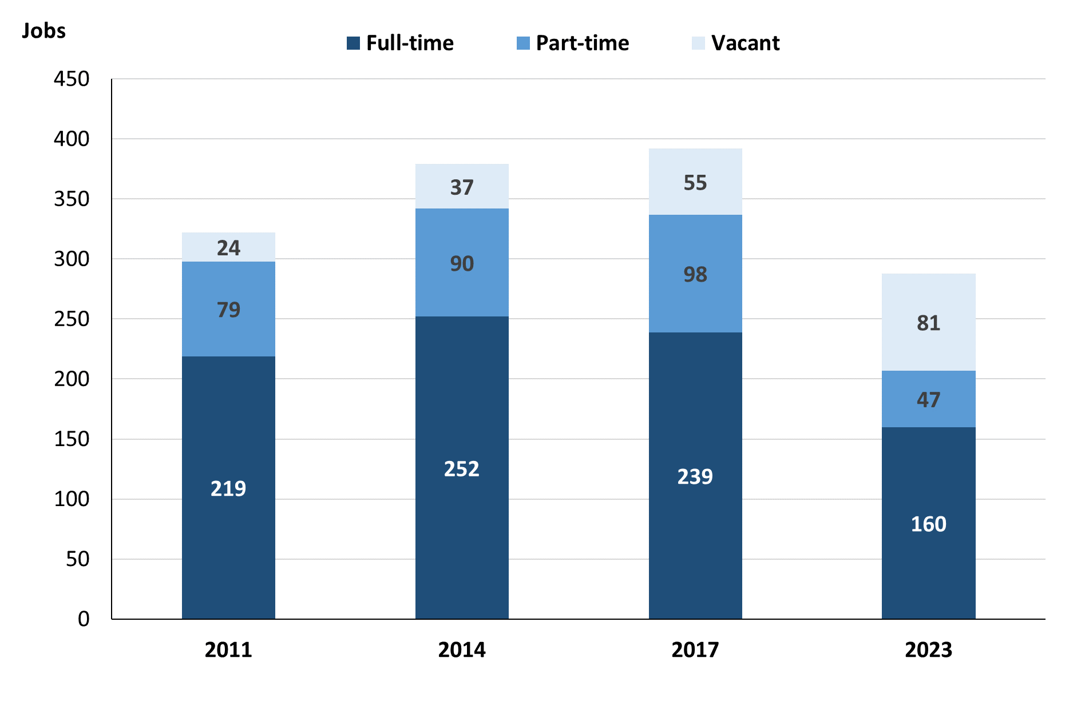

Source: Northern Territory Department of Industry, Tourism and Trade

In 2023 in Borroloola:

* there was a total of 207 **filled jobs**, a decrease of 130 jobs from 2017 and a decrease of 135 jobs from 2014
* of the 207 **filled jobs** in 2023:
* 160 were full-time jobs, a decrease of 79 jobs from 2017 and a decrease of 92 jobs from 2014
* 47 were part-time jobs, a decrease of 51 jobs from 2017 and a decrease of 43 jobs from 2014
* there were 81 total **job vacancies** in 2023, an increase of 26 vacancies from 2017 and an increase of 44 vacancies from 2014.

# Jobs filled by Aboriginality

Chart 2: Count of filled jobs by Aboriginality, 2011, 2014, 2017 & 2023 (a)(c)

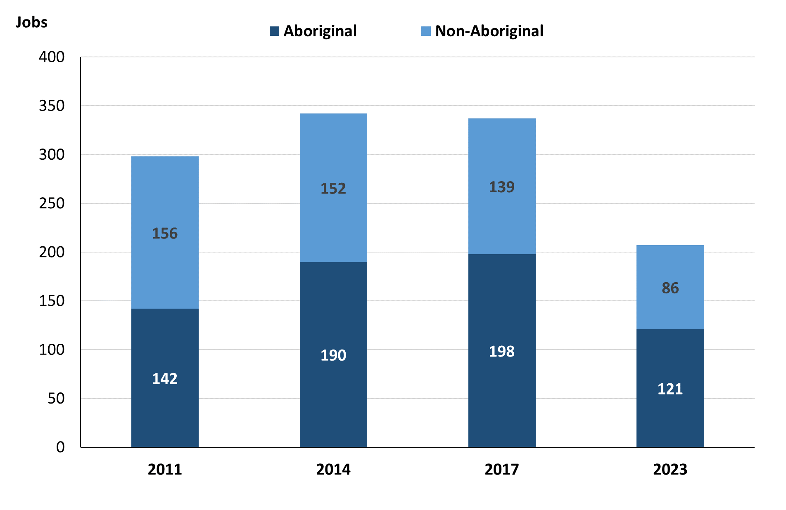

Source: Northern Territory Department of Industry, Tourism and Trade

In 2023 in Borroloola:

* of the 207 **filled jobs**:
* **Aboriginal** people filled 121 jobs, a decrease of 77 jobs from 2017 and a decrease of 69 jobs from 2014
* **non-Aboriginal** people filled 86 jobs, a decrease of 53 jobs from 2017 and a decrease of 66 jobs from 2014
* **Aboriginal** people accounted for 58% of job holders compared to 59% in 2017 and 56% in 2014.

Table 2a: Count of filled jobs by full-time/part-time status, 2011, 2014, 2017 & 2023 (a)(b)(c)

|  |  |  |  |  |  |  |  |  |  |  |  |  |
| --- | --- | --- | --- | --- | --- | --- | --- | --- | --- | --- | --- | --- |
| **Indicator** | **2011** | | | **2014** | | | **2017** | | | **2023** | | |
| **Aboriginal** | **Non-Aboriginal** | **Total** | **Aboriginal** | **Non-Aboriginal** | **Total** | **Aboriginal** | **Non-Aboriginal** | **Total** | **Aboriginal** | **Non-Aboriginal** | **Total** |
| Full-time | 87 | 132 | **219** | 112 | 140 | **252** | 118 | 121 | **239** | 81 | 79 | **160** |
| Part-time | 55 | 24 | **79** | 78 | 12 | **90** | 80 | 18 | **98** | 40 | 7 | **47** |
| **Total** | **142** | **156** | **298** | **190** | **152** | **342** | **198** | **139** | **337** | **121** | **86** | **207** |

Source: Northern Territory Department of Industry, Tourism and Trade

Table 2b: Count of filled jobs by full-time/part-time status, 2011-2014, 2014-2017 & 2017-2023 (a)(b)(c)

|  |  |  |  |  |  |  |  |  |  |
| --- | --- | --- | --- | --- | --- | --- | --- | --- | --- |
| **Indicator** | **Change 2011-2014** | | | **Change 2014-2017** | | | **Change 2017-2023** | | |
| **Aboriginal** | **Non-Aboriginal** | **Total** | **Aboriginal** | **Non-Aboriginal** | **Total** | **Aboriginal** | **Non-Aboriginal** | **Total** |
| Full-time | 25 | 8 | **33** | 6 | -19 | **-13** | -37 | -42 | **-79** |
| Part-time | 23 | -12 | **11** | 2 | 6 | **8** | -40 | -11 | **-51** |
| **Total** | **48** | **-4** | **44** | **8** | **-13** | **-5** | **-77** | **-53** | **-130** |

Source: Northern Territory Department of Industry, Tourism and Trade

Chart 3: Count of filled jobs by full-time/part-time status, 2011, 2014, 2017 & 2023 (a)(b)(c)

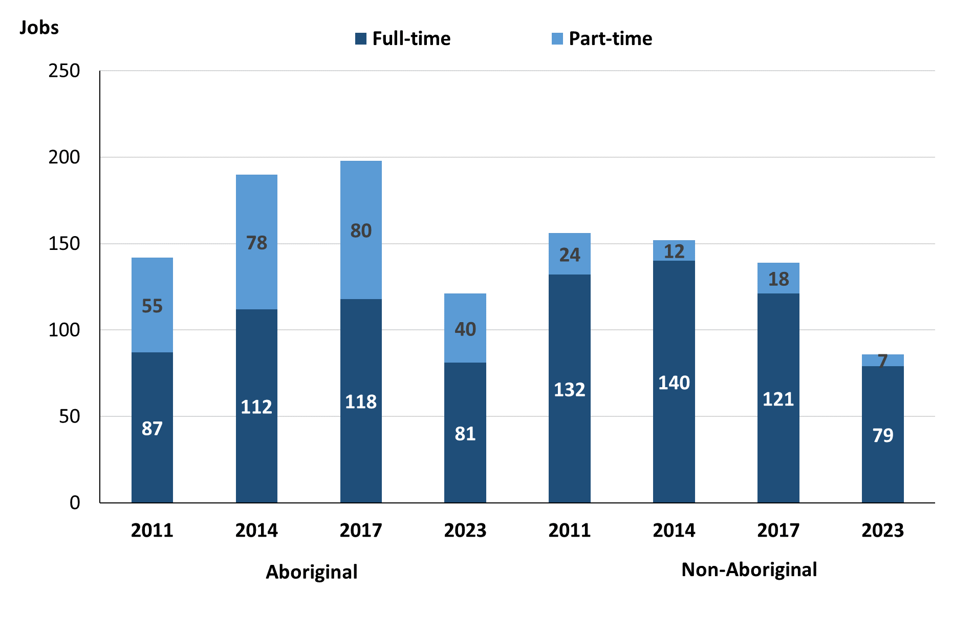

Source: Northern Territory Department of Industry, Tourism and Trade

In 2023 in Borroloola:

* of the 207 **filled jobs**:
* 81 were **full-time** jobs filled by **Aboriginal** people, a decrease of 37 jobs from 2017 and a decrease of 31 jobs from 2014
* 40 were **part-time** jobs filled by **Aboriginal** people, a decrease of 40 jobs from 2017 and a decrease of 38 jobs from 2014
* 79 were **full-time** jobs filled by **non-Aboriginal** people, a decrease of 42 jobs from 2017 and a decrease of 61 jobs from 2014
* 7 were **part-time** jobs filled by **non-Aboriginal** people, a decrease of 11 jobs from 2017 and a decrease of 5 jobs from 2014.

# Jobs by Sector: Private and Public

Table 3a: Count of filled jobs by business sector, 2011, 2014, 2017 & 2023 (a)(c)(d)

|  |  |  |  |  |  |  |  |  |  |  |  |  |
| --- | --- | --- | --- | --- | --- | --- | --- | --- | --- | --- | --- | --- |
| **Indicator** | **2011** | | | **2014** | | | **2017** | | | **2023** | | |
| **Aboriginal** | **Non-Aboriginal** | **Total** | **Aboriginal** | **Non-Aboriginal** | **Total** | **Aboriginal** | **Non-Aboriginal** | **Total** | **Aboriginal** | **Non-Aboriginal** | **Total** |
| **Public Sector** | 44 | 45 | **89** | 37 | 56 | **93** | 50 | 43 | **93** | 34 | 30 | **64** |
| Australian Government | 3 | 2 | **5** | 6 | 1 | **7** | 6 | 0 | **6** | 2 | 0 | **2** |
| Territory Government | 28 | 36 | **64** | 18 | 46 | **64** | 32 | 36 | **68** | 32 | 30 | **62** |
| Local Government | 13 | 7 | **20** | 13 | 9 | **22** | 12 | 7 | **19** | 0 | 0 | **0** |
| **Private Sector** | 98 | 111 | **209** | 153 | 96 | **249** | 148 | 96 | **244** | 87 | 56 | **143** |
| **Total** | **142** | **156** | **298** | **190** | **152** | **342** | **198** | **139** | **337** | **121** | **86** | **207** |

Source: Northern Territory Department of Industry, Tourism and Trade

Table 3b: Count of filled jobs by business sector, 2011-2014, 2014-2017 & 2017-2023 (a)(c)(d)

|  |  |  |  |  |  |  |  |  |  |
| --- | --- | --- | --- | --- | --- | --- | --- | --- | --- |
| **Indicator** | **Change 2011-2014** | | | **Change 2014-2017** | | | **Change 2017-2023** | | |
| **Aboriginal** | **Non-Aboriginal** | **Total** | **Aboriginal** | **Non-Aboriginal** | **Total** | **Aboriginal** | **Non-Aboriginal** | **Total** |
| **Public Sector** | -7 | 11 | **4** | 13 | -13 | **0** | -16 | -13 | **-29** |
| Australian Government | 3 | -1 | **2** | 0 | -1 | **-1** | -4 | 0 | **-4** |
| Territory Government | -10 | 10 | **0** | 14 | -10 | **4** | 0 | -6 | **-6** |
| Local Government | 0 | 2 | **2** | -1 | -2 | **-3** | -12 | -7 | **-19** |
| **Private Sector** | 55 | -15 | **40** | -5 | 0 | **-5** | -61 | -40 | **-101** |
| **Total** | **48** | **-4** | **44** | **8** | **-13** | **-5** | **-77** | **-53** | **-130** |

Source: Northern Territory Department of Industry, Tourism and Trade

**Chart 4: Count of filled jobs by sector of business, 2011, 2014, 2017 & 2023 (a)(d)**

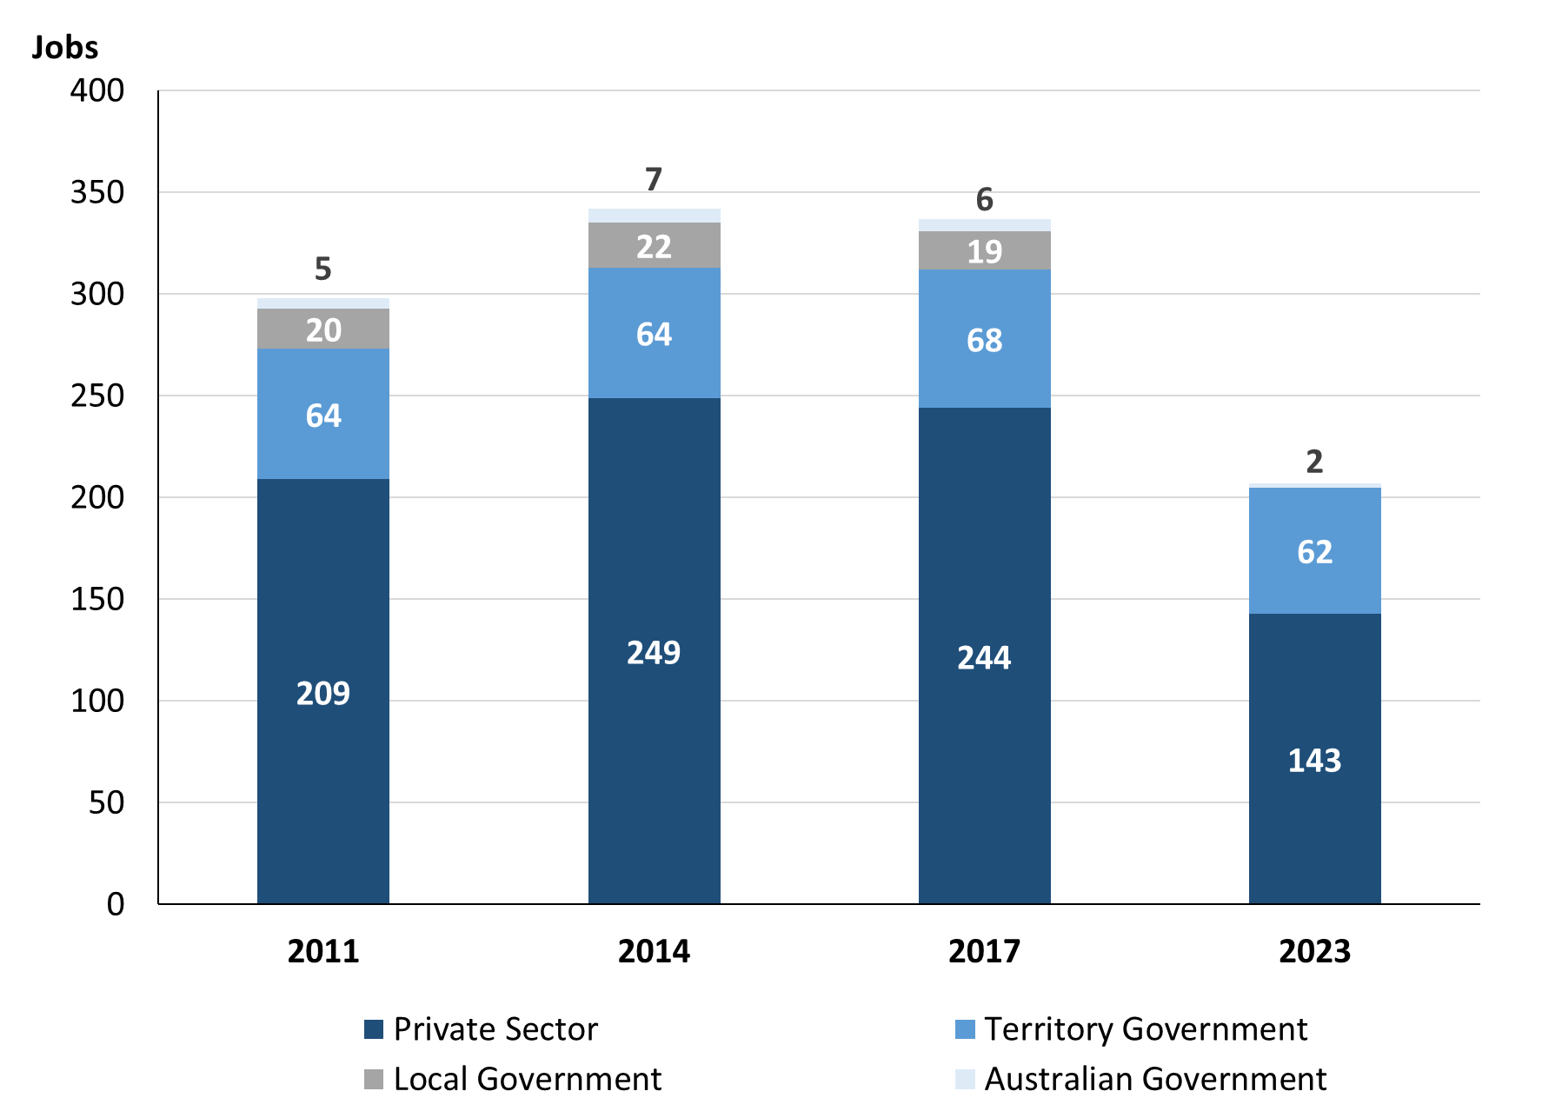

Source: Northern Territory Department of Industry, Tourism and Trade

Chart 5: Percentage of filled jobs by sector of business in 2023 (a)(d)

Source: Northern Territory Department of Industry, Tourism and Trade

In 2023 in Borroloola:

* there were 64 jobs in the **Public Sector**, a decrease of 29 jobs from 2017 and a decrease of 29 jobs from 2014
* of the 64 jobs in the **Public Sector**:
* 2 jobs were in the Australian Government, a decrease of 4 jobs from 2017 and a decrease of 5 jobs from 2014
* 62 jobs were in the Territory Government, a decrease of 6 jobs from 2017 and a decrease of 2 jobs from 2014
* none were in the Local Government, a decrease of 19 jobs from 2017 and a decrease of 22 jobs from 2014
* there were 143 jobs in the **Private Sector**, a decrease of 101 jobs from 2017 and a decrease of 106 jobs from 2014.

Chart 6: Count of filled jobs by sector, 2011, 2014, 2017 & 2023 (a)(c)(d)

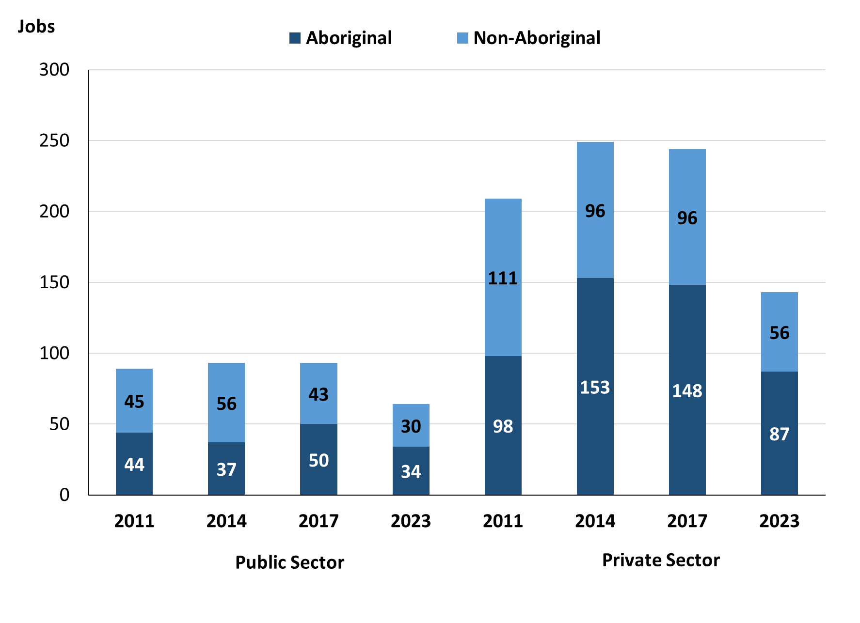

Source: Northern Territory Department of Industry, Tourism and Trade

In 2023 in Borroloola:

* of the 64 jobs in the **Public Sector**:
* **Aboriginal** people filled 34 jobs, a decrease of 16 jobs from 2017 and a decrease of 3 jobs from 2014
* **non-Aboriginal** people filled 30 jobs, a decrease of 13 jobs from 2017 and a decrease of 26 jobs from 2014
* of the 143 jobs in the **Private Sector**:
* **Aboriginal** people filled 87 jobs, a decrease of 61 jobs from 2017 and a decrease of 66 jobs from 2014
* **non-Aboriginal** people filled 56 jobs, a decrease of 40 jobs from 2017 and a decrease of 40 jobs from 2014.

Chart 7: Count of filled jobs by sector and full-time/part-time status, 2011, 2014, 2017 & 2023 (a)(b)(d)

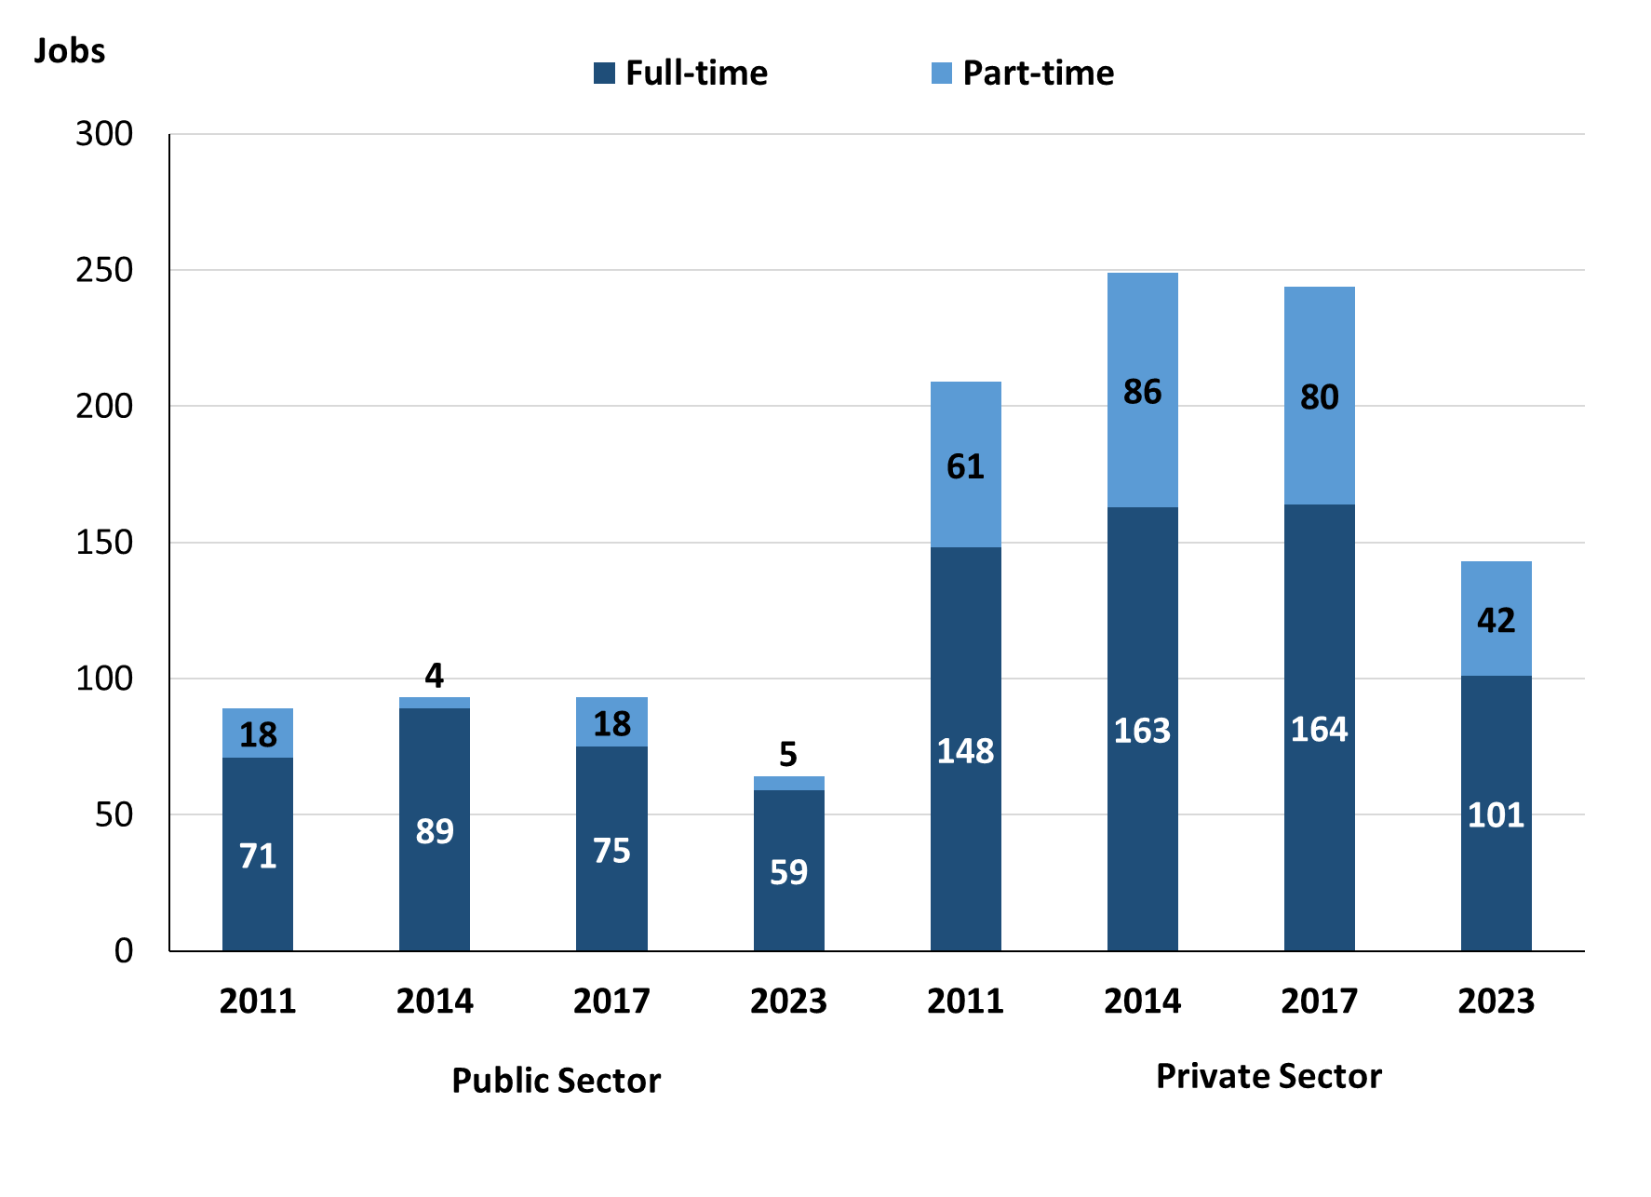

Source: Northern Territory Department of Industry, Tourism and Trade

In 2023 in Borroloola:

* of the 64 jobs in the **Public Sector**:
* 59 were **full-time** jobs, a decrease of 16 jobs from 2017 and a decrease of 30 jobs from 2014
* 5 were **part-time** jobs, a decrease of 13 jobs from 2017 and an increase of 1 job from 2014
* of the 143 jobs in the **Private Sector**:
* 101 were **full-time** jobs, a decrease of 63 jobs from 2017 and a decrease of 62 jobs from 2014
* 42 were **part-time** jobs, a decrease of 38 jobs from 2017 and a decrease of 44 jobs from 2014.

Table 4: Count of filled jobs by full-time/part-time status by sector, 2011, 2014, 2017 & 2023 (a)(b)(c)(d)

|  |  |  |  |  |  |  |  |  |  |
| --- | --- | --- | --- | --- | --- | --- | --- | --- | --- |
| **Indicator** | **2011** | | | | | | | | |
| **Aboriginal** | | | **Non-Aboriginal** | | | **Total** | | |
| **Full-time** | **Part-time** | **Total** | **Full-time** | **Part-time** | **Total** | **Full-time** | **Part-time** | **Total** |
| Public Sector | 34 | 10 | **44** | 38 | 9 | **47** | 72 | 19 | **91** |
| Private Sector | 53 | 45 | **98** | 94 | 15 | **109** | 147 | 60 | **207** |
| **Total** | **87** | **55** | **142** | **132** | **24** | **156** | **219** | **79** | **298** |

|  |  |  |  |  |  |  |  |  |  |
| --- | --- | --- | --- | --- | --- | --- | --- | --- | --- |
| **Indicator** | **2014** | | | | | | | | |
| **Aboriginal** | | | **Non-Aboriginal** | | | **Total** | | |
| **Full-time** | **Part-time** | **Total** | **Full-time** | **Part-time** | **Total** | **Full-time** | **Part-time** | **Total** |
| Public Sector | 33 | 4 | **37** | 56 | 0 | **56** | 89 | 4 | **93** |
| Private Sector | 79 | 74 | **153** | 84 | 12 | **96** | 163 | 86 | **249** |
| **Total** | **112** | **78** | **190** | **140** | **12** | **152** | **252** | **90** | **342** |

|  |  |  |  |  |  |  |  |  |  |  |
| --- | --- | --- | --- | --- | --- | --- | --- | --- | --- | --- |
| **Indicator** | **2017** | | | | | | | | | |
| **Aboriginal** | | | **Non-Aboriginal** | | | **Total** | | | |
| **Full-time** | **Part-time** | **Total** | **Full-time** | **Part-time** | **Total** | **Full-time** | **Part-time** | **Total** |
| Public Sector | 39 | 11 | **50** | 36 | 7 | **43** | 75 | 18 | **93** |
| Private Sector | 79 | 69 | **148** | 85 | 11 | **96** | 164 | 80 | **244** |
| **Total** | **112** | **78** | **198** | **121** | **18** | **139** | **239** | **98** | **337** |

|  |  |  |  |  |  |  |  |  |  |  |
| --- | --- | --- | --- | --- | --- | --- | --- | --- | --- | --- |
| **Indicator** | **2023** | | | | | | | | | |
| **Aboriginal** | | | **Non-Aboriginal** | | | **Total** | | | |
| **Full-time** | **Part-time** | **Total** | **Full-time** | **Part-time** | **Total** | **Full-time** | **Part-time** | **Total** |
| Public Sector | 32 | 2 | **34** | 27 | 3 | **30** | 59 | 5 | **64** |
| Private Sector | 49 | 38 | **87** | 52 | 4 | **56** | 101 | 42 | **143** |
| **Total** | **81** | **40** | **121** | **79** | **7** | **86** | **160** | **47** | **207** |

Source: Northern Territory Department of Industry, Tourism and Trade

In 2023 in Borroloola there were:

* 34 jobs in the **Public Sector** filled by **Aboriginal** people, a decrease of 16 jobs from 2017 and a decrease of 3 jobs from 2014, of which:
* 32 were **full-time** jobs, a decrease of 7 jobs from 2017 and a decrease of 1 job from 2014
* 2 were **part-time** jobs, a decrease of 9 jobs from 2017 and a decrease of 2 jobs from 2014
* 87 jobs in the **Private Sector** filled by **Aboriginal** people, a decrease of 61 jobs from 2017 and a decrease of 66 jobs from 2014, of which:
* 49 were **full-time** jobs, a decrease of 30 jobs from 2017 and a decrease of 30 jobs from 2014
* 38 were **part-time** jobs, a decrease of 31 jobs from 2017 and a decrease of 36 jobs from 2014
* 30 jobs in the **Public Sector** filled by **non-Aboriginal** people, a decrease of 13 jobs from 2017 and a decrease of 26 jobs from 2014, of which:
* 27 were **full-time** jobs, a decrease of 9 jobs from 2017 and a decrease of 29 jobs from 2014
* 3 were **part-time** jobs, a decrease of 4 jobs from 2017 and an increase of 3 jobs from 2014
* 56 jobs in the **Private Sector** filled by **non-Aboriginal** people, a decrease of 40 jobs from 2017 and a decrease of 40 jobs from 2014, of which:
* 52 were **full-time** jobs, a decrease of 33 jobs from 2017 and a decrease of 32 jobs from 2014
* 4 were **part-time** jobs, a decrease of 7 jobs from 2017 and a decrease of 8 jobs from 2014.

# Job Status: Permanent and Temporary

Table 5a: Count of filled jobs by employment status, 2011, 2014, 2017 & 2023 (a)(c)(e)

|  |  |  |  |  |  |  |  |  |  |  |  |  |  |  |
| --- | --- | --- | --- | --- | --- | --- | --- | --- | --- | --- | --- | --- | --- | --- |
| **Indicator** | **2011** | | | **2014** | | | **2017** | | | | **2023** | | | |
| **Aboriginal** | **Non-Aboriginal** | **Total** | **Aboriginal** | **Non-Aboriginal** | **Total** | **Aboriginal** | **Non-Aboriginal** | **Total** | **Aboriginal** | | **Non-Aboriginal** | **Total** |
| Permanent | 31 | 84 | **115** | 70 | 102 | **172** | 41 | 80 | **121** | 68 | | 55 | **123** |
| Temporary | 111 | 72 | **183** | 120 | 50 | **170** | 157 | 59 | **216** | 53 | | 31 | **84** |
| **Total** | **142** | **156** | **298** | **190** | **152** | **342** | **198** | **139** | **337** | **121** | | **86** | **207** |

Source: Northern Territory Department of Industry, Tourism and Trade

Table 5b: Count of filled jobs by employment status, 2011-2014, 2014-2017 & 2017-2023 (a)(c)(e)

|  |  |  |  |  |  |  |  |  |  |
| --- | --- | --- | --- | --- | --- | --- | --- | --- | --- |
| **Indicator** | **Change 2011-2014** | | | **Change 2014-2017** | | | **Change 2017-2023** | | |
| **Aboriginal** | **Non-Aboriginal** | **Total** | **Aboriginal** | **Non-Aboriginal** | **Total** | **Aboriginal** | **Non-Aboriginal** | **Total** |
| Permanent | 39 | 18 | **57** | -29 | -22 | **-51** | 27 | -25 | **2** |
| Temporary | 9 | -22 | **-13** | 37 | 9 | **46** | -104 | -28 | **-132** |
| **Total** | **48** | **-4** | **44** | **8** | **-13** | **-5** | **-77** | **-53** | **-130** |

Source: Northern Territory Department of Industry, Tourism and Trade

Chart 8: Count of filled jobs by employment status, 2011, 2014, 2017 & 2023 (a)(c)(e)

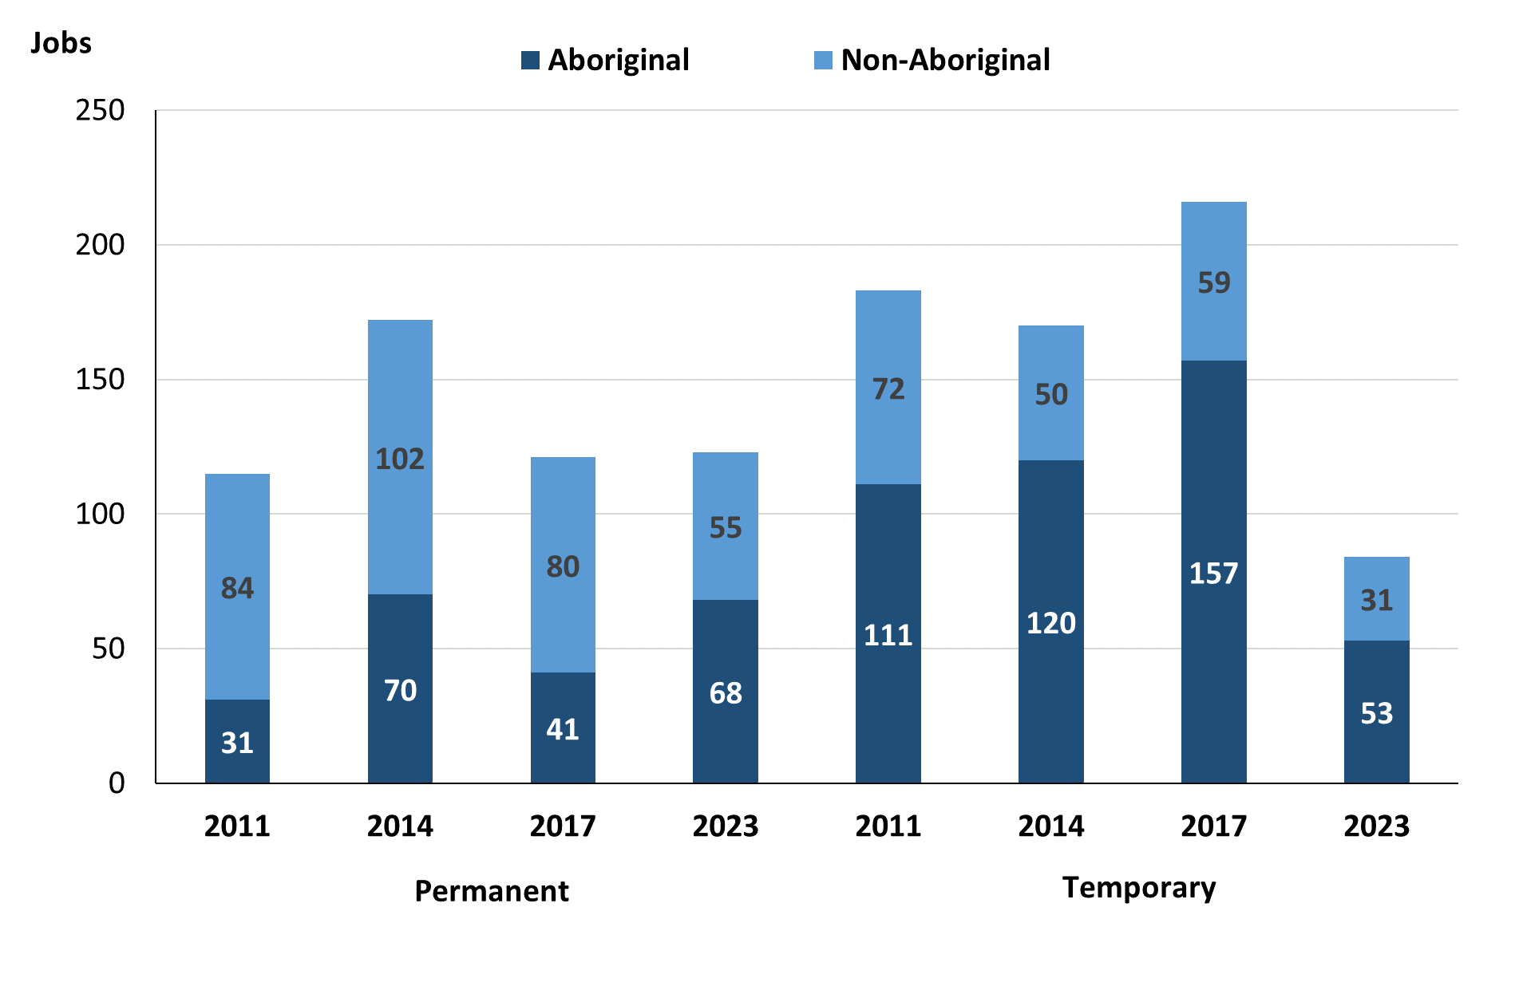

Source: Northern Territory Department of Industry, Tourism and Trade

In 2023 in Borroloola:

* there were 123 **permanent jobs**, an increase of 2 jobs from 2017, and a decrease of 49 jobs from 2014, of which:
* **Aboriginal** people filled 68 jobs, an increase of 27 jobs from 2017 and a decrease of 2 jobs from 2014
* **non-Aboriginal** people filled 55 jobs, a decrease of 25 jobs from 2017 and a decrease of 47 jobs from 2014
* there were 84 **temporary jobs,** a decrease of 132 jobs from 2017 and a decrease of 86 jobs from 2014, of which:
* **Aboriginal** people filled 53 jobs, a decrease of 104 jobs from 2017 and a decrease of 67 jobs from 2014
* **non-Aboriginal** people filled 31 jobs, a decrease of 28 jobs from 2017 and a decrease of 19 jobs from 2014.

Table 6: Count of filled jobs by sector and employment status, 2011, 2014, 2107 & 2023 (a)(c)(d)(e)

|  |  |  |  |  |  |  |  |  |  |  |
| --- | --- | --- | --- | --- | --- | --- | --- | --- | --- | --- |
| **Indicator** | **2011** | | | | | | | | | |
| **Aboriginal** | | | **Non-Aboriginal** | | | **Total** | | | |
| **Perm** | **Temp** | **Total** | **Perm** | **Temp** | **Total** | **Perm** | **Temp** | **Total** |
| Public Sector | 28 | 16 | **44** | 27 | 20 | **47** | 55 | 36 | **91** |
| Private Sector | 3 | 95 | **98** | 57 | 52 | **109** | 60 | 147 | **207** |
| **Total** | **31** | **111** | **142** | **84** | **72** | **156** | **115** | **183** | **298** |

|  |  |  |  |  |  |  |  |  |  |  |
| --- | --- | --- | --- | --- | --- | --- | --- | --- | --- | --- |
| **Indicator** | **2014** | | | | | | | | | |
| **Aboriginal** | | | **Non-Aboriginal** | | | **Total** | | | |
| **Perm** | **Temp** | **Total** | **Perm** | **Temp** | **Total** | **Perm** | **Temp** | **Total** |
| Public Sector | 30 | 7 | **37** | 48 | 8 | **56** | 78 | 15 | **93** |
| Private Sector | 40 | 113 | **153** | 54 | 42 | **96** | 94 | 155 | **249** |
| **Total** | **70** | **120** | **190** | **102** | **50** | **152** | **172** | **170** | **342** |

|  |  |  |  |  |  |  |  |  |  |  |
| --- | --- | --- | --- | --- | --- | --- | --- | --- | --- | --- |
| **Indicator** | **2017** | | | | | | | | | |
| **Aboriginal** | | | **Non-Aboriginal** | | | **Total** | | | |
| **Perm** | **Temp** | **Total** | **Perm** | **Temp** | **Total** | **Perm** | **Temp** | **Total** |
| Public Sector | 24 | 26 | **50** | 21 | 22 | **43** | 45 | 48 | **93** |
| Private Sector | 17 | 131 | **148** | 59 | 37 | **96** | 76 | 168 | **244** |
| **Total** | **41** | **157** | **198** | **80** | **59** | **139** | **121** | **216** | **337** |

|  |  |  |  |  |  |  |  |  |  |  |  |
| --- | --- | --- | --- | --- | --- | --- | --- | --- | --- | --- | --- |
| **Indicator** | **2023** | | | | | | | | | | |
| **Aboriginal** | | | **Non-Aboriginal** | | | **Total** | | | |
| **Perm** | **Temp** | **Total** | **Perm** | **Temp** | **Total** | **Perm** | **Temp** | **Total** |
| Public Sector | 15 | 19 | **34** | 12 | 18 | **30** | 27 | 37 | **64** |
| Private Sector | 53 | 34 | **87** | 43 | 13 | **56** | 96 | 47 | **143** |
| **Total** | **68** | **53** | **121** | **55** | **31** | **86** | **123** | **84** | **207** |

Source: Northern Territory Department of Industry, Tourism and Trade

In 2023 in Borroloola there were:

* 64 jobs in the **Public Sector**, a decrease of 29 jobs from 2017 and a decrease of 29 jobs from 2014, of which:
* 27 jobs were **permanent**, a decrease of 18 jobs from 2017 and a decrease of 51 jobs from 2014, of which:
* **Aboriginal** people filled 15 jobs, a decrease of 19 jobs from 2017 and a decrease of 15 jobs from 2014
* **non-Aboriginal** people filled 12 jobs, a decrease of 9 jobs from 2017 and a decrease of 36 jobs from 2014
* 37 jobs were **temporary**, a decrease of 11 jobs from 2017 and an increase of 22 jobs from 2014, of which:
* **Aboriginal** people filled 19 jobs, a decrease of 7 jobs from 2017 and an increase of 12 jobs from 2014
* **non-Aboriginal** people filled 18 jobs, a decrease of 4 jobs from 2017 and an increase of 10 jobs from 2014
* 143 jobs in the **Private Sector**, a decrease of 101 jobs from 2017 and a decrease of 106 jobs from 2014, of which:
* 96 jobs were **permanent**, an increase of 20 jobs from 2017 and an increase of 2 jobs from 2014, of which:
* **Aboriginal** people filled 53 jobs, an increase of 36 jobs from 2017 and an increase of 13 jobs from 2014
* **non-Aboriginal** people filled 43 jobs, a decrease of 16 jobs from 2017 and a decrease of 11 jobs from 2014
* 47 jobs were **temporary**, a decrease of 121 jobs from 2017 and a decrease of 108 jobs from 2014, of which:
* **Aboriginal** people filled 34 jobs, a decrease of 97 jobs from 2017 and a decrease of 79 jobs from 2014
* **non-Aboriginal** people filled 13 jobs, a decrease of 24 jobs from 2017 and a decrease of 29 jobs from 2014.

# Job Vacancies

Table 7: Job vacancies, 2011, 2014, 2017 and 2023

|  |  |  |  |  |  |  |  |
| --- | --- | --- | --- | --- | --- | --- | --- |
| **Indicator** | **2011** | **2014** | **2017** | **2023** | **Change 2011-2014** | **Change 2014-2017** | **Change 2017-2023** |
| **Job vacancies** | **24** | **37** | **55** | **81** | **13** | **18** | **26** |

Source: Northern Territory Department of Industry, Toursim and Trade

Table 8a: Job vacancies by occupation, 2011, 2014, 2017 and 2023 (f)(g)

|  |  |  |  |  |
| --- | --- | --- | --- | --- |
| **Occupation (ANZSCO major group)** | **2011** | **2014** | **2017** | **2023** |
| Clerical and Administrative Workers | 1 | 4 | 6 | 8 |
| Community and Personal Service Workers | 9 | 13 | 19 | 23 |
| Labourers | 4 | 1 | 3 | 3 |
| Machinery Operators and Drivers | 3 | 0 | 0 | 1 |
| Managers | 0 | 1 | 3 | 1 |
| Professionals | 6 | 16 | 23 | 40 |
| Sales Workers | 0 | 0 | 1 | 2 |
| Technicians and Trades Workers | 1 | 2 | 0 | 3 |
| **Total** | **24** | **37** | **55** | **81** |

Source: Northern Territory Department of Industry, Tourism and Trade

Table 8b: Job vacancies by occupation, 2011-2014, 2014-2017 & 2017-2023 (f)(g)

|  |  |  |  |
| --- | --- | --- | --- |
| **Occupation (ANZSCO major group)** | **Change 2011-2014** | **Change 2014-2017** | **Change 2017-2023** |
| Clerical and Administrative Workers | 3 | 2 | 2 |
| Community and Personal Service Workers | 4 | 6 | 4 |
| Labourers | -3 | 2 | 0 |
| Machinery Operators and Drivers | -3 | 0 | 1 |
| Managers | 1 | 2 | -2 |
| Professionals | 10 | 7 | 17 |
| Sales Workers | 0 | 1 | 1 |
| Technicians and Trades Workers | 1 | -2 | 3 |
| **Total** | **13** | **18** | **26** |

Source: Northern Territory Department of Industry, Tourism and Trade

Table 9: Job vacancies by job title, 2023 profile (f)

|  |  |  |  |  |  |
| --- | --- | --- | --- | --- | --- |
| **Job Vacancy** | | **No.** | **Job Vacancy** | | **No.** |
| Aboriginal and Torres Strait Islander Education Worker | | 2 | Interpreter | | 1 |
| Aboriginal and Torres Strait Islander Health Worker | | 3 | Liaison Officer | | 2 |
| Aboriginal and Torres Strait Islander Land and Sea Ranger | | 4 | Medical Practitioner | | 3 |
| Aged or Disabled Carer Worker | | 2 | Nutritionist | | 1 |
| Bus Driver | | 1 | Office and Practice Manager | | 2 |
| Carpenter | | 1 | Officer Manager | | 1 |
| Child Care Worker | | 4 | Park Ranger | | 1 |
| Classroom Teacher | | 15 | Personal Assistant | | 1 |
| Construction and Mining Labourer | | 1 | Plumber (General) | | 1 |
| Early Childhood (Pre-Primary School Teacher) | | 2 | Police Officer | | 3 |
| Education Aide | | 3 | Primary Health Organisation Manager | | 1 |
| Electrician | | 1 | Radio Presenter | | 1 |
| Environmental Scientist | | 1 | Registered Nurse n | | 6 |
| General Clerk | | 4 | Sales Assistant (General) | | 2 |
| Handyperson | | 2 | Senior Teacher | | 2 |
| Health and Welfare Support Worker | | 2 | Vocational Education Teacher | | 1 |
| Health Professional | | 2 | Welfare Support Worker | | 3 |
| **Total** | | **81** |  |  |

Source: Northern Territory Department of Industry, Tourism and Trade

In 2023 in Borroloola:

* there were 81 **vacancies** reported, an increase of 26 vacancies from 2017 and an increase of 44 vacancies from 2014
* of the 81 reported **vacancies**, the largest requirements were for:
* 40 Professionals, the majority of which are in the following jobs:
* Aboriginal and Torres Strait Islander Land and Sea Ranger
* Classroom Teacher
* Medical Practitioner
* Registered Nurse
* 23 Community and Personal Service Workers, the majority of which are in the following jobs:
* Aboriginal and Torres Strait Islander Health Worker
* Education Aide
* Police Officer
* Welfare Support Worker
* 8 Clerical and Administrative Workers, the majority of which are in the following jobs:
* General Clerk
* Office and Practice Manager.

# Jobs by Industry

Table 10: Count of filled jobs by industry of business, 2011, 2014, 2017, 2023 and change in count of filled jobs by industry 2011-2014, 2014-2017 & 2017-2023 (a)(h)

|  |  |  |  |  |  |  |  |  |  |  |  |  |  |  |  |  |  |  |
| --- | --- | --- | --- | --- | --- | --- | --- | --- | --- | --- | --- | --- | --- | --- | --- | --- | --- | --- |
| **Industry (ANZSIC Division)** | **2011** | | | **2014** | | | **2017** | | | **2023** | | | **Change 2011-2014** | | **Change 2014-2017** | | **Change**  **2017-2023** | |
| **Total** | **% of Total** | **Total** | | **% of Total** | **Total** | | **% of Total** | **Total** | | **% of Total** | **Total** | | **Total** | | **Total** | |
| Accommodation and Food Services | 10 | 3.4% | 10 | | 2.9% | 16 | | 4.7% | 4 | | 1.9% | 0 | | 6 | | -12 | |
| Administrative and Support Services | 0 | 0.0% | 0 | | 0.0% | 45 | | 13.4% | 0 | | 0.0% | 0 | | 45 | | -45 | |
| Agriculture, Forestry and Fishing | 0 | 0 | 0 | | 0 | 0 | | 0 | 14 | | 6.8% | 0 | | 0 | | 14 | |
| Arts and Recreation Services | 2 | 0.7% | 3 | | 0.9% | 0 | | 0.0% | 4 | | 1.9% | 1 | | -3 | | 4 | |
| Construction | 33 | 11.1% | 24 | | 7.0% | 26 | | 7.7% | 31 | | 15.0% | -9 | | 2 | | 5 | |
| Education and Training | 43 | 14.4% | 46 | | 13.5% | 34 | | 10.1% | 42 | | 20.3% | 3 | | -12 | | 8 | |
| Electricity, Gas, Water and Waste Services | 1 | 0.3% | 4 | | 1.2% | 0 | | 0.0% | 0 | | 0.0% | 3 | | -4 | | 0 | |
| Financial and Insurance Services | 0 | 0.0% | 3 | | 0.9% | 2 | | 0.6% | 0 | | 0.0% | 3 | | -1 | | -2 | |
| Health Care and Social Assistance | 11 | 3.7% | 16 | | 4.7% | 24 | | 7.1% | 25 | | 12.1% | 5 | | 8 | | 1 | |
| Information Media and Telecommunications | 0 | 0 | 0 | | 0 | 0 | | 0 | 1 | | 0.5% | 0 | | 0 | | 1 | |
| Manufacturing | 0 | 0 | 0 | | 0 | 0 | | 0 | 3 | | 1.4% | 0 | | 0 | | 3 | |
| Other Services | 3 | 1.0% | 8 | | 2.3% | 2 | | 0.6% |  | | 0.0% | 5 | | -6 | | -2 | |
| Public Administration and Safety | 136 | 45.6% | 170 | | 49.7% | 134 | | 39.8% | 43 | | 20.8% | 34 | | -36 | | -91 | |
| Retail Trade | 41 | 13.8% | 56 | | 16.4% | 53 | | 15.7% | 40 | | 19.3% | 15 | | -3 | | -13 | |
| Transport, Postal and Warehousing | 10 | 3.4% | 2 | | 0.6% | 1 | | 0.3% | 0 | | 0.0% | -8 | | -1 | | -1 | |
| **Total** | **298** | **100.0%** | **342** | | **100.0%** | **337** | | **100.0%** | **207** | | **100.0%** | **44** | | **-5** | | **-130** | |

Source: Northern Territory Department of Industry, Tourism and Trade

In 2023 in Borroloola:

* the Public Administration and Safety industry was the **largest industry employer**, with 43 filled jobs or 20.8% of filled jobs, a decrease of 91 jobs from 2017 and a decrease of 127 jobs from 2014
* **other significant** industry employers were:
* Education and Training with 42 jobs (or 20.3% of filled jobs), an increase of 8 jobs from 2017 and a decrease of 4 jobs from 2014
* Retail Trade with 40 jobs (or 19.3% of filled jobs), a decrease of 13 jobs from 2017 and a decrease of 16 jobs from 2014
* Construction with 31 jobs (or 15.0% of filled jobs), an increase of 5 jobs from 2017 and an increase of 7 jobs from 2014.

Table 11a: Count of filled jobs by industry of business, 2011, 2014, 2017 & 2023 (a)(c)(h)

|  |  |  |  |  |  |  |  |  |  |  |  |  |  |
| --- | --- | --- | --- | --- | --- | --- | --- | --- | --- | --- | --- | --- | --- |
| **Industry (ANZSIC division)** | **2011** | | | **2014** | | | **2017** | | | **2023** | | | |
| **Aboriginal** | **Non-Aboriginal** | **Total** | **Aboriginal** | **Non-Aboriginal** | **Total** | **Aboriginal** | **Non-Aboriginal** | **Total** | **Aboriginal** | **Non-Aboriginal** | **Total** |
| Accommodation and Food Services | 0 | 10 | **10** | 1 | 9 | **10** | 0 | 16 | **16** | 3 | 1 | **4** |
| Administrative and Support Services | 0 | 0 | **0** | 0 | 0 | **0** | 35 | 10 | **45** | 0 | 0 | **0** |
| Agriculture, Forestry and Fishing | 0 | 0 | **0** | 0 | 0 | **0** | 0 | 0 | **0** | 13 | 1 | **14** |
| Arts and Recreation Services | 0 | 2 | **2** | 1 | 2 | **3** | 0 | 0 | **0** | 3 | 1 | **4** |
| Construction | 5 | 28 | **33** | 2 | 22 | **24** | 4 | 22 | **26** | 8 | 23 | **31** |
| Education and Training | 17 | 26 | **43** | 17 | 29 | **46** | 14 | 20 | **34** | 26 | 16 | **42** |
| Electricity, Gas, Water and Waste Services | 0 | 1 | **1** | 0 | 4 | **4** | 0 | 0 | **0** | 0 | 0 | **0** |
| Financial and Insurance Services | 0 | 0 | **0** | 3 | 0 | **3** | 2 | 0 | **2** | 0 | 0 | **0** |
| Health Care and Social Assistance | 6 | 5 | **11** | 5 | 11 | **16** | 13 | 11 | **24** | 14 | 11 | **25** |
| Information Media and Telecommunications | 0 | 0 | **0** | 0 | 0 | **0** | 0 | 0 | **0** | 1 | 0 | **1** |
| Manufacturing | 0 | 0 | **0** | 0 | 0 | **0** | 0 | 0 | **0** | 3 | 0 | **3** |
| Other Services | 0 | 3 | **3** | 0 | 8 | **8** | 1 | 1 | **2** | 0 | 0 | **0** |
| Public Administration and Safety | 93 | 43 | **136** | 137 | 33 | **170** | 103 | 31 | **134** | 29 | 14 | **43** |
| Retail Trade | 19 | 22 | **41** | 24 | 32 | **56** | 26 | 27 | **53** | 21 | 19 | **40** |
| Transport, Postal and Warehousing | 2 | 8 | **10** | 0 | 2 | **2** | 0 | 1 | **1** | 0 | 0 | **0** |
| **Total** | **142** | **156** | **298** | **190** | **152** | **342** | **198** | **139** | **337** | **121** | **86** | **207** |

Source: Northern Territory Department of Industry, Tourism and Trade

Table 11b: Count of filled jobs by industry of business, 2011-2014, 2014-2017 & 2017-2023 (a)(c)(h)

|  |  |  |  |  |  |  |  |  |  |
| --- | --- | --- | --- | --- | --- | --- | --- | --- | --- |
| **Industry (ANZSIC division)** | **Change 2011-2014** | | | **Change  2014-2017** | | | **Change 2017-2023** | | |
| **Aboriginal** | **Non-Aboriginal** | **Total** | **Aboriginal** | **Non-Aboriginal** | **Total** | **Aboriginal** | **Non-Aboriginal** | **Total** |
| Accommodation and Food Services | 1 | -1 | **0** | -1 | 7 | **6** | 3 | -15 | **-12** |
| Administrative and Support Services | 0 | 0 | **0** | 35 | 10 | **45** | -35 | -10 | **-45** |
| Agriculture, Forestry and Fishing | 0 | 0 | **0** | 0 | 0 | **0** | 13 | 1 | **14** |
| Arts and Recreation Services | 1 | 0 | **1** | -1 | -2 | **-3** | 3 | 1 | **4** |
| Construction | -3 | -6 | **-9** | 2 | 0 | **2** | 4 | 1 | **5** |
| Education and Training | 0 | 3 | **3** | -3 | -9 | **-12** | 12 | -4 | **8** |
| Electricity, Gas, Water and Waste Services | 0 | 3 | **3** | 0 | -4 | **-4** | 0 | 0 | **0** |
| Financial and Insurance Services | 3 | 0 | **3** | -1 | 0 | **-1** | -2 | 0 | **-2** |
| Health Care and Social Assistance | -1 | 6 | **5** | 8 | 0 | **8** | 1 | 0 | **1** |
| Information Media and Telecommunications | 0 | 0 | **0** | 0 | 0 | **0** | 1 | 0 | **1** |
| Manufacturing | 0 | 0 | **0** | 0 | 0 | **0** | 3 | 0 | **3** |
| Other Services | 0 | 5 | **5** | 1 | -7 | **-6** | -1 | -1 | **-2** |
| Public Administration and Safety | 44 | -10 | **34** | -34 | -2 | **-36** | -74 | -17 | **-91** |
| Retail Trade | 5 | 10 | **15** | 2 | -5 | **-3** | -5 | -8 | **-13** |
| Transport, Postal and Warehousing | -2 | -6 | **-8** | 0 | -1 | **-1** | 0 | -1 | **-1** |
| **Total** | **48** | **-4** | **44** | **8** | **-13** | **-5** | **-77** | **-53** | **-130** |

Source: Northern Territory Department of Industry, Tourism and Trade

Chart 9: Count of filled jobs by top 5 industries, 2023 (a)(c)(h)

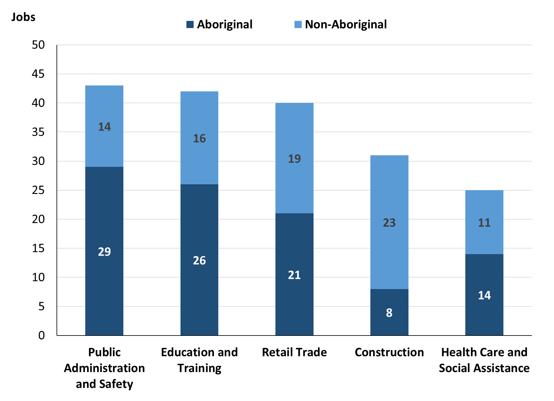

Source: Northern Territory Department of Industry, Tourism and Trade

In 2023 in Borroloola of the:

* 121 **jobs filled** by **Aboriginal** people, there were:
* 29 jobs in Public Administration and Safety, a decrease of 74 jobs from 2017 and a decrease of 108 jobs from 2014
* 26 jobs in Education and Training, an increase of 12 jobs from 2017 and an increase of 9 jobs from 2014
* 21 jobs in Retail Trade, a decrease of 5 jobs from 2017 and a decrease of 3 jobs from 2014
* 86 **jobs filled** by **non-Aboriginal** people, there were:
* 23 jobs in Construction, an increase of 1 job from 2017 and an increase of 1 job from 2014
* 19 jobs in Retail Trade, a decrease of 8 jobs from 2017 and a decrease of 13 jobs from 2014
* 16 jobs in Education and Training, a decrease of 4 jobs from 2017 and a decrease of 13 jobs from 2014.

Table 12: Count of filled jobs by industry and employment status, 2011 (a)(c)(e)(h)

|  |  |  |  |  |  |  |  |  |  |
| --- | --- | --- | --- | --- | --- | --- | --- | --- | --- |
| **Industry (ANZSIC division)** | **2011** | | | | | | | | |
| **Aboriginal** | | | **Non-Aboriginal** | | | **Total** | | |
| **Perm** | **Temp** | **Total** | **Perm** | **Temp** | **Total** | **Perm** | **Temp** | **Total** |
| Accommodation and Food Services | 0 | 0 | **0** | 7 | 3 | **10** | 7 | 3 | **10** |
| Arts and Recreation Services | 0 | 0 | **0** | 1 | 1 | **2** | 1 | 1 | **2** |
| Construction | 2 | 3 | **5** | 27 | 1 | **28** | 29 | 4 | **33** |
| Education and Training | 7 | 10 | **17** | 13 | 13 | **26** | 20 | 23 | **43** |
| Electricity, Gas, Water and Waste Services | 0 | 0 | **0** | 0 | 1 | **1** | 0 | 1 | **1** |
| Health Care and Social Assistance | 2 | 4 | **6** | 0 | 5 | **5** | 2 | 9 | **11** |
| Other Services | 0 | 0 | **0** | 3 | 0 | **3** | 3 | 0 | **3** |
| Public Administration and Safety | 18 | 75 | **93** | 12 | 31 | **43** | 30 | 106 | **136** |
| Retail Trade | 2 | 17 | **19** | 10 | 12 | **22** | 12 | 29 | **41** |
| Transport, Postal and Warehousing | 0 | 2 | **2** | 5 | 3 | **8** | 5 | 5 | **10** |
| **Total** | **31** | **111** | **142** | **84** | **72** | **156** | **115** | **183** | **298** |

Source: Northern Territory Department of Industry, Tourism and Trade

Table 13: Count of filled jobs by industry and employment status, 2014 (a)(c)(e)(h)

|  |  |  |  |  |  |  |  |  |  |
| --- | --- | --- | --- | --- | --- | --- | --- | --- | --- |
| **Industry (ANZSIC division)** | **2014** | | | | | | | | |
| **Aboriginal** | | | **Non-Aboriginal** | | | **Total** | | |
| **Perm** | **Temp** | **Total** | **Perm** | **Temp** | **Total** | **Perm** | **Temp** | **Total** |
| Accommodation and Food Services | 1 | 0 | **1** | 5 | 4 | **9** | 6 | 4 | **10** |
| Arts and Recreation Services | 1 | 0 | **1** | 1 | 1 | **2** | 2 | 1 | **3** |
| Construction | 2 | 0 | **2** | 22 | 0 | **22** | 24 | 0 | **24** |
| Education and Training | 10 | 7 | **17** | 21 | 8 | **29** | 31 | 15 | **46** |
| Electricity, Gas, Water and Waste Services | 0 | 0 | **0** | 1 | 3 | **4** | 1 | 3 | **4** |
| Financial and Insurance Services | 3 | 0 | **3** | 0 | 0 | **0** | 3 | 0 | **3** |
| Health Care and Social Assistance | 5 | 0 | **5** | 11 | 0 | **11** | 16 | 0 | **16** |
| Other Services | 0 | 0 | **0** | 7 | 1 | **8** | 7 | 1 | **8** |
| Public Administration and Safety | 25 | 112 | **137** | 16 | 17 | **33** | 41 | 129 | **170** |
| Retail Trade | 23 | 1 | **24** | 16 | 16 | **32** | 39 | 17 | **56** |
| Transport, Postal and Warehousing | 0 | 0 | **0** | 2 | 0 | **2** | 2 | 0 | **2** |
| **Total** | **70** | **120** | **190** | **102** | **50** | **152** | **172** | **170** | **342** |

Source: Northern Territory Department of Industry, Tourism and Trade

Table 14: Count of filled jobs by industry and employment status, 2017 (a)(c)(e)(h)

|  |  |  |  |  |  |  |  |  |  |
| --- | --- | --- | --- | --- | --- | --- | --- | --- | --- |
| **Industry (ANZSIC division)** | **2017** | | | | | | | | |
| **Aboriginal** | | | **Non-Aboriginal** | | | **Total** | | |
| **Perm** | **Temp** | **Total** | **Perm** | **Temp** | **Total** | **Perm** | **Temp** | **Total** |
| Accommodation and Food Services | 0 | 0 | **0** | 16 | 0 | **16** | 16 | 0 | **16** |
| Administrative and Support Services | 0 | 35 | **35** | 0 | 10 | **10** | 0 | 45 | **45** |
| Construction | 3 | 1 | **4** | 22 | 0 | **22** | 25 | 1 | **26** |
| Education and Training | 8 | 6 | **14** | 8 | 12 | **20** | 16 | 18 | **34** |
| Financial and Insurance Services | 2 | 0 | **2** | 0 | 0 | **0** | 2 | 0 | **2** |
| Health Care and Social Assistance | 3 | 10 | **13** | 2 | 9 | **11** | 5 | 19 | **24** |
| Other Services | 0 | 1 | **1** | 0 | 1 | **1** | 0 | 2 | **2** |
| Public Administration and Safety | 20 | 83 | **103** | 11 | 20 | **31** | 31 | 103 | **134** |
| Retail Trade | 5 | 21 | **26** | 20 | 7 | **27** | 25 | 28 | **53** |
| Transport, Postal and Warehousing | 0 | 0 | **0** | 1 | 0 | **1** | 1 | 0 | **1** |
| **Total** | **41** | **157** | **198** | **80** | **59** | **139** | **121** | **216** | **337** |

Source: Northern Territory Department of Industry, Tourism and Trade

Table 15: Count of filled jobs by industry and employment status, 2023 (a)(c)(e)(h)

|  |  |  |  |  |  |  |  |  |  |
| --- | --- | --- | --- | --- | --- | --- | --- | --- | --- |
| **Industry (ANZSIC division)** | **2023** | | | | | | | | |
| **Aboriginal** | | | **Non-Aboriginal** | | | **Total** | | |
| **Perm** | **Temp** | **Total** | **Perm** | **Temp** | **Total** | **Perm** | **Temp** | **Total** |
| Accommodation and Food Services | 2 | 1 | **3** | 0 | 1 | **1** | 2 | 2 | **4** |
| Agriculture, Forestry and Fishing | 10 | 3 | **13** | 1 | 0 | **1** | 11 | 3 | **14** |
| Arts and Recreation Services | 0 | 3 | **3** | 0 | 1 | **1** | 0 | 4 | **4** |
| Construction | 7 | 1 | **8** | 22 | 1 | **23** | 29 | 2 | **31** |
| Education and Training | 9 | 17 | **26** | 5 | 11 | **16** | 14 | 28 | **42** |
| Health Care and Social Assistance | 7 | 7 | **14** | 4 | 7 | **11** | 11 | 14 | **25** |
| Information Media and Telecommunications | 1 | 0 | **1** | 0 | 0 | **0** | 1 | 0 | **1** |
| Manufacturing | 1 | 2 | **3** | 0 | 0 | **0** | 1 | 2 | **3** |
| Public Administration and Safety | 16 | 13 | **29** | 12 | 2 | **14** | 28 | 15 | **43** |
| Retail Trade | 15 | 6 | **21** | 11 | 8 | **19** | 26 | 14 | **40** |
| **Total** | **68** | **53** | **121** | **55** | **31** | **86** | **123** | **84** | **207** |

Source: Northern Territory Department of Industry, Tourism and Trade

In 2023 in Borroloola:

* of the 123 **permanent jobs**, there were:
* 29 jobs in Construction, an increase of 4 jobs from 2017 and an increase of 5 jobs from 2014, of which:
* **Aboriginal** people filled 7 jobs, an increase of 4 jobs from 2017 and an increase of 5 jobs from 2014
* **non-Aboriginal** people filled 22 jobs, unchanged from 2017 and unchanged from 2014
* 28 jobs in Public Administration and Safety, a decrease of 3 jobs from 2017 and a decrease of 13 jobs from 2014, of which:
* **Aboriginal** people filled 16 jobs, a decrease of 4 jobs from 2017 and a decrease of 9 jobs from 2014
* **non-Aboriginal** people filled 12 jobs, an increase of 1 job from 2017 and a decrease of 4 jobs from 2014
* 26 jobs in Retail Trade, an increase of 1 job from 2017 and a decrease of 13 jobs from 2014, of which:
* **Aboriginal** people filled 15 jobs, an increase of 10 jobs from 2017 and a decrease of 8 jobs from 2014
* **non-Aboriginal** people filled 11 jobs, a decrease of 9 jobs from 2017 and a decrease of 5 jobs from 2014
* of the 84 **temporary jobs,** there were:
* 28 jobs in Education and Training, an increase of 10 jobs from 2017 and an increase of 13 jobs from 2014, of which:
* **Aboriginal** people filled 17 jobs, an increase of 11 jobs from 2017 and an increase of 10 jobs from 2014
* **non-Aboriginal** people filled 11 jobs, a decrease of 1 job from 2017 and an increase of 3 jobs from 2014
* 15 jobs in Public Administration and Safety, a decrease of 88 jobs from 2017 and a decrease of 114 jobs from 2014, of which:
* **Aboriginal** people filled 13 jobs, a decrease of 70 jobs from 2017 and a decrease of 99 jobs from 2014
* **non-Aboriginal** people filled 2 jobs, a decrease of 18 jobs from 2017 and a decrease of 15 jobs from 2014
* 14 jobs in Health Care and Social Assistance, a decrease of 5 jobs from 2017 and an increase of 14 jobs from 2014, of which:
* **Aboriginal** people filled 7 jobs, a decrease of 3 jobs from 2017 and an increase of 7 jobs from 2014
* **non-Aboriginal** people filled 7 jobs, a decrease of 2 jobs from 2017 and an increase of 7 jobs from 2014.

# Jobs by Occupation

Table 16a: Count of filled jobs by occupation, 2011, 2014, 2017 and 2023 (a)(f)(g)

|  |  |  |  |  |  |  |  |  |
| --- | --- | --- | --- | --- | --- | --- | --- | --- |
| **Occupation (ANZSCO major group)** | **2011** | | **2014** | | **2017** | | **2023** | |
| **Total** | **% of Total** | **Total** | **% of Total** | **Total** | **% of Total** | **Total** | **% of Total** |
| Clerical and Administrative Workers | 25 | 8.4% | 45 | 13.2% | 50 | 14.8% | 32 | 15.5% |
| Community and Personal Service Workers | 53 | 17.8% | 63 | 18.4% | 53 | 15.7% | 49 | 23.7% |
| Labourers | 35 | 11.7% | 50 | 14.6% | 46 | 13.6% | 12 | 5.8% |
| Machinery Operators and Drivers | 11 | 3.7% | 13 | 3.8% | 13 | 3.9% | 9 | 4.3% |
| Managers | 36 | 12.1% | 22 | 6.4% | 38 | 11.3% | 18 | 8.7% |
| Professionals | 73 | 24.5% | 79 | 23.1% | 75 | 22.3% | 39 | 18.8% |
| Sales Workers | 23 | 7.7% | 38 | 11.1% | 33 | 9.8% | 28 | 13.5% |
| Technicians and Trades Workers | 38 | 12.8% | 32 | 9.4% | 29 | 8.6% | 20 | 9.7% |
| **Total** | **298** | **100.0%** | **342** | **100.0%** | **337** | **100.0%** | **207** | **100.0%** |

Source: Northern Territory Department of Industry, Tourism and Trade

Table 16b: Count of filled jobs by occupation, 2011-2014, 2014-2017 & 2017-2023 (a)(f)(g)

|  |  |  |  |
| --- | --- | --- | --- |
| **Occupation (ANZSCO major group)** | **Change 2011-2014** | **Change 2014-2017** | **Change 2017-2023** |
| **Total** | **Total** | **Total** |
| Clerical and Administrative Workers | 20 | 5 | -18 |
| Community and Personal Service Workers | 10 | -10 | -4 |
| Labourers | 15 | -4 | -34 |
| Machinery Operators and Drivers | 2 | 0 | -4 |
| Managers | -14 | 16 | -20 |
| Professionals | 6 | -4 | -36 |
| Sales Workers | 15 | -5 | -5 |
| Technicians and Trades Workers | -6 | -3 | -9 |
| **Total** | **44** | **-5** | **-130** |

Source: Northern Territory Department of Industry, Tourism and Trade

Chart 10: Percentage and count of top 6 filled jobs by occupation, 2011, 2014, 2017 & 2023 (a)(f)(g)

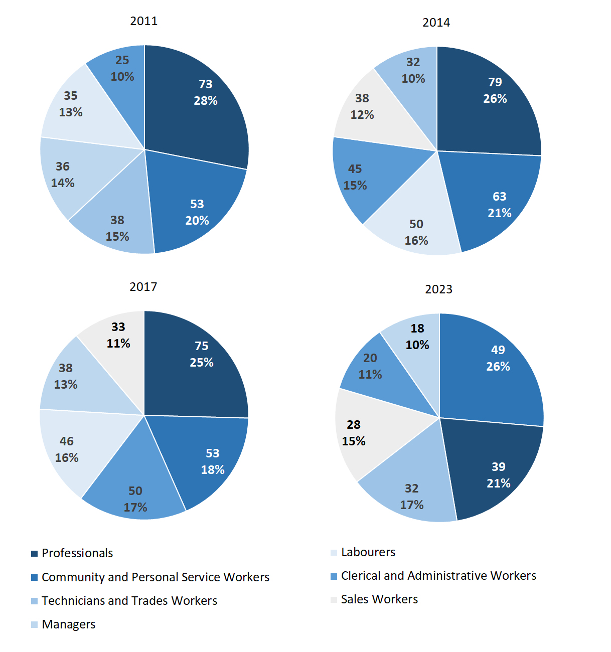

Source: Northern Territory Department of Industry, Tourism and Trade

In 2023 in Borroloola:

* Community and Personal Service Workers was the **largest occupation classification** in terms of filled jobs, accounting for 49 jobs (23.7% of total filled jobs), a decrease of 4 jobs from 2017 and a decrease of 14 jobs from 2014
* **other significant** occupation classifications were:
* Professionals accounted for 39 jobs or 18.8% of total jobs a decrease of 36 jobs from 2017 and a decrease of 40 jobs from 2014
* Clerical and Administrative Workers accounted for 32 jobs or 15.5% of total jobs a decrease of 18 jobs from 2017 and a decrease of 13 jobs from 2014
* Sales Workers accounted for 28 jobs or 13.5% of total jobs a decrease of 5 jobs from 2017 and a decrease of 10 jobs from 2014.

**Table 17a: Count of filled jobs by ANZSCO occupation, 2011, 2014, 2017 & 2023 (a)(c)(f)(g)**

|  |  |  |  |  |  |  |  |  |  |  |  |  |  |
| --- | --- | --- | --- | --- | --- | --- | --- | --- | --- | --- | --- | --- | --- |
| **Occupation (ANZSCO major group)** | **2011** | | | **2014** | | | **2017** | | | **2023** | | | |
| **Aboriginal** | **Non-Aboriginal** | **Total** | **Aboriginal** | **Non-Aboriginal** | **Total** | **Aboriginal** | **Non-Aboriginal** | **Total** | **Aboriginal** | **Non-Aboriginal** | **Total** |
| Clerical and Administrative Workers | 11 | 14 | **25** | 27 | 18 | **45** | 35 | 15 | **50** | 22 | 10 | **32** |
| Community and Personal Service Workers | 41 | 12 | **53** | 49 | 14 | **63** | 39 | 14 | **53** | 41 | 8 | **49** |
| Labourers | 23 | 12 | **35** | 32 | 18 | **50** | 34 | 12 | **46** | 9 | 3 | **12** |
| Machinery Operators and Drivers | 6 | 5 | **11** | 4 | 9 | **13** | 5 | 8 | **13** | 2 | 7 | **9** |
| Managers | 4 | 32 | **36** | 2 | 20 | **22** | 7 | 31 | **38** | 8 | 10 | **18** |
| Professionals | 38 | 35 | **73** | 41 | 38 | **79** | 48 | 27 | **75** | 19 | 20 | **39** |
| Sales Workers | 12 | 11 | **23** | 24 | 14 | **38** | 25 | 8 | **33** | 16 | 12 | **28** |
| Technicians and Trades Workers | 5 | 33 | **38** | 11 | 21 | **32** | 5 | 24 | **29** | 4 | 16 | **20** |
| Other Occupations | 2 | 2 | **4** | 0 | 0 | **0** | 0 | 0 | **0** | 0 | 0 | **0** |
| **Total** | **142** | **156** | **298** | **190** | **152** | **342** | **198** | **139** | **337** | **121** | **86** | **207** |

Source: Northern Territory Department of Industry, Tourism and Trade

**Table 17b: Count of filled jobs by ANZSCO occupation, 2011-2014, 2014-2017 & 2017-2023 (a)(c)(f)(g)**

|  |  |  |  |  |  |  |  |  |  |
| --- | --- | --- | --- | --- | --- | --- | --- | --- | --- |
| **Occupation (ANZSCO major group)** | **Change 2011-2014** | | | **Change 2014-2017** | | | **Change 2017-2023** | | |
| **Aboriginal** | **Non-Aboriginal** | **Total** | **Aboriginal** | **Non-Aboriginal** | **Total** | **Aboriginal** | **Non-Aboriginal** | **Total** |
| Clerical and Administrative Workers | 16 | 4 | **20** | 8 | -3 | **5** | -13 | -5 | **-18** |
| Community and Personal Service Workers | 8 | 2 | **10** | -10 | 0 | **-10** | 2 | -6 | **-4** |
| Labourers | 9 | 6 | **15** | 2 | -6 | **-4** | -25 | -9 | **-34** |
| Machinery Operators and Drivers | -2 | 4 | **2** | 1 | -1 | **0** | -3 | -1 | **-4** |
| Managers | -2 | -12 | **-14** | 5 | 11 | **16** | 1 | -21 | **-20** |
| Professionals | 3 | 3 | **6** | 7 | -11 | **-4** | -29 | -7 | **-36** |
| Sales Workers | 12 | 3 | **15** | 1 | -6 | **-5** | -9 | 4 | **-5** |
| Technicians and Trades Workers | 6 | -12 | **-6** | -6 | 3 | **-3** | -1 | -8 | **-9** |
| Other Occupations | -2 | -2 | **-4** | 0 | 0 | **0** | 0 | 0 | **0** |
| **Total** | **48** | **-4** | **44** | **8** | **-13** | **-5** | **-77** | **-53** | **-130** |

Department of Industry, Tourism and Trade

In 2023 in Borroloola:

* of the 121 **jobs filled by Aboriginal** people, there were:
* 41 Community and Personal Service Workers, an increase of 2 jobs from 2017 and a decrease of 8 jobs from 2014
* 22 Clerical and Administrative Workers, a decrease of 13 jobs from 2017 and a decrease of 5 jobs from 2014
* 19 Professionals, a decrease of 29 jobs from 2017 and a decrease of 22 jobs from 2014
* of the 86 **jobs filled by non-Aboriginal** people, there were:
* 20 Professionals, a decrease of 7 jobs from 2017 and a decrease of 18 job from 2014
* 16 Technicians and Trades Workers, a decrease of 8 jobs from 2017 and a decrease of 5 jobs from 2014
* 12 Sales Workers, an increase of 4 jobs from 2017 and a decrease of 2 jobs from 2014.

# Jobs by Industry by Occupation

Table 18: Count of filled jobs by industry by occupation, 2011 (a)(f)(g)(h)

|  |  |  |  |  |  |  |  |  |  |  |  |
| --- | --- | --- | --- | --- | --- | --- | --- | --- | --- | --- | --- |
| **2011** | | | | | | | | | | | |
| **Industry (ANZSIC Division)** |  | **Occupation (ANZSCO major group)** | | | | | | | | | |
| **Clerical and Administrative Workers** | **Community and Personal Service Workers** | **Labourers** | **Machinery Operators and Drivers** | **Managers** | **Professionals** | **Sales Workers** | **Technicians and Trades Workers** | **Other Occupations** | **Total** |
| Accommodation and Food Services | 0 | 0 | 1 | 1 | 5 | 1 | 0 | 2 | 0 | **10** |
| Arts and Recreation Services | 0 | 0 | 0 | 1 | 1 | 0 | 0 | 0 | 0 | **2** |
| Construction | 2 | 1 | 7 | 4 | 1 | 0 | 1 | 17 | 0 | **33** |
| Education and Training | 4 | 9 | 1 | 1 | 1 | 27 | 0 | 0 | 0 | **43** |
| Electricity, Gas, Water and Waste Services | 0 | 0 | 0 | 0 | 0 | 0 | 0 | 1 | 0 | **1** |
| Health Care and Social Assistance | 0 | 3 | 3 | 0 | 0 | 3 | 0 | 0 | 2 | **11** |
| Other Services | 0 | 0 | 0 | 0 | 0 | 0 | 0 | 3 | 0 | **3** |
| Public Administration and Safety | 17 | 38 | 20 | 0 | 10 | 35 | 2 | 12 | 2 | **136** |
| Retail Trade | 1 | 2 | 3 | 4 | 13 | 2 | 14 | 2 | 0 | **41** |
| Transport, Postal and Warehousing | 1 | 0 | 0 | 0 | 3 | 3 | 3 | 0 | 0 | **10** |
| **Total** | **25** | **53** | **35** | **11** | **36** | **73** | **23** | **38** | **4** | **298** |

Source: Northern Territory Department of Industry, Tourism and Trade

Table 19: Count of filled jobs by industry by occupation, 2014 (a)(f)(g)(h)

|  |  |  |  |  |  |  |  |  |  |  |  |
| --- | --- | --- | --- | --- | --- | --- | --- | --- | --- | --- | --- |
| **2014** | | | | | | | | | | | |
| **Industry (ANZSIC Division)** |  | **Occupation (ANZSCO major group)** | | | | | | | | | |
| **Clerical and Administrative Workers** | **Community and Personal Service Workers** | **Labourers** | **Machinery Operators and Drivers** | **Managers** | **Professionals** | **Sales Workers** | **Technicians and Trades Workers** | **Other Occupations** | **Total** |
| Accommodation and Food Services | 2 | 0 | 3 | 0 | 3 | 0 | 0 | 2 | 0 | **10** |
| Arts and Recreation Services | 0 | 0 | 0 | 0 | 0 | 3 | 0 | 0 | 0 | **3** |
| Construction | 5 | 0 | 1 | 9 | 0 | 0 | 0 | 9 | 0 | **24** |
| Education and Training | 5 | 7 | 1 | 0 | 3 | 30 | 0 | 0 | 0 | **46** |
| Electricity, Gas, Water and Waste Services | 0 | 0 | 3 | 0 | 0 | 0 | 0 | 1 | 0 | **4** |
| Financial and Insurance Services | 3 | 0 | 0 | 0 | 0 | 0 | 0 | 0 | 0 | **3** |
| Health Care and Social Assistance | 3 | 3 | 2 | 1 | 1 | 6 | 0 | 0 | 0 | **16** |
| Other Services | 0 | 0 | 1 | 0 | 1 | 0 | 2 | 4 | 0 | **8** |
| Public Administration and Safety | 25 | 53 | 32 | 3 | 7 | 39 | 1 | 10 | 0 | **170** |
| Retail Trade | 1 | 0 | 7 | 0 | 7 | 0 | 35 | 6 | 0 | **56** |
| Transport, Postal and Warehousing | 1 | 0 | 0 | 0 | 0 | 1 | 0 | 0 | 0 | **2** |
| **Total** | **45** | **63** | **50** | **13** | **22** | **79** | **38** | **32** | **0** | **342** |

Source: Northern Territory Department of Industry, Tourism and Trade

Table 20: Count of filled jobs by occupation and by industry, 2017 (a)(f)(g)(h)

|  |  |  |  |  |  |  |  |  |  |  |  |
| --- | --- | --- | --- | --- | --- | --- | --- | --- | --- | --- | --- |
| **2017** | | | | | | | | | | | |
| **Industry (ANZSIC Division)** |  | **Occupation (ANZSCO major group)** | | | | | | | | | |
| **Clerical and Administrative Workers** | **Community and Personal Service Workers** | **Labourers** | **Machinery Operators and Drivers** | **Managers** | **Professionals** | **Sales Workers** | **Technicians and Trades Workers** | **Other Occupations** | **Total** |
| Accommodation and Food Services | 1 | 1 | 4 | 0 | 8 | 0 | 0 | 2 | 0 | **16** |
| Administrative and Support Services | 17 | 0 | 12 | 0 | 5 | 11 | 0 | 0 | 0 | **45** |
| Construction | 3 | 0 | 2 | 6 | 2 | 0 | 0 | 13 | 0 | **26** |
| Education and Training | 5 | 5 | 1 | 0 | 3 | 20 | 0 | 0 | 0 | **34** |
| Financial and Insurance Services | 2 | 0 | 0 | 0 | 0 | 0 | 0 | 0 | 0 | **2** |
| Health Care and Social Assistance | 8 | 5 | 3 | 1 | 0 | 7 | 0 | 0 | 0 | **24** |
| Other Services | 0 | 0 | 0 | 0 | 0 | 1 | 0 | 1 | 0 | **2** |
| Public Administration and Safety | 12 | 41 | 22 | 3 | 13 | 36 | 0 | 7 | 0 | **134** |
| Retail Trade | 1 | 1 | 2 | 3 | 7 | 0 | 33 | 6 | 0 | **53** |
| Transport, Postal and Warehousing | 1 | 0 | 0 | 0 | 0 | 0 | 0 | 0 | 0 | **1** |
| **Total** | **50** | **53** | **46** | **13** | **38** | **75** | **33** | **29** | **0** | **337** |

Source: Northern Territory Department of Industry, Tourism and Trade

Table 21: Count of filled jobs by occupation and by industry, 2023 (a)(f)(g)(h)

|  |  |  |  |  |  |  |  |  |  |  |  |
| --- | --- | --- | --- | --- | --- | --- | --- | --- | --- | --- | --- |
| **2023** | | | | | | | | | | | |
| **Industry (ANZSIC Division)** |  | **Occupation (ANZSCO major group)** | | | | | | | | | |
| **Clerical and Administrative Workers** | **Community and Personal Service Workers** | **Labourers** | **Machinery Operators and Drivers** | **Managers** | **Professionals** | **Sales Workers** | **Technicians and Trades Workers** | **Other Occupations** | **Total** |
| Accommodation and Food Services | 0 | 2 | 0 | 0 | 2 | 0 | 0 | 0 | 0 | **4** |
| Agriculture, Forestry and Fishing | 4 | 9 | 0 | 0 | 0 | 1 | 0 | 0 | 0 | **14** |
| Arts and Recreation Services | 1 | 0 | 0 | 0 | 0 | 3 | 0 | 0 | 0 | **4** |
| Construction | 2 | 0 | 6 | 6 | 3 | 0 | 0 | 14 | 0 | **31** |
| Education and Training | 12 | 6 | 1 | 0 | 1 | 22 | 0 | 0 | 0 | **42** |
| Health Care and Social Assistance | 1 | 8 | 3 | 1 | 1 | 9 | 0 | 2 | 0 | **25** |
| Information Media and Telecommunications | 0 | 0 | 0 | 0 | 0 | 1 | 0 | 0 | 0 | **1** |
| Manufacturing | 1 | 0 | 1 | 0 | 0 | 0 | 0 | 1 | 0 | **3** |
| Public Administration and Safety | 11 | 24 | 1 | 0 | 4 | 2 | 1 | 0 | 0 | **43** |
| Retail Trade | 0 | 0 | 0 | 2 | 7 | 1 | 27 | 3 | 0 | **40** |
| **Total** | **32** | **49** | **12** | **9** | **18** | **39** | **28** | **20** | **0** | **207** |

Source: Northern Territory Department of Industry, Tourism and Trade

In 2023 in Borroloola:

* the largest occupation group, Community and Personal Service Workers filled the majority of jobs with 49 jobs which were shared across the Public Administration and Safety sector with 24 jobs, Agriculture, Forestry and Fishing had 9 jobs and Health Care and Social Assistance industries had 8 jobs,
* in the largest industry group, Public Administration and Safety, there were 24 filled jobs for Community and Personal Service Workers, a decrease of 17 filled jobs from 2017,
* Public Administration and Safety had the largest decrease in jobs filled of 91 between 2023 and 2017,
* new industries in 2023 were Agriculture, Forestry and Fishing with 14 filled jobs, Arts and Recreation Services with 4 filled jobs, Information Media and Telecommunications with 1 filled job, and Manufacturing with 3 filled jobs, these industries had nil jobs filled in 2017.

# Jobs by Gender

Table 22a: Count of filled jobs by gender2, 2011, 2014, 2017 & 2023 (a)(c)(i)

|  |  |  |  |  |  |  |  |  |  |  |  |  |
| --- | --- | --- | --- | --- | --- | --- | --- | --- | --- | --- | --- | --- |
| **Indicator** | **2011** | | | **2014** | | | **2017** | | | **2023** | | |
| **Aboriginal** | **Non-Aboriginal** | **Total** | **Aboriginal** | **Non-Aboriginal** | **Total** | **Aboriginal** | **Non-Aboriginal** | **Total** | **Aboriginal** | **Non-Aboriginal** | **Total** |
| Male | 65 | 78 | **143** | 88 | 71 | **159** | 100 | 70 | **170** | 51 | 46 | **97** |
| Female | 77 | 78 | **155** | 102 | 81 | **183** | 93 | 69 | **162** | 68 | 39 | **107** |
| **Total** | **142** | **156** | **298** | **190** | **152** | **342** | **193** | **139** | **332** | **121** | **86** | **207** |

Source: Northern Territory Department of Industry, Tourism and Trade

Table 22b: Count of filled jobs by gender2, 2011-2014, 2014-2017 & 2017-2023 (a)(c)(i)

|  |  |  |  |  |  |  |  |  |  |
| --- | --- | --- | --- | --- | --- | --- | --- | --- | --- |
| **Indicator** | **2011-2014 Change** | | | **2014-2017 Change** | | | **2017-2023 Change** | | |
| **Aboriginal** | **Non-Aboriginal** | **Total** | **Aboriginal** | **Non-Aboriginal** | **Total** | **Aboriginal** | **Non-Aboriginal** | **Total** |
| Male | 23 | -7 | **16** | 12 | -1 | **11** | -49 | -24 | **-73** |
| Female | 25 | 3 | **28** | -9 | -12 | **-21** | -25 | -30 | **-55** |
| **Total** | **48** | **-4** | **44** | **3** | **-13** | **-10** | **-72** | **-53** | **-125** |

Source: Northern Territory Department of Industry, Tourism and Trade

*2 5 Aboriginal filled jobs gender status not identified in 2017*

Chart 11: Count of filled jobs by gender, 2011, 2014, 2017 & 2023 (a)(c)(i)

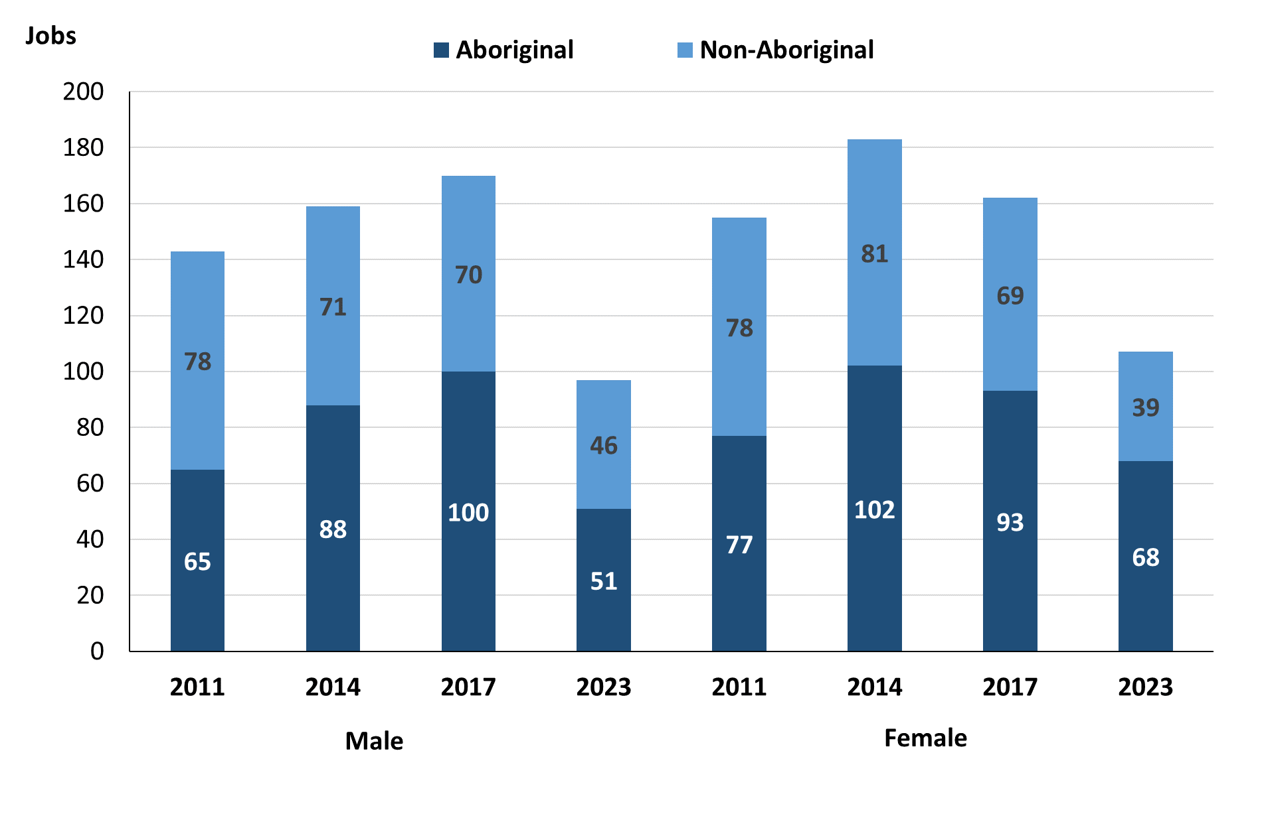

Source: Northern Territory Department of Industry, Tourism and Trade

In 2023 in Borroloola:

* there were 97 **jobs filled by males**, a decrease of 73 jobs from 2017 and a decrease of 62 jobs from 2014
* of the 97 **jobs filled by males**:
* 51 were **Aboriginal**, a decrease of 49 jobs from 2017 and a decrease of 37 jobs from 2014
* 46 were **non-Aboriginal**, a decrease of 24 jobs from 2017 and a decrease of 25 jobs from 2014
* there were 107 **jobs filled by females**, a decrease of 55 jobs from 2017 and a decrease of 76 jobs from 2014
* of the 107 **jobs filled by females**:
* 68 were **Aboriginal**, a decrease of 25 jobs from 2017 and a decrease of 34 jobs from 2014
* 39 were **non-Aboriginal**, a decrease of 30 jobs from 2017 and a decrease of 42 jobs from 2014.

Table 23: Count of filled jobs by gender, by full-time/part-time status, by job permanency and by sector 2011 (a)(b)(c)(d)(e)(i)

|  |  |  |  |  |  |  |  |  |  |
| --- | --- | --- | --- | --- | --- | --- | --- | --- | --- |
| **2011** | | | | | | | | | |
| **Indicator** | **Male** | | | **Female** | | | **Total** | | |
| **Aboriginal** | **Non-Aboriginal** | **Total** | **Aboriginal** | **Non-Aboriginal** | **Total** | **Aboriginal** | **Non-Aboriginal** | **Total** |
| Full-time | 43 | 73 | **116** | 44 | 59 | **103** | 87 | 132 | **219** |
| Part-time | 22 | 5 | **27** | 33 | 19 | **52** | 55 | 24 | **79** |
| **Total** | **65** | **78** | **143** | **77** | **78** | **155** | **142** | **156** | **298** |
| Permanent | 16 | 44 | **60** | 15 | 40 | **55** | 31 | 84 | **115** |
| Temporary | 49 | 34 | **83** | 62 | 38 | **100** | 111 | 72 | **183** |
| **Total** | **65** | **78** | **143** | **77** | **78** | **155** | **142** | **156** | **298** |
| Public Sector | 21 | 13 | **34** | 23 | 34 | **57** | 44 | 47 | **91** |
| Private Sector | 44 | 65 | **109** | 54 | 44 | **98** | 98 | 109 | **207** |
| **Total** | **65** | **78** | **143** | **77** | **78** | **155** | **142** | **156** | **298** |

Source: Northern Territory Department of Industry, Tourism and Trade

Table 24: Count of filled jobs by gender, by full time/part time status, by job permanency and by sector 2014 (a)(b)(c)(d)(e)(i)

|  |  |  |  |  |  |  |  |  |  |
| --- | --- | --- | --- | --- | --- | --- | --- | --- | --- |
| **2014** | | | | | | | | | |
| **Indicator** | **Male** | | | **Female** | | | **Total** | | |
| **Aboriginal** | **Non-Aboriginal** | **Total** | **Aboriginal** | **Non-Aboriginal** | **Total** | **Aboriginal** | **Non-Aboriginal** | **Total** |
| Full-time | 57 | 68 | **125** | 55 | 72 | **127** | 112 | 140 | **252** |
| Part-time | 31 | 3 | **34** | 47 | 9 | **56** | 78 | 12 | **90** |
| **Total** | **88** | **71** | **159** | **102** | **81** | **183** | **190** | **152** | **342** |
| Permanent | 25 | 51 | **76** | 45 | 51 | **96** | 70 | 102 | **172** |
| Temporary | 63 | 20 | **83** | 57 | 30 | **87** | 120 | 50 | **170** |
| **Total** | **88** | **71** | **159** | **102** | **81** | **183** | **190** | **152** | **342** |
| Public Sector | 13 | 17 | **30** | 24 | 39 | **63** | 37 | 56 | **93** |
| Private Sector | 75 | 54 | **129** | 78 | 42 | **120** | 153 | 96 | **249** |
| **Total** | **88** | **71** | **159** | **102** | **81** | **183** | **190** | **152** | **342** |

Source: Northern Territory Department of Industry, Tourism and Trade

Table 25: Count of filled jobs by gender[2], by full-time/part-time status, by job permanency and by sector 2017 (a)(b)(c)(d)(e)(i)

|  |  |  |  |  |  |  |  |  |  |  |
| --- | --- | --- | --- | --- | --- | --- | --- | --- | --- | --- |
| **2017** | | | | | | | | | | |
| **Indicator** | **Male** | | | **Female** | | | **Total** | | | |
| **Aboriginal** | **Non-Aboriginal** | **Total** | **Aboriginal** | **Non-Aboriginal** | **Total** | **Aboriginal** | **Non-Aboriginal** | **Total** |
| Full-time | 64 | 64 | **128** | 51 | 57 | **108** | 118 | 121 | **239** |
| Part-time | 36 | 6 | **42** | 42 | 12 | **54** | 80 | 18 | **98** |
| **Total** | **100** | **70** | **170** | **93** | **69** | **162** | **198** | **139** | **337** |
| Permanent | 22 | 45 | **67** | 16 | 35 | **51** | 41 | 80 | **121** |
| Temporary | 78 | 25 | **103** | 77 | 34 | **111** | 157 | 59 | **216** |
| **Total** | **100** | **70** | **170** | **93** | **69** | **162** | **198** | **139** | **337** |
| Public Sector | 17 | 17 | **34** | 30 | 26 | **56** | 50 | 43 | **93** |
| Private Sector | 83 | 53 | **136** | 63 | 43 | **106** | 148 | 96 | **244** |
| **Total** | **100** | **70** | **170** | **93** | **69** | **162** | **198** | **139** | **337** |

Source: Northern Territory Department of Industry, Tourism and Trade

Table 26: Count of filled jobs by gender, by full-time/part-time status, by job permanency and by sector 2023 (a)(b)(c)(d)(e)(i)

|  |  |  |  |  |  |  |  |  |  |  |
| --- | --- | --- | --- | --- | --- | --- | --- | --- | --- | --- |
| **2023** | | | | | | | | | | |
| **Indicator** | **Male** | | | **Female** | | | **Total** | | | |
| **Aboriginal** | **Non-Aboriginal** | **Total** | **Aboriginal** | **Non-Aboriginal** | **Total** | **Aboriginal** | **Non-Aboriginal** | **Total** |
| Full-time | 40 | 43 | **83** | 39 | 35 | **74** | 81 | 79 | **160** |
| Part-time | 11 | 3 | **14** | 29 | 4 | **33** | 40 | 7 | **47** |
| **Total** | **51** | **46** | **97** | **68** | **39** | **107** | **121** | **86** | **207** |
| Permanent | 28 | 35 | **63** | 39 | 20 | **59** | 68 | 55 | **123** |
| Temporary | 23 | 11 | **34** | 29 | 19 | **48** | 53 | 31 | **84** |
| **Total** | **51** | **46** | **97** | **68** | **39** | **107** | **121** | **86** | **207** |
| Public Sector | 9 | 13 | **22** | 24 | 17 | **41** | 33 | 30 | **63** |
| Private Sector | 42 | 33 | **75** | 44 | 22 | **66** | 86 | 55 | **141** |
| **Total** | **51** | **46** | **97** | **68** | **39** | **107** | **121** | **86** | **207** |

Source: Northern Territory Department of Industry, Tourism and Trade

In 2023 in Borroloola:

* of the 97 **jobs filled by males**, there were:
* 51 jobs filled by **Aboriginal males**, a decrease of 49 jobs from 2017 and a decrease of 37 jobs from 2014, of which:
* 40 full-time jobs, a decrease of 24 jobs from 2017 and a decrease of 17 jobs from 2014
* 11 part-time jobs, a decrease of 25 jobs from 2017 and a decrease of 20 jobs from 2014
* 28 Permanent jobs, an increase of 6 jobs from 2017 and an increase of 3 jobs from 2014
* 23 Temporary jobs, a decrease of 55 jobs from 2017 and a decrease of 40 jobs from 2014
* 9 Public Sector jobs, a decrease of 8 jobs from 2017 and a decrease of 4 jobs from 2014
* 42 Private Sector jobs, a decrease of 41 jobs from 2017 and a decrease of 33 jobs from 2014
* 46 jobs filled by **non-Aboriginal males**, a decrease of 24 jobs from 2017 and a decrease of 25 jobs from 2014, including:
* 43 full-time jobs, a decrease of 21 jobs from 2017 and a decrease of 25 jobs from 2014
* 3 part-time jobs, a decrease of 3 jobs from 2017 and unchanged from 2014
* 35 Permanent jobs, a decrease of 10 jobs from 2017 and a decrease of 16 jobs from 2014
* 11 Temporary jobs, a decrease of 14 jobs from 2017 and a decrease of 9 jobs from 2014
* 13 Public Sector jobs, a decrease of 4 jobs from 2017 and a decrease of 4 jobs from 2014
* 33 Private Sector jobs, a decrease of 20 jobs from 2017 and a decrease of 21 jobs from 2014
* of the 107 **jobs filled by females**, there were:
* 68 jobs filled by **Aboriginal females**, a decrease of 25 jobs from 2017 and a decrease of 34 jobs from 2014, of which:
* 39 full-time jobs, a decrease of 12 jobs from 2017 and a decrease of 16 jobs from 2014
* 29 part-time jobs, a decrease of 13 jobs from 2017 and a decrease of 18 jobs from 2014
* 39 Permanent jobs, an increase of 23 jobs from 2017 and a decrease of 6 jobs from 2014
* 29 Temporary jobs, a decrease of 48 jobs from 2017 and a decrease of 28 jobs from 2014
* 24 Public Sector jobs, a decrease of 6 jobs from 2017 and unchanged from 2014
* 44 Private Sector jobs, a decrease of 19 jobs from 2017 and a decrease of 34 jobs from 2014.
* 39 jobs filled by **non-Aboriginal females**, a decrease of 30 jobs from 2017 and a decrease of 42 jobs from 2014, of which:
* 35 full-time jobs, a decrease of 22 jobs from 2017 and a decrease of 37 jobs from 2014
* 4 part-time jobs, a decrease of 8 jobs from 2017 and a decrease of 5 jobs from 2014
* 20 Permanent jobs, a decrease of 15 jobs from 2017 and a decrease of 31 jobs from 2014
* 19 Temporary jobs, a decrease of 15 jobs from 2017 and a decrease of 11 jobs from 2014
* 17 Public Sector jobs, a decrease of 9 jobs from 2017 and a decrease of 22 jobs from 2014
* 22 Private Sector jobs, a decrease of 21 jobs from 2017 and a decrease of 20 jobs from 2014.

# Jobs by Age

Table 27a: Count of filled jobs by age, 2011, 2014, 2017 & 2023 (a)(c)(j)

|  |  |  |  |  |  |  |  |  |  |  |  |  |
| --- | --- | --- | --- | --- | --- | --- | --- | --- | --- | --- | --- | --- |
| **Indicator** | **2011** | | | **2014** | | | **2017** | | | **2023** | | |
| **Aboriginal** | **Non-Aboriginal** | **Total** | **Aboriginal** | **Non-Aboriginal** | **Total** | **Aboriginal** | **Non-Aboriginal** | **Total** | **Aboriginal** | **Non-Aboriginal** | **Total** |
| 15-24 years | 16 | 7 | **23** | 28 | 16 | **44** | 30 | 4 | **34** | 14 | 5 | **19** |
| 25-44 years | 85 | 65 | **150** | 97 | 54 | **151** | 102 | 78 | **180** | 45 | 32 | **77** |
| 45+ years | 41 | 84 | **125** | 65 | 82 | **147** | 61 | 57 | **118** | 61 | 48 | **109** |
| **Total** | **142** | **156** | **298** | **190** | **152** | **342** | **198** | **139** | **337** | **121** | **86** | **207** |

Source: Northern Territory Department of Industry, Tourism and Trade

Table 27b: Count of filled jobs by age, 2011-2014, 2014-2017 & 2017-2023 (a)(c)(j)

|  |  |  |  |  |  |  |  |  |  |
| --- | --- | --- | --- | --- | --- | --- | --- | --- | --- |
| **Indicator** | **Change 2011-2014** | | | **Change 2014-2017** | | | **Change 2017-2023** | | |
| **Aboriginal** | **Non-Aboriginal** | **Total** | **Aboriginal** | **Non-Aboriginal** | **Total** | **Aboriginal** | **Non-Aboriginal** | **Total** |
| 15-24 years | 12 | 9 | **21** | 2 | -12 | **-10** | -16 | 1 | **-15** |
| 25-44 years | 12 | -11 | **1** | 5 | 24 | **29** | -57 | -46 | **-103** |
| 45+ years | 24 | -2 | **22** | -4 | -25 | **-29** | 0 | -9 | **-9** |
| **Total** | **48** | **-4** | **44** | **8** | **-13** | **-5** | **-72** | **-53** | **-125** |

Source: Northern Territory Department of Industry, Tourism and Trade

Chart 12: Count of filled jobs by age, 2011, 2014, 2017 & 2023 (a)(c)(j)

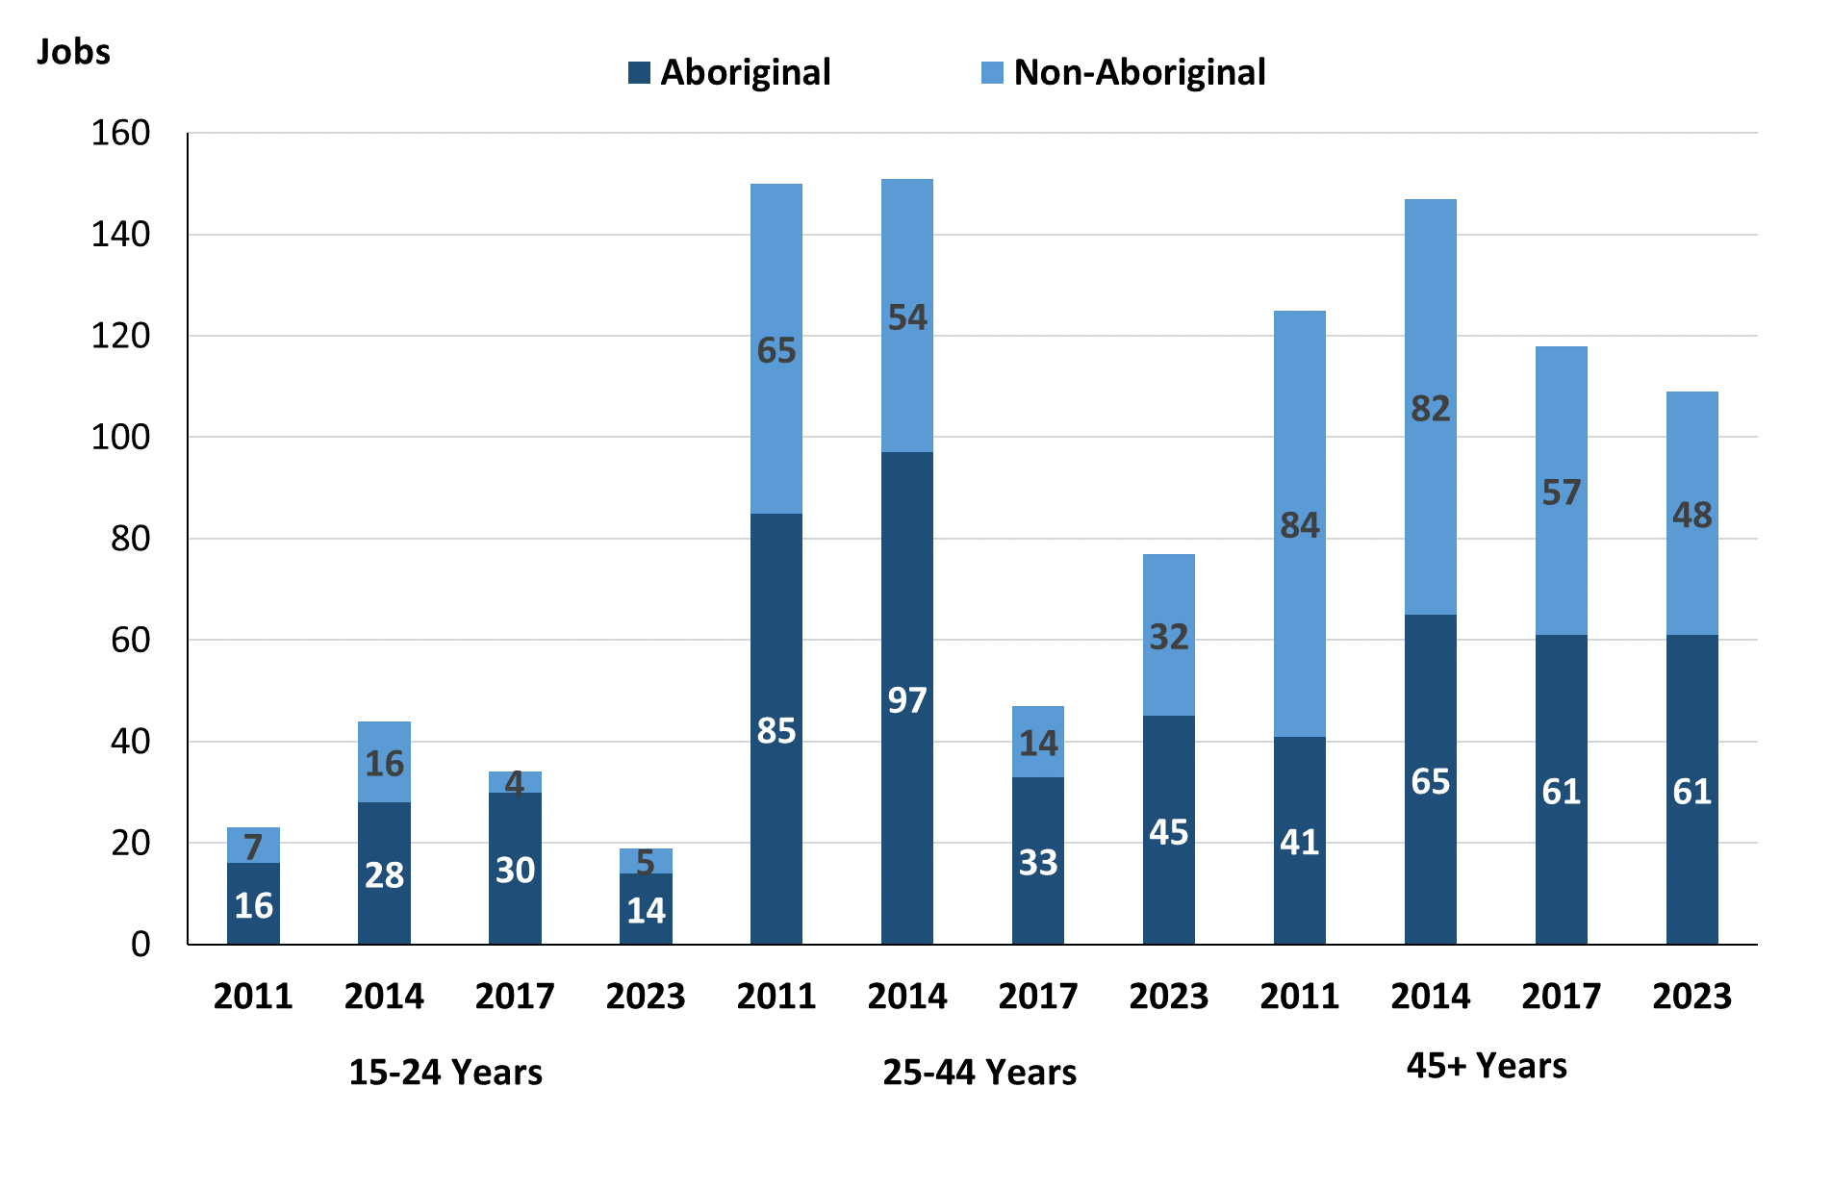

Source: Northern Territory Department of Industry, Tourism and Trade

In 2023 in Borroloola:

* there were: 19 **jobs filled** by people aged **15-24 years**, a decrease of 15 jobs from 2017 and a decrease of 25 jobs from 2014. Of these:
* **Aboriginal** people filled 14 jobs, a decrease of 16 jobs from 2017 and a decrease of 14 jobs from 2014
* **non-Aboriginal** people filled 5 jobs, an increase of 1 job from 2017 and a decrease of 11 jobs from 2014
* there were: 77 **jobs filled** by people aged **25-44 years**, a decrease of 103 jobs from 2017 and a decrease of 74 jobs from 2014. Of these:
* **Aboriginal** people filled 45 jobs, a decrease of 57 jobs from 2017 and a decrease of 52 jobs from 2014
* **non-Aboriginal** people filled 32 jobs, a decrease of 46 jobs from 2017 and a decrease of 22 jobs from 2014
* there were: 109 **jobs filled** by people aged **45+ years**, a decrease of 9 jobs from 2017 and a decrease of 38 jobs from 2014. Of these:
* **Aboriginal** people filled 61 jobs, unchanged from 2017 and a decrease of 4 jobs from 2014
* **non-Aboriginal** people filled 48 jobs, a decrease of 9 jobs from 2017 and a decrease of 34 jobs from 2014.

Table 28: Count of filled jobs by age, by full-time/part-time status, by job permanency and by sector June-July 2011 (a)(b)(c)(d)(e)(i)

|  |  |  |  |  |  |  |  |  |  |  |  |  |  |
| --- | --- | --- | --- | --- | --- | --- | --- | --- | --- | --- | --- | --- | --- |
| **2011** | | | | | | | | | | | | | |
| **Indicator** | **15-24 years** | | | **25-44 years** | | | **45+ years** | | | **Total** | | | |
| **Aboriginal** | **Non-Aboriginal** | **Total** | **Aboriginal** | **Non-Aboriginal** | **Total** | **Aboriginal** | **Non-Aboriginal** | **Total** | **Aboriginal** | **Non-Aboriginal** | **Total** |
| Full-time | 12 | 3 | **15** | 48 | 61 | **109** | 27 | 68 | **95** | 87 | 132 | **219** |
| Part-time | 4 | 4 | **8** | 37 | 4 | **41** | 14 | 16 | **30** | 55 | 24 | **79** |
| **Total** | **16** | **7** | **23** | **85** | **65** | **150** | **41** | **84** | **125** | **142** | **156** | **298** |
| Permanent | 6 | 4 | **10** | 14 | 43 | **57** | 11 | 37 | **48** | 31 | 84 | **115** |
| Temporary | 10 | 3 | **13** | 71 | 22 | **93** | 30 | 47 | **77** | 111 | 72 | **183** |
| **Total** | **16** | **7** | **23** | **85** | **65** | **150** | **41** | **84** | **125** | **142** | **156** | **298** |
| Public Sector | 7 | 1 | **8** | 23 | 17 | **40** | 14 | 29 | **43** | 44 | 47 | **91** |
| Private Sector | 9 | 6 | **15** | 62 | 48 | **110** | 27 | 55 | **82** | 98 | 109 | **207** |
| **Total** | **16** | **7** | **23** | **85** | **65** | **150** | **41** | **84** | **125** | **142** | **156** | **298** |

Source: Northern Territory Department of Industry, Tourism and Trade

Table 29: Count of filled jobs by age, by full-time/part-time status, by job permanency and by sector June-July 2014 (a)(b)(c)(d)(e)(i)

|  |  |  |  |  |  |  |  |  |  |  |  |  |  |
| --- | --- | --- | --- | --- | --- | --- | --- | --- | --- | --- | --- | --- | --- |
| **2014** | | | | | | | | | | | | | |
| **Indicator** | **15-24 years** | | | **25-44 years** | | | **45+ years** | | | **Total** | | | |
| **Aboriginal** | **Non-Aboriginal** | **Total** | **Aboriginal** | **Non-Aboriginal** | **Total** | **Aboriginal** | **Non-Aboriginal** | **Total** | **Aboriginal** | **Non-Aboriginal** | **Total** |
| Full-time | 16 | 15 | **31** | 53 | 51 | **104** | 43 | 74 | **117** | 112 | 140 | **252** |
| Part-time | 12 | 1 | **13** | 44 | 3 | **47** | 22 | 8 | **30** | 78 | 12 | **90** |
| **Total** | **28** | **16** | **44** | **97** | **54** | **151** | **65** | **82** | **147** | **190** | **152** | **342** |
| Permanent | 11 | 11 | **22** | 40 | 38 | **78** | 19 | 53 | **72** | 70 | 102 | **172** |
| Temporary | 17 | 5 | **22** | 57 | 16 | **73** | 46 | 29 | **75** | 120 | 50 | **170** |
| **Total** | **28** | **16** | **44** | **97** | **54** | **151** | **65** | **82** | **147** | **190** | **152** | **342** |
| Public Sector | 7 | 1 | **8** | 17 | 21 | **38** | 13 | 34 | **47** | 37 | 56 | **93** |
| Private Sector | 21 | 15 | **36** | 80 | 33 | **113** | 52 | 48 | **100** | 153 | 96 | **249** |
| **Total** | **28** | **16** | **44** | **97** | **54** | **151** | **65** | **82** | **147** | **190** | **152** | **342** |

Source: Northern Territory Department of Industry, Tourism and Trade

**Table 30: Count of filled jobs by age, by full-time/part-time status, by job permanency and by sector June-July 2017 (a)(b)(c)(d)(e)(i)**

|  |  |  |  |  |  |  |  |  |  |  |  |  |  |  |
| --- | --- | --- | --- | --- | --- | --- | --- | --- | --- | --- | --- | --- | --- | --- |
| **2017** | | | | | | | | | | | | | | |
| **Indicator** | **15-24 years** | | | **25-44 years** | | | **45+ years** | | | | **Total** | | | |
| **Aboriginal** | **Non-Aboriginal** | **Total** | **Aboriginal** | **Non-Aboriginal** | **Total** | **Aboriginal** | **Non-Aboriginal** | **Total** | **Aboriginal** | | **Non-Aboriginal** | **Total** |
| Full-time | 14 | 3 | **17** | 60 | 71 | **131** | 41 | 47 | **88** | 118 | | 121 | **239** |
| Part-time | 16 | 1 | **17** | 42 | 7 | **49** | 20 | 10 | **30** | 80 | | 18 | **98** |
| **Total** | **30** | **4** | **34** | **102** | **78** | **180** | **61** | **57** | **118** | **198** | | **139** | **337** |
| Permanent | 6 | 3 | **9** | 15 | 43 | **58** | 17 | 34 | **51** | 41 | | 80 | **121** |
| Temporary | 24 | 1 | **25** | 87 | 35 | **122** | 44 | 23 | **67** | 157 | | 59 | **216** |
| **Total** | **30** | **4** | **34** | **102** | **78** | **180** | **61** | **57** | **118** | **198** | | **139** | **337** |
| Public Sector | 6 | 1 | **7** | 23 | 26 | **49** | 18 | 16 | **34** | 50 | | 43 | **93** |
| Private Sector | 24 | 3 | **27** | 79 | 52 | **131** | 43 | 41 | **84** | 148 | | 96 | **244** |
| **Total** | **30** | **4** | **34** | **102** | **78** | **180** | **61** | **57** | **118** | **198** | | **139** | **337** |

Source: Northern Territory Department of Industry, Tourism and Trade

**Table 31: Count of filled jobs by age, by full-time/part-time status, by job permanency and by sector September 2023 (a)(b)(c)(d)(e)(i)**

| **2023** | | | | | | | | | | | | |
| --- | --- | --- | --- | --- | --- | --- | --- | --- | --- | --- | --- | --- |
| **Indicator** | **15-24 years** | | | **25-44 years** | | | **45+ years** | | | **Total** | | |
| **Aboriginal** | **Non-Aboriginal** | **Total** | **Aboriginal** | **Non-Aboriginal** | **Total** | **Aboriginal** | **Non-Aboriginal** | **Total** | **Aboriginal** | **Non-Aboriginal** | **Total** |
| Full-time | 5 | 4 | **9** | 26 | 30 | **56** | 49 | 44 | **93** | 81 | 79 | **160** |
| Part-time | 9 | 1 | **10** | 19 | 2 | **21** | 12 | 4 | **16** | 40 | 7 | **47** |
| **Total** | **14** | **5** | **19** | **45** | **32** | **77** | **61** | **48** | **109** | **121** | **86** | **207** |
| Permanent | 6 | 3 | **9** | 30 | 21 | **51** | 31 | 31 | **62** | 68 | 55 | **123** |
| Temporary | 8 | 2 | **10** | 15 | 11 | **26** | 30 | 17 | **47** | 53 | 31 | **84** |
| **Total** | **14** | **5** | **19** | **45** | **32** | **77** | **61** | **48** | **109** | **121** | **86** | **207** |
| Public Sector | 2 | 0 | **2** | 9 | 8 | **17** | 22 | 22 | **44** | 33 | 30 | **63** |
| Private Sector | 12 | 5 | **17** | 36 | 24 | **60** | 39 | 26 | **65** | 87 | 55 | **142** |
| **Total** | **14** | **5** | **19** | **45** | **32** | **77** | **61** | **48** | **109** | **121** | **86** | **207** |

*Source: Northern Territory Department of Industry, Tourism and Trade*

In 2023 in Borroloola:

* of the 19 **jobs** **filled** by people aged **15-24 years**, there were:
* 14 jobs filled by **Aboriginal** people, of which
* 5 were full-time jobs, a decrease of 9 jobs from 2017 and a decrease of 11 jobs from 2014
* 9 were part-time jobs, a decrease of 7 jobs from 2017 and a decrease of 3 jobs from 2014
* 6 were Permanent jobs, unchanged from 2017 and a decrease of 5 jobs from 2014
* 8 were Temporary jobs, a decrease of 16 jobs from 2017 and a decrease of 9 jobs from 2014
* 2 were Public Sector jobs, a decrease of 4 jobs from 2017 and a decrease of 5 jobs from 2014
* 12 were Private Sector jobs, a decrease of 12 jobs from 2017 and a decrease of 9 jobs from 2014
* 5 jobs filled by **non-Aboriginal** people, of which:
* 4 were full-time jobs, an increase of 1 job from 2017 and a decrease of 11 jobs from 2014
* 1 was a part-time job, unchanged from 2017 and unchanged from 2014
* 3 were Permanent jobs, unchanged from 2017 and a decrease of 8 jobs from 2014
* 2 were Temporary jobs, an increase of 1 job from 2017 and a decrease of 3 jobs from 2014
* none were Public Sector jobs, a decrease of 1 job from 2017 and a decrease of 1 job from 2014
* 5 were Private Sector jobs, an increase of 2 jobs from 2017 and a decrease of 10 jobs from 2014
* of the 77 **jobs** **filled** by people aged **25-44 years**, there were:
* 45 jobs filled by **Aboriginal** people, of which:
* 26 were full-time jobs, a decrease of 34 jobs from 2017 and a decrease of 27 jobs from 2014
* 19 were part-time jobs, a decrease of 23 jobs from 2017 and a decrease of 25 jobs from 2014
* 30 were Permanent jobs, an increase of 15 jobs from 2017 and a decrease of 10 jobs from 2014
* 15 were Temporary jobs, a decrease of 72 jobs from 2017 and a decrease of 42 jobs from 2014
* 9 were Public Sector jobs, a decrease of 14 jobs from 2017 and a decrease of 8 jobs from 2014
* 36 were Private Sector jobs, a decrease of 43 jobs from 2017 and a decrease of 44 jobs from 2014
* 32 jobs filled by **non-Aboriginal** people, of which:
* 30 were full-time jobs, a decrease of 41 jobs from 2017 and a decrease of 21 jobs from 2014
* 2 were part-time jobs, a decrease of 5 jobs from 2017 and a decrease of 1 job from 2014
* 21 were Permanent jobs, a decrease of 22 jobs from 2017 and a decrease of 17 jobs from 2014
* 11 were Temporary jobs, a decrease of 24 jobs from 2017 and a decrease of 5 jobs from 2014
* 8 were Public Sector jobs, a decrease of 18 jobs from 2017 and a decrease of 13 jobs from 2014
* 24 were Private Sector jobs, a decrease of 28 jobs from 2017 and a decrease of 9 jobs from 2014
* of the 109 **jobs** **filled** by people aged **45+ years**, there were:
* 61 jobs filled by **Aboriginal** people, of which:
* 49 were full-time jobs, an increase of 8 jobs from 2017 and an increase of 6 jobs from 2014
* 12 were part-time jobs, a decrease of 8 jobs from 2017 and a decrease of 10 jobs from 2014
* 31 were Permanent jobs, an increase of 14 jobs from 2017 and an increase of 12 jobs from 2014
* 30 were Temporary jobs, a decrease of 14 jobs from 2017 and a decrease of 16 jobs from 2014
* 22 were Public Sector jobs, an increase of 4 jobs from 2017 and an increase of 9 jobs from 2014
* 39 were Private Sector jobs, a decrease of 4 jobs from 2017 and a decrease of 13 jobs from 2014
* 48 jobs filled by **non-Aboriginal** people, of which:
* 44 were full-time jobs, a decrease of 3 jobs from 2017 and a decrease of 30 jobs from 2014
* 4 were part-time jobs, a decrease of 6 jobs from 2017 and a decrease of 4 jobs from 2014
* 31 were Permanent jobs, a decrease of 3 jobs from 2017 and a decrease of 22 jobs from 2014
* 17 were Temporary jobs, a decrease of 6 jobs from 2017 and a decrease of 12 jobs from 2014
* 22 were Public Sector jobs, an increase of 6 jobs from 2017 and a decrease of 12 jobs from 2014
* 26 were Private Sector jobs, a decrease of 15 jobs from 2017 and a decrease of 22 jobs from 2014.

# Vocational Education and Training

Note: *The 2010 data is in accordance with the new, standardised reporting procedures that focus on all training activities conducted in the remote town, irrespective of funding source, as compared to earlier publications. As a result, the 2010 VET data values in this publication might not match those in earlier publications.*

*The impact of the Remote Jobs and Communities Program (RJCP), established in 2013, has played a significant role in the reduction of accredited training in many remote towns across the Territory.*

Table 32a: Northern Territory Vocational Education and Training (VET) Students, 2010, 2013, 2016 and 2023 (k)

|  |  |  |  |  |  |  |  |  |
| --- | --- | --- | --- | --- | --- | --- | --- | --- |
| **VET Funding Group** | **2010** | | **2013** | | **2016** | | **2023** | |
| **No.** | **% of Total** | **No.** | **% of Total** | **No.** | **% of Total** | **No.** | **% of Total** |
| Arts, Entertainment, Sports and Recreation | 0 | 0% | 12 | 7% | 20 | 7% | 18 | 8% |
| Automotive | 14 | 6% | 3 | 2% | 0 | 0% | 10 | 4% |
| Building and Construction | 69 | 29% | 9 | 5% | 23 | 8% | 66 | 28% |
| Business and Clerical | 21 | 9% | 2 | 1% | 11 | 4% | 7 | 3% |
| Community Services, Health and Education | 48 | 20% | 40 | 24% | 94 | 31% | 24 | 10% |
| Engineering and Mining | 25 | 11% | 4 | 2% | 28 | 9% | 5 | 2% |
| Finance, Banking and Insurance | 0 | 0% | 0 | 0% | 4 | 1% | 0 | 0% |
| General Education and Training | 12 | 5% | 0 | 0% | 5 | 2% | 26 | 11% |
| Primary Industry | 27 | 11% | 55 | 34% | 83 | 27% | 29 | 12% |
| Sales and Personal Service | 6 | 3% | 16 | 10% | 8 | 3% | 16 | 7% |
| Tourism and Hospitality | 10 | 4% | 0 | 0% | 0 | 0% | 23 | 10% |
| Transport and Storage | 3 | 1% | 23 | 14% | 26 | 9% | 13 | 5% |
| Utilities | 1 | 0% | 0 | 0% | 0 | 0% | 0 | 0% |
| **Total** | **236** | **100%** | **164** | **100%** | **302** | **100%** | **194** | **100%** |

Source: Northern Territory Department of Industry, Tourism and Trade

Table 32b: Northern Territory Vocational Education and Training (VET) Students, 2010-2013, 2013-2016 and 2016-2023 (k)

|  |  |  |  |
| --- | --- | --- | --- |
| **VET Funding Group** | **Change** | | |
| **2010-2013** | **2013-2016** | **2016-2023** |
| Arts, Entertainment, Sports and Recreation | 12 | 8 | -2 |
| Automotive | - 11 | - 3 | 10 |
| Building and Construction | - 60 | 14 | 43 |
| Business and Clerical | - 19 | 9 | -4 |
| Community Services, Health and Education | - 8 | 54 | -70 |
| Engineering and Mining | - 21 | 24 | -23 |
| Finance, Banking and Insurance | 0 | 4 | -4 |
| General Education and Training | - 12 | 5 | 21 |
| Primary Industry | 28 | 28 | -54 |
| Sales and Personal Service | 10 | - 8 | 8 |
| Tourism and Hospitality | - 10 | 0 | 23 |
| Transport and Storage | 20 | 3 | -13 |
| Utilities | - 1 | 0 | 0 |
| **Total** | **- 72** | **138** | **-65** |

Source: Northern Territory Department of Industry, Tourism and Trade

In 2023 in Borroloola:

* there were 194 **VET students**, a decrease of 65 students from 2016 and an increase of 30 students from 2013,
* VET activity with the most students were Building and Construction with 66 students,
* Primary Industry had 29 students,
* General Education and Training had 26 students,
* Building and Construction reported the largest increase in students with 43 more students compared to 2016,
* Community Services, Health and Education reported the largest decrease in students with 70 less students over the same period.

Table 33a: Northern Territory Vocational Education and Training (VET) Unit Enrolments, 2010, 2013, 2016 and 2023 (l)

|  |  |  |  |  |  |  |  |  |
| --- | --- | --- | --- | --- | --- | --- | --- | --- |
| **VET Funding Group** | **2010** | | **2013** | | **2016** | | **2023** | |
| **No.** | **% of Total** | **No.** | **% of Total** | **No.** | **% of Total** | **No.** | **% of Total** |
| Arts, Entertainment, Sports and Recreation | 0 | 0% | 35 | 5% | 57 | 5% | 93 | 8% |
| Automotive | 49 | 5% | 8 | 1% | 0 | 0% | 81 | 7% |
| Building and Construction | 69 | 7% | 58 | 8% | 167 | 15% | 239 | 22% |
| Business and Clerical | 87 | 9% | 2 | 0% | 37 | 3% | 14 | 1% |
| Community Services, Health and Education | 132 | 14% | 150 | 21% | 288 | 25% | 230 | 21% |
| Engineering and Mining | 244 | 26% | 26 | 4% | 163 | 14% | 6 | 1% |
| Finance, Banking and Insurance | 0 | 0% | 0 | 0% | 22 | 2% | 0 | 0% |
| General Education and Training | 105 | 11% | 0 | 0% | 54 | 5% | 29 | 3% |
| Primary Industry | 125 | 13% | 298 | 42% | 191 | 17% | 175 | 16% |
| Sales and Personal Service | 17 | 2% | 84 | 12% | 61 | 5% | 113 | 10% |
| Tourism and Hospitality | 63 | 7% | 0 | 0% | 0 | 0% | 63 | 6% |
| Transport and Storage | 50 | 5% | 50 | 7% | 105 | 9% | 54 | 5% |
| Utilities | 12 | 1% | 0 | 0% | 0 | 0% | 0 | 0% |
| **Total** | **953** | **100%** | **711** | **100%** | **1 145** | **100%** | **1097** | **100%** |

Source: Northern Territory Department of Industry, Tourism and Trade

Table 33b: Northern Territory Vocational Education and Training (VET) Unit Enrolments, 2010-2013, 2013-2016 and 2016-2023 2023 (l)

|  |  |  |  |
| --- | --- | --- | --- |
| **VET Funding Group** | **Change** | | |
| **2010-2013** | **2013-2016** | **2016-2023** |
| Arts, Entertainment, Sports and Recreation | 35 | 22 | 36 |
| Automotive | - 41 | - 8 | 81 |
| Building and Construction | - 11 | 109 | 72 |
| Business and Clerical | - 85 | 35 | -23 |
| Community Services, Health and Education | 18 | 138 | -58 |
| Engineering and Mining | - 218 | 137 | -157 |
| Finance, Banking and Insurance | 0 | 22 | -22 |
| General Education and Training | - 105 | 54 | -25 |
| Primary Industry | 173 | - 107 | -16 |
| Sales and Personal Service | 67 | - 23 | 52 |
| Tourism and Hospitality | - 63 | 0 | 63 |
| Transport and Storage | 0 | 55 | -51 |
| Utilities | - 12 | 0 | 0 |
| **Total** | **- 242** | **434** | **-48** |

Source: Northern Territory Department of Industry, Tourism and Trade

In 2023 in Borroloola:

* there were 1,097 **VET unit enrolments**, a decrease of 48-unit enrolments from 2016 and an increase of 386-unit enrolments from 2013,
* VET activity with the most unit enrolments were Building and Construction with 239-unit enrolments,
* Community Services, Health and Education had 230-unit enrolments,
* Primary Industry had 175-unit enrolments,
* Automotive reported the largest increase in unit enrolments with 81 more-unit enrolments compared to 2016,
* Engineering and Mining reported the largest decrease in unit enrolments with 157 less unit enrolments over the same period.

Table 34a: Northern Territory Vocational Education and Training (VET) Nominal Hours, 2010, 2013, 2016 and 2023 (m)

|  |  |  |  |  |  |  |  |  |
| --- | --- | --- | --- | --- | --- | --- | --- | --- |
| **VET Funding Group** | **2010** | | **2013** | | **2016** | | **2023** | |
| **No.** | **% of Total** | **No.** | **% of Total** | **No.** | **% of Total** | **No.** | **% of Total** |
| Arts, Entertainment, Sports and Recreation | 0 | 0% | 1 420 | 6% | 0 | 0% | 1 964 | 4% |
| Automotive | 1 110 | 5% | 140 | 1% | 0 | 0% | 1 680 | 3% |
| Building and Construction | 1 384 | 6% | 1 706 | 7% | 4832 | 18% | 16 230 | 32% |
| Business and Clerical | 2 855 | 12% | 60 | 0% | 855 | 3% | 760 | 2% |
| Community Services, Health and Education | 4 247 | 18% | 6 157 | 25% | 5615 | 21% | 14 131 | 28% |
| Engineering and Mining | 4 346 | 18% | 748 | 3% | 5900 | 22% | 240 | 1% |
| Finance, Banking and Insurance | 0 | 0% | 0 | 0% | 400 | 1% | 0 | 0% |
| General Education and Training | 2 309 | 10% | 0 | 0% | 1325 | 5% | 440 | 1% |
| Primary Industry | 3 885 | 16% | 10 690 | 43% | 5960 | 22% | 8 280 | 16% |
| Sales and Personal Services | 545 | 2% | 2 425 | 10% | 1560 | 6% | 3 530 | 7% |
| Tourism and Hospitality | 1 044 | 4% | 0 | 0% | 0 | 0% | 1 605 | 3% |
| Transport and Storage | 1 460 | 6% | 1 390 | 6% | 440 | 2% | 1 745 | 3% |
| Utilities | 400 | 2% | 0 | 0% | 0 | 0% | 0 | 0% |
| **Total** | **23 585** | **100%** | **24 736** | **100%** | **26 887** | **100%** | **50 605** | **100%** |

Source: Northern Territory Department of Industry, Tourism and Trade

Table 34b: Northern Territory Vocational Education and Training (VET) Nominal Hours, 2010-2013, 2013-2016 and 2016-2023 (m)

|  |  |  |  |
| --- | --- | --- | --- |
| **VET Funding Group** | **Change** | | |
| **2010-2013** | **2013-2016** | **2016-2023** |
| Arts, Entertainment, Sports and Recreation | 1 420 | -1 420 | 1 964 |
| Automotive | - 970 | - 140 | 1 680 |
| Building and Construction | 322 | 3 126 | 11 398 |
| Business and Clerical | -2 795 | 795 | -95 |
| Community Services, Health and Education | 1 910 | - 542 | 8 516 |
| Engineering and Mining | -3 598 | 5 152 | -5 660 |
| Finance, Banking and Insurance | 0 | 400 | -400 |
| General Education and Training | -2 309 | 1 325 | -885 |
| Primary Industry | 6 805 | -4 730 | 2 320 |
| Sales and Personal Services | 1 880 | - 865 | 1 970 |
| Tourism and Hospitality | -1 044 | 0 | 0 |
| Transport and Storage | - 70 | - 950 | 1 305 |
| Utilities | - 400 | 0 | 0 |
| **Total** | **1 151** | **2 151** | **23 718** |

Source: Northern Territory Department of Industry, Tourism and Trade

In 2023 in Borroloola:

* there were 50,605 **VET nominal hours** delivered, an increase of 23,718 nominal hours delivered from 2016 and an increase of 25,869 nominal hours delivered from 2013,
* VET activity with the most nominal hours delivered were Building and Construction with 16,230 hours,
* Community Services, Health and Education delivered 14,131 hours,
* Primary Industry delivered 8,280 hours,
* Building and Construction reported the largest increase in nominal hours delivered with 11,398 more hours compared to 2016,
* Engineering and Mining reported the largest decrease in nominal hours delivered with 5,660 less hours over the same period.

Caveat: *Nominal hours are based on the hours funded through Northern Territory Government contracts and fee for service. Students and units include delivery that may have been funded in a previous year. Because of these factors, a direct match cannot be made between hours and student/units.*

Table 35a: Northern Territory Vocational Education and Training (VET) Unit Completions, 2010, 2013, 2016 and 2023 (n)

|  |  |  |  |  |  |  |  |  |
| --- | --- | --- | --- | --- | --- | --- | --- | --- |
| **VET Funding Group** | **2010** | | **2013** | | **2016** | | **2023** | |
| **No.** | **% of Total** | **No.** | **% of Total** | **No.** | **% of Total** | **No.** | **% of Total** |
| Arts, Entertainment, Sports and Recreation | 0 | 0% | 35 | 7% | 50 | 6% | 25 | 5% |
| Automotive | 37 | 5% | 6 | 1% | 0 | 0% | 42 | 8% |
| Building and Construction | 65 | 8% | 44 | 9% | 122 | 14% | 160 | 30% |
| Business and Clerical | 59 | 7% | 1 | 0% | 10 | 1% | 8 | 1% |
| Community Services, Health and Education | 91 | 11% | 69 | 15% | 213 | 24% | 33 | 6% |
| Engineering and Mining | 196 | 25% | 26 | 5% | 127 | 14% | 3 | 1% |
| Finance, Banking and Insurance | 0 | 0% | 0 | 0% | 3 | 0% | 0 | 0% |
| General Education and Training | 100 | 13% | 0 | 0% | 54 | 6% | 0 | 0% |
| Primary Industry | 122 | 15% | 177 | 37% | 163 | 18% | 123 | 23% |
| Sales and Personal Services | 0 | 0% | 74 | 16% | 51 | 6% | 94 | 17% |
| Tourism and Hospitality | 63 | 8% | 0 | 0% | 0 | 0% | 8 | 1% |
| Transport and Storage | 50 | 6% | 43 | 9% | 105 | 12% | 44 | 8% |
| Utilities | 11 | 1% | 0 | 0% | 0 | 0% | 0 | 0% |
| **Total** | **794** | **100%** | **475** | **100%** | **898** | **100%** | **540** | **100%** |

Source: Northern Territory Department of Industry, Tourism and Trade

Table 35b: Northern Territory Vocational Education and Training (VET) Unit Completions, 2010-2013, 2013-2016 and 2016-2023 (n)

|  |  |  |  |
| --- | --- | --- | --- |
| **VET Funding Group** | **Change** | | |
| **2010-2013** | **2013-2016** | **2016-2023** |
| Arts, Entertainment, Sports and Recreation | 35 | 15 | -25 |
| Automotive | - 31 | - 6 | 42 |
| Building and Construction | - 21 | 78 | 38 |
| Business and Clerical | - 58 | 9 | -2 |
| Community Services, Health and Education | - 22 | 144 | -180 |
| Engineering and Mining | - 170 | 101 | -124 |
| Finance, Banking and Insurance | 0 | 3 | -3 |
| General Education and Training | - 100 | 54 | -54 |
| Primary Industry | 55 | - 14 | -40 |
| Sales and Personal Services | 74 | - 23 | 43 |
| Tourism and Hospitality | - 63 | 0 | 8 |
| Transport and Storage | - 7 | 62 | -61 |
| Utilities | - 11 | 0 | 0 |
| **Total** | **- 319** | **423** | **-358** |

Source: Northern Territory Department of Industry, Tourism and Trade

In 2023 in Borroloola:

* there were 540 **VET unit completions**, a decrease of 358-unit completions from 2016 and an increase of 65-unit completions from 2013,
* VET activity with the most unit completions were Building and Construction with 160 completions,
* Primary Industry had 123 completions,
* Sales and Personal Services had 94 completions,
* Sales and Personal Services reported the largest increase in unit completions with 43 more completions compared to 2016,
* Community Services, Health and Education reported the largest decrease in unit completions with 180 less completions over the same period.

# Population

**Table 36: Population distribution by gender and age (p)(r)**

|  |  |  |  |  |  |  |  |  |  |
| --- | --- | --- | --- | --- | --- | --- | --- | --- | --- |
| **Indicator** | **2011** | | | **2021** | | | **Change (2011-2021)** | | |
| **Male** | **Female** | **Total** | **Male** | **Female** | **Total** | **Male** | **Female** | **Total** |
| **0-4 years** | 53 | 51 | **104** | 34 | 23 | **57** | -19 | -28 | **-47** |
| **5-14 years** | 89 | 79 | **168** | 70 | 54 | **124** | -19 | -25 | **-44** |
| **15-24 years** | 77 | 86 | **163** | 52 | 65 | **117** | -25 | -21 | **-46** |
| **25-44 years** | 140 | 129 | **269** | 102 | 101 | **203** | -38 | -28 | **-66** |
| **45-64 years** | 87 | 80 | **167** | 94 | 99 | **193** | 7 | 19 | **26** |
| **65+ years** | 28 | 23 | **51** | 31 | 25 | **56** | 3 | 2 | **5** |
| **Total** | **473** | **454** | **927** | **383** | **375** | **758** | **-90** | **-79** | **-169** |

*Source: Australian Bureau of Statistics*

In 2023 in Borroloola:

* there were an estimated 758 people, of which:
* 383 (50.5%) were male
* 375 (49.5%) were female
* between 2011 and 2021, the **overall population** in Borroloola decreased by 169 people from 2011, or an average of -1.8% per year compared to -0.5% across the 28 remote towns and 1.0% Territory wide
* the **male population** decreased by 90 people from 2011
* the **female population** decreased by 79 people from 2011
* in 2021, the **working age population** (15 years and over) in Borroloola was an estimated 569 people (75.1% of the total population) compared with 650 people (70.1% of the total population) in 2011. Of these:
* 117 (15.4%) were between 15 and 24 years of age
* 203 (26.8%) were between 25 and 44 years of age
* 193 (25.5%) were between 45 and 64 years of age
* 56 (7.4%) were over 65 years of age
* of the 569 people of **working age**:
* 279 (49%) were male
* 290 (51%) were female

There were 0.5 jobs in Borroloola per working age person compared to 0.3 jobs per working age person across the 28 remote towns in the Northern Territory.

**Chart 13: Population comparison (p)(q)**

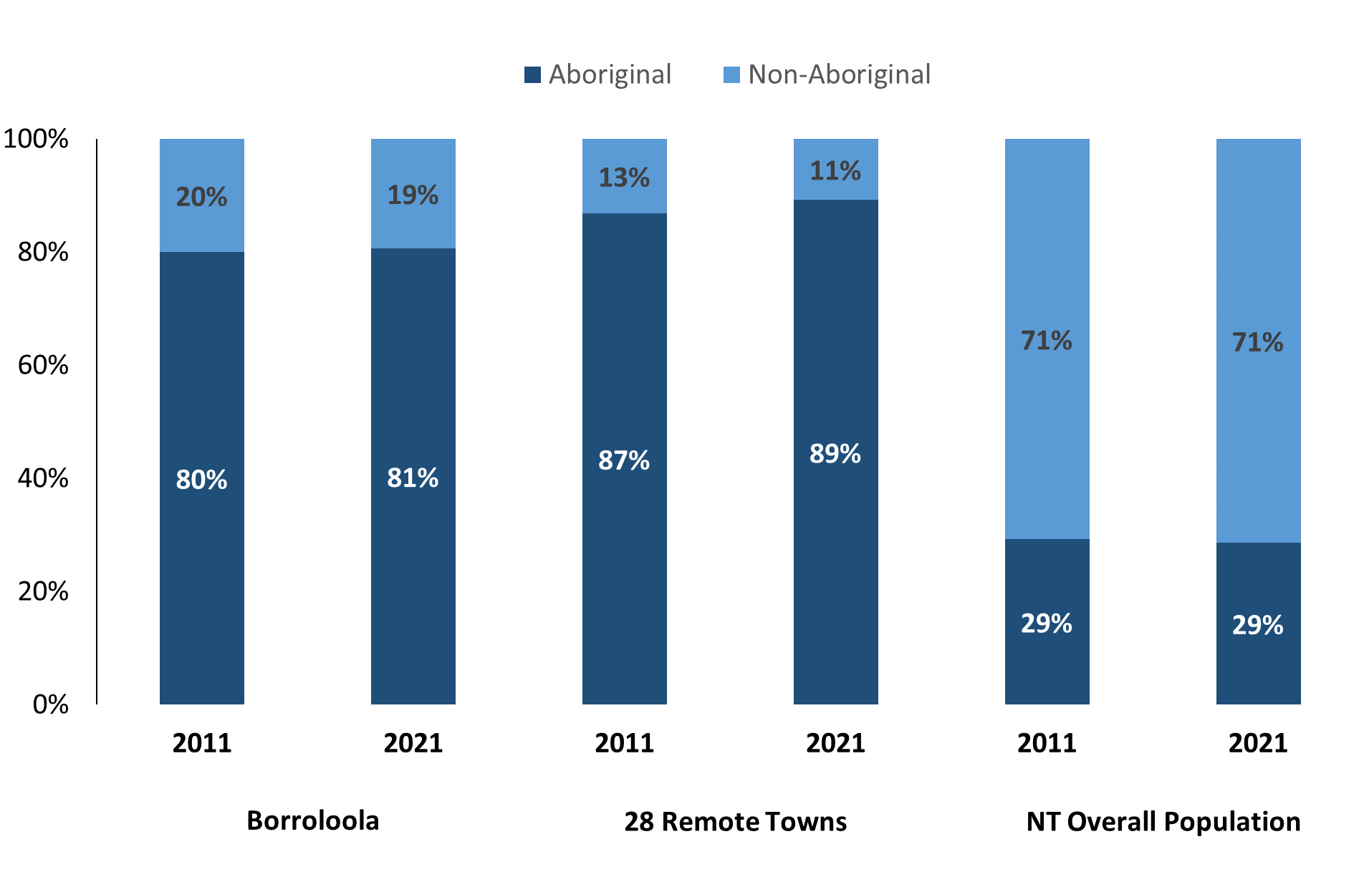

*Source: Australian Bureau of Statistics*

In 2021:

* 81% of the population in Borroloola were **Aboriginal**, compared to 80% in 2011
* 89% of the population across the 28 remote towns were **Aboriginal**
* 29% of the NT population were **Aboriginal**.

**Table 37: Unemployment and Aboriginal participation rates (q)**

|  |  |  |  |  |  |  |  |
| --- | --- | --- | --- | --- | --- | --- | --- |
|  | **Borroloola** | | | **Northern Territory** | | | |
| **Aboriginal** | **Non-Aboriginal** | **Total** | **Aboriginal** | **Non-Aboriginal** | **Total** |
| **Unemployment rate** | 12.1% | 0.0% | 6.9% | 20.8% | 3.2% | 5.6% |
| **Participation rate** | 31.2% | 74.6% | 40.7% | 35.4% | 78.3% | 64.9% |

*Source: Australian Bureau of Statistics*

In 2021 in Borroloola the:

* **total unemployment rate** was 6.9% compared to 5.6% for the total Northern Territory
* **Aboriginal unemployment rate** was 12.1% compared to 20.8% for the total Northern Territory
* **non-Aboriginal unemployment rate** was 0.0% compared to 3.2% for the total Northern Territory
* **total participation rate** was 40.7% compared to 64.9% for the total Northern Territory
* **Aboriginal participation rate** was 31.2% compared to 35.4% for the total Northern Territory
* **non-Aboriginal participation rate** was 74.6% compared to 78.3% for the total Northern Territory.

# Community Development Program

**Table 38: Community Development Program Aboriginal Job Seekers, 31 December 2023 (o)**

|  |  |  |
| --- | --- | --- |
| **Indicator** | **Aboriginal** | |
| **No.** | **%** |
| **Total Aboriginal Job Seekers** | 124 | N/A |
| **Age (years)** | | |
| 15-24 | 33 | 26.6% |
| 25-44 | 65 | 52.4% |
| 45+ | 26 | 21.0% |
| **Total** | 124 | 100.0% |
| **Gender** | | |
| Male | 68 | 54.8% |
| Female | 56 | 45.2% |
| **Total** | 124 | 100.0% |
| **Employment Outcome - 1 January 2023 to 31 December 2023** | | |
| 13 Weeks | <20 | N/A |
| 26 Weeks | <20 | N/A |

*Source: Department of Prime Minister and Cabinet*

**Chart 14: Community Development Program Aboriginal Job Seekers by Gender and Age Group, 31 December 2023 (o)**

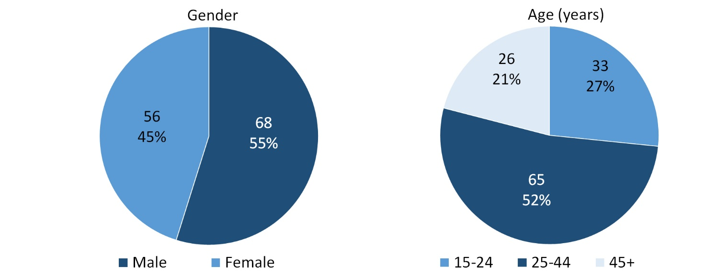

*Source: Department of Prime Minister and Cabinet*

As of 31 December 2023, in Borroloola, there were 124 CDP **Aboriginal** job seekers, of these:

* 68 (54.8%) were male and 56 (45.2%) were female
* 33 (26.6%) were aged 15-24 years, 65 (52.4%) were aged 25-44 years, and 26 (21.0%) were aged 45+ years
* between 1 January 2023 to 31 December 2023, less than 20 had reached the 13-week reporting milestone and less than 20 had reached the 26-week reporting milestone.

# Businesses

**Table 39: Businesses by sector (d)(s)**

| **Business Name** | **Reported on in 2011** | **Reported on in 2014** | **Reported on in 2017** | **Reported on in 2023** |
| --- | --- | --- | --- | --- |
| **PUBLIC SECTOR** | | | | |
| **Aboriginal Interpreter Service** | No | No | Yes | **Yes** |
| Borroloola Community Education Centre | Yes | No | No | No |
| **Department of Education** | Yes | Yes | Yes | **Yes** |
| **Department of Health** | Yes | Yes | Yes | **Yes** |
| Department of Housing, Local Government and Regional Services (DHLGRS) | Yes | No | No | No |
| Department of Human Services trading as Centrelink | Yes | Yes | Yes | No |
| Department of Natural Resources, Environment, The Arts and Sports (NRETAS) | Yes | No | No | No |
| Department of the Prime Minister and Cabinet | Yes | Yes | Yes | No |
| **National Indigenous Australians Agency** | No | No | No | **Yes** |
| **Northern Territory Police, Fire Emergency Services** | Yes | Yes | Yes | **Yes** |
| **Parks and Wildlife Commission of the Northern Territory** | No | Yes | Yes | **Yes** |
| Post Office | Yes | No | No | No |
| Roper Gulf Regional Council | Yes | Yes | Yes | No |
| **Territory Families** | No | No | Yes | **Yes** |
| **PRIVATE SECTOR** | | | | |
| BB's Place | Yes | Yes | No | No |
| Borroloola Aerial Service | Yes | No | No | No |
| Borroloola Hotel Motel | Yes | Yes | Yes | No |
| Borroloola Pharmacy | No | No | Yes | No |
| **Cairns Industries Pty Ltd** | Yes | Yes | Yes | **Yes** |
| Cape Crawford Tourism | Yes | No | No | No |
| Chartair Pty Ltd | Yes | No | No | No |
| Gulf Mini Mart | Yes | Yes | Yes | No |
| Gulf Savannah NT Aboriginal Corporation | No | Yes | Yes | No |
| IS Australia Pty Ltd | Yes | No | No | No |
| J and A Charters and Tours | No | No | Yes | No |
| **JAYEM Auto Repairs** | No | No | Yes | **Yes** |
| Katherine Aviation Pty Ltd | Yes | Yes | No | No |
| King Ash Bay Lodge | Yes | No | No | No |
| King Ash Bay Service Station | Yes | No | No | No |
| **Mabunji Aboriginal Resource Indigenous Corporation** | Yes | Yes | Yes | **Yes** |
| **Malandari Store - ALPA** | Yes | Yes | Yes | **Yes** |
| Marbrom Pty Ltd | Yes | Yes | Yes | No |
| McArthur River Caravan Park | Yes | Yes | Yes | No |
| Naigai Garden and Maintenance | Yes | Yes | Yes | No |
| **Northern Land Council** | Yes | Yes | Yes | **Yes** |
| Outbush Photography | Yes | Yes | Yes | No |
| Pandion Haulage Pty Ltd | Yes | Yes | Yes | No |
| PaperBark Café | Yes | Yes | Yes | No |
| PDG-NT Pty Ltd | No | No | Yes | No |
| Peter Brown Refrigeration | Yes | No | No | No |
| **Power Projects NT Pty Ltd/ Aus Projects NT Pty Ltd** | Yes | Yes | Yes | **Yes** |
| Red Dirt Trading (Gulf Meats) | Yes | Yes | Yes | No |
| **Redimart Pty Ltd** | No | Yes | Yes | **Yes** |
| Savannah Way Motel | Yes | Yes | Yes | No |
| Terry Fischer Motors | Yes | Yes | No | No |
| **TJS One Stop Pty Ltd** | Yes | No | Yes | **Yes** |
| Traditional Credit Union (TCU) | No | Yes | Yes | No |

*Source: Northern Territory Department of Industry, Tourism and Trade*

*Note: Business names captured across the four survey periods have been identified by the current 2023 Business ABN name listed.*

In 2023 in Borroloola:

* There were 15 businesses reported on, of which:
* 7 businesses were from the Public Sector (47%)
* 8 businesses were from the Private Sector (53%)
* there was 1 business operating that was not operating in 2017.

# Notes

1. These counts represent numbers of filled jobs and not the number of people. As such the totals represent the total number of filled jobs, not the total number of employees. This count is not directly comparable to the total number of employed people as a person may have several jobs or one job may be shared by more than one person.
2. Full-time is defined as a job usually requiring 35 hours or more per week or that required 35 hours or more work during the reference week. Part-time is defined as a job usually requiring less than 35 hours per week or that required less than 35 hours work during the reference week. The reference week refers to the period that respondents were asked to provide information about. In most instances it would be the week prior to the week the questionnaire was completed. Questionnaires were predominantly conducted in June and July.
3. Care needs to be taken when analysing the counts of filled jobs by Aboriginal people. Aboriginality was reported by the business representative completing the questionnaire.
4. Sector was classified using the Standard Economic Sector of Classifications of Australia (SESCA), 2008.
5. Job permanency is classified according to what the business believes the level of job permanency is based on guidelines provided by data collectors. Those guidelines state a permanent job has paid annual and/or sick leave entitlements while a temporary job includes casual and fixed-term contract jobs.
6. Classified according to the Australian and New Zealand Standard Classification of Occupations (ANZSCO), 2006, major occupation level.
7. Other Occupations include jobs where occupation was not stated, not known or inadequately described.
8. Classified using the Australian and New Zealand Standard Industrial Classification (ANZSIC), 2006, division level.
9. Care needs to be taken when analysing the counts of filled jobs by the gender of people in the jobs. The gender of the person employed in a job is reported by the business representative completing the questionnaire.
10. Care needs to be taken when analysing the counts of filled jobs by the age of people in the jobs. The age of the person employed in a job is reported by the business representative completing the questionnaire.
11. Students represent the number of individual clients that enrolled in a Vocational Education and Training unit during the calendar year.
12. Unit enrolments represent the count of individual units that students enrolled in during the calendar year.
13. Nominal hours delivered is the sum of the nominal hours of the units commenced during the calendar year regardless of when the course enrolment commenced.
14. Unit completions are the count of all successfully completed units reported in the calendar year regardless of the year of commencement of the units.
15. The Community Development Program (CDP) supports job seekers in remote Australia to build skills, address barriers and contribute to their communities through a range of flexible activities. Under the CDP, job seekers with activity requirements are expected to do up to 25 hours per week of work-like activities that benefit their community. It should be noted that some CDP participants may be reported on within the profile if they are attached to a filled position with an employer captured in the survey. Due to confidentiality issues, data below 20 people is not published.
16. Population estimates for both 2011 and 2021 are taken from the estimated resident population (ERP) data produced by the Australian Bureau of Statistics (ABS) and based on Australian Statistical Geography Standard (ASGS) Statistical Area Level 1 (SA1) regions. ERP are official estimates of the Australian population, which link people to a place of usual residence within Australia. All ERP data sources, including the Census of Population and Housing (Census), are subject to error (including inaccuracies in collection, recording and processing data) and should be used with caution.
17. Indigenous population proportions, unemployment and workforce participation rates are based on ABS Census counts at ASGS Indigenous Locations (ILOCs) for each remote town.
18. Working-age population includes all residents aged 15 years and over (commonly referred to as the civilian population) and consists of people that are employed, unemployed or not in the labour force.
19. A ‘business’ has been defined as any organisation that has undertaken productive activities in the last year, including companies, non-profit organisations, government departments and enterprises operating within the designated remote geography (town), and has one or more employees in paid employment and an Australian Business Number (ABN).

# Abbreviations and Acronyms

ABN Australian Business Number

ABS Australian Bureau of Statistics

ANZSCO Australian and New Zealand Standard Classification of Occupations

ANZSIC Australian and New Zealand Standard Industrial Classification

ASGS Australian Statistical Geography Standard

CDP Community Development Program

ERP Estimated Resident Population

ILOC Indigenous Locations

nec Not Elsewhere Classified

No. Number

Perm Permanent

ppt Percentage point

RJCP Remote Jobs and Communities Program

Temp Temporary

SA1 Statistical Area Level 1

VET Vocational Education and Training

1. The number of filled jobs does not represent the number of people as a person may have several jobs or one job may be shared by more than one person.
2. 5 Aboriginal filled jobs gender status not identified in 2017