Mineral Titles Act 2010
NOTICE OF LAND CEASING TO BE A MINERAL TITLE AREA
Title Type and Number: | Exploration Licence 22349
Area Ceased on: | 16 January 2025
Area: | 27 Blocks, 69.70 km²
Locality: | JINKA
Name of Applicant(s)/Holder(s): | 100% MOLYHIL MINING PTY LTD [ACN. 112 922 497]
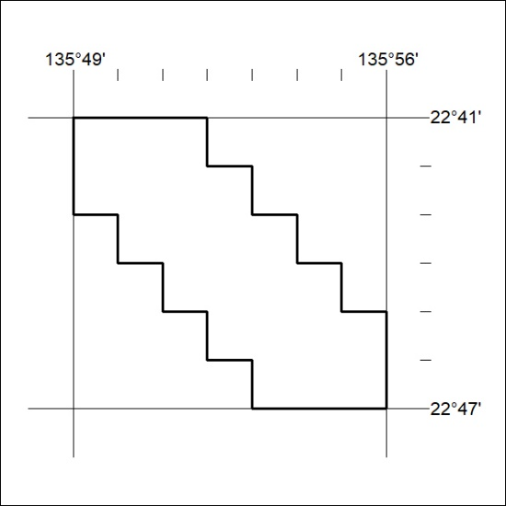
(Area now divided into Exploration Licence 34050 under s101 – EL moratorium period does not apply)

28/25

