Mineral Titles Act 2010
NOTICE OF LAND CEASING TO BE A MINERAL TITLE AREA
Title Type and Number: | Exploration Licence 26620
Area Ceased on: | 13 December 2024
Area: | 34 Blocks, 109.40 km²
Locality: | PTILOTUS
Name of Applicant(s)/Holder(s): | 100% PRODIGY GOLD NL* [ACN. 009 127 020]
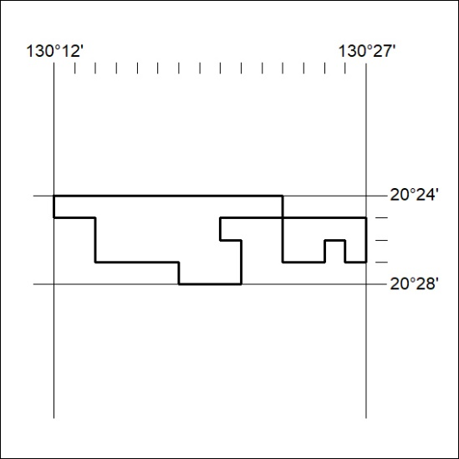

467/24

Mineral Titles Act 2010
NOTICE OF LAND CEASING TO BE A MINERAL TITLE AREA
Title Type and Number: | Exploration Licence 25845
Area Ceased on: | 14 December 2024
Area: | 22 Blocks, 70.54 km²
Locality: | PTILOTUS
Name of Applicant(s)/Holder(s): | 100% PRODIGY GOLD NL* [ACN. 009 127 020]
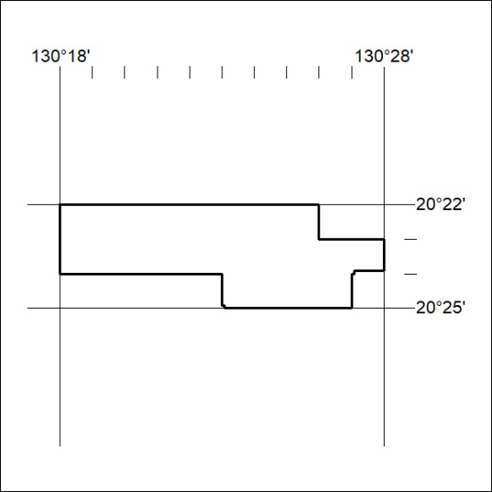

468/24

