Mineral Titles Act 2010
NOTICE OF LAND CEASING TO BE A MINERAL TITLE AREA
Title Type and Number: | Mineral Lease (Central) 498
Area ceased on: | 29 November 2024
Area: | 8.00 Hectare
Locality: | TENNANT CREEK
Name of Applicants(s)Holder(s): | 100% SANTEXCO PTY LTD [ACN. 002 910 296]
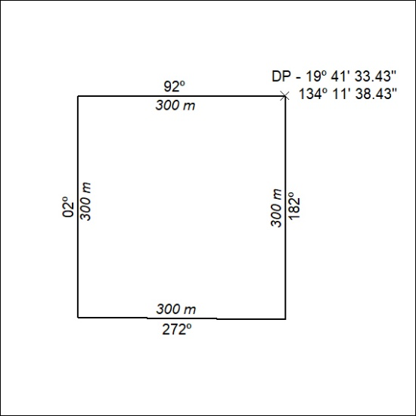
(Area now amalgamated into Mineral Lease 34025 under s102)

442/24

Mineral Titles Act 2010
NOTICE OF LAND CEASING TO BE A MINERAL TITLE AREA
Title Type and Number: | Mineral Lease (Central) 582
Area ceased on: | 29 November 2024
Area: | 6.00 Hectare
Locality: | TENNANT CREEK
Name of Applicants(s)Holder(s): | 100% SANTEXCO PTY LTD [ACN. 002 910 296]
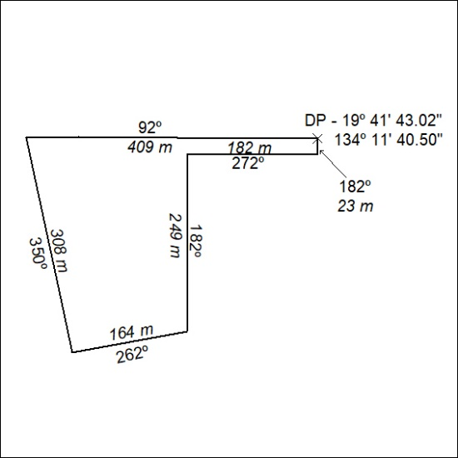
(Area now amalgamated into Mineral Lease 34025 under s102)

443/24

Mineral Titles Act 2010
NOTICE OF LAND CEASING TO BE A MINERAL TITLE AREA
Title Type and Number: | Mineral Lease (Central) 504
Area ceased on: | 29 November 2024
Area: | 5.00 Hectare
Locality: | TENNANT CREEK
Name of Applicants(s)Holder(s): | 100% SANTEXCO PTY LTD [ACN. 002 910 296]
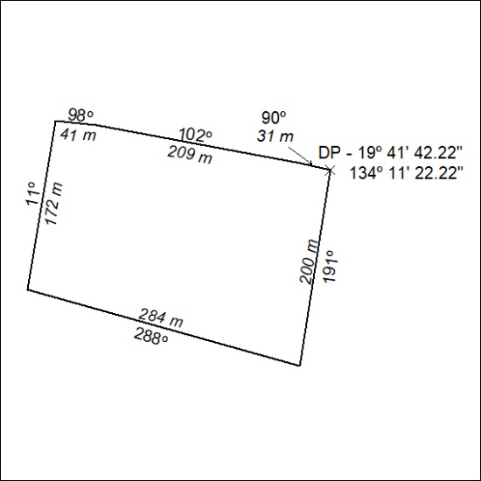
(Area now amalgamated into Mineral Lease 34026 under s102)

444/24

Mineral Titles Act 2010
NOTICE OF LAND CEASING TO BE A MINERAL TITLE AREA
Title Type and Number: | Mineral Lease (Central) 505
Area ceased on: | 29 November 2024
Area: | 4.00 Hectare
Locality: | TENNANT CREEK
Name of Applicants(s)Holder(s): | 100% SANTEXCO PTY LTD [ACN. 002 910 296]
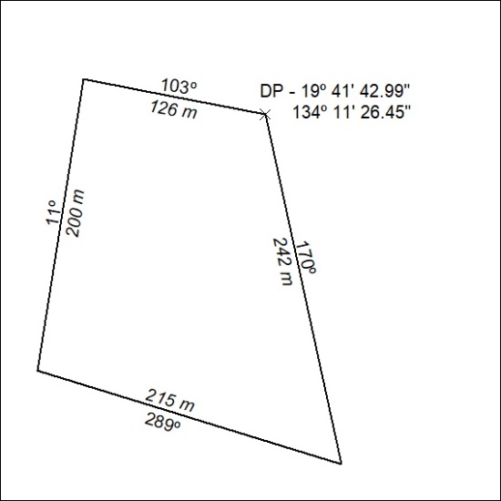
Area now amalgamated into Mineral Lease 34026 under s102)

445/24

Mineral Titles Act 2010
NOTICE OF LAND CEASING TO BE A MINERAL TITLE AREA
Title Type and Number: | Mineral Lease (Central) 581
Area ceased on: | 29 November 2024
Area: | 116.12 Hectare
Locality: | TENNANT CREEK
Name of Applicants(s)Holder(s): | 100% SANTEXCO PTY LTD [ACN. 002 910 296]
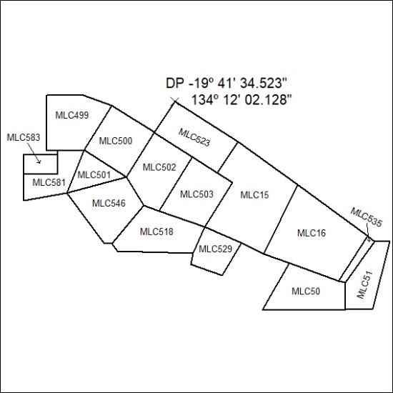
Area now amalgamated into Mineral Lease 34027 under s102)

446/24

Mineral Titles Act 2010
NOTICE OF LAND CEASING TO BE A MINERAL TITLE AREA
Title Type and Number: | Mineral Lease (Central) 406, 407, 408 & 409
Area ceased on: | 29 November 2024
Area: | 64.00 Hectare
Locality: | TENNANT CREEK
Name of Applicants(s)Holder(s): | 100% SANTEXCO PTY LTD [ACN. 002 910 296]
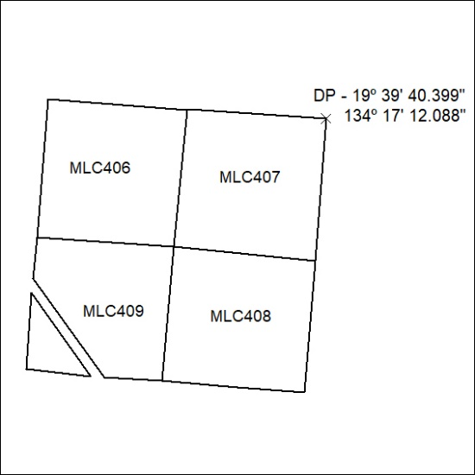
(Area now amalgamated into Mineral Lease 34028 under s102)

447/24

Mineral Titles Act 2010
NOTICE OF LAND CEASING TO BE A MINERAL TITLE AREA
Title Type and Number: | Mineral Lease (Central) 66
Area ceased on: | 29 November 2024
Area: | 16.00 Hectare
Locality: | TENNANT CREEK
Name of Applicants(s)Holder(s): | 100% SANTEXCO PTY LTD [ACN. 002 910 296]
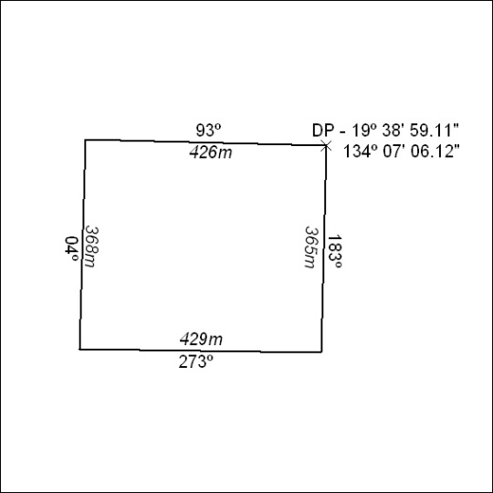
(Area now amalgamated into Mineral Lease 34030 under s102)

448/24

Mineral Titles Act 2010
NOTICE OF LAND CEASING TO BE A MINERAL TITLE AREA
Title Type and Number: | Mineral Lease (Central) 67
Area ceased on: | 29 November 2024
Area: | 16.00 Hectare
Locality: | TENNANT CREEK
Name of Applicants(s)Holder(s): | 100% SANTEXCO PTY LTD [ACN. 002 910 296]
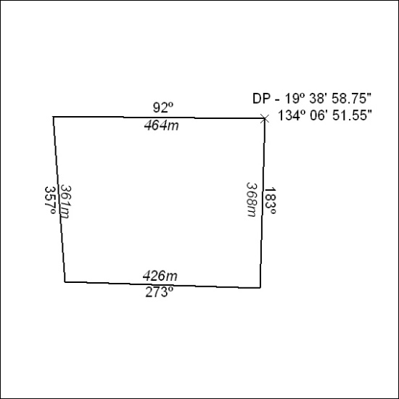
(Area now amalgamated into Mineral Lease 34030 under s102)

449/24
Corrigendum
Notice Number 437/24 appearing in MN144/24 on 2 December 2024 is hereby cancelled and replaced by the following:

Mineral Titles Act 2010
NOTICE OF LAND CEASING TO BE A MINERAL TITLE AREA

Title Type and Number: | Mineral Leases (Central) 32, 35, 36, 37, 54, 55, 56, 130, 131, 132, 133, 134, 135, 136, 137, 138, 139,140, 141, 142, 143,144, 146, 147, 148, 149, 343, 344, 345, 346, 347, 352, 353, 354, 355, 576, 577, 584, 585, 586 & 598
Area ceased on: | 27 November 2024
Area: | 571.00 Hectare
Locality: | TENNANT CREEK
Name of Applicants(s)Holder(s): | 100% SANTEXCO PTY LTD [ACN. 002 910 296]
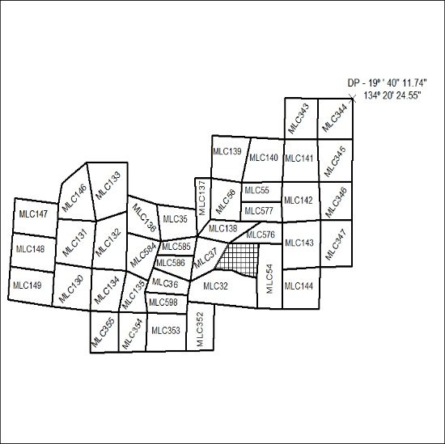
(Area now amalgamated into Mineral Lease 34014 under s102)

450/24

