Mineral Titles Act 2010
NOTICE OF LAND CEASING TO BE A MINERAL TITLE APPLICATION AREA
Title Type and Number: | Exploration Licence 24861
Area Ceased on: | 15 October 2024
Area: | 50 Blocks, 158.67 km²
Locality: | EGERTON
Name of Applicant(s)/Holder(s): | 100% AGRIMIN POTASH PTY LTD [ACN. 609 043 772]
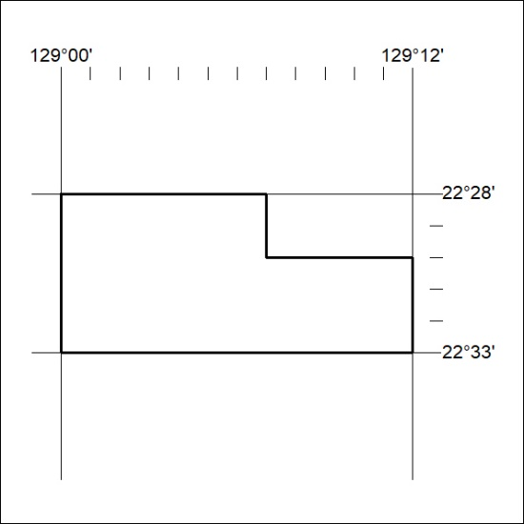

368/24

Mineral Titles Act 2010
NOTICE OF LAND CEASING TO BE A MINERAL TITLE APPLICATION AREA
Title Type and Number: | Exploration Licence 30651
Area Ceased on: | 15 October 2024
Area: | 57 Blocks, 180.71 km²
Locality: | SANDFORD CLIFFS
Name of Applicant(s)/Holder(s): | 100% AGRIMIN POTASH PTY LTD [ACN. 609 043 772]
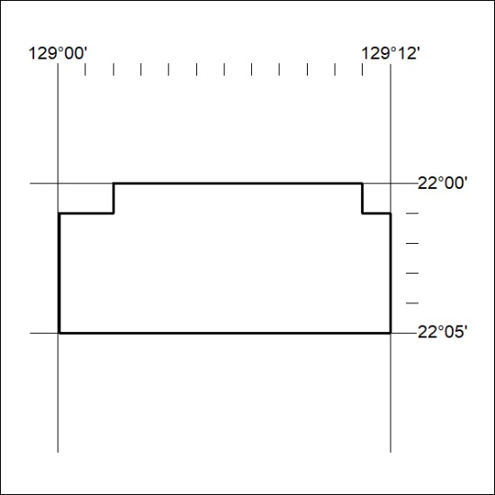

369/24

Mineral Titles Act 2010
NOTICE OF LAND CEASING TO BE A MINERAL TITLE APPLICATION AREA
Title Type and Number: | Exploration Licence 31780
Area Ceased on: | 15 October 2024
Area: | 168 Blocks, 531.22 km²
Locality: | SANDFORD CLIFFS
Name of Applicant(s)/Holder(s): | 100% AGRIMIN POTASH PTY LTD [ACN. 609 043 772]
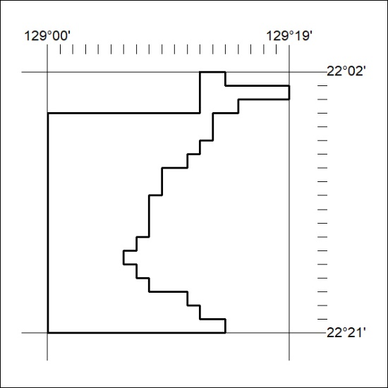

370/24

Mineral Titles Act 2010
NOTICE OF LAND CEASING TO BE A MINERAL TITLE APPLICATION AREA
Title Type and Number: | Exploration Licence 31781
Area Ceased on: | 15 October 2024
Area: | 167 Blocks, 528.18 km²
Locality: | SANDFORD CLIFFS
Name of Applicant(s)/Holder(s): | 100% AGRIMIN POTASH PTY LTD [ACN. 609 043 772]
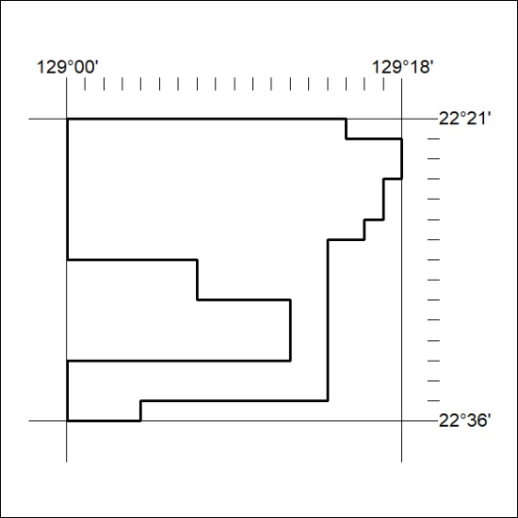

371/24

Corrigendum
Notice Number 367/24 appearing in MN124/24 on 14 October 2024 is hereby cancelled and replaced by the following:

Mineral Titles Act 2010
NOTICE OF LAND CEASING TO BE A MINERAL TITLE AREA
Title Type and Number: | Exploration Licence 24915
Area Ceased on: | 23 September 2024
Area: | 115 Blocks, 363.59 km²
Locality: | WILLIE
Name of Applicant(s)/Holder(s): | 100% PRODIGY GOLD NL* [ACN. 009 127 020]
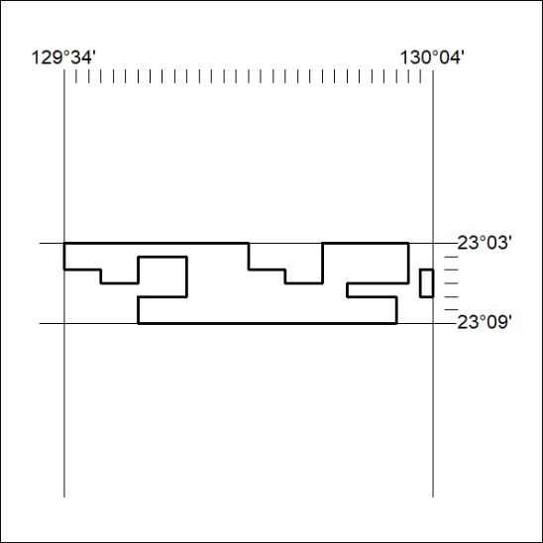

372/24

