Mineral Titles Act
NOTICE OF GRANT OF A MINERAL TITLE
Title Type and Number: | Exploration Licence 33095
Granted: | 11 June 2024, for a period of 6 Years
Area: | 93 Blocks, 252.79 km²
Locality: | WOOLLA
Name of Holder/s: | 100% TIVAN LIMITED* [ACN. 000 817 023]
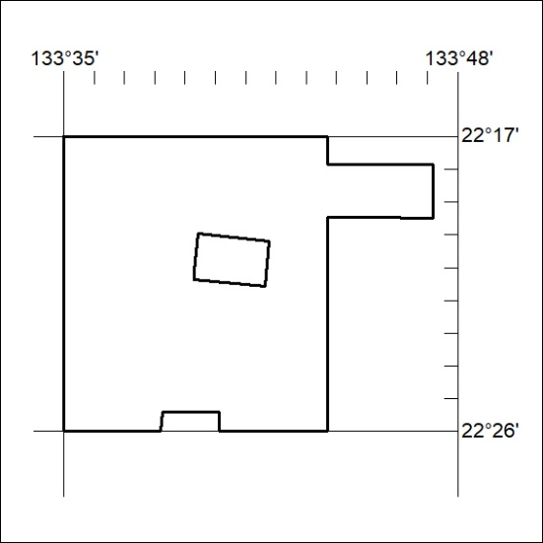
Area granted is indicated above. The titleholder is not permitted to exercise occupational rights on any land that is subject to a development title, or an application for a development title. Any land the subject of a Reserved Land gazettal under the Mineral Titles Act and all land vested in the Commonwealth of Australia is also excluded by description but not excised from the grant area.
251/24

Mineral Titles Act
NOTICE OF GRANT OF A MINERAL TITLE
Title Type and Number: | Exploration Licence 33096
Granted: | 11 June 2024, for a period of 6 Years
Area: | 145 Blocks, 429.05 km²
Locality: | BUSHY PARK
Name of Holder/s: | 100% TIVAN LIMITED* [ACN. 000 817 023]
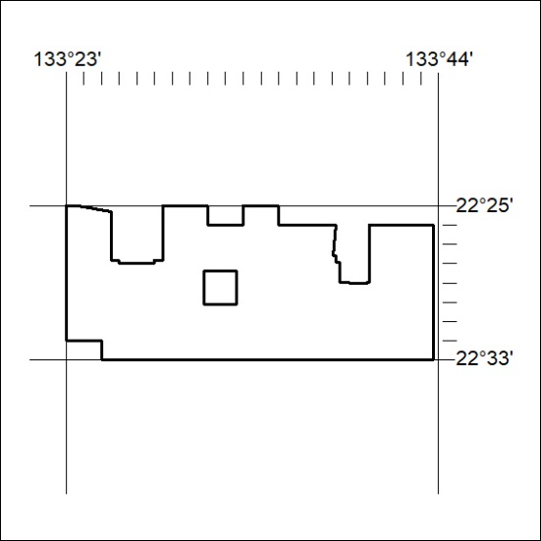
Area granted is indicated above. The titleholder is not permitted to exercise occupational rights on any land that is subject to a development title, or an application for a development title. Any land the subject of a Reserved Land gazettal under the Mineral Titles Act and all land vested in the Commonwealth of Australia is also excluded by description but not excised from the grant area.
252/24

Mineral Titles Act
NOTICE OF GRANT OF A MINERAL TITLE
Title Type and Number: | Exploration Licence 33097
Granted: | 11 June 2024, for a period of 6 Years
Area: | 158 Blocks, 476.76 km²
Locality: | BUSHY PARK
Name of Holder/s: | 100% TIVAN LIMITED* [ACN. 000 817 023]
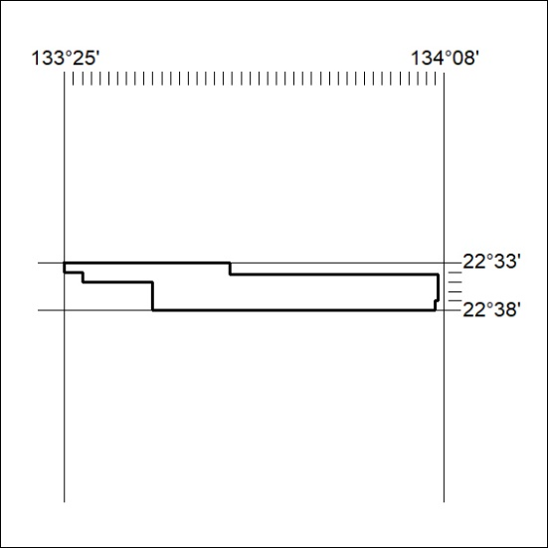
Area granted is indicated above. The titleholder is not permitted to exercise occupational rights on any land that is subject to a development title, or an application for a development title. Any land the subject of a Reserved Land gazettal under the Mineral Titles Act and all land vested in the Commonwealth of Australia is also excluded by description but not excised from the grant area.
253/24

Mineral Titles Act
NOTICE OF GRANT OF A MINERAL TITLE
Title Type and Number: | Exploration Licence 33106
Granted: | 11 June 2024, for a period of 6 Years
Area: | 135 Blocks, 417.58 km²
Locality: | DNEIPER
Name of Holder/s: | 100% TIVAN LIMITED* [ACN. 000 817 023]
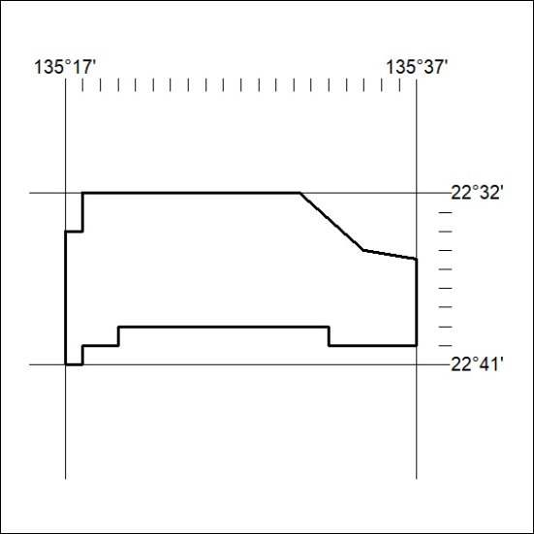
Area granted is indicated above. The titleholder is not permitted to exercise occupational rights on any land that is subject to a development title, or an application for a development title. Any land the subject of a Reserved Land gazettal under the Mineral Titles Act and all land vested in the Commonwealth of Australia is also excluded by description but not excised from the grant area.
254/24

Mineral Titles Act
NOTICE OF GRANT OF A MINERAL TITLE
Title Type and Number: | Exploration Licence 33594
Granted: | 11 June 2024, for a period of 6 Years
Area: | 8 Blocks, 8.68 km²
Locality: | ALCOOTA
Name of Holder/s: | 100% TIVAN LIMITED* [ACN. 000 817 023]
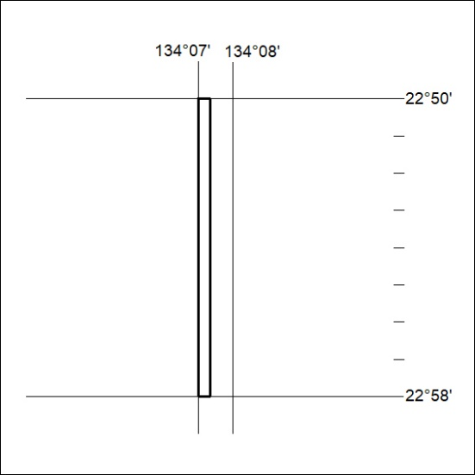
Area granted is indicated above. The titleholder is not permitted to exercise occupational rights on any land that is subject to a development title, or an application for a development title. Any land the subject of a Reserved Land gazettal under the Mineral Titles Act and all land vested in the Commonwealth of Australia is also excluded by description but not excised from the grant area.
255/24

