Mineral Titles Act 2010
NOTICE OF LAND CEASING TO BE A MINERAL TITLE AREA
Title Type and Number: | Extractive Mineral Exploration Licence 32953
Area Ceased on: | 29 May 2024
Area: | 4 Blocks, 13.36 km²
Locality: | McKINLAY RIVER
Name of Applicant(s)/Holder(s): | 100% TANK BIZ PTY LTD [ACN. 155 050 749]
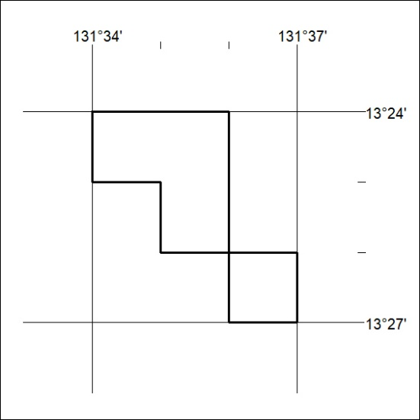

218/24

Mineral Titles Act 2010
NOTICE OF LAND CEASING TO BE A MINERAL TITLE AREA
Title Type and Number: | Mineral Leases (Central) 512, 513, 514, 515, 516, 517, 521, 525, 526, 531, 532, 533, 534, 537, 538, 539, 540, 541, 542, 543, 544, 545, 548, 549, 550, 556, 589, 590, 688, 689, 690 & 691
Area ceased on: | 29 May 2024
Area: | 261.81 Hectare
Locality: | TENNANT CREEK
Name of Applicants(s)Holder(s): | 100% TENNANT CONSOLIDATED MINING GROUP PTY LTD [ACN. 645 263 547]
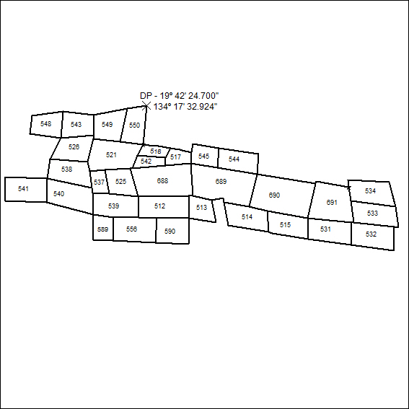
(Area now amalgamated into Mineral Lease 33779 under s102)

219/24

