Mineral Titles Act
NOTICE OF GRANT OF A MINERAL TITLE
Title Type and Number: | Exploration Licence 33528
Granted: | 27 May 2024, for a period of 6 Years
Area: | 50 Blocks, 156.54 km²
Locality: | RIDDOCH
Name of Holder/s: | 100% RIO TINTO EXPLORATION PTY LIMITED [ACN. 000 057 125]
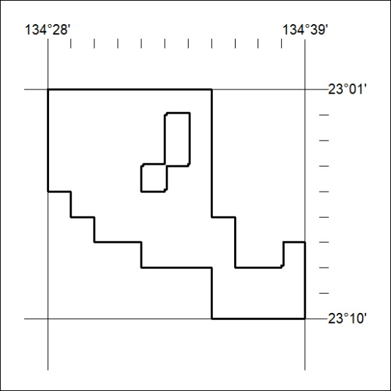
Area granted is indicated above. The titleholder is not permitted to exercise occupational rights on any land that is subject to a development title, or an application for a development title. Any land the subject of a Reserved Land gazettal under the Mineral Titles Act and all land vested in the Commonwealth of Australia is also excluded by description but not excised from the grant area.

207/24

