Mineral Titles Act 2010
NOTICE OF LAND CEASING TO BE A MINERAL TITLE AREA
Title Type and Number: | Extractive Mineral Permit 30299
Area ceased on: | 16 May 2024
Area: | 15.00 Hectare
Locality: | MARY RIVER
Name of Applicants(s)Holder(s): | 100% DARWIN CHRISTIAN MINISTRIES INC
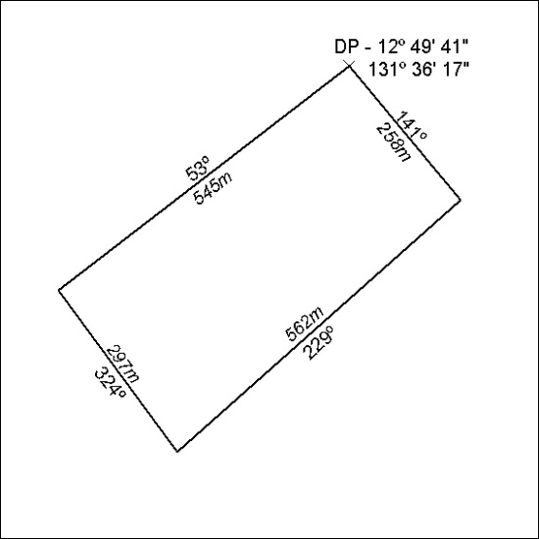

200/24

