Mineral Titles Act 2010
NOTICE OF LAND CEASING TO BE A MINERAL TITLE APPLICATION AREA
Title Type and Number: | Exploration Licence 32048
Area Ceased on: | 14 May 2024
Area: | 88 Blocks, 286.06 km²
Locality: | BUCHANAN
Name of Applicant(s)/Holder(s): | 100% CENTREX QLD EXPLORATION PTY LTD [ACN. 152 383 054]
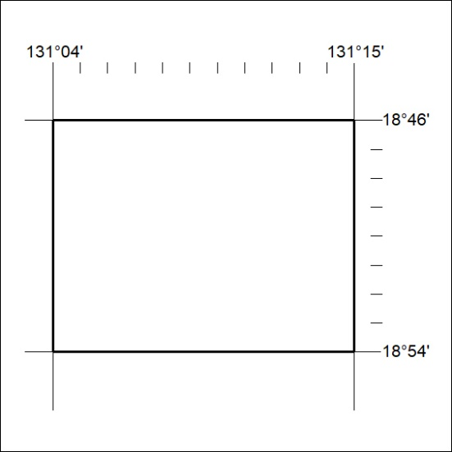
198/24

