Mineral Titles Act 2010
NOTICE OF LAND CEASING TO BE A MINERAL TITLE AREA
Title Type and Number: | Exploration Licence 24906
Area Ceased on: | 24 April 2024
Area: | 9 Blocks, 26.75 km²
Locality: | BATCHELOR
Name of Applicant(s)/Holder(s): | 100% AUSTRALIA MINING & GEMSTONE CO. PTY LTD [ACN. 114 395 247]
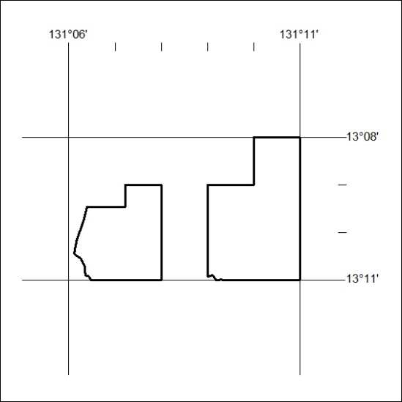

171/24

Mineral Titles Act 2010
NOTICE OF LAND CEASING TO BE A MINERAL TITLE AREA
Title Type and Number: | Exploration Licence 25294
Area Ceased on: | 24 April 2024
Area: | 4 Blocks, 13.36 km²
Locality: | PINE CREEK
Name of Applicant(s)/Holder(s): | 100% AUSTRALIA MINING & GEMSTONE CO. PTY LTD [ACN. 114 395 247]
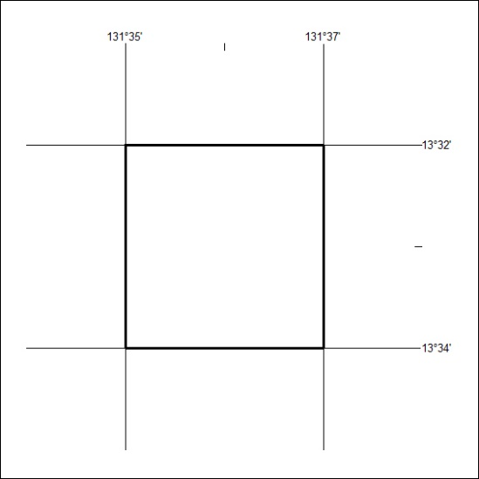

172.24

