Mineral Titles Act 2010
NOTICE OF LAND CEASING TO BE A MINERAL TITLE AREA
Title Type and Number: | Exploration Licence 32861
Area Ceased on: | 04 April 2024
Area: | 165 Blocks, 524.07 km²
Locality: | TEA TREE
Name of Applicant(s)/Holder(s): | 100% PEGMATITE ONE PTY LTD [ACN. 652 853 391]
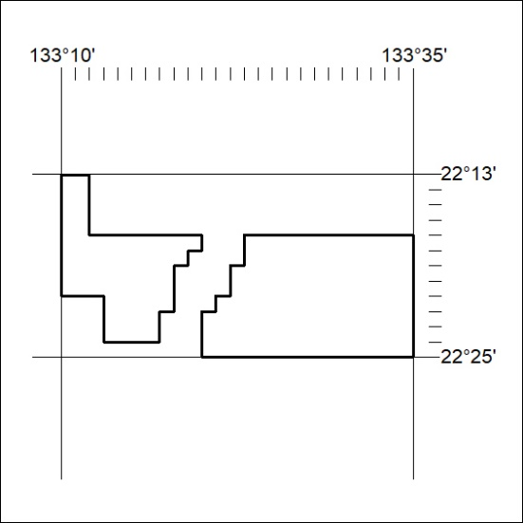

120/24

Mineral Titles Act 2010
NOTICE OF LAND CEASING TO BE A MINERAL TITLE AREA
Title Type and Number: | Exploration Licence 32862
Area Ceased on: | 04 April 2024
Area: | 39 Blocks, 123.78 km²
Locality: | TEA TREE
Name of Applicant(s)/Holder(s): | 100% PEGMATITE ONE PTY LTD [ACN. 652 853 391]
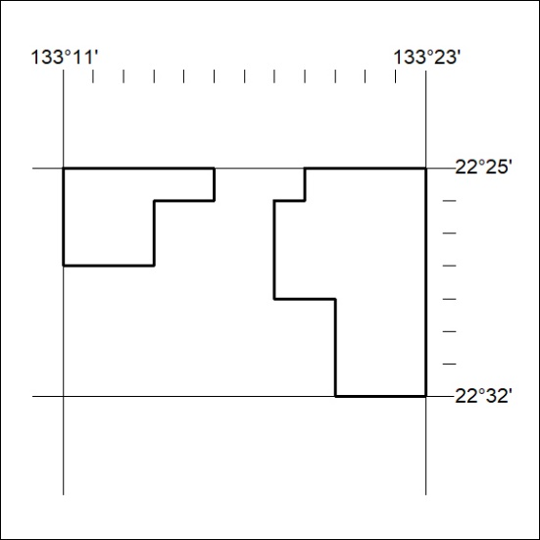

121/24

Mineral Titles Act
NOTICE OF GRANT OF A MINERAL TITLE
Title Type and Number: | Exploration Licence 33621
Granted: | 15 April 2024, for a period of 6 Years
Area: | 196 Blocks, 614.62 km²
Locality: | TOBERMORY
Name of Holder/s: | 100% GEMPART (NT) PTY LTD* [ACN. 081 859 896]
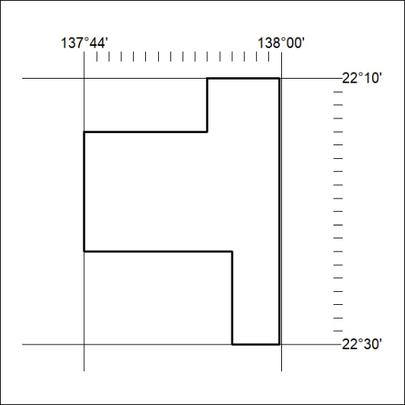
Area granted is indicated above. The titleholder is not permitted to exercise occupational rights on any land that is subject to a development title, or an application for a development title. Any land the subject of a Reserved Land gazettal under the Mineral Titles Act and all land vested in the Commonwealth of Australia is also excluded by description but not excised from the grant area.

122/24

Mineral Titles Act
NOTICE OF GRANT OF A MINERAL TITLE
Title Type and Number: | Exploration Licence 33637
Granted: | 15 April 2024, for a period of 6 Years
Area: | 208 Blocks, 617.74 km²
Locality: | PALM VALLEY
Name of Holder/s: | 100% GEMPART (NT) PTY LTD* [ACN. 081 859 896]
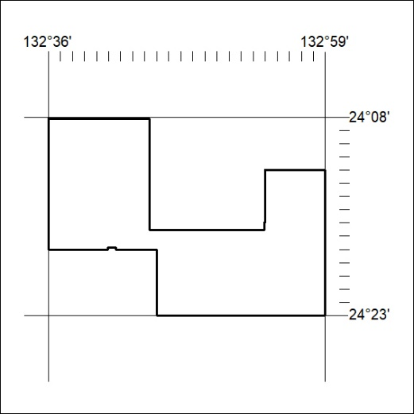
Area granted is indicated above. The titleholder is not permitted to exercise occupational rights on any land that is subject to a development title, or an application for a development title. Any land the subject of a Reserved Land gazettal under the Mineral Titles Act and all land vested in the Commonwealth of Australia is also excluded by description but not excised from the grant area.

123/24

Mineral Titles Act
NOTICE OF GRANT OF A MINERAL TITLE
Title Type and Number: | Exploration Licence 33638
Granted: | 15 April 2024, for a period of 6 Years
Area: | 147 Blocks, 445.48 km²
Locality: | JAMES
Name of Holder/s: | 100% GEMPART (NT) PTY LTD* [ACN. 081 859 896]
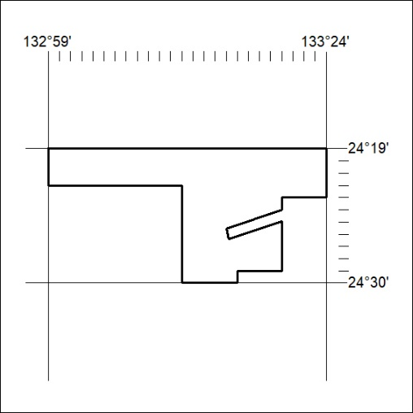
Area granted is indicated above. The titleholder is not permitted to exercise occupational rights on any land that is subject to a development title, or an application for a development title. Any land the subject of a Reserved Land gazettal under the Mineral Titles Act and all land vested in the Commonwealth of Australia is also excluded by description but not excised from the grant area.

124/24

