Mineral Titles Act 2010
NOTICE OF LAND CEASING TO BE A MINERAL TITLE AREA
Title Type and Number: | Exploration Licence 32834
Area Ceased on: | 04 April 2024
Area: | 97 Blocks, 309.47 km²
Locality: | HOME OF BULLION
Name of Applicant(s)/Holder(s): | 100% PEGMATITE ONE PTY LTD [ACN. 652 853 391]
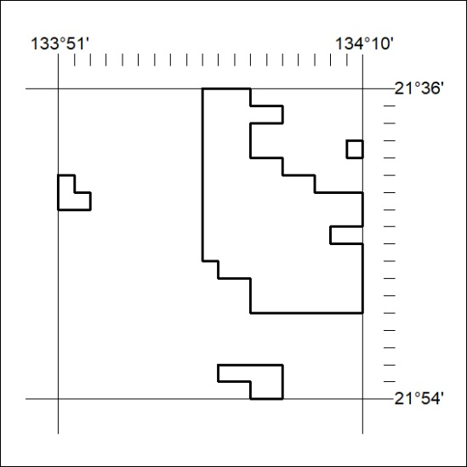

107/24

Mineral Titles Act 2010
NOTICE OF LAND CEASING TO BE A MINERAL TITLE AREA
Title Type and Number: | Exploration Licence 32840
Area Ceased on: | 04 April 2024
Area: | 21 Blocks, 67.12 km²
Locality: | CONICAL HILL
Name of Applicant(s)/Holder(s): | 100% PEGMATITE ONE PTY LTD [ACN. 652 853 391]
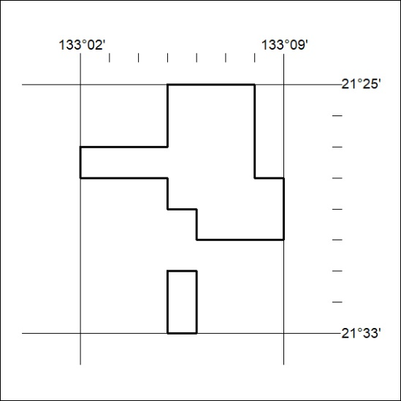

108/24

Mineral Titles Act 2010
NOTICE OF LAND CEASING TO BE A MINERAL TITLE AREA
Title Type and Number: | Exploration Licence 32868
Area Ceased on: | 04 April 2024
Area: | 16 Blocks, 51.11 km²
Locality: | HOME OF BULLION
Name of Applicant(s)/Holder(s): | 100% PEGMATITE ONE PTY LTD [ACN. 652 853 391]
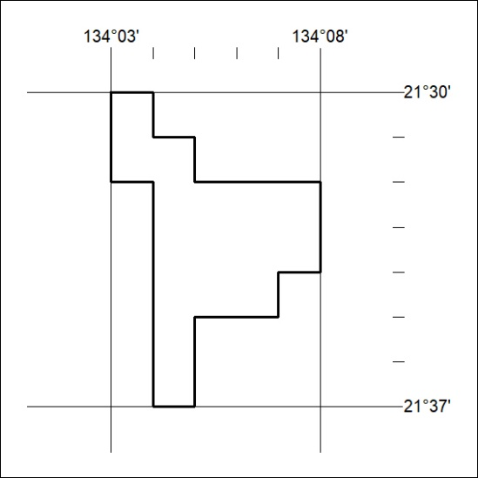

109/24

