Mineral Titles Act 2010
NOTICE OF LAND CEASING TO BE A MINERAL TITLE AREA
Title Type and Number: | Extractive Mineral Permit 27679
Area ceased on: | 07 March 2024
Area: | 2.00 Hectare
Locality: | NOONAMAH
Name of Applicants(s)Holder(s): | 100% DARWIN MATERIALS SUPPLIES (DMS) PTY LTD [ACN. 618 038 798]
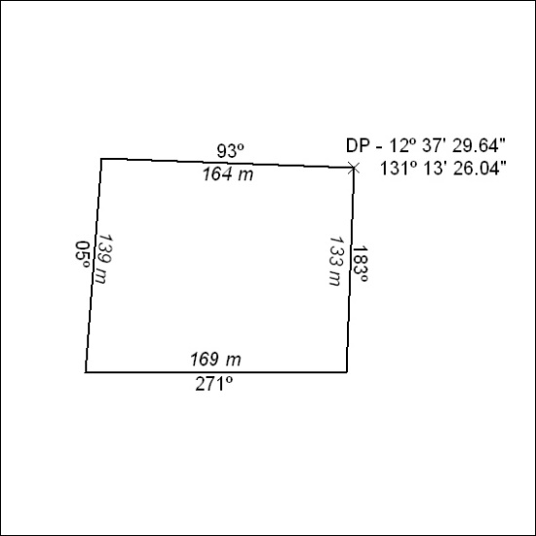

54/24

Mineral Titles Act 2010
NOTICE OF LAND CEASING TO BE A MINERAL TITLE AREA
Title Type and Number: | Extractive Mineral Permit 31697
Area ceased on: | 07 March 2024
Area: | 0.45 Hectare
Locality: | NOONAMAH
Name of Applicants(s)Holder(s): | 100% BIRCH Shane Alan Taylor
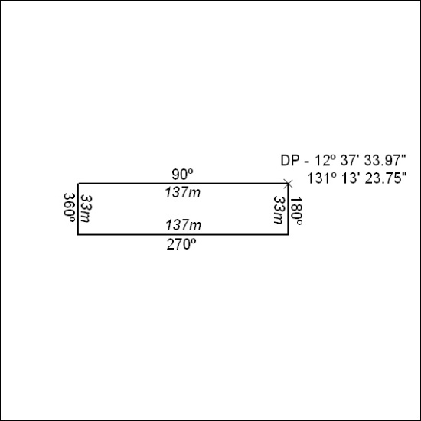

55/24

