Mineral Titles Act 2010
NOTICE OF LAND CEASING TO BE A MINERAL TITLE AREA
Title Type and Number: | Extractive Mineral Permit 27863
Area ceased on: | 13 February 2024
Area: | 102.00 Hectares
Locality: | BYNOE
Name of Applicants(s)Holder(s): | 100% CECCON Suzanne Yoko
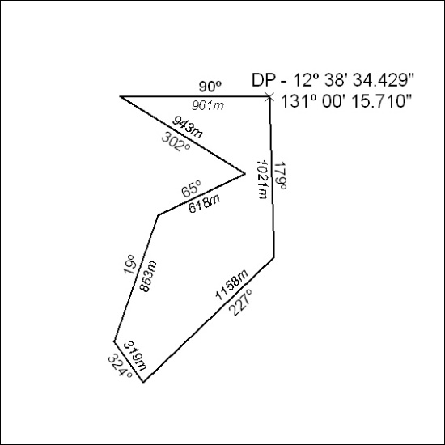

38/24

Mineral Titles Act 2010
NOTICE OF LAND CEASING TO BE A MINERAL TITLE AREA
Title Type and Number: | Exploration Licence 28322
Area Ceased on: | 08 February 2024
Area: | 6 Blocks, 13.85 km²
Locality: | McFARLANE
Name of Applicant(s)/Holder(s): | 100% PRODIGY GOLD NL* [ACN. 009 127 020]
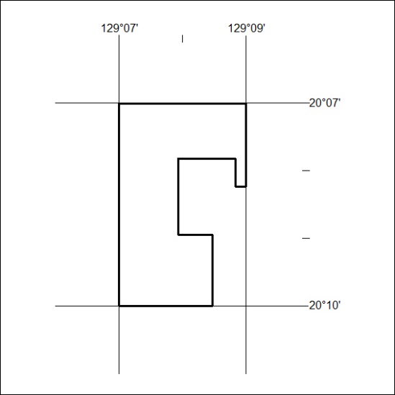

(Area now divided into Exploration Licence 33724 under s101 – EL moratorium period does not apply)

39/24

