Mineral Titles Act 2010
NOTICE OF LAND CEASING TO BE A MINERAL TITLE AREA
Title Type and Number: | Exploration Licence 31457
Area Ceased on: | 20 December 2023
Area: | 7 Blocks, 23.33 km²
Locality: | FERGUSSON RIVER
Name of Applicant(s)/Holder(s): | 100% KINGSLAND MINERALS LIMITED [ACN. 647 904 014]
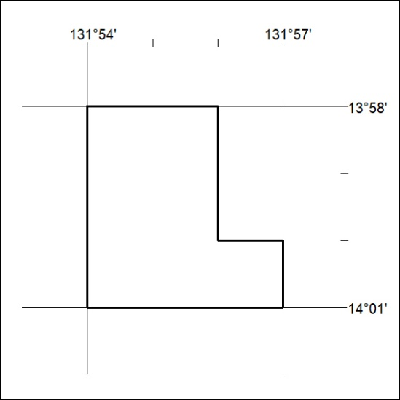

507/23

Mineral Titles Act 2010
NOTICE OF LAND CEASING TO BE A MINERAL TITLE AREA
Title Type and Number: | Exploration Licence 31492
Area Ceased on: | 20 December 2023
Area: | 3 Blocks, 9.96 km²
Locality: | MOROAK
Name of Applicant(s)/Holder(s): | 100% MOROAK RESOURCES PTY LTD [ACN. 616 553 014]
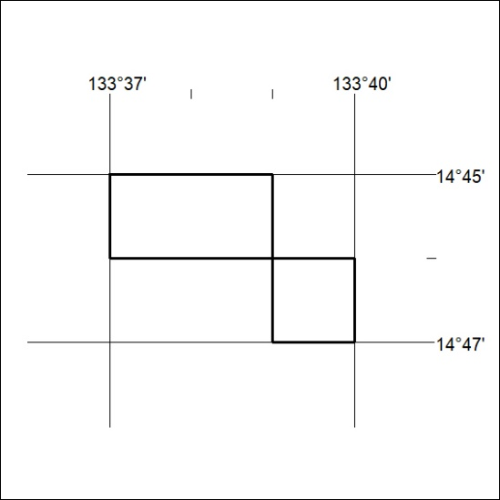

508/23
Mineral Titles Act 2010
NOTICE OF LAND CEASING TO BE A MINERAL TITLE AREA
Title Type and Number: | Exploration Licence 32758
Area Ceased on: | 16 December 2023
Area: | 49 Blocks, 145.22 km²
Locality: | LAUGHLEN
Name of Applicant(s)/Holder(s): | 100% GEMPART (NT) PTY LTD* [ACN. 081 859 896]
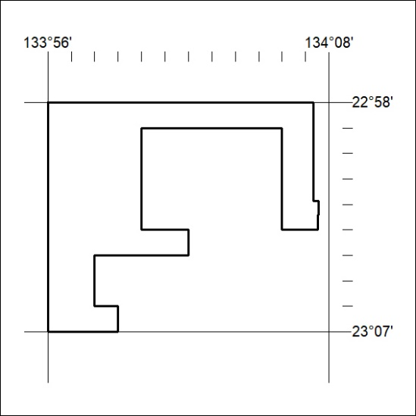

509/23

