Mineral Titles Act 2010
NOTICE OF LAND CEASING TO BE A MINERAL TITLE AREA
Title Type and Number: | Exploration Licence 32070
Area Ceased on: | 06 December 2023
Area: | 51 Blocks, 167.76 km²
Locality: | MALLAPUNYAH
Name of Applicant(s)/Holder(s): | 100% CERBERUS RESOURCES PTY LTD [ACN. 615 192 535]
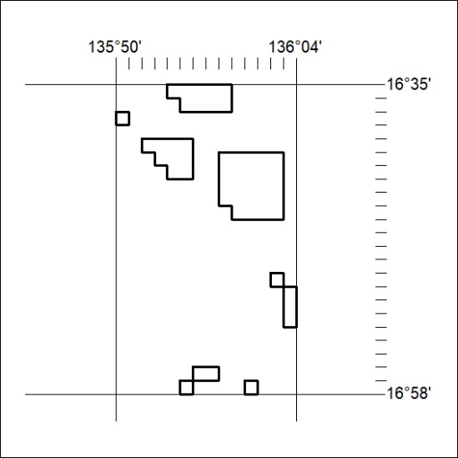

504/23

Mineral Titles Act 2010
NOTICE OF LAND CEASING TO BE A MINERAL TITLE APPLICATION AREA
Title Type and Number: | Exploration Licence 33609
Area Ceased on: | 07 December 2023
Area: | 12 Blocks, 39.53 km²
Locality: | BATTEN
Name of Applicant(s)/Holder(s): | 100% CERBERUS RESOURCES PTY LTD [ACN. 615 192 535]
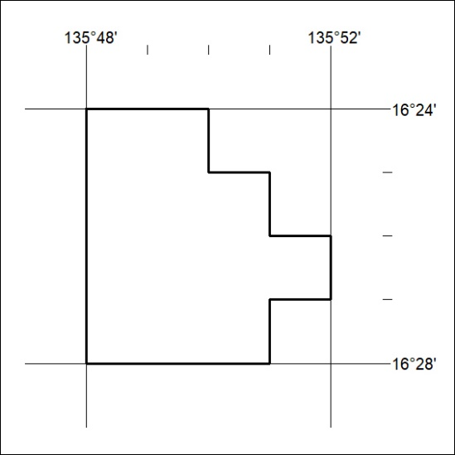

505/23

