Mineral Titles Act
NOTICE OF GRANT OF A MINERAL TITLE
Title Type and Number: | Extractive Mineral Exploration Licence 33403
Granted: | 27 October 2023, for a period of 2 Years
Area: | 4 Blocks, 13.12 km²
Locality: | NEWCASTLE WATERS
Name of Holder/s: | 100% TERRITORY SANDS PTY LTD [ACN. 632 797 972]
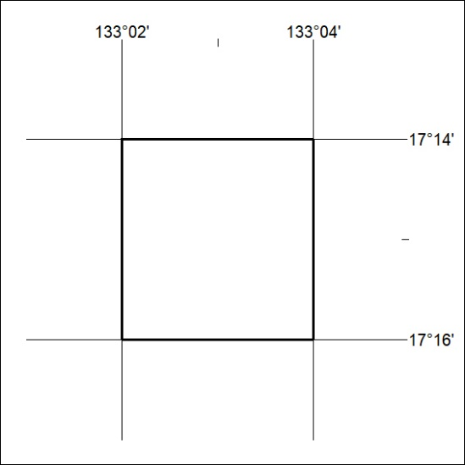
Area granted is indicated above. The titleholder is not permitted to exercise occupational rights on any land that is subject to a development title, or an application for a development title. Any land the subject of a Reserved Land gazettal under the Mineral Titles Act and all land vested in the Commonwealth of Australia is also excluded by description but not excised from the grant area.
451/23

Mineral Titles Act
NOTICE OF GRANT OF A MINERAL TITLE
Title Type and Number: | Extractive Mineral Exploration Licence 33404
Granted: | 27 October 2023, for a period of 2 Years
Area: | 4 Blocks, 13.12 km²
Locality: | NEWCASTLE WATERS
Name of Holder/s: | 100% TERRITORY SANDS PTY LTD [ACN. 632 797 972]
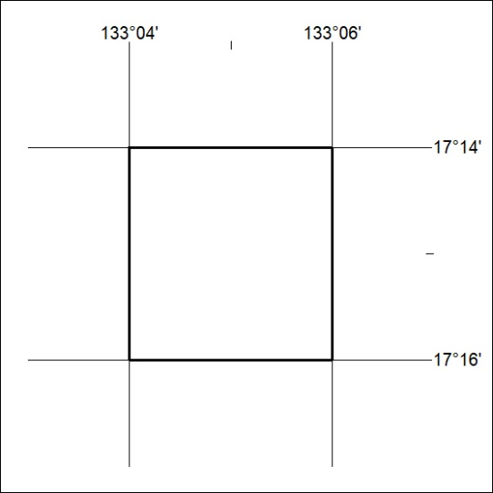
Area granted is indicated above. The titleholder is not permitted to exercise occupational rights on any land that is subject to a development title, or an application for a development title. Any land the subject of a Reserved Land gazettal under the Mineral Titles Act and all land vested in the Commonwealth of Australia is also excluded by description but not excised from the grant area.
452/23

Mineral Titles Act
NOTICE OF GRANT OF A MINERAL TITLE
Title Type and Number: | Extractive Mineral Exploration Licence 33405
Granted: | 27 October 2023, for a period of 2 Years
Area: | 4 Blocks, 13.12 km²
Locality: | NEWCASTLE WATERS
Name of Holder/s: | 100% TERRITORY SANDS PTY LTD [ACN. 632 797 972]
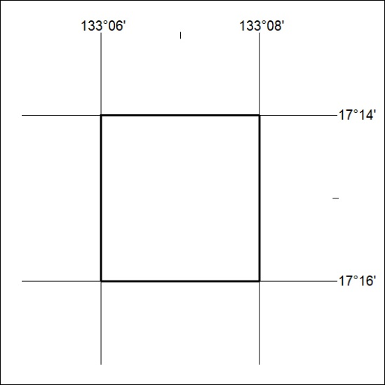
Area granted is indicated above. The titleholder is not permitted to exercise occupational rights on any land that is subject to a development title, or an application for a development title. Any land the subject of a Reserved Land gazettal under the Mineral Titles Act and all land vested in the Commonwealth of Australia is also excluded by description but not excised from the grant area.
453/23

Mineral Titles Act
NOTICE OF GRANT OF A MINERAL TITLE
Title Type and Number: | Extractive Mineral Exploration Licence 33406
Granted: | 27 October 2023, for a period of 2 Years
Area: | 2 Blocks, 6.56 km²
Locality: | NEWCASTLE WATERS
Name of Holder/s: | 100% TERRITORY SANDS PTY LTD [ACN. 632 797 972]
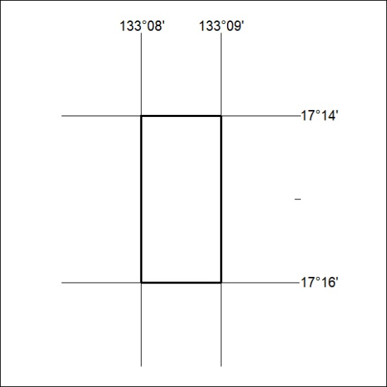
Area granted is indicated above. The titleholder is not permitted to exercise occupational rights on any land that is subject to a development title, or an application for a development title. Any land the subject of a Reserved Land gazettal under the Mineral Titles Act and all land vested in the Commonwealth of Australia is also excluded by description but not excised from the grant area.
454/23

Mineral Titles Act
NOTICE OF GRANT OF A MINERAL TITLE
Title Type and Number: | Extractive Mineral Exploration Licence 33407
Granted: | 27 October 2023, for a period of 2 Years
Area: | 4 Blocks, 13.12 km²
Locality: | NEWCASTLE WATERS
Name of Holder/s: | 100% TERRITORY SANDS PTY LTD [ACN. 632 797 972]
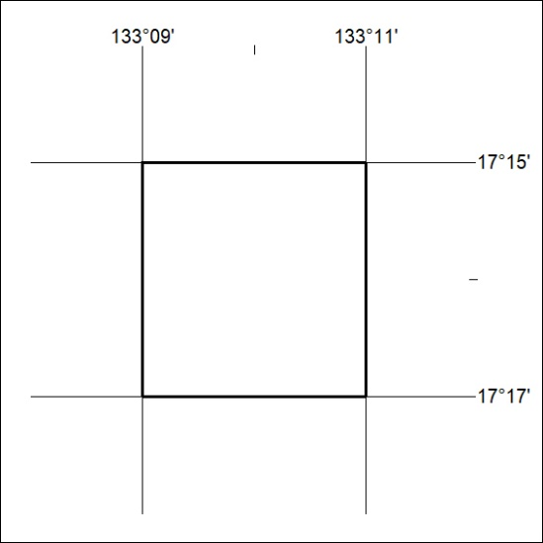
Area granted is indicated above. The titleholder is not permitted to exercise occupational rights on any land that is subject to a development title, or an application for a development title. Any land the subject of a Reserved Land gazettal under the Mineral Titles Act and all land vested in the Commonwealth of Australia is also excluded by description but not excised from the grant area.
455/23

Mineral Titles Act
NOTICE OF GRANT OF A MINERAL TITLE
Title Type and Number: | Extractive Mineral Exploration Licence 33408
Granted: | 27 October 2023, for a period of 2 Years
Area: | 4 Blocks, 13.12 km²
Locality: | NEWCASTLE WATERS
Name of Holder/s: | 100% TERRITORY SANDS PTY LTD [ACN. 632 797 972]
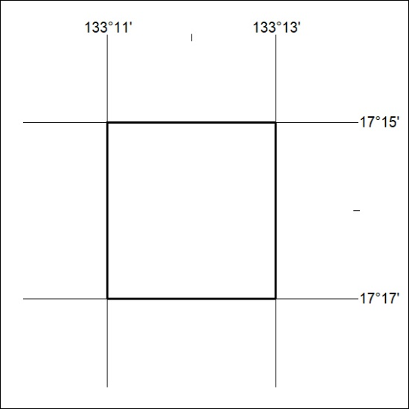
Area granted is indicated above. The titleholder is not permitted to exercise occupational rights on any land that is subject to a development title, or an application for a development title. Any land the subject of a Reserved Land gazettal under the Mineral Titles Act and all land vested in the Commonwealth of Australia is also excluded by description but not excised from the grant area.
456/23

Mineral Titles Act
NOTICE OF GRANT OF A MINERAL TITLE
Title Type and Number: | Extractive Mineral Exploration Licence 33409
Granted: | 27 October 2023, for a period of 2 Years
Area: | 4 Blocks, 13.12 km²
Locality: | NEWCASTLE WATERS
Name of Holder/s: | 100% TERRITORY SANDS PTY LTD [ACN. 632 797 972]
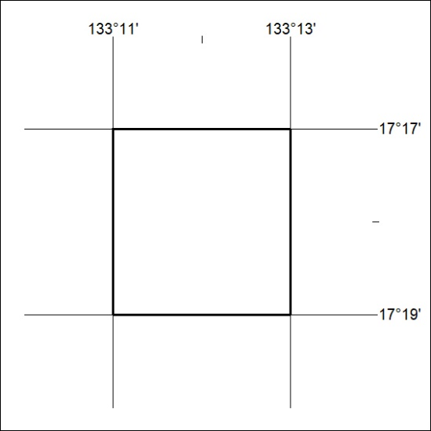
Area granted is indicated above. The titleholder is not permitted to exercise occupational rights on any land that is subject to a development title, or an application for a development title. Any land the subject of a Reserved Land gazettal under the Mineral Titles Act and all land vested in the Commonwealth of Australia is also excluded by description but not excised from the grant area.
457/23

Mineral Titles Act
NOTICE OF GRANT OF A MINERAL TITLE
Title Type and Number: | Extractive Mineral Exploration Licence 33515
Granted: | 27 October 2023, for a period of 2 Years
Area: | 4 Blocks, 13.12 km²
Locality: | NEWCASTLE WATERS
Name of Holder/s: | 100% TERRITORY SANDS PTY LTD [ACN. 632 797 972]
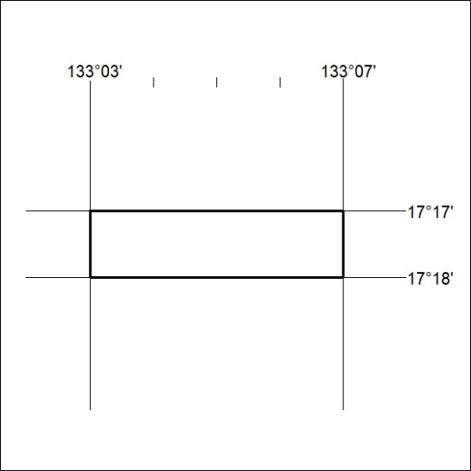
Area granted is indicated above. The titleholder is not permitted to exercise occupational rights on any land that is subject to a development title, or an application for a development title. Any land the subject of a Reserved Land gazettal under the Mineral Titles Act and all land vested in the Commonwealth of Australia is also excluded by description but not excised from the grant area.
458/23

Mineral Titles Act
NOTICE OF GRANT OF A MINERAL TITLE
Title Type and Number: | Extractive Mineral Exploration Licence 33516
Granted: | 27 October 2023, for a period of 2 Years
Area: | 3 Blocks, 9.84 km²
Locality: | NEWCASTLE WATERS
Name of Holder/s: | 100% TERRITORY SANDS PTY LTD [ACN. 632 797 972]
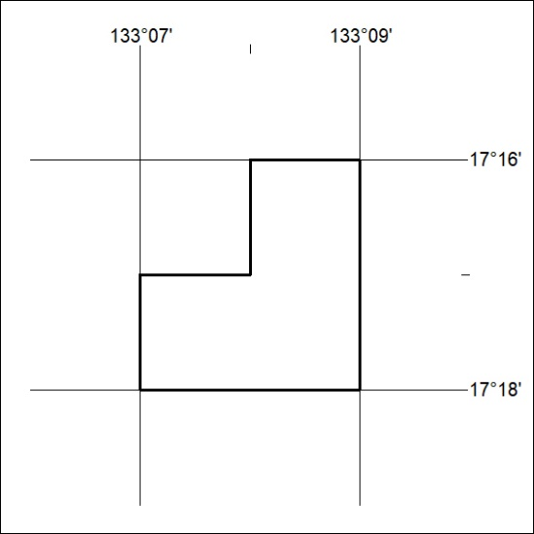
Area granted is indicated above. The titleholder is not permitted to exercise occupational rights on any land that is subject to a development title, or an application for a development title. Any land the subject of a Reserved Land gazettal under the Mineral Titles Act and all land vested in the Commonwealth of Australia is also excluded by description but not excised from the grant area.
459/23

