Mineral Titles Act 2010
NOTICE OF LAND CEASING TO BE A MINERAL TITLE AREA
Title Type and Number: | Exploration Licence 32496
Area Ceased on: | 20 October 2023
Area: | 30 Blocks, 97.24 km²
Locality: | LULU
Name of Applicant(s)/Holder(s): | 100% BREMA RESOURCES PTY LTD [ACN. 643 480 693]
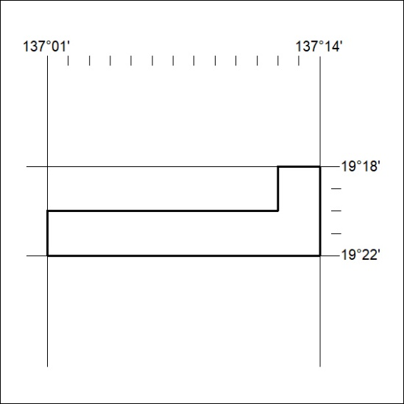

437/23

Mineral Titles Act 2010
NOTICE OF LAND CEASING TO BE A MINERAL TITLE AREA
Title Type and Number: | Exploration Licence 32693
Area Ceased on: | 20 October 2023
Area: | 248 Blocks, 805.46 km²
Locality: | MITCHIEBO
Name of Applicant(s)/Holder(s): | 100% CHALCO RESOURCES PTY LTD [ACN. 648 662 346]
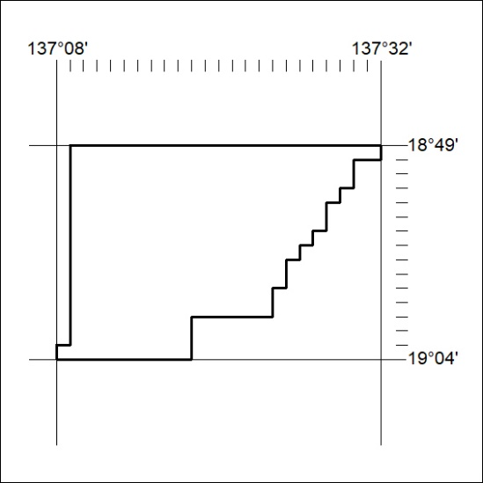

438/23

