Mineral Titles Act 2010
NOTICE OF LAND CEASING TO BE A MINERAL TITLE AREA
Title Type and Number: | Exploration Licence 26825
Area Ceased on: | 17 October 2023
Area: | 101 Blocks, 315.05 km²
Locality: | CRAWFORD
Name of Applicant(s)/Holder(s): | 100% PRODIGY GOLD NL* [ACN. 009 127 020]
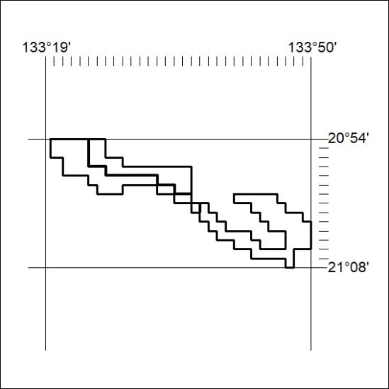

432/23

Mineral Titles Act 2010
NOTICE OF LAND CEASING TO BE A MINERAL TITLE AREA
Title Type and Number: | Exploration Licence 29723
Area Ceased on: | 17 October 2023
Area: | 51 Blocks, 163.46 km²
Locality: | CRAWFORD
Name of Applicant(s)/Holder(s): | 100% PRODIGY GOLD NL* [ACN. 009 127 020]
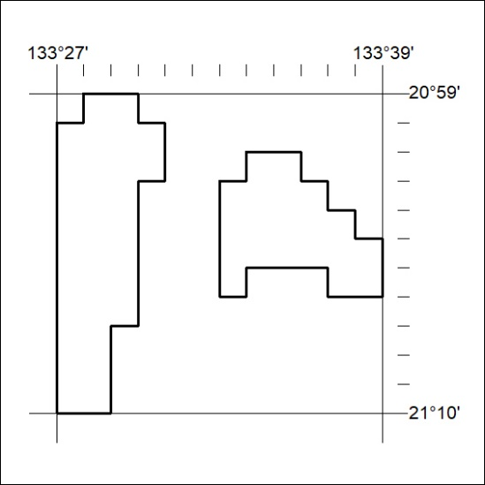

433/23
Mineral Titles Act 2010
NOTICE OF LAND CEASING TO BE A MINERAL TITLE AREA
Title Type and Number: | Exploration Licence 29896
Area Ceased on: | 17 October 2023
Area: | 47 Blocks, 149.34 km²
Locality: | CRAWFORD
Name of Applicant(s)/Holder(s): | 100% PRODIGY GOLD NL* [ACN. 009 127 020]
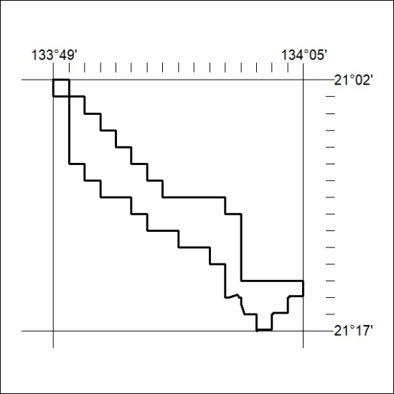

434/23

Mineral Titles Act 2010
NOTICE OF LAND CEASING TO BE A MINERAL TITLE AREA
Title Type and Number: | Exploration Licence 30637
Area Ceased on: | 17 October 2023
Area: | 79 Blocks, 243.75 km²
Locality: | CONICAL HILL
Name of Applicant(s)/Holder(s): | 100% PRODIGY GOLD NL* [ACN. 009 127 020]
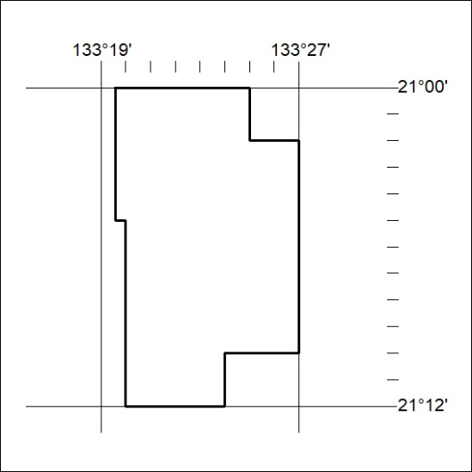

435/23
Mineral Titles Act 2010
NOTICE OF LAND CEASING TO BE A MINERAL TITLE AREA
Title Type and Number: | Exploration Licence 32665
Area Ceased on: | 17 October 2023
Area: | 31 Blocks, 99.48 km²
Locality: | HANLON
Name of Applicant(s)/Holder(s): | 100% KAILI GOLD PTY LTD [ACN. 608 163 202]
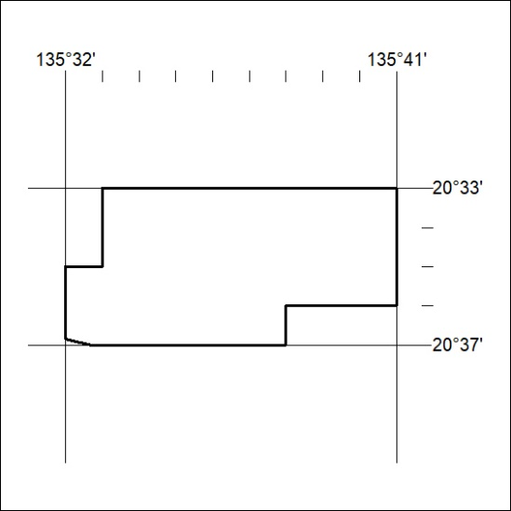

436/23

