Mineral Titles Act 2010
NOTICE OF LAND CEASING TO BE A MINERAL TITLE APPLICATION AREA
Title Type and Number: | Exploration Licence 33490
Area Ceased on: | 10 October 2023
Area: | 58 Blocks, 183.56 km²
Locality: | NAPPERBY
Name of Applicant(s)/Holder(s): | 100% RECHARGE MINERALS PTY LTD [ACN. 654 924 713]
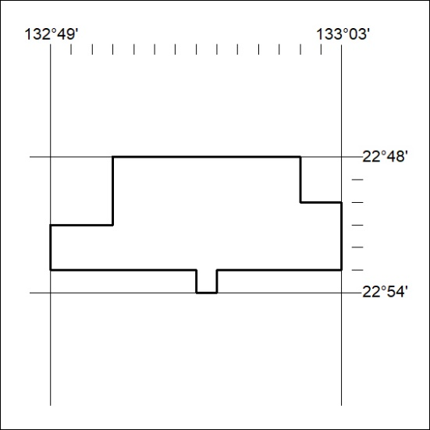

419/23

