Mineral Titles Act 2010
NOTICE OF LAND CEASING TO BE A MINERAL TITLE APPLICATION AREA
Title Type and Number: | Exploration Licence 33498
Area Ceased on: | 01 September 2023
Area: | 240 Blocks, 750.57 km²
Locality: | AREYONGA
Name of Applicant(s)/Holder(s): | 100% MCCLEARY Norman Sydney
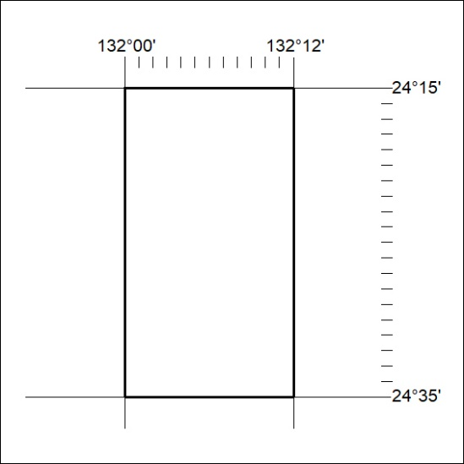

358/23

Mineral Titles Act 2010
NOTICE OF LAND CEASING TO BE A MINERAL TITLE APPLICATION AREA
Title Type and Number: | Exploration Licence 33499
Area Ceased on: | 01 September 2023
Area: | 240 Blocks, 750.57 km²
Locality: | AREYONGA
Name of Applicant(s)/Holder(s): | 100% MCCLEARY Norman Sydney
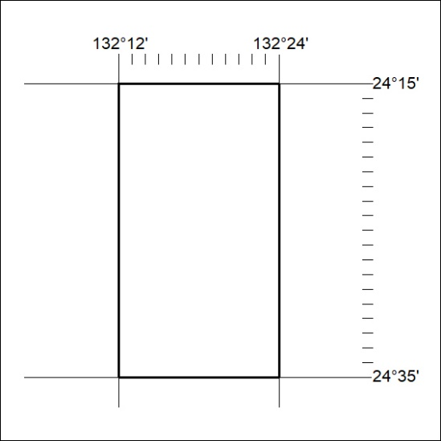

359/23
Mineral Titles Act 2010
NOTICE OF LAND CEASING TO BE A MINERAL TITLE APPLICATION AREA
Title Type and Number: | Exploration Licence 33500
Area Ceased on: | 01 September 2023
Area: | 220 Blocks, 654.86 km²
Locality: | AREYONGA
Name of Applicant(s)/Holder(s): | 100% MCCLEARY Norman Sydney
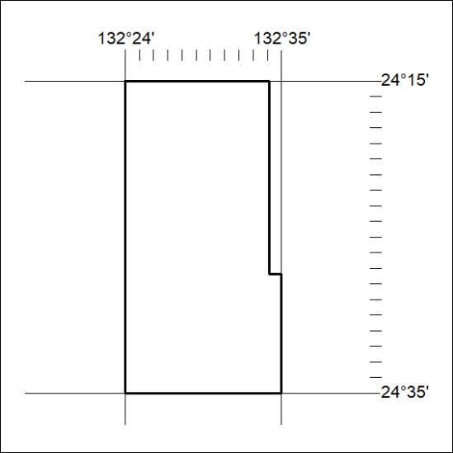

360/23

