Mineral Titles Act 2010
NOTICE OF LAND CEASING TO BE A MINERAL TITLE AREA
Title Type and Number: | Exploration Licence 31358
Area Ceased on: | 25 July 2023
Area: | 105 Blocks, 326.40 km²
Locality: | MUSGRAVE
Name of Applicant(s)/Holder(s): | 100% TRI-STAR ENERGY COMPANY [ACN. 089 539 695]
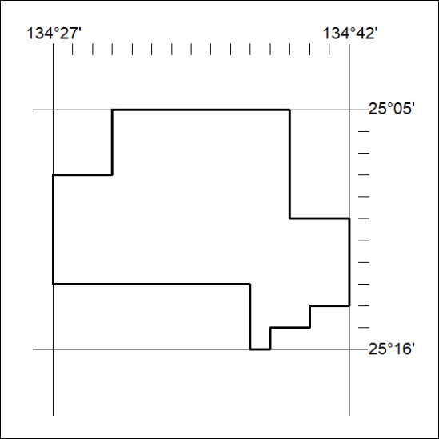

310/23

Mineral Titles Act 2010
NOTICE OF LAND CEASING TO BE A MINERAL TITLE AREA
Title Type and Number: | Exploration Licence 31371
Area Ceased on: | 25 July 2023
Area: | 244 Blocks, 757.44 km²
Locality: | MUSGRAVE
Name of Applicant(s)/Holder(s): | 100% TRI-STAR ENERGY COMPANY [ACN. 089 539 695]
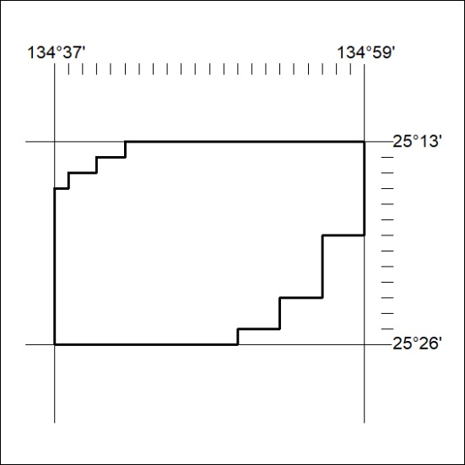

311/23
Mineral Titles Act 2010
NOTICE OF LAND CEASING TO BE A MINERAL TITLE AREA
Title Type and Number: | Exploration Licence 31375
Area Ceased on: | 25 July 2023
Area: | 79 Blocks, 244.87 km²
Locality: | ENGOORDINA
Name of Applicant(s)/Holder(s): | 100% TRI-STAR ENERGY COMPANY [ACN. 089 539 695]
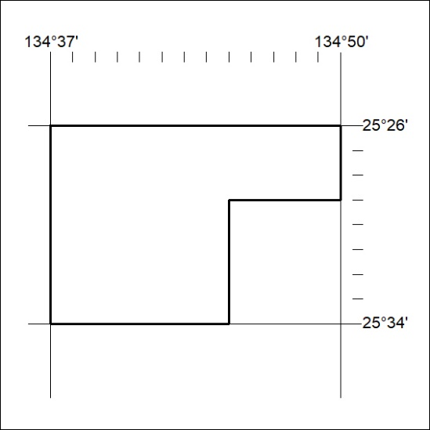

312/23

Mineral Titles Act 2010
NOTICE OF LAND CEASING TO BE A MINERAL TITLE AREA
Title Type and Number: | Exploration Licence 31378
Area Ceased on: | 25 July 2023
Area: | 70 Blocks, 214.06 km²
Locality: | BEDDOME
Name of Applicant(s)/Holder(s): | 100% TRI-STAR ENERGY COMPANY [ACN. 089 539 695]
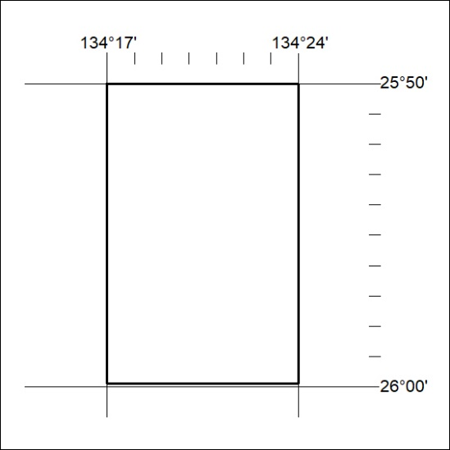

313/23

